Numbers and figures requested for Prelim report

2020-12-15

# Specific numbers requested

* Date of first survey: 14 October
* Date of last survey: 26 November, 2020
* Number of households surveyed: 192
* Number of individuals surveyed: 1007
* Mean number of adults per household: 4.6
* Mean number of children per household: 1.8
* Number of household where the head was not interviewed: 15
* Percentage of household where the head was not interviewed: 7.8%
* Number of households where the breadwinner was interviewed: 136
* Percentage of households where the breadwinner was interviewed: 70.8%
* Percentage of households in which the father is the breadwinner: 55.7%
* Percentage of households in which the mother is the breadwinner: 36.5%
* Top four occupations: Student, Small trader, Businessperson, Unemployed
* Percentage of households where there has been a death since March 1st: 5.7
* Mean age of those who diead since March 1st: 69.5454545
* Number of households where a prior positive test was reported: 6
* Number of individuals who have reported any COVID-like symptoms: 302
* Percentage of individuals who have reported any COVID-like symptoms: 30
* Percentage of individuals who are completely or partially complying with social distancing: 57.8%
* Number seropositive (either IgG or IgM): 328
* Number seronegative (both IgG and IgM): 642

# Tables and Figures Requested

## Sample characteristics table

Below is the sample table. Still needs lots of work: More variables, percentages. A similar table that is faceted by seropositivity instead of sex may also be good.

|  |  |  |  |
| --- | --- | --- | --- |
| **Characteristic** | **Female** | **Male** | **Total** |
| n | 570 | 437 | 1007 |
| Num. household heads | 77 | 101 | 178 |
| Mean Age (SD) | 29.6 (17.4) | 28.5 (17.6) | 29.1 (17.5) |
| Mean BMI (SD) | 27.3 (26.7) | 23.2 (6.26) | 25.5 (20.6) |
| *Age groups, n (% of sex in each group)* | | | |
| 5-15 | 137 (24%) | 128 (29.3%) | 265 (26.3%) |
| 16-29 | 186 (32.6%) | 136 (31.1%) | 322 (32%) |
| 30-45 | 140 (24.6%) | 89 (20.4%) | 229 (22.7%) |
| 46-65 | 79 (13.9%) | 66 (15.1%) | 145 (14.4%) |
| >65 | 28 (4.9%) | 18 (4.1%) | 46 (4.6%) |
| *Education Level, n (% of sex in each group)* | | | |
| Secondary | 258 (45.3%) | 184 (42.1%) | 442 (43.9%) |
| Primary | 191 (33.5%) | 137 (31.4%) | 328 (32.6%) |
| University | 76 (13.3%) | 81 (18.5%) | 157 (15.6%) |
| No formal instruction | 35 (6.1%) | 18 (4.1%) | 53 (5.3%) |
| Doctorate | 7 (1.2%) | 13 (3%) | 20 (2%) |
| Other | 3 (0.5%) | 4 (0.9%) | 7 (0.7%) |
| *Profession, n (% of sex in each group)* | | | |
| Student | 216 (36.5%) | 202 (43.3%) | 418 (39.5%) |
| Small trader | 86 (14.5%) | 136 (29.1%) | 222 (21%) |
| Businessperson | 81 (13.7%) | 50 (10.7%) | 131 (12.4%) |
| Home-maker | 74 (12.5%) | 0 (0%) | 74 (7%) |
| Unemployed | 52 (8.8%) | 21 (4.5%) | 73 (6.9%) |
| Salaried worker | 38 (6.4%) | 22 (4.7%) | 60 (5.7%) |
| Retired | 18 (3%) | 17 (3.6%) | 35 (3.3%) |
| Other | 17 (2.9%) | 15 (3.2%) | 32 (3%) |
| Farmer | 10 (1.7%) | 4 (0.9%) | 14 (1.3%) |
| *Chronic conditions, n (% of sex with that condition)* | | | |
| Hypertension | 25 (4.3%) | 12 (2.7%) | 37 (3.6%) |
| Respiratory illness | 9 (1.6%) | 8 (1.8%) | 17 (1.7%) |
| Diabetes | 7 (1.2%) | 4 (0.9%) | 11 (1.1%) |
| Cardiovascular illness | 0 (0%) | 3 (0.7%) | 3 (0.3%) |
| Chronic neurologic disease | 1 (0.2%) | 2 (0.5%) | 3 (0.3%) |
| HIV | 1 (0.2%) | 1 (0.2%) | 2 (0.2%) |
| Cancer | 0 (0%) | 1 (0.2%) | 1 (0.1%) |
| No response | 0 (0%) | 1 (0.2%) | 1 (0.1%) |
| Tuberculosis | 0 (0%) | 1 (0.2%) | 1 (0.1%) |
| Other | 22 (3.8%) | 19 (4.3%) | 41 (4%) |

## Seropositivity breakdown by age and sex figure

Anyone who had either a positive IgG or IgM is shown as positive here. Inconclusive results are not included in the denominator for the percentages.

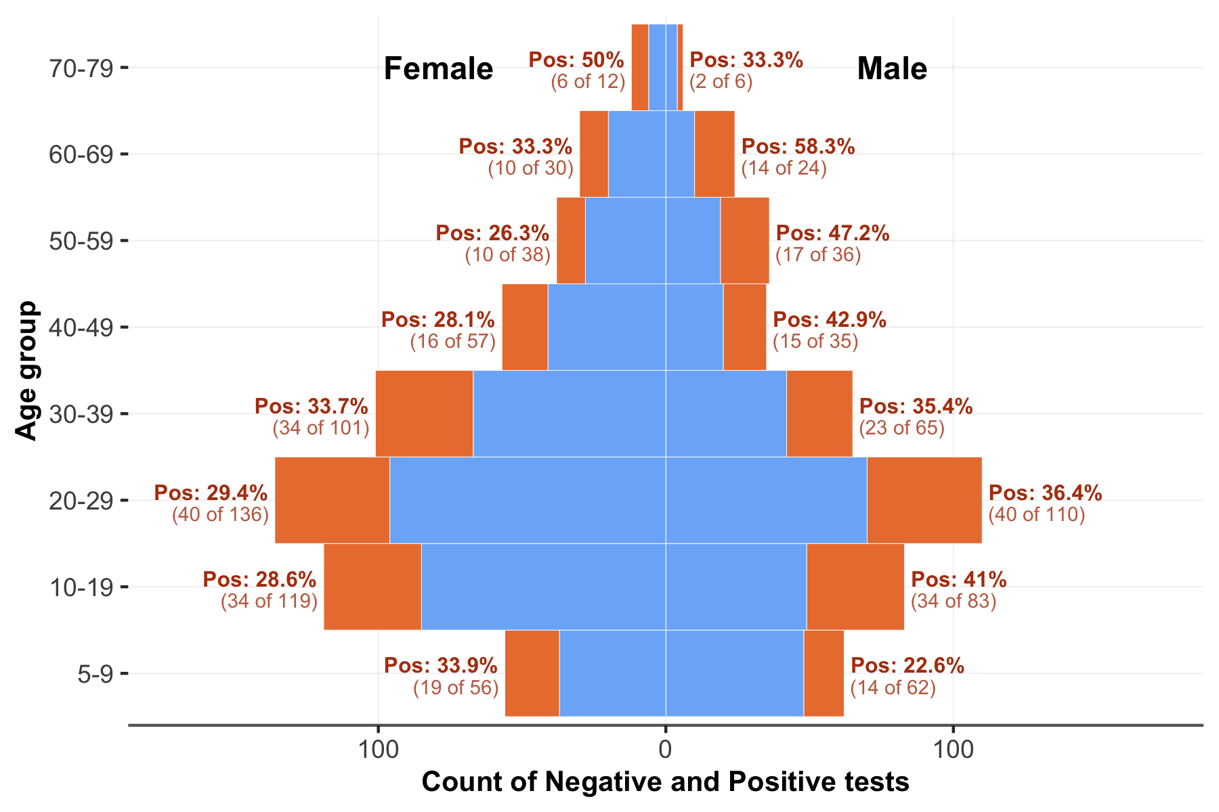

## Seropositivity breakdown table

|  |  |  |
| --- | --- | --- |
| **Characteristic** | **Positive** | **Negative** |
| n | 328 | 642 |
| Mean Age (SD) | 30.6 (18) | 28.2 (17) |
| Mean BMI (SD) | 27.3 (32.5) | 24.6 (10.9) |
| *Age groups, n (% of all positive/negatives that are of each sex)* | | |
| Female | 169 (51.5%) | 380 (59.2%) |
| Male | 159 (48.5%) | 262 (40.8%) |
| *Age groups, n (% of all positive/negatives that are in each age group)* | | |
| 5-15 | 79 (24.1%) | 179 (27.9%) |
| 16-29 | 102 (31.1%) | 206 (32.1%) |
| 30-45 | 77 (23.5%) | 145 (22.6%) |
| 46-65 | 53 (16.2%) | 89 (13.9%) |
| above 65 | 17 (5.2%) | 23 (3.6%) |
| *Education Level, n (% of all positive/negatives that are in each education class)* | | |
| Secondary | 138 (42.1%) | 294 (45.8%) |
| Primary | 117 (35.7%) | 201 (31.3%) |
| University | 54 (16.5%) | 91 (14.2%) |
| No formal instruction | 12 (3.7%) | 40 (6.2%) |
| Doctorate | 6 (1.8%) | 11 (1.7%) |
| Other | 1 (0.3%) | 5 (0.8%) |
| *Profession, n (% of all positive/negatives that are in each profession class)* | | |
| Student | 129 (39.3%) | 273 (42.5%) |
| Small trader | 79 (24.1%) | 139 (21.7%) |
| Businessperson | 44 (13.4%) | 84 (13.1%) |
| Home-maker | 26 (7.9%) | 48 (7.5%) |
| Unemployed | 25 (7.6%) | 45 (7%) |
| Salaried worker | 21 (6.4%) | 33 (5.1%) |
| Retired | 9 (2.7%) | 23 (3.6%) |
| Other | 9 (2.7%) | 20 (3.1%) |
| Farmer | 5 (1.5%) | 9 (1.4%) |
| *Symptoms, n (% of all positive/negatives that reported each symptom)* | | |
| No symptoms | 212 (64.6%) | 463 (72.1%) |
| Fever | 60 (18.3%) | 83 (12.9%) |
| Headache | 59 (18%) | 76 (11.8%) |
| Cough | 59 (18%) | 71 (11.1%) |
| Runny or stuffy nose | 39 (11.9%) | 49 (7.6%) |
| Sneezing | 23 (7%) | 25 (3.9%) |
| Fatigue | 14 (4.3%) | 27 (4.2%) |
| Muscle pain | 18 (5.5%) | 18 (2.8%) |
| Smell or taste loss | 13 (4%) | 13 (2%) |
| Sore throat | 8 (2.4%) | 10 (1.6%) |
| Stomach ache | 8 (2.4%) | 9 (1.4%) |
| Diarrhoea | 2 (0.6%) | 11 (1.7%) |
| Nausea, Vomiting | 4 (1.2%) | 10 (1.6%) |
| Shortness of breath | 2 (0.6%) | 4 (0.6%) |
| Other | 1 (0.3%) | 3 (0.5%) |

## Symptoms reported (since March 1st)

All respondents. Denominator of percentages is everyone who was surveyed.

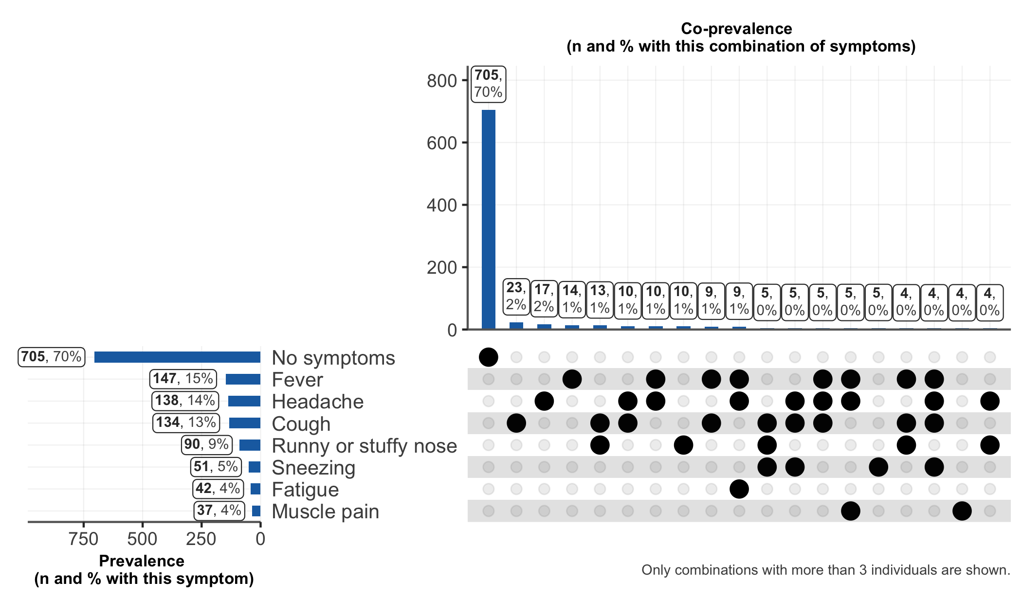

Subset of those who have had symptoms. Denominator of percentages is everyone who was surveyed.

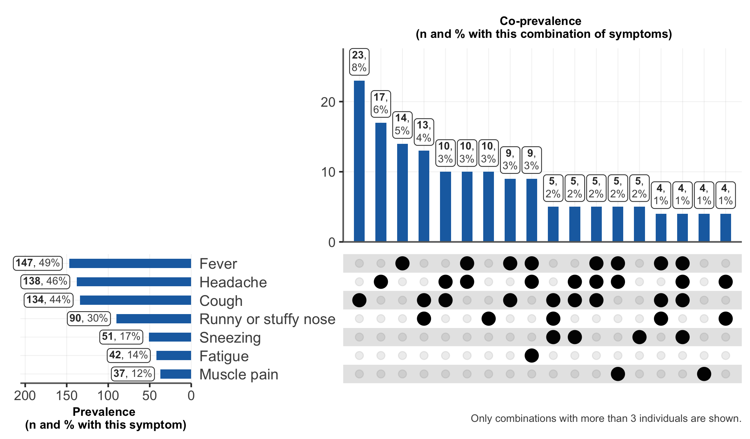

Subset of those who had a positive IgG or IgM test and have reported symptoms. Denominator of percentages is everyone who was seropositive.

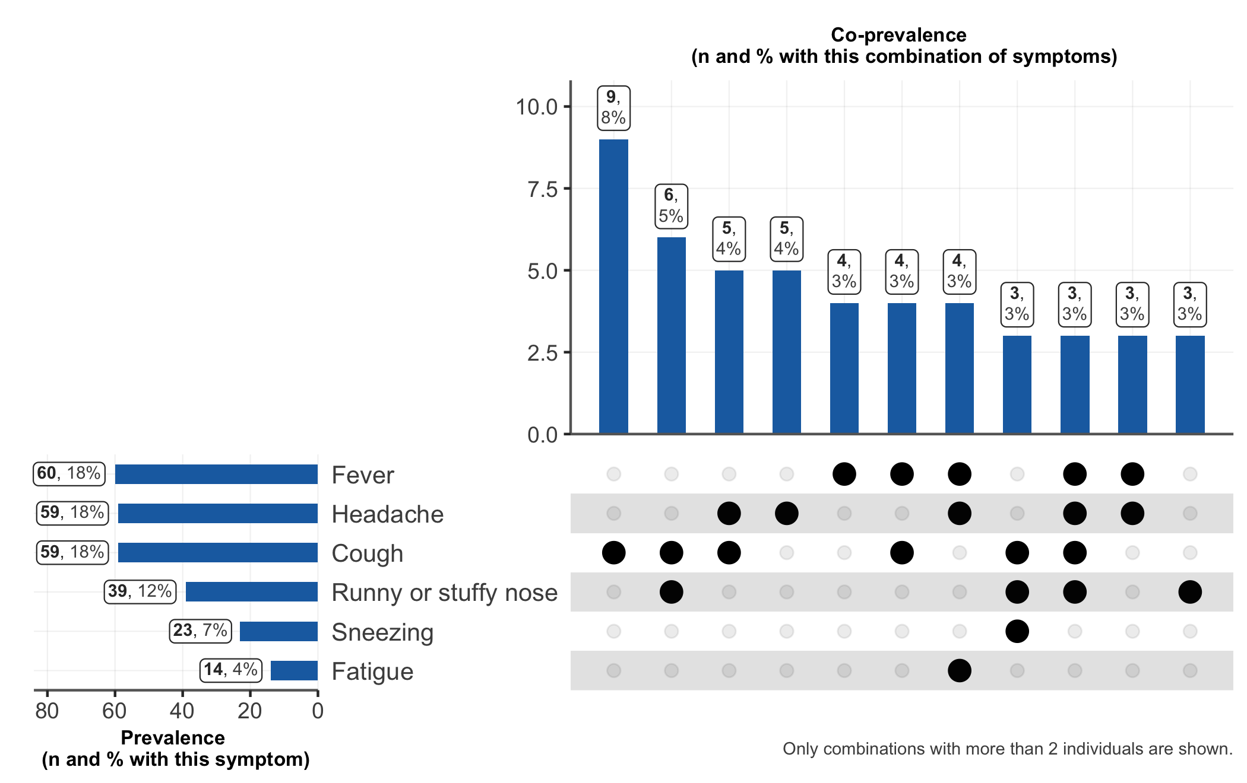

Subset of those who had negative test results for both the IgG and IgM and have reported symptoms. Denominator of percentages is everyone who was seronegative

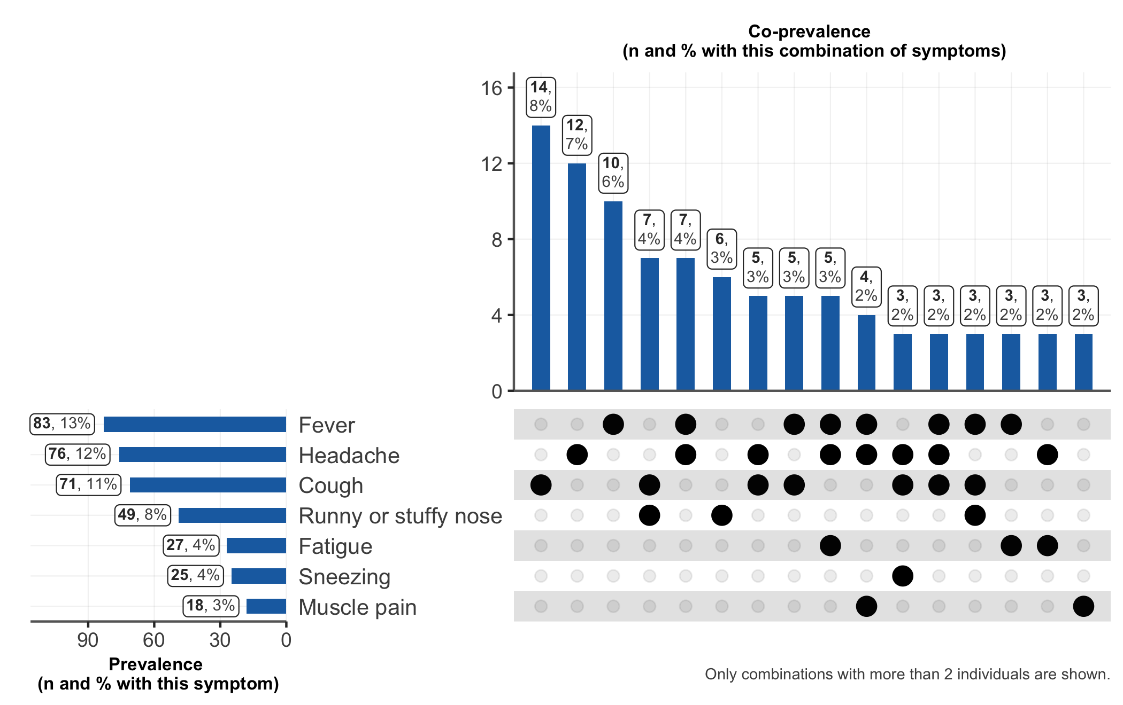

## Questions on respect of hygiene behavior

