Male: 29–36 kg, Female: 25–32 k

JULY 20

JULY 20

August 20

AUGUST 10

AUGUST 10

<- SAME BUT DIFFERENT DOGS

SAVE

Name of Dog: High Classification: Life Span: Temperament: Height: Weight :

IMPORT PHOTO

+ ADD DOGS

**ADMIN PAGE:**

**>**

**<**

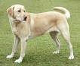

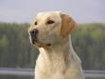

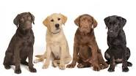

**High Classification:** Dog **Life Span**: 10-12 years **Temperament:** Outgoing, Kind ,Agile ,Event Tempered , Trusting, Intelligent Height: Male: 57–62 cm, Female: 55–60 cm **Weight :Male:** 29–36 kg, **Female:** 25–32 kg

View Commnets

Type of retriever gun dog, it is one of the most popular breed of dog in United Kingdom

**LABRADOR RETRIEVER**



< PREVIOUS



< PREVIOUS

NEXT >

Pug

Yorkshire Terrier

Chow Chow

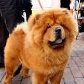





Border Collie

Chihuahua

Beagle







German Shepherd

Labrador Retriever

Bulldog

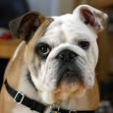

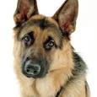





Full name:

Username:

**SIGN UP FOR FREE:**

Don’t have an account? **Sign p**





**LOG**



**USER LOGIN:**

Username

Passord

Full name:

Username:

**SIGN UP FOR FREE:**

Don’t have an account? **Sign p**





**LOG**



**USER LOGIN:**

Username

Passord