Delay: 0.255 ms

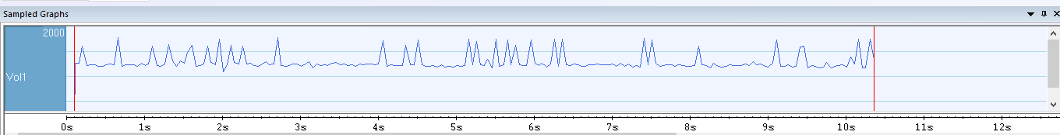

Delay: 32.767 ms

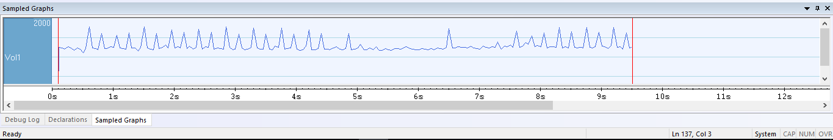

Delay: 65.535 ms

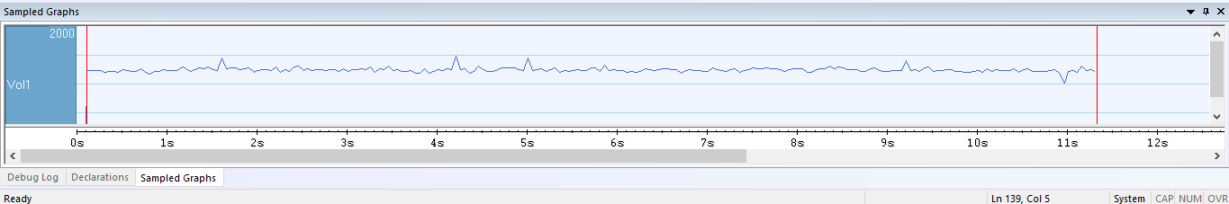

Delay: 131.070 ms

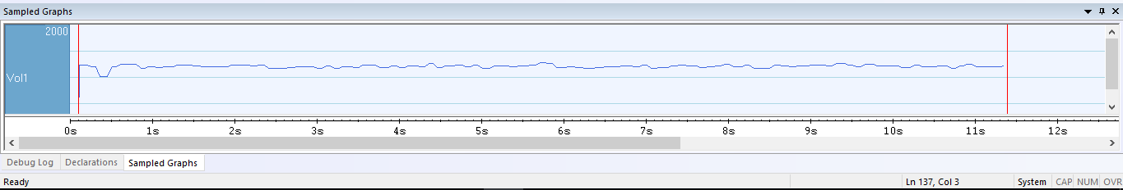

Delay: 196.605 ms

