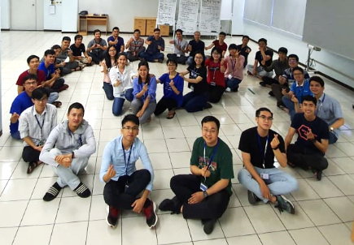

**TEAM WORK - EFFECTIVE TEAMS**

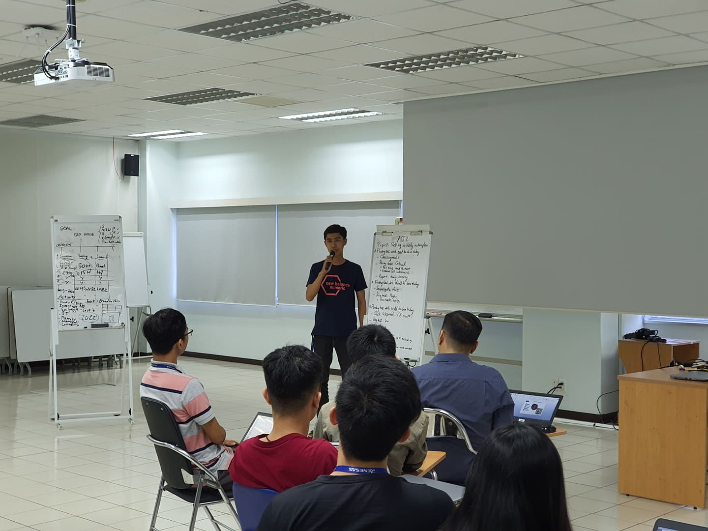

Organising and Planning

If you don’t know what needs to be done, and by when, it’s quite hard to make it happen by your deadline. So, you need to make a plan to manage your task and your time. Setting a daily action plan as an example.

Work according to priority: must/should/could do on today.

Work according to fixed task.

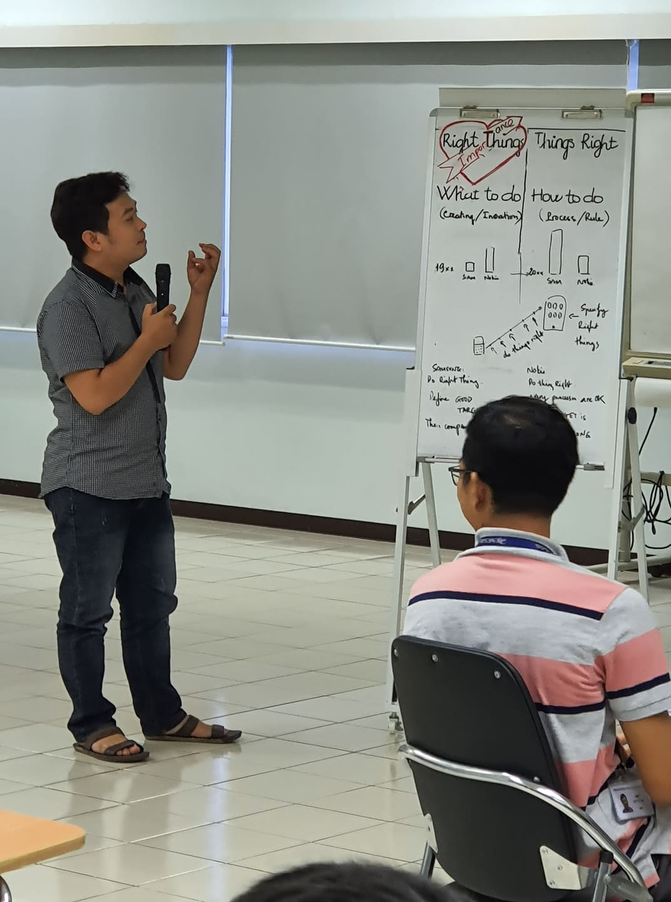

Decision - Making

Being able to make decisions is also crucial to moving things forward.

Doing right things are better than doing thing rights.

Setting a short and long -term goals with team also becomes the foundation for every task they set out to complete each day. Follow goals we will not go wrong way. You can go so fast but it is nothing if you can’t achieve your goals

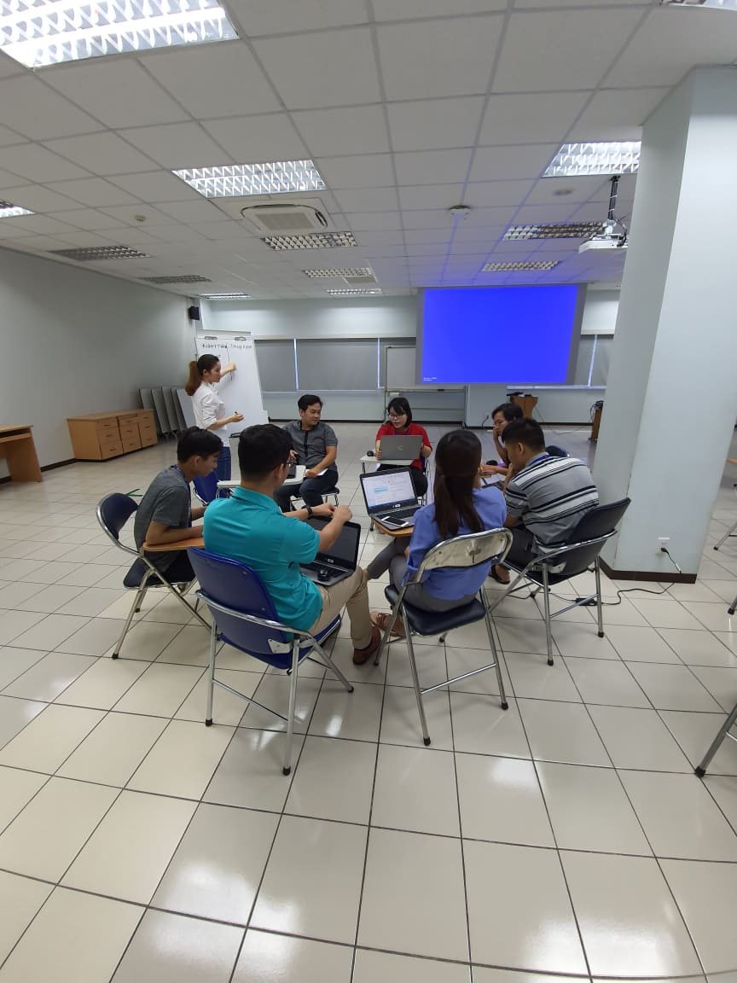

Conflict resolution

In some cases, you must to deal with difficult people or situations, or even resolve a conflict. Seating and talk together to understand others. And then, get the best of solution.

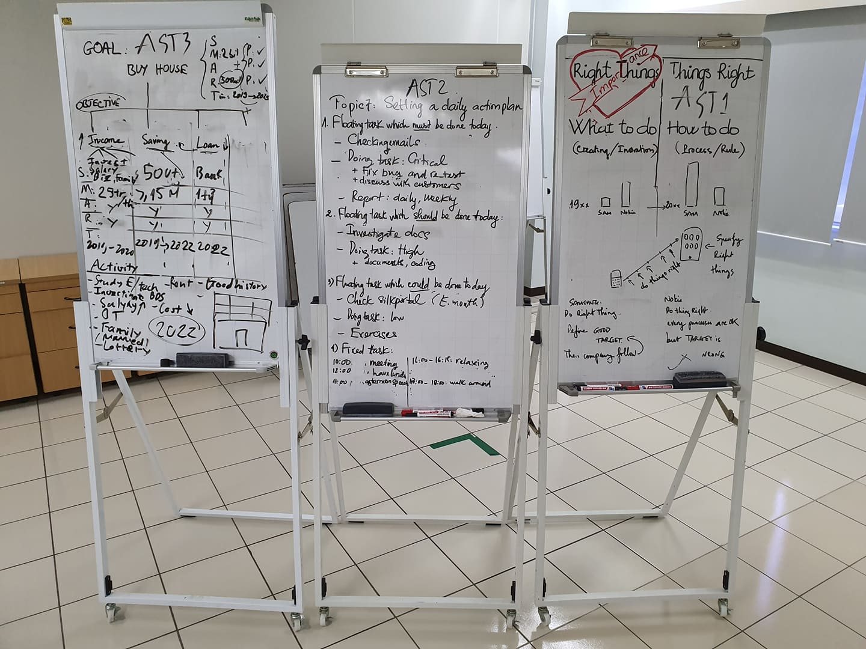

Team building

Important thing to remember that all team-working situations are fundamentally about working with other people. So we need to have some activity to improve relationship in team.

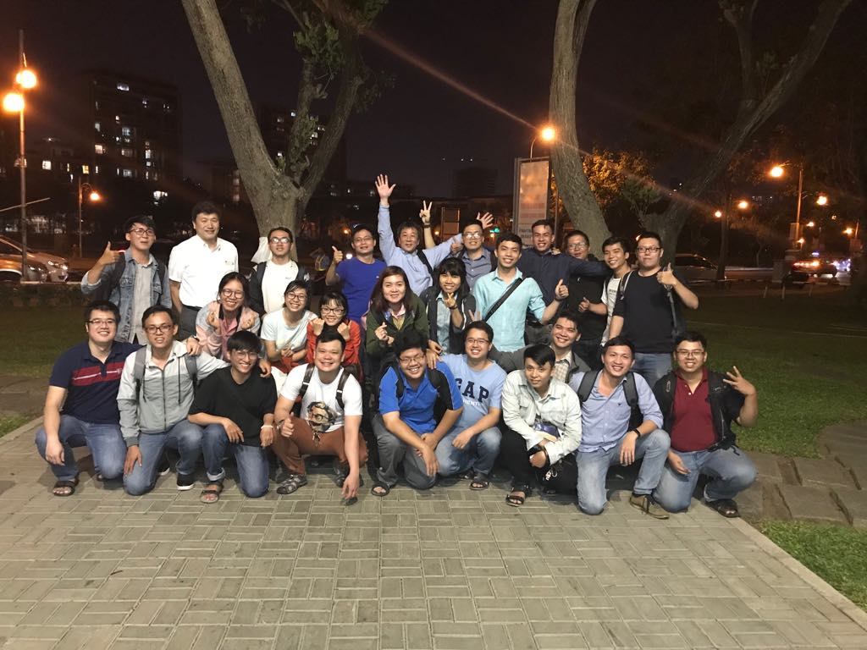

Team building connect teams and members close to others  
 ONE RENESAS