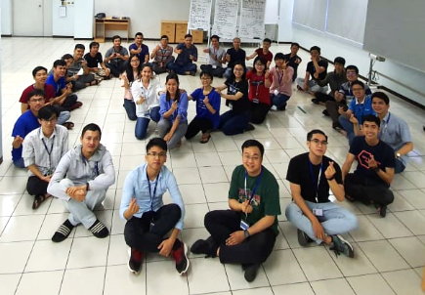

**TEAM WORK FOR EFFECTIVE TEAM**

Each team is a group of people working together cohesively, towards a common goal, creating a positive working atmosphere, support each other to combine individual strengths to enhance team performance.

A strong team with effective team work will enhance the productivity of the team, improve job satisfaction for each individual, and create an open and trustworthy network.

Here are some tips for better, more effective team work.

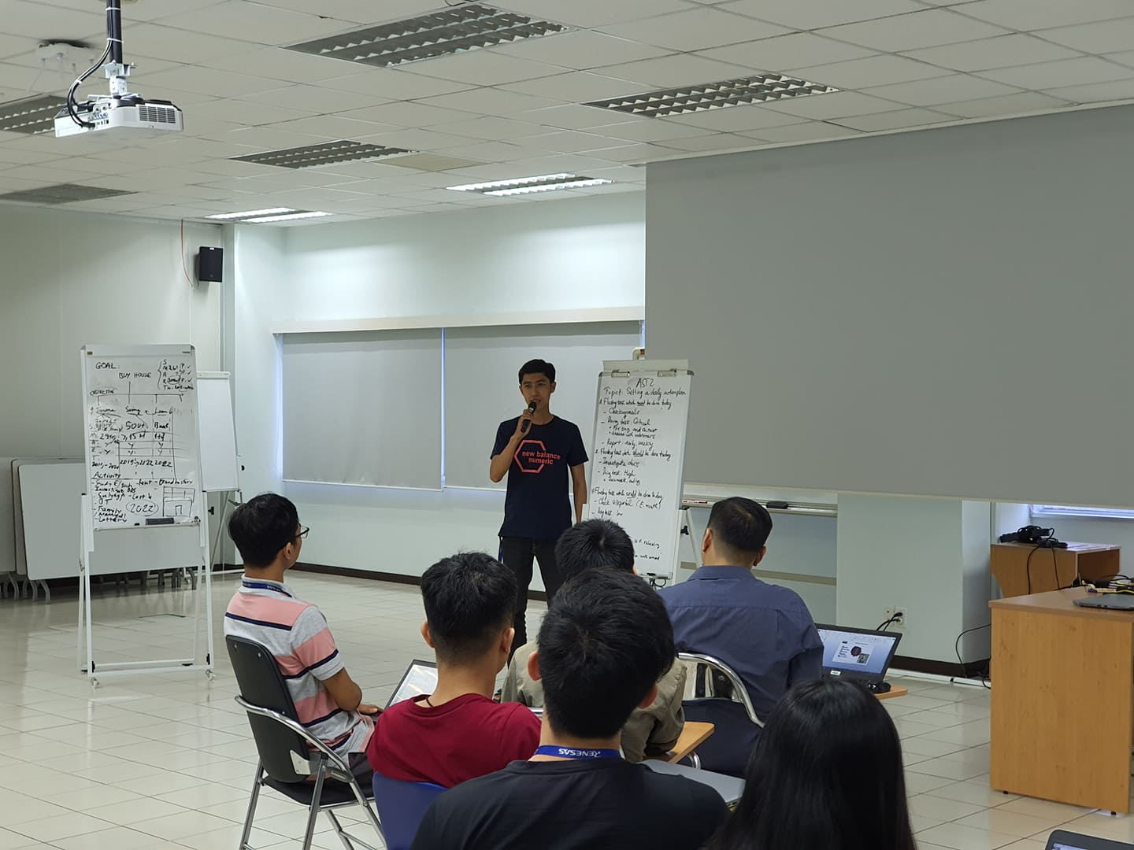

Organizing and planning – share the common goal

If each person in the team is not aware of what needs to be done, it is quite hard for any team to accomplish a significant goal within a deadline. So each team member must be clear about the long team and short term goals of the team. When every person in the team starts manage their daily task and time to contribute to the team, the goal now is a guaranteed success.

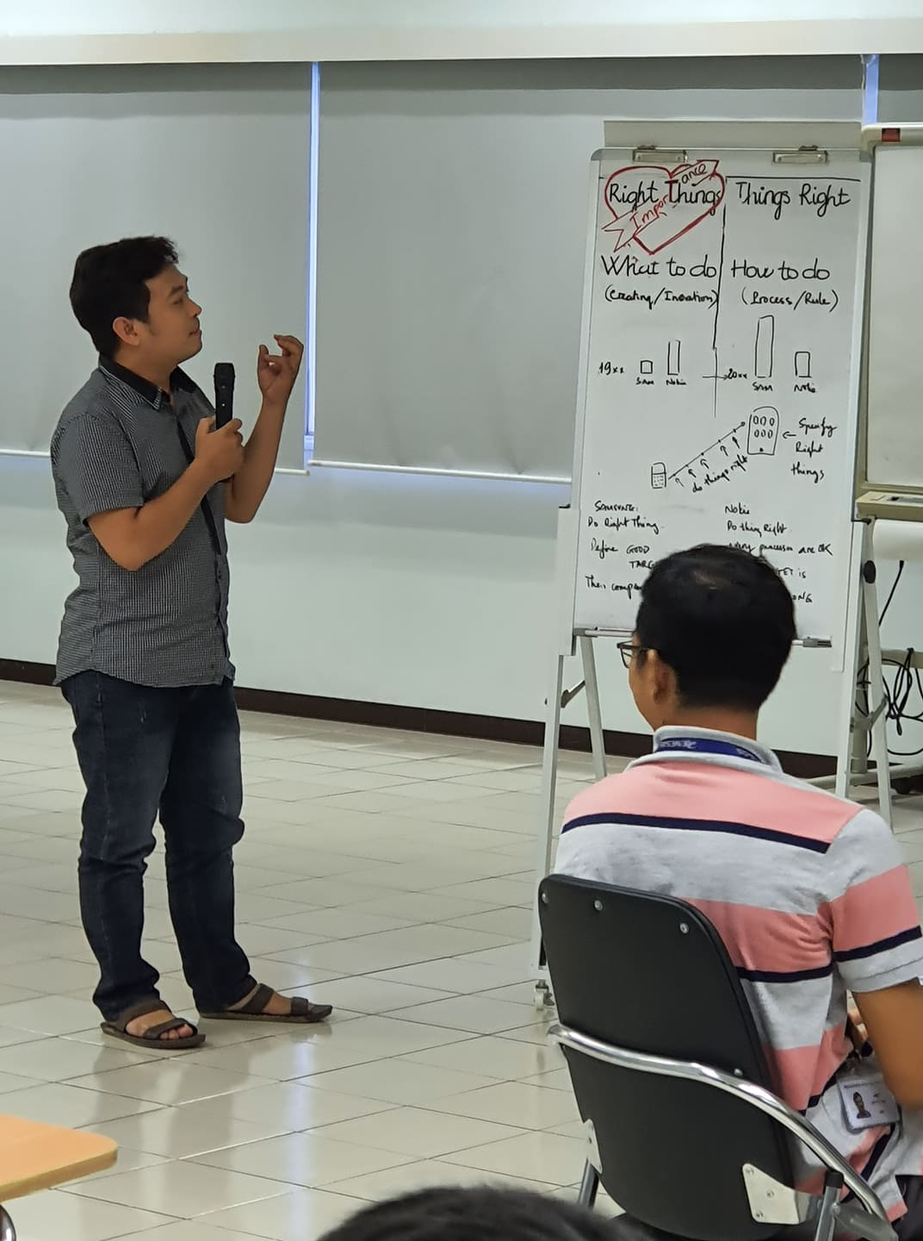

Decision making – to do the right things

Being able to make decisions is also crucial to moving things forward but it can be hard in a team with many different individuals. Remember doing the right things will come before doing things right. As long as the team agrees that the short/long term goal is the right thing to do, doing things right will become every task the team members set out to complete each day

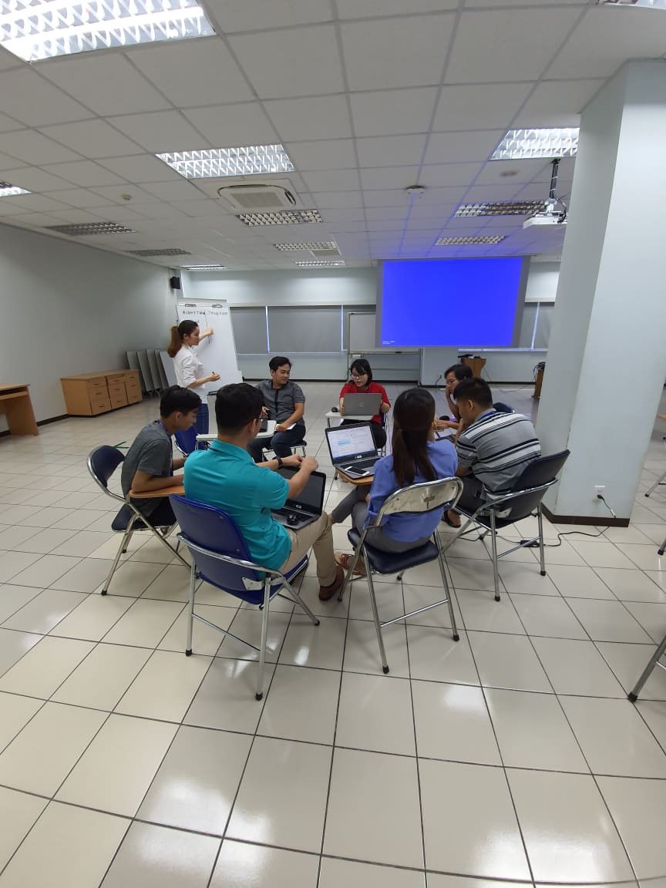

When dealing difficult people, situations, or even resolving a conflict in a team, the ability to listen and being patient is crucial. Siting and talking to each other is the best way to reach understanding. And then, gather all opinions and follow the best solution.

Conflict resolution – communicate

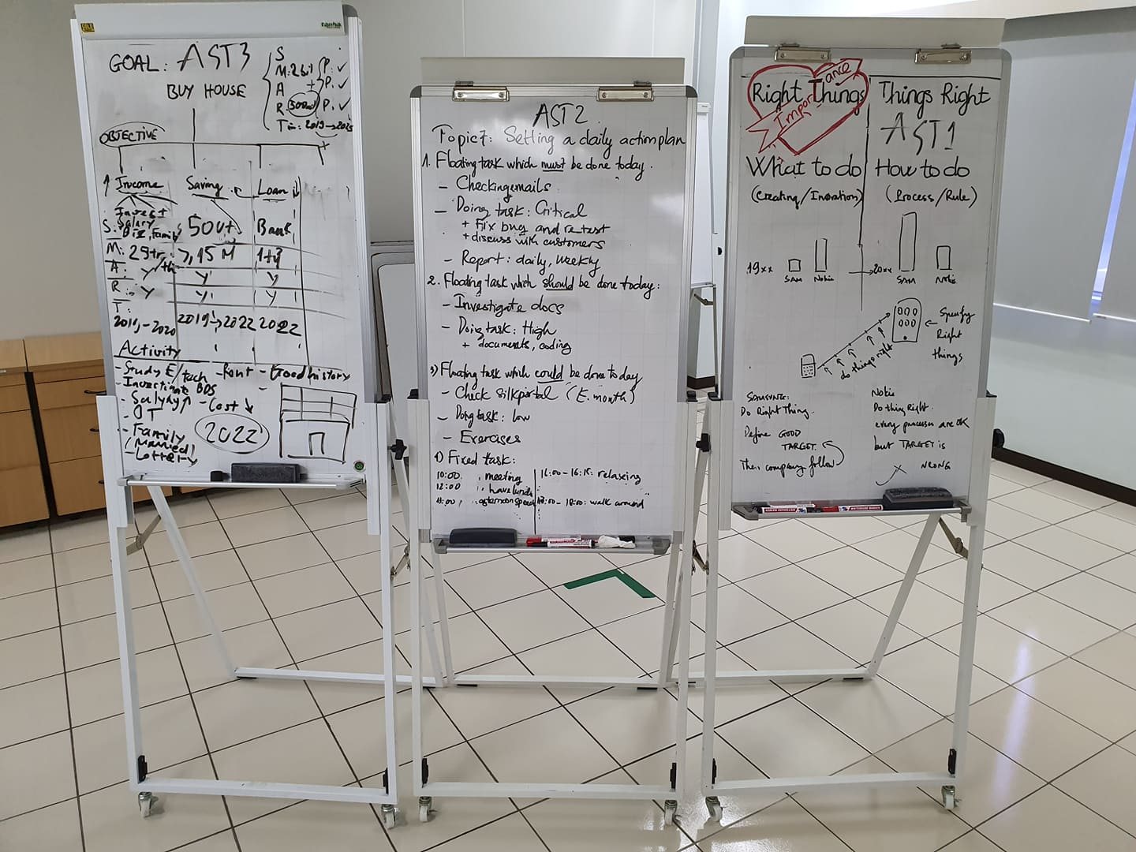

Team building

Most importantly, working in a team always means working with other people. A strong, effective team is a team that creates many opportunities for team member to bond with each other. At the end, you want to work with your friends, not strangers.

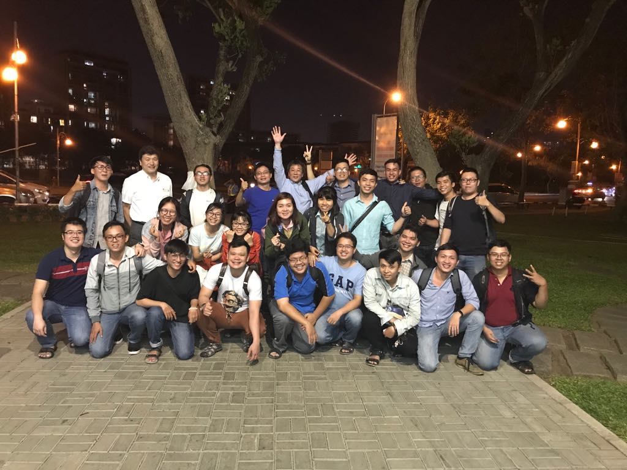

Team building connect teams and members close to others  
 ONE RENESAS