**Background**

The first COVID-19 outbreak was reported in Wuhan in 2019, and the disease eventually spread around the world, prompting the World Health Organization (WHO) to declare a global COVID-19 pandemic in March 2020 [1], [2]. As in 6 August 2021, the COVID-19 pandemic has caused more than 4 million deaths worldwide [3], and a total of more than 12,000 confirmed cases in Hong Kong [3]. Transmission of COVID-19 is largely attributed to direct or close contact with infected individuals. Social distancing policies, which include wearing face masks, limiting the opening hours of restaurants, restricting the opening hours of schools, restricting the maximum number of people gather at once in public, have lowered the number of new cases, indicating that a general reduction in the number of contacts can decrease the number of individuals contracting the disease. In addition to these social distancing policies, all in-bound travellers are required to quarantine at one of the designated quarantine hotels and tested periodically for COVID-19. Once new community cases of COVID-19 are confirmed, buildings where confirmed cases reside are being blocked and residents of the entire building are being mandatorily tested. However, these measures are not sustainable. The city needs to pay societal and economic costs to keep the number of new cases at low level. For instance, for making bars close early. Thus, since the vaccine roll-out, public health officials have continued to deliberate over when to reopen, which places are safe to return to, and how much activity to allow.

Answering these questions requires epidemiological models that can capture the effects of changes in mobility of virus spread. In particular, findings of COVID-19 superspreader events motivate models that can reflect the heterogeneous risks of visiting different locations.

Genomic sequencing analyses the virus sample taken from a diagnosed patient and compares it with other cases. As a virus passes from human to human, the virus changes slightly. While the genome of one COVID-19 patient compared with the person they caught it from will appear almost identical, after the virus has been transmitted onto further people, difference between the strands of the virus they carry become more apparent. These different changes, or mutations, define branches on a tree. Each branch of COVID-19 could be linked back to China in the original Wuhan outbreak, as well as via an outbreak in a foreign county.

There have been several new variants of SARS-CoV-2 emerged in late 2020 that are more human-to-human transmissible than the other variants [4]. Alpha (B.1.1.7) was reported in the United Kingdom in September 2020 as variant of concern [5], which has increased the virus’ transmissibility by 70% [4]. Another variant beta (B.1.351) emerged independently of alpha in South Africa in May 2020 [6], and gamma (P.1) was reported in Brazil in November 2020 [6]. The delta variant (B.1.617.2) was first detected in India last October [6].

COVID-19 has mutated to variants that the World Health Organization has denoted as variant of interest (VOI) and variant of concern (VOC). For VOI, it is a SARS-CoV-2 variant with genetic changes that are predicted or known to affect virus characteristics such as transmissibility, disease severity, immune escape, diagnostic or therapeutic escape and identified to cause significant community transmission or multiple COVID-19 clusters, in multiple counties with increasing relative prevalence alongside increasing number of cases over time, or other apparent epidemiological impacts to suggest an emerging risk to global public health [6]. For VOC, it is a SARS-COV-2 variant that meets the definition of a VOI, and one of the following: Increase in transmissibility or detrimental change in COVID-19 epidemiology, increase in virulence or change in clinical disease presentation, or decrease in effectiveness of public health and social measures or available diagnostics, vaccines, therapeutics [6].

New data from England suggests that for some groups, protection offered by vaccines against severe disease and death begins to wane several months after the second dose of vaccine. For Pfizer/ BioNTech, for example, efficacy against symptomatic infection for age 16 and above was 90% at week 2-9 and waned to 70% after week 20 [7]. For AstraZeneca, it was 67% at week 2-9 and waned to 50% after week 20 [7]. For Pfizer/ BioNTech, efficacy against hospital admission for age 65 and above and not clinical extremely vulnerable was 100% at week 2-9 and waned to 95% at week 20; for the clinical extremely vulnerable, it was 95% at week 2-9 and waned to 70% at week 20 [7]. For AstraZeneca, efficacy against hospital admission for age 65 and above and not clinical extremely vulnerable was 95% at week 2-9 and waned to 80% at week 20; for the clinical extremely vulnerable, it was 80% at week 2-9 and waned to 60% at week 20 [7]. For Pfizer/ BioNTech, efficacy against death was 95% at week 2-9 and waned to 90% at week 20. For AstraZeneca, it was 90% at week 2-9 and weaned to 80% at week 20 [7].

Efficacy is higher if vaccine dose gap is longer. For Pfizer/ BioNTech and for age 80 and above, efficacy against symptomatic infection was 35% (15%, 50%) at week 25 for vaccine dose gap less than 4 weeks; whereas, it was 65% (38%, 82%) at week 25 for dose gap that is 8 weeks and beyond [7].

Rates of cases, severe disease, and death are markedly lower among over-60s Israelis who have received a booster shot than among those who have not [7].

Using Hong Kong as a case study, the objectives of the study are as follows:

1. Determine the workload of Hong Kong healthcare system after vaccines rollout;
2. Determine which social distancing measure can be relaxed in Hong Kong after vaccines roll-out, particularly in the impact of schools returning; and
3. Determine the incidence of COVID-19 of some foreign countries which frequently have travellers travelling to Hong Kong;

**Methodology**

Three level of efficacies of vaccines (50%, 70%, and 90%) were distributed among the population, and half of the population had their social distancing measures relaxed.

$$\frac{dS_{1}}{dt}=-(β_{1}S_{1}I)(1-{vac}_{1})$$

$$\frac{dS_{2}}{dt}=-\left(β_{2}S_{2}I\right)\left(1-{vac}_{2}\right)$$

$$\frac{dS_{3}}{dt}=-(β_{3}S_{3}I)(1-{vac}_{3})$$

$$\frac{dS_{4}}{dt}=-(β_{2}S_{4}I)(1-{vac}_{1})$$

$\frac{dS_{5}}{dt}=-\left(β_{2}S_{5}I\right)\left(1-{vac}_{2}\right)$

$\frac{dS_{6}}{dt}=-(β_{2}S_{6}I)(1-{vac}_{3})$

$\frac{dE}{dt}=\left(β_{1}S_{1}I\right)\left(1-{vac}_{1}\right)+\left(β_{2}S_{2}I\right)\left(1-{vac}_{2}\right)+\left(β_{3}S_{3}I\right)\left(1-{vac}_{3}\right)$ + $\left(β_{2}S_{4}I\right)\left(1-{vac}_{1}\right)+\left(β_{2}S_{5}I\right)\left(1-{vac}_{2}\right)+\left(β_{2}S_{6}I\right)\left(1-{vac}_{3}\right)-σE$

$$\frac{dI}{dt}=σE-γI$$

$$\frac{dR}{dt}=γI$$

where vaci is vaccine efficacy in percentage and vac1 was 50%, vac2 was 70%, and vac3 was 90%.

Using function estimate_R in library EpiEstim of R, reproductive number was estimated.

We do not have empirical data.

**Results**

Figure 1 shows the epidemic curves over time, Figure 2a shows the estimated reproductive number over time when no social distancing measures was relaxed, and Figure 2b shows the estimated reproductive number over time when half of the population had their social distancing measures relaxed. The six lines of susceptibles in Figure 1 were S1-S6. This figure shows half of the population have their social distancing measures relaxed.

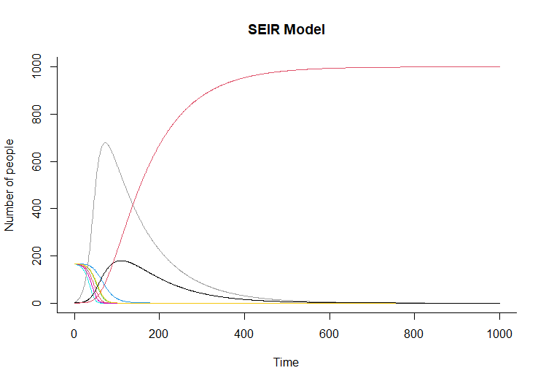

Figure 1. The epidemic curves over time. The grey line was exposed, the black line was infected, the red line was recovered, and the rest of the lines were susceptibles.

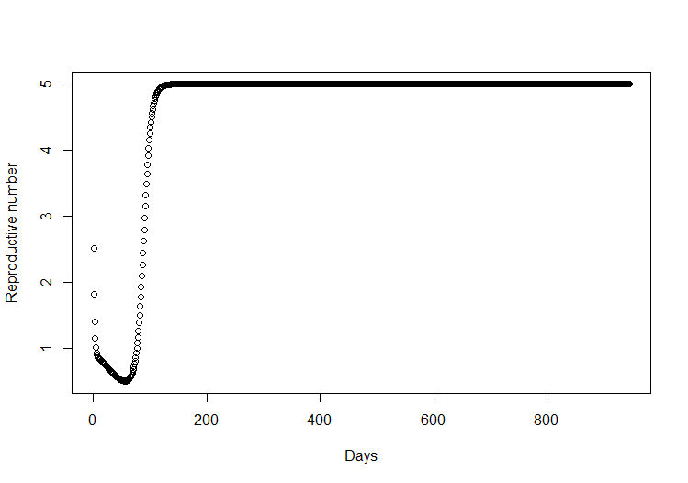

Figure 2a. The estimated reproductive number over time when no social distancing measures is relaxed.

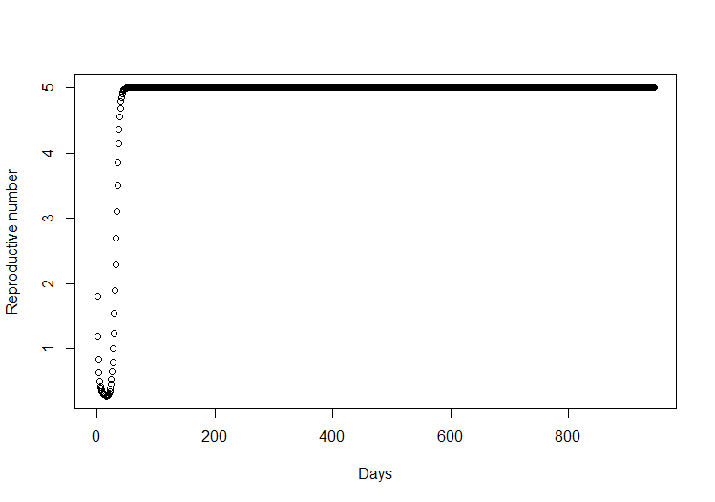

Figure 2b. The estimated reproductive number over time when half of the population had their social distancing measures relaxed.

**Bibliography**

[1] C. Wang, P. W. Horby, F. G. Hayden, and G. F. Gao, “A novel coronavirus outbreak of global health concern,” *The Lancet*, vol. 395, no. 10223, pp. 470–473, Feb. 2020, doi: 10.1016/S0140-6736(20)30185-9.

[2] C. Sohrabi *et al.*, “World Health Organization declares global emergency: A review of the 2019 novel coronavirus (COVID-19),” *International Journal of Surgery*, vol. 76, pp. 71–76, Apr. 2020, doi: 10.1016/j.ijsu.2020.02.034.

[3] “COVID-19 coronavirus pandemic,” *Worldometer*, Aug. 06, 2021. https://www.worldometers.info/coronavirus/#countries

[4] K. Kupferschmidt, “Mutant coronavirus in the United Kingdom sets off alarms, but its importance remains unclear,” *Science*, Dec. 20, 2020. [Online]. Available: https://www.sciencemag.org/news/2020/12/mutant-coronavirus-united-kingdom-sets-alarms-its-importance-remains-unclear

[5] UK Parliament, “SARS-CoV-2 virus variants: a year into the COVID-19 pandemic,” Jan. 27, 2021. https://post.parliament.uk/sars-cov-2-virus-variants-a-year-into-the-covid-19-pandemic/

[6] World Health Organization, “Tracking SARS-CoV-2 variants,” Aug. 01, 2021. https://www.who.int/en/activities/tracking-SARS-CoV-2-variants/

[7] C. Cookson, O. Barnes, and J. Burn-Murdoch, “Why are Covid vaccine boosters needed and who in the UK will receive them?,” *Financial Times*, Sep. 15, 2021. [Online]. Available: https://www.ft.com/content/cf83b3a1-fe06-4c9f-999c-7500090aee7c