VIETNAM GENERAL CONFEDERATION OF LABOR

**TON DUC THANG UNIVERSITY**

**FALCUTY OF INFORMATION TECHNOLOGY**



**SOFTWARE ENGINEER FINAL REPORT**

**COFFEE SHOP MANAGEMENT SOFTWARE**

*Instructor*: **PhD. NGUYEN NGOC PHIEN**

*Executors*: **TA HOAI SY NGUYEN - 522H0074**

**NGUYEN QUANG PHUOC – 522H0049**

**NGUYEN THANH DAT – 521H0348**

**LUU HUNG – 518H0185**

**Group: 10**

**Course group: 5**

**Ho Chi Minh city, 2024**

VIETNAM GENERAL CONFEDERATION OF LABOR

**TON DUC THANG UNIVERSITY**

**FALCUTY OF INFORMATION TECHNOLOGY**



**SOFTWARE ENGINEER FINAL REPORT**

**COFFEE SHOP MANAGEMENT SOFTWARE**

*Instructor*: **PhD. NGUYEN NGOC PHIEN**

*Executors*: **TA HOAI SY NGUYEN - 522H0074**

**NGUYEN QUANG PHUOC – 522H0049**

**NGUYEN THANH DAT – 521H0348**

**LUU HUNG – 518H0185**

**Group: 10**

**Course group: 5**

**Ho Chi Minh city, 2024**

THANK YOU

We would like to sincerely thank Mr. Nguyen Ngoc Phien for his great support for my midterm report.

We would like to sincerely thank you for teaching the Discrete Structures course with great enthusiasm. You have dedicated yourself to teaching knowledge in an easy-to-understand and engaging way, making it easier for us to understand the difficult concepts and problem-solving methods of this subject. Your passion for your work is evident in your teaching. When students have questions, you are always willing to support and answer them wholeheartedly, which makes we respect you even more. Your dedication, professionalism, and dedication have helped us have a very good learning experience while studying this subject. The knowledge that this subject brings will be a valuable asset on our future career path.

We would like to express my sincere thanks.

# REPORT IS COMPLETED AT TON DUC THANG UNIVERSITY

We declare that this is my process report and is guided by PhD. Nguyen Ngoc Phien The research content and results in this topic are honest and have not been published in any form before. The data in the tables for analysis, comments, and evaluation were collected by the author from different sources and clearly stated in the reference section.

If any plagirism discovered, I will take full responsibility for the content of my project. Ton Duc Thang University is not involved in copyright violations caused by me during the implementation process (if any).

*Ho Chi Minh city, 10th May 2024*

*Author*

*(sign and state full name)*

*Hung*

*Lưu Hùng*

*Nguyen*

*Tạ Hoài Sỹ Nguyên*

*Phuoc*

*Nguyễn Quang Phước*

*Dat*

*Nguyễn Thành Đạt*

**INSTRUCTOR VERIFICATION AND EVALUATION SECTION**

**Confirmation from the instructor**

____________________________________________________________________________________________________________________________________________________________________________________________________________________________________________________________________________________________________________________________________________________________

Ho Chi Minh city, day month year

(Sign and state full name)

**The lecturer's evaluation CHAPTER marks the test**

____________________________________________________________________________________________________________________________________________________________________________________________________________________________________________________________________________________________________________________________________________________________

Ho Chi Minh city, day month year

(Sign and state full name)

# SUMMARY

In today's fast-paced world, managing a coffee shop with traditional pen and paper methods is cumbersome and outdated. This approach struggles to keep pace with the demands of a thriving business, leading to inefficiencies, errors, and wasted time. Manual record-keeping creates security risks and hinders valuable insights that could significantly improve your bottom line.

Coffee shop management software offers a modern solution to these challenges. This innovative technology streamlines daily operations, enhances efficiency, and empowers data-driven decision-making for a more successful coffee shop.

**TABLE OF CONTENTS**

THANK YOU 1

REPORT IS COMPLETED AT TON DUC THANG UNIVERSITY 2

**INSTRUCTOR VERIFICATION AND EVALUATION SECTION** 3

SUMMARY 4

LIST OF SYMBOLS AND ABBREVIATIONS 7

LIST OF TABLES, DRAWINGS AND GRAPHS 8

CHAPTER I: INTRODUCTION 9

1. Project introduction 9

2. Purpose and scope 9

**2.1. Purpose** 9

**2.2. Scope** 10

3. Requirement engineering 10

3.1. Functional requirements 10

3.2. Non-functional requirements 10

4. Final deliverable application product to customer 12

5. Relevant parties 12

6. Customer survey 13

CHAPTER 2: PROJECT MANANGEMENT PLAN 14

1. Project organization 14

2. Lifecycle model used 15

3. Risk Analysis 17

4. Hardware and Software Resource Requirements 19

**4.1.** **Hardware:** 19

**4.2.** **Software:** 19

CHAPTER 3: REQUIREMENT SPECIFICATIONS 20

CHAPTER 4: ARCHITECTURE 20

CHAPTER 5: DESIGN 20

CHAPTER 6: TEST PLAN 20

CHAPTER 7: DEMO 20

REFERENCES 21

# LIST OF SYMBOLS AND ABBREVIATIONS

**SYMBOLS**

**ABBRIVIATIONS**

CSMS: Coffee shop management software

# LIST OF TABLES, DRAWINGS AND GRAPHS

**LIST OF IMAGES**

Image 1. WATERFALL MODEL 15

**LIST OF TABLES**

Table 1. RELEVANT PARTIES 13

Table 2. CUSTOMER SURVEY 14

Table 3. PROJECT ORGANIZATION 15

Table 4. RISK ANALYSIS 18

**LIST OF GRAPHS**

# CHAPTER I: INTRODUCTION

## Project introduction

Aubert Coffee Shop has always been dedicated to brewing not just delicious coffee, but unforgettable coffee experiences. From sourcing high-quality beans to meticulously crafting each cup, we've aimed to be your haven for warmth, community, and the perfect pick-me-up. However, running a thriving coffee shop requires more than just great coffee.

Recognizing this, we're thrilled to announce the introduction of a brand new coffee shop management software solution. This innovative system is designed to be the secret ingredient behind Aubert's continued success. By automating and streamlining key tasks, this software will empower our manager and staff to truly focus on what matters most - creating a welcoming environment and serving you, our valued customer, with exceptional care.

This investment in technology reflects our ongoing commitment to improvement. It's all part of our mission to not only brew exceptional coffee, but to brew an exceptional coffee shop experience at Aubert.

## Purpose and scope

### **Purpose**

This SRS is intended to describe the functional and non-functional requirements of the CSMS. With these prerequisites, the document also provides clear external interfaces as well as performance considerations and constraints that can shape future implementations. The outlined set of requirements clearly demonstrates attributes such as clarity, thoroughness, verifiability, and traceability. Therefore, this document serves as a foundation for effective project completion, as well as a reliable reference in the future. The person who plays an important role in SRS is the development team assigned to implement the CSMS project. It not only provides resources for planning and progress assessment but also facilitates interaction between stakeholders. Objects involved in the project include store owners and employees. The SRS will communicate and confirm the necessary functions and represent the contractual agreements between the parties involved.

### **Scope**

Traditional cake and cafe shops still use paper to record customer orders and therefore create limitations in managing the number of products as well as the store's revenue. This document specifies the requirements for a campaign to innovate the store's order capture method and reduce price and customer order confusion and problems associated with the current method. The above concepts are included in the overall scope of the coffee shop management system. The first is to handle the replacement of recording customer orders from paper to electronic. The second will involve the transition to electronics in managing store income and managing product and raw material quantities

## Requirement engineering

* 1. Functional requirements  
     - Manager: Dashboard, staff management, product management, membership customer management, coupon management, receipt management.

- Cashier: Take order, add membership customer, view receipts.

### Non-functional requirements

**Usability:**

* **User Interface (UI):** The user interface should be intuitive and easy to learn for staff with varying levels of technical experience.
* **Navigation:** Navigation through different features should be logical and efficient.
* **Customization:** The software should allow some level of customization to fit the specific needs and workflow of the coffee shop.

**Performance:**

* **Speed:** The software should be responsive and able to handle transactions quickly, even during peak hours.
* **Uptime:** The software should be highly available with minimal downtime to avoid disrupting business operations.
* **Scalability:** The software should be able to scale to accommodate a growing business and increasing number of transactions.

**Security:**

* **Data Security:** Customer and financial data should be encrypted and protected against unauthorized access.
* **User Authentication:** User access should be controlled with different permission levels to restrict functionalities based on roles.
* **Audit Trail:** All actions within the software should be logged for security and accountability purposes.

**Reliability:**

* **Data Integrity:** Data entered into the software should be accurate and consistent to ensure reliable reporting and decision-making.
* **Error Handling:** The software should handle errors gracefully and provide clear error messages to the user.
* **Disaster Recovery:** The software should have a disaster recovery plan in place to minimize data loss and ensure quick system restoration in case of failures.

**Maintainability:**

* **Modular Design:** The software should be designed with modular components to facilitate future updates and bug fixes.
* **Documentation:** Comprehensive documentation should be provided for both users and developers.
* **Configurability:** The software should be easily configurable to adapt to changing business needs.

## Final deliverable application product to customer

* The system is designed and has all the functions required by the coffee shop.
* The project's database system is provided by the same coffee shop.
* Source code of the program (source code, database, related images).
* User manual (video + notes).
* Software product development documents.

## Relevant parties

|  |  |  |
| --- | --- | --- |
| ROLE | FULL NAME | CONTACT |
| PROJECT SPONSOR | Pham Dnog nghi | Tel: 03263823810  Email: Phamdong5279@gmail.com |
| CUSTOMER | The Aubert coffee  Representor: Nguyen Thi Ngoc Linh | Tel: 032656278921  Email: Ngoclinh1872@gmail.com |
| SUPPORT SPECIALIST | Nguyen Thanh Dat | Tel: 03265567891  Email: Thanhdat2003@gmail.com |
| BUSSINESS ANALYSIS | LUU HUNG | Tel: 09127821244  Email: Luuhung2000@gmail.com |

Table 1. RELEVANT PARTIES

## Customer survey

|  |  |  |  |
| --- | --- | --- | --- |
| **Interviewer** | **Interview Question** | **Interview Answer** | **Location** |
| Dat Nguyen | Hello, thank you for agreeing to this interview. During our consultation on operational procedures, would it be possible for me to record this interview for reference? | Of course, you're welcome to record this interview for your convenience in reference and consultation. If there are any specific requests regarding recording or information usage, please feel free to let us know. We'll collaborate with you to ensure convenience and respect for your information. | Zoom |
| Dat Nguyen | Could you describe how your coffee shop operates? (For example: business model, types of services, target customers) | Our coffee shop is a small establishment in the city center. We offer high-quality coffee and a variety of beverages. Our business model focuses on attracting both sit-in customers and those who prefer takeaway or office delivery. | Zoom |
| Dat Nguyen | What challenges have you encountered in managing your coffee shop? | One of the biggest challenges we face is efficiently managing the cashiering process, especially during peak hours when there are many orders to process quickly. | Zoom |
| Dat Nguyen | What do you expect this software system to help you manage? (For example: cashiering, order management, customer management, event organization) | We want this software system to help us manage all cashiering transactions, from accepting payments to generating invoices and tracking orders. | Zoom |
| Dat Nguyen | What challenges do you expect the software system to help you address in managing your coffee shop? | We expect the system to help us reduce payment processing time, increase transaction accuracy, and provide prompt feedback on business performance. | Zoom |
| Dat Nguyen | What specific features do you want the software system to have?  (For example: customer management, flexible cashiering, payment integration, order creation and tracking) | We hope the system will have features for customer management, flexible cashiering, and easy management of new orders. | Zoom |
| Dat Nguyen | Are there any other specific requirements you'd like to add to the system? | In addition, an integrated online payment feature would make payment processing more convenient for us and enhance the customer experience. | Zoom |
| Dat Nguyen | Currently, what methods or tools are you using to manage your coffee shop and cashiering? | Currently, we use a basic cashiering software and manage orders manually. However, this software lacks the full features we need and sometimes encounters errors during usage. | Zoom |
| Dat Nguyen | What limitations do you face with your current method? | One of the biggest limitations of our current method is the lack of automation in many processes, leading to time wastage and potential errors in management. | Zoom |

Table 2. CUSTOMER SURVEY

# CHAPTER 2: PROJECT MANANGEMENT PLAN

## Project organization

|  |  |  |
| --- | --- | --- |
| Full name | Student ID | Works |
| Ta Hoai Sy Nguyen | 522H0074 | - Survey and evaluate data gathered from clients. - Choose the software model.  - Choose the software model. - Handle the project's scope. |
| Nguyen Quang Phuoc | 522H0049 | -Plan for managing time and expenses. -Plan for project quality management. |
| Nguyen Thanh Dat | 521H0348 | - Plan for the administration of human resources. -The next delivery management and communication strategy. |
| Luu Hung | 518H0185 | - Plan for risk management. - Plan for the procurement process. |

Table 3. PROJECT ORGANIZATION

## Lifecycle model used

We chose the Waterfall model to build our CSMS because it's a well-defined project with a limited scope. Since we're building software for a single coffee shop, the functionalities are unlikely to change significantly. Waterfall's structured approach allows us to establish a predictable timeline and budget for the project, which is important for our financial planning.

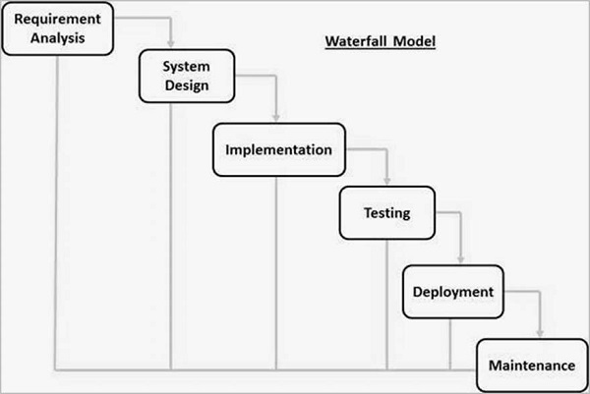

Image 1. WATERFALL MODEL

The sequential phases in Waterfall model are:

* **Requirement Gathering and analysis** − All possible requirements of the system to be developed are captured in this phase and documented in a requirement specification document.
* **System Design** − The requirement specifications from first phase are studied in this phase and the system design is prepared. This system design helps in specifying hardware and system requirements and helps in defining the overall system architecture.
* **Implementation** − With inputs from the system design, the system is first developed in small programs called units, which are integrated in the next phase. Each unit is developed and tested for its functionality, which is referred to as Unit Testing.
* **Integration and Testing** − All the units developed in the implementation phase are integrated into a system after testing of each unit. Post integration the entire system is tested for any faults and failures.
* **Deployment of system** − Once the functional and non-functional testing is done; the product is deployed in the customer environment or released into the market.
* **Maintenance** − There are some issues which come up in the client environment. To fix those issues, patches are released. Also to enhance the product some better versions are released. Maintenance is done to deliver these changes in the customer environment.

## Risk Analysis

|  |  |  |  |
| --- | --- | --- | --- |
| Risk | Probability | Effect (Impact) | Mitigation Strategies |
| Data Breaches: Hackers gain access to customer information (names, addresses, credit cards), financial data (sales figures, employee payroll), or even recipes. | Varies (Depends on security measures & attacker sophistication) - Low to High | High: Regulatory fines reputational damage, loss of customer trust, financial losses (fraudulent charges, data recovery costs). | - Choose vendors with strong security practices (encryption, access controls, penetration testing). awareness, password hygiene). - Conduct regular security audits and vulnerability assessments. |
| Accidental Data Loss: System crashes, human error (e.g., deleting data), or inadequate backups lead to lost data. | Low (with proper backups) | Medium: Disruption of operations potential loss of historical sales data difficulty recreating reports. | - Implement a regular backup schedule (cloud-based or local) with version control and test restores frequently |
| Software Malfunctions: Bugs or glitches in the software cause issues like incorrect order processing, inaccurate inventory tracking, or system crashes. | Medium | High: Lost sales, frustrated customers, delayed service, staff inefficiency | - Thoroughly test software before deployment (user acceptance testing). - Maintain a log of software errors and report them to the vendor promptly. |
| System Downtime: Unexpected outages due to technical problems or internet connectivity issues prevent using the software. | Low (with proper maintenance and redundancy) | High: Complete halt of business activities (orders, inventory management, payments). | - Invest in a reliable internet service provider (ISP) with a good uptime record. - Consider cloud-based software with built-in redundancy features |
| Integration Issues: Difficulty integrating the software with existing systems like accounting software or inventory management systems. | Medium (depends on software chosen and APIs) | Medium: Disruption of workflows, duplicate data entry, errors due to data inconsistencies (e.g., discrepancies between inventory levels). | - Choose software with open APIs or strong integration capabilities. - Plan and test integrations thoroughly before deployment (mapping data fields, testing data flow). - Work with the vendor or a consultant for integration assistance if needed. |
| Over-reliance on Software: Staff become overly dependent on the software, neglecting manual processes or staff training, leading to problems if the system goes down. | High (depends on training and company culture) | High: Increased downtime if the software malfunctions, difficulty adapting to unexpected situations | - Provide comprehensive staff training on both software use and manual processes. - Encourage a culture of problem-solving and critical thinking |

Table 4. RISK ANALYSIS

## Hardware and Software Resource Requirements

### **Hardware:**

* **Processor (CPU):** A mid-range multi-core processor (e.g., Intel Core i5 or AMD Ryzen 5) is sufficient for most coffee shops. High-volume shops might consider a more powerful CPU for faster processing.
* **Memory (RAM):** 8GB of RAM is a good starting point, 16GB is recommended for busy shops or those using many features.
* **Storage:** A solid-state drive (SSD) with at least 250GB of storage is ideal for fast boot times and application loading. Additional storage might be needed for historical data or media files.
* **Point-of-Sale System:** A separate touch screen monitor and receipt printer might be required for order processing. Consider options that integrate seamlessly with your CSMS.
* **Internet Connectivity:** Reliable internet access is crucial for software updates, online features (e.g., mobile ordering), and data backups.

### **Software:**

* **Operating System:** Most CSMS are compatible with Windows 10 or 11. For advanced users, cloud-based CSMS might be an option, eliminating the need for a local operating system.
* **Coffee Shop Management Software:** Choose a CSMS that offers the features you need (inventory management, sales tracking, employee scheduling etc.). Ensure it integrates with your existing systems (accounting, payroll) if necessary.
* **Backup Software:** Regularly back up your CSMS data to prevent loss in case of hardware failure or software glitches.

# CHAPTER 3: REQUIREMENT SPECIFICATIONS

# CHAPTER 4: ARCHITECTURE

# CHAPTER 5: DESIGN

# CHAPTER 6: TEST PLAN

# CHAPTER 7: DEMO

* 1. Manager interface
  2. Cashier interface
  3. GIT

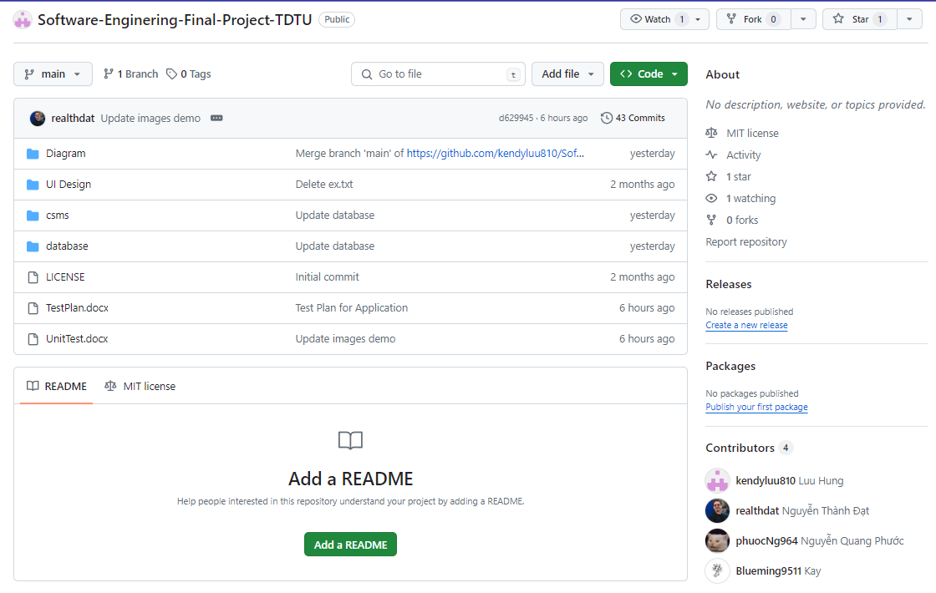We choose GIT to manage our code because it offers all the functionalities of tracking changes, collaboration through branches, and keeping a project history.

//caption git//

Our repository link: <https://github.com/kendyluu810/Software-Enginering-Final-Project-TDTU>

# REFERENCES

* Online resources:
  1. Waterfall model : <https://www.tutorialspoint.com/sdlc/sdlc_waterfall_model.htm>