|  |  |  |  |
| --- | --- | --- | --- |
| **ID** | **Unit test** | **Test case** | **Result** |
| 1 | Admin Login | username: admin password: admin | Success |
| 2 | Admin Login | username: admin password: admin1 | Fail |
| 3 | System Login | Active mode: ON | Success |
| 4 | System Login | Active mode: OFF | Fail |
| 5 | Adding new staff | Missing any information | Fail |
| 6 | Adding new staff | Wrong data type | Fail |
| 7 | Adding new staff | Auto generating Staff ID | Success |
| 8 | Adding new staff | Fill out all blanks, choose option in combobox and correct data types | Success |
| 9 | Adding new product | Missing any information | Fail |
| 10 | Adding new product | Wrong data type | Fail |
| 11 | Adding new product | Auto generating Product ID | Success |
| 12 | Adding new product | Fill out all blanks, choose option in combobox and correct data types | Success |
| 13 | Export Product CSV File | Click button Export | Success |
| 14 | Adding new membership | Missing any information | Fail |
| 15 | Adding new membership | Wrong data type | Fail |
| 16 | Adding new membership | Auto generating Membership ID | Success |
| 17 | Adding new membership | Fill out all blanks, choose option in combobox and correct data types | Success |
| 18 | Export Membership CSV File | Click button PDF | Success |
| 19 | Adding new coupon | Fill out the blank, and correct data type | Success |
| 20 | Adding new coupon | Wrong data type | Fail |
| 21 | Counting total of stalls | Watch at Dashboard | Success |
| 22 | Counting total of memberships | Watch at Dashboard | Success |
| 23 | Coating Today’s income | Watch at Dashboard | Fail |
| 24 | Counting total income | Watch at Dashboard | Fail |

**1. Admin Login**

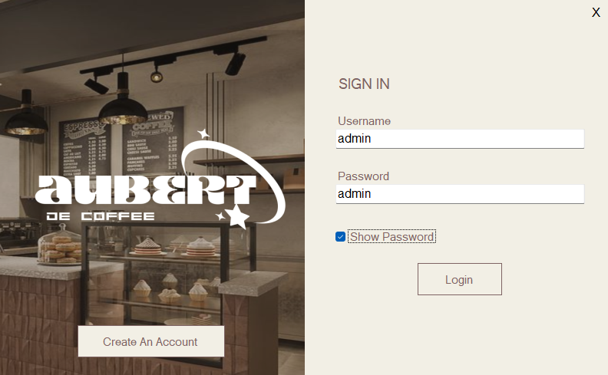

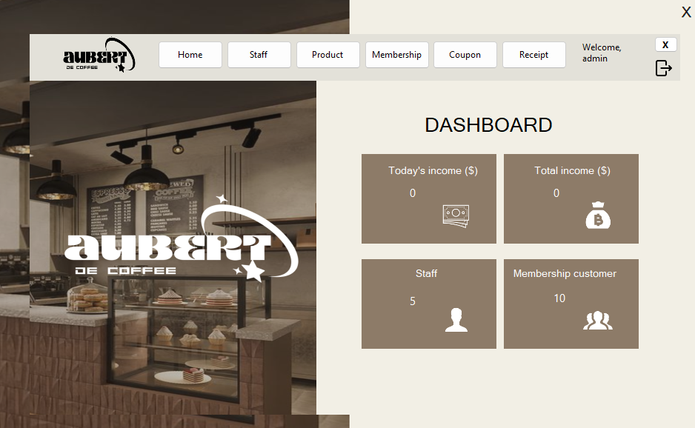

**2. User Login**

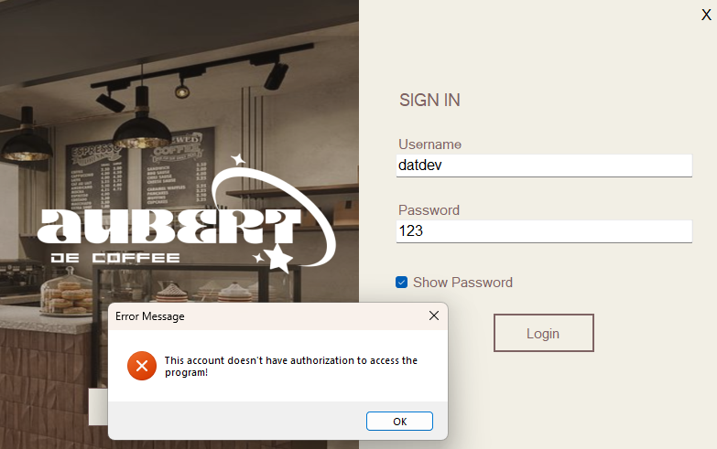

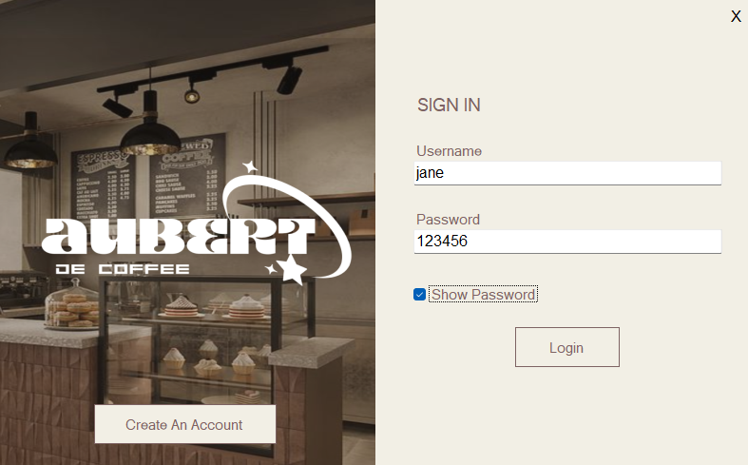

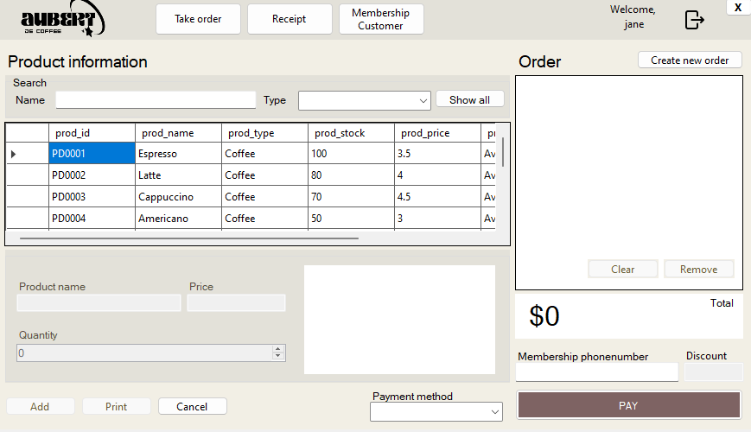

**3. Adding a new staff**

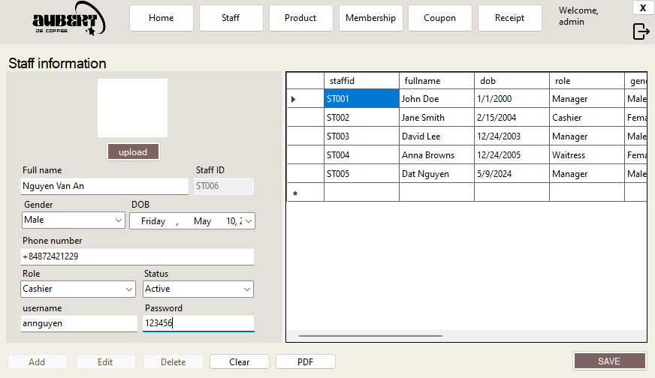

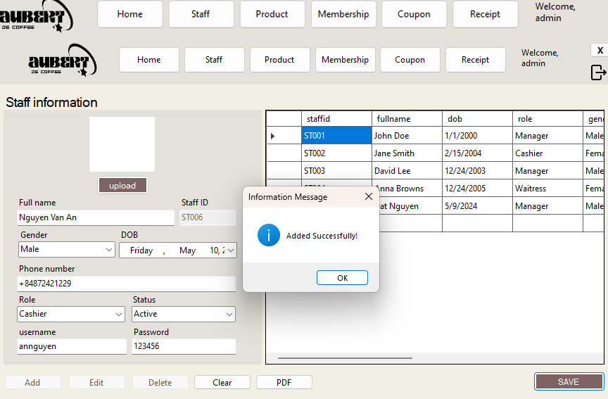

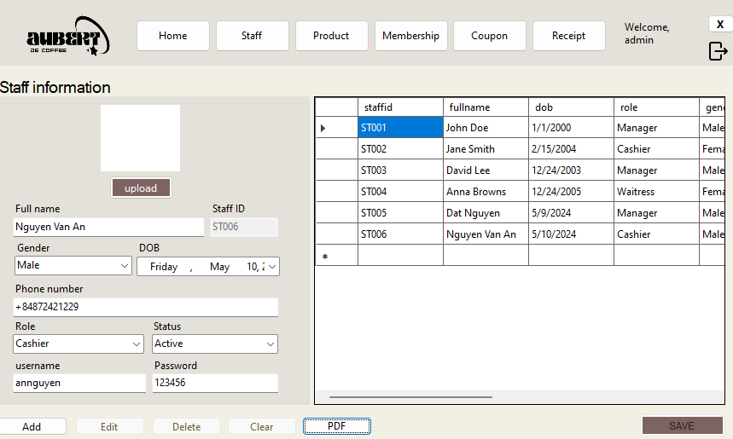

**4. Adding a new product**

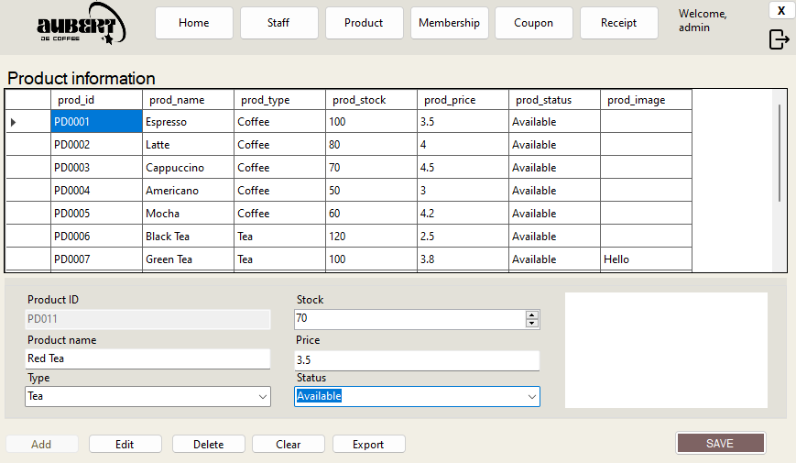

**5. Adding a new membership**

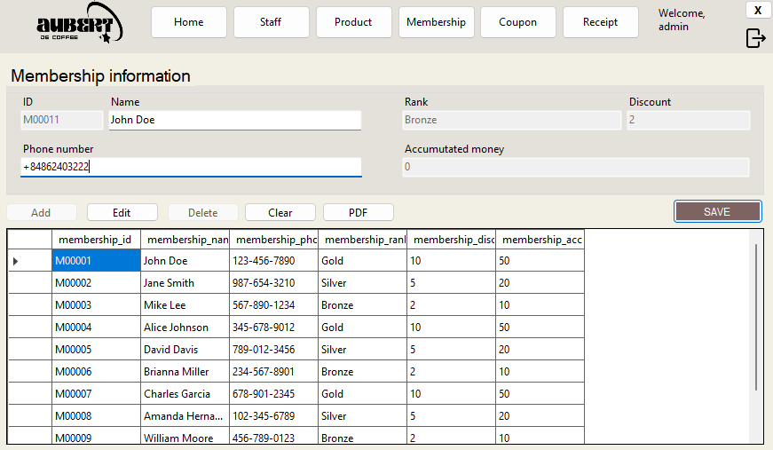

**6. Adding a new coupon**

