Implementation Report
AI-Powered Personalised Study Planning & Learning Recommendation System

1. Overview
This document summarises the implementation work completed to date for the, covering data preparation, model training and evaluation, backend inference integration, and frontend updates.

2. Data Pipeline and Canonical Schema
An external dataset (OULAD) is adapted into a canonical, project-semantic schema used by the model pipeline. This preserves project meaning while allowing proxy features when needed.

3. Model Training and Evaluation
An adherence prediction model was trained using a time-based train/validation/test split and a small hyperparameter search for a tree-based regressor.
- Training setup:
- Split strategy: time
- Validation size: 0.1
- Test size: 0.2
- Best params: {'n_estimators': 200, 'max_depth': 20, 'min_samples_leaf': 5}
Metrics (baseline vs model):
Model | MAE | RMSE | R2
Baseline | 0.3119 | 0.3406 | -0.0037
Adherence model | 0.0217 | 0.0574 | 0.9715
Evaluation plots:
- Predicted vs True
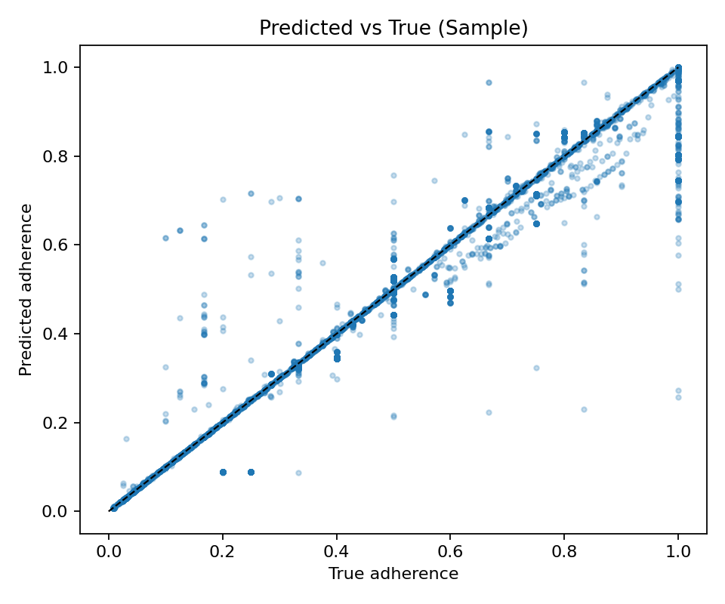
- Residuals Histogram
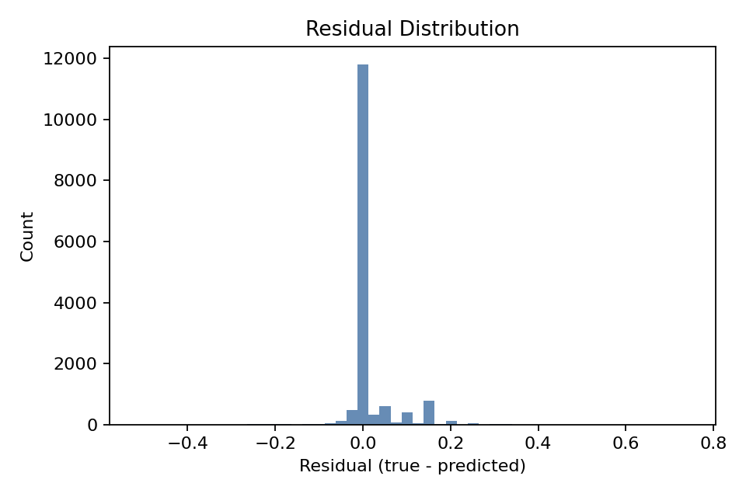
- Baseline vs Model
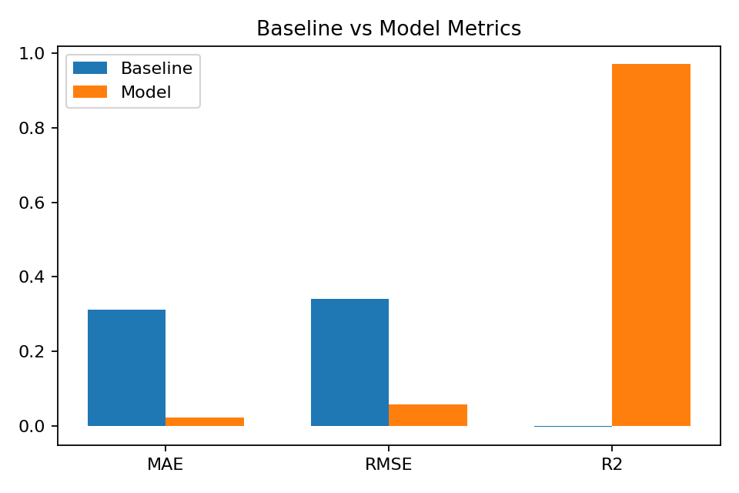
- Feature Importance
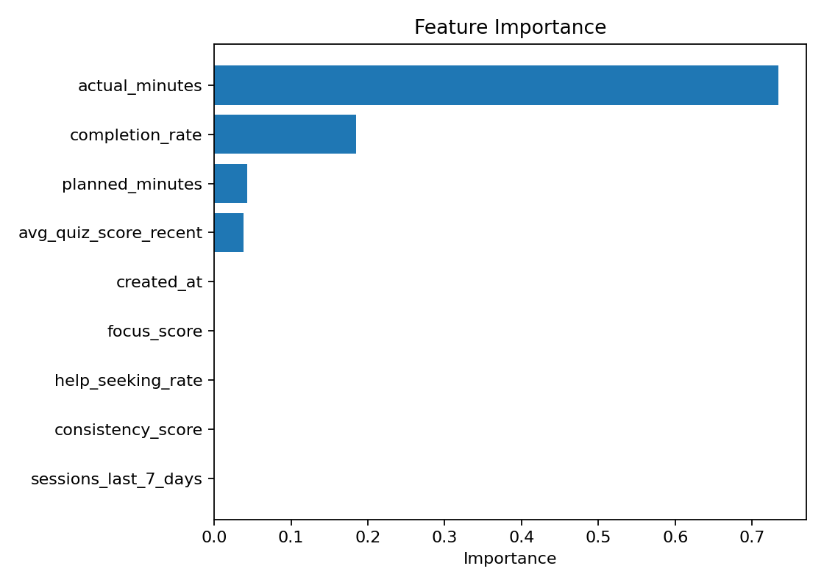

4. Backend Inference and API Integration
The trained model is loaded for inference in the tracking service. Two main API workflows are supported: session logging (with adherence and predicted adherence stored) and pre-session prediction.
- Endpoints:
- POST /api/tracking/session-log/ (persists predicted_adherence + model_version)
- POST /api/tracking/predict/ (returns forecast without persistence)

5. Frontend Updates
The progress dashboard was updated to reflect the new prediction capabilities and to surface meaningful history instead of counters only.
- Key changes:
- Pre-session adherence predictor with optional signals
- Predicted adherence and model version shown on logs
- Planner, recommendation, and session histories displayed with paging

6. Validation
Smoke tests executed against the backend API:
- Registered a user, obtained JWT, called /tracking/predict
- Logged a session and confirmed history includes predicted_adherence

