FLOWBRIDGE
FlowBridge Whitepaper v1.1
A non-custodial AI-guided DeFi and ecosystem growth layer for BOT Chain
Earn. Learn. Grow. Support BOT Chain.
BOT Mainnet 677 | Mainnet Live | Non-custodial | EVM Deployment Track #1 Winner
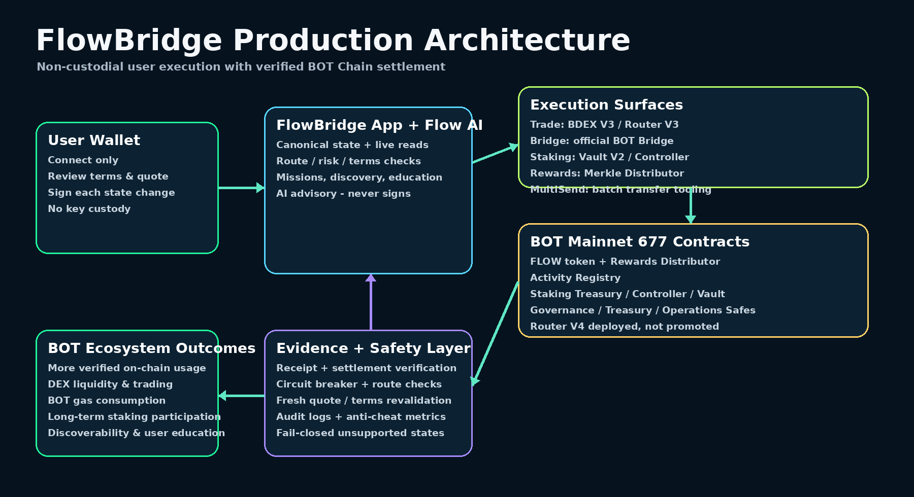
FlowBridge Whitepaper v1.0 | 29 Sep 2026

Abstract
FlowBridge is a mainnet-live application that reduces the complexity of participating in the BOT Chain ecosystem. It brings trading, bridging, staking, rewards, batch asset movement, ecosystem discovery and guided education into one non-custodial experience.
FlowBridge is designed around a simple principle: software may guide and verify, but the user wallet remains the authority for economic transactions.
The project uses deployed smart contracts and canonical on-chain evidence to separate user principal, reward inventory, governance authority and application guidance. FlowBridge won 1st Place in the EVM Deployment Track of BOT Chain Builder Challenge #1 and is now positioned to scale from technical validation to broader ecosystem adoption.
1. Vision
Web3 users often encounter a fragmented journey: find a token, locate the correct DEX, understand the route, bridge assets, verify network settings, stake, claim rewards, and determine which actions are actually final. FlowBridge turns this fragmented flow into a guided path while retaining the open, wallet-controlled nature of on-chain execution.
Core message

•••• | Earn. Learn. Grow. Support BOT Chain.  Earn: access transparent staking and verified campaign rewards without fabricated yields.  Learn: understand what an action does, what it costs, what can fail and what happens next.  Grow: discover new BOT Chain routes, projects and participation opportunities.  Support BOT Chain: increase meaningful on-chain usage, liquidity, application discovery and long-term participation.
2. Why BOT Chain
BOT Chain is an EVM-compatible Layer 1 designed for high-frequency applications, AI agents, DePIN and decentralized applications. FlowBridge uses the familiar EVM model while building product-specific safety and usability layers around BOT Mainnet 677.
• BOT is the network gas token, so genuine application usage directly consumes BOT gas.
• BDEX provides native decentralized exchange infrastructure for FLOW liquidity and trading.
• The official BOT Bridge remains the production bridge path where FlowBridge uses direct user-wallet interaction instead of hidden custody.
• BOT Chain ecosystem programs provide a path from deployed application to liquidity, user growth and official distribution.
FlowBridge Whitepaper v1.0 | 29 Sep 2026

3. Product System
3.1 Trade and Buy
FlowBridge discovers live BOT Chain liquidity, obtains route-specific quotes and lets the user review expected output, minimum received, price impact and protection mode before signing. FLOW/USDT BDEX V3 liquidity is live. Route discovery supports the direct 1% pool and valid protected multi-hop routes when they provide the better canonical execution path.
• Circuit breaker states distinguish warming, temporary reference unavailability and actual abnormal-price risk.• Transient RPC/reference failures self-heal and cannot permanently lock the route.
• Connect-wallet behavior is connect-only; token approvals and swaps are separate explicit actions.• Price protection is evaluated on route-effective execution price, not merely the first hop.
3.2 Cross-Chain Bridge
The production bridge model sends the user wallet directly to the official BOT Bridge. FlowBridge prepares the route and explains the steps, but it does not custody the user asset or silently sign bridge transactions. This separation reduces adapter risk and keeps the canonical bridge settlement path visible to the user.
3.3 MultiSend
MultiSend extends FlowBridge from single transfers to operational asset movement: one-to-many distribution, many-to-one consolidation and advanced many-to-many workflows across supported networks. Safety tests cover invalid addresses, bad amounts, approvals, reverting recipients, reentrancy and non-standard token behavior. QR and CSV workflows improve usability without granting signing authority to the application.
3.4 Rewards
FlowBridge rewards use a funded, finite, evidence-backed model. Mainnet rewards are distributed through a Merkle/epoch Distributor. A user receives FLOW only when a specific campaign publishes a verified entitlement for that wallet. FLOW Points and Campaign PTS remain distinct accounting systems and are never silently converted into FLOW.
3.5 Staking
Staking separates user principal from reward inventory. The mainnet system contains a Reward Treasury, Controller and Vault V2.
Genesis/floor staking products are live under funded capacity and per-wallet quote checks. Flexible, 30D, 90D, 180D and 365D products exist; longer products transition from the Genesis window to their reserved floor when the standard variable layer is unavailable.
FlowBridge Whitepaper v1.0 | 29 Sep 2026

• Genesis applies for at most 90 reward-days or until a shorter product matures.• Locked floor obligations are reserved at position entry before the user commits.• Flexible has no guaranteed standard floor.
• Principal and reward inventory are never commingled.
• Dynamic standard bonus remains disabled while the production oracle is unset.
3.6 Flow AI and Guided Journeys
Flow AI is an advisory and orchestration layer. It can explain state, surface opportunities, prepare user-readable actions and guide onboarding. It cannot hold private keys, sign transactions, alter staking economics, move treasury funds or invent an on-chain result. Economic execution always returns to an explicit wallet confirmation.
4. Production Architecture and Trust Boundaries
Layer | Responsibility | Authority Boundary
User wallet | Owns assets and signs state changes | Final economic authority
FlowBridge UI / Flow AI | Discovery, education, preparation, simulation | No custody; no signing
Evidence / state layer | Canonical network, balances, quotes, receipts, eligibility | Read / verify; fail closed
Deployed contracts | Rewards, staking, activity, routing candidates | Role-gated on-chain state
Governance Safes | Treasury, governance, operations | 2-of-3 multisig authorities
BOT Chain | Final settlement | Canonical mainnet 677
5. Mainnet Contract Stack - updated 11 Oct 2026
See the current public-safe deployment appendix at the end of this document.
6. FLOW Token Economics
FLOW has a fixed genesis supply of 1,000,000,000 tokens with 18 decimals. The deployed token has no future mint authority. The approved v1.1 allocation is designed to fund ecosystem participation while keeping user rewards, staking, liquidity and long-term reserves distinct.
Allocation | Share | FLOW
Community & Ecosystem | 50% | 500,000,000
Team & Core Contributors | 15% | 150,000,000
Protocol Treasury | 15% | 150,000,000
Liquidity & Market Infrastructure | 10% | 100,000,000
Strategic Ecosystem Partners | 5% | 50,000,000
Security & Contingency Reserve | 5% | 50,000,000
Community/Ecosystem internal planning includes user rewards, partner campaign matching, long-term staking,
referral/community/developer programs, Genesis recognition and a future ecosystem reserve. FLOW Points are not a 1:1 token claim.
FlowBridge Whitepaper v1.0 | 29 Sep 2026

7. Staking Economics and Solvency
Product | Genesis max APR | Standard floor / target / cap | Current production behavior
Flexible | 18% | 0% / 10% / 12% | Genesis only; no guaranteed floor
30D | 27% | 8% / 14% / 18% | Genesis-covered when eligible; floor reserved
90D | 36% | 10% / 18% / 24% | Genesis + reserved floor as applicable
180D | 48% | 12% / 24% / 32% | Genesis first 90 days, then reserved floor while dynamic layer off
365D | 60% | 15% / 30% / 40% | Genesis first 90 days, then reserved floor while dynamic layer off

•  •  •  •  • | Long-term staking reserve: 75M FLOW.  Year-1 staking ceiling: 3M FLOW total, including Genesis <=1M and Standard <=2M.  Approved maxFlowPerEpoch: 50,000 FLOW per 7 days.  Initial staking reward treasury inventory: 10M FLOW. Inventory does not raise Year-1 release ceilings.  Dynamic standard rewards remain disabled until a production-safe FLOW price reference is explicitly approved and activated.
8. DEX Liquidity, Price Protection and Future Oracle
A FLOW/USDT BDEX V3 1% pair is live. FlowBridge treats trading liquidity and staking-oracle security as separate concerns. The
pool can support normal swaps while still being classified as bootstrap-only for oracle purposes.
• Normal FLOW/USDT swap protection uses bounded slippage and price-impact checks.
• A >=30% abnormal deviation is a FlowBridge route-preparation circuit-breaker condition; FlowBridge does not widen slippage
to tolerate a collapse.
• Temporary reference failures are retryable and self-healing.
• Observation capacity has been increased to 128 so genuine TWAP history can accumulate.
• The staking oracle remains address(0) until sufficient real history, liquidity resistance, freshness and deviation policies all pass
explicit owner review.
9. Security Model
Control | Design
Non-custodial execution | User wallet signs every state-changing action.
Exact approvals | Use exact/bounded approvals for canaries and reviewed flows; avoid unnecessary unlimited approvals.
Terms-change protection | Fresh independent on-chain quote immediately before locked staking; drift forces re-review.
Wallet binding | Single-use server challenge signed by the wallet; canonical bound wallet enforced.
Role separation | Governance, Treasury, Operations and specialized publishers/attesters are separated.
Principal protection | Staking principal is separate from reward inventory and cannot be treated as free rewards.
Oracle fail closed | No dynamic standard rate when the price reference is absent or unsafe.
Evidence settlement | Receipt success plus live post-state is required before FlowBridge treats an economic action as settled.
10. Governance
• Treasury Safe: 0xeFc13d1A1dC30BA2DA0Bb005ba5A783c6b229Ea4.
• Governance Safe: 0x88A4CC1F5771523baeB83DaEea07D323a3ce9507, 2-of-3.
• Operations Safe: 0x1Ce0b1DF5d2055f6e92122D8cB7669609C2359eF, 2-of-3.
• No AI or ordinary application service receives final treasury/governance authority.
•
FlowBridge Whitepaper v1.0 | 29 Sep 2026

11. Ecosystem Contribution to BOT Chain
Mechanism | How FlowBridge Supports BOT Chain
Gas usage | Real user swaps, staking, rewards and transfers settle on BOT Mainnet and consume BOT gas.
Liquidity | FLOW markets deepen native BDEX activity and make ecosystem assets easier to access.
Retention | Staking, rewards, missions and education give users reasons to remain active after a first swap/bridge.
Discovery | FlowBridge can surface verified BOT Chain projects, routes and participation opportunities.
Developer proof | Verified production contracts and security gates demonstrate deployable EVM use cases on BOT Chain.
Data integrity | Program metrics and reward eligibility are based on canonical on-chain evidence rather than marketing estimates.
13. Roadmap - Use the Deployed Stack First
Horizon | Workstream | New Contract Required?
Immediate |  | No
Immediate | public docs / contract registry / support metrics. | No
Immediate | Continue FLOW/USDT TWAP observation and range/liquidity security analysis. | No
Near term | Activate dynamic standard staking only if oracle, budget, roles and security gates pass. | No - existing R4/R5/R6
Near term | Expand finite verified rewards campaigns. | No - existing Distributor
Near term | Evidence-backed Activity Registry attestations if approved. | No - existing Registry
Near term | Improve MultiSend, ecosystem discovery and guided journeys. | No
Later |  | No - already deployed
Later | Additional chains / new protocol modules only after a separate security and business decision. | Maybe
14. Risks and Disclosures
• Smart-contract and integration risk cannot be eliminated; verified source, tests and staged canaries reduce but do not remove
risk.
• DEX liquidity can move out of range and remains exposed to impermanent loss, price manipulation and market volatility.
• APR is not APY. Staking rewards are estimates based on the applicable rate and time; variable rewards may remain
unavailable.
• Campaign rewards exist only when a funded, verified allocation is published for the wallet.
• Bridge transactions inherit official bridge and destination-chain risks.
• Program incentives are subject to BOT Chain rules, audit rights, anti-cheating controls and future updates.
• Nothing in this whitepaper is a guarantee of investment return, token price appreciation, ecosystem funding or exchange
listing.
FlowBridge Whitepaper v1.0 | 29 Sep 2026

15. Recognition
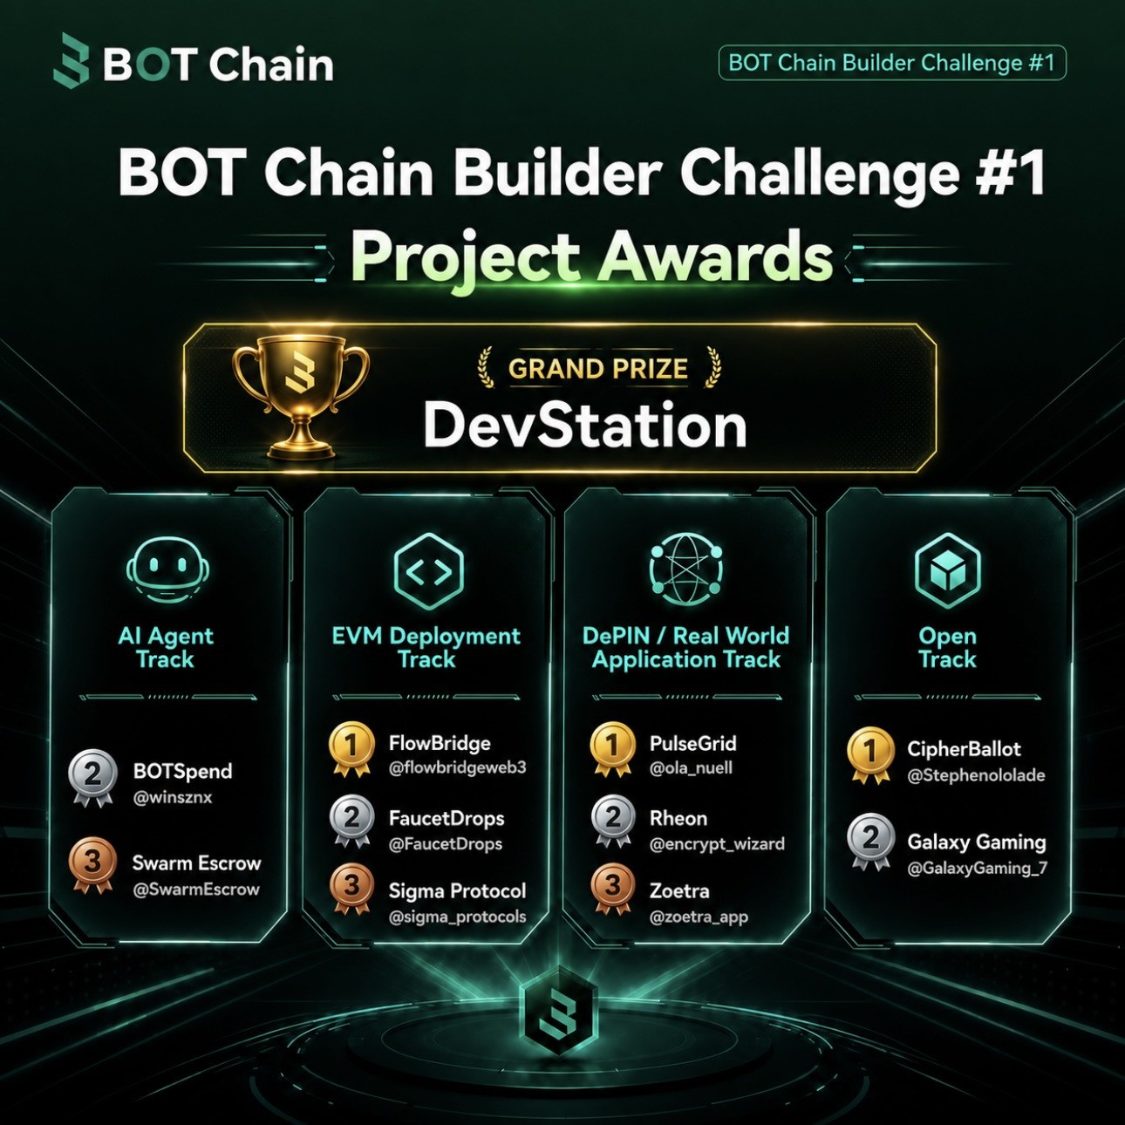
FlowBridge - 1st Place, EVM Deployment Track, BOT Chain Builder Challenge #1.
16. References
• BOT Chain Ecosystem Support Program - https://www.botchain.ai/en/ecosystem-support/
• BOT Chain Developer Documentation - https://dev-docs.botchain.ai/
• BOT Chain Ecosystem Leaderboard - https://www.botchain.ai/en/blog/bot-chain-ecosystem-leaderboard/
• FlowBridge - https://flowbridge.space
• FlowBridge X - https://x.com/flowbridgeweb3
• BOT Chain Builder Challenge #1 award announcement and project-supplied award graphic.
• FlowBridge V30.2B production evidence and owner-frozen project records.
FlowBridge Whitepaper v1.0 | 29 Sep 2026

FlowBridge Whitepaper v1.1 |
Deployment Appendix
Public-safe refresh, 11 Oct 2026. This appendix supersedes prior deployment/status references only; unchanged product principles are retained.
Current V3 single-step/staged and V4 native/BDEX V3 atomic paths are active. Flexible and 30D real lifecycle evidence is complete; long-term terms are canary-only and real maturity remains pending. Oracle remains disabled. External integrations are not owned by FlowBridge.
VERIFIED SMART CONTRACTS & ON-CHAIN INFRASTRUCTURE
FLOW Token | BOT Mainnet | Chain 677
ACTIVE PRODUCTION — Fixed-supply FLOW token; no future mint authority.
0xcaaB50F36252a57529AFeF651fa6B9f9281917fF
https://scan.botchain.ai/address/0xcaaB50F36252a57529AFeF651fa6B9f9281917fF
Explorer verification and runtime parity recorded in canonical settlement; fresh code hash included in private evidence.
Evidence: contracts/production/V30_2B_R1_SETTLEMENT.json; code present at block 26336087.
Rewards Distributor | BOT Mainnet | Chain 677
ACTIVE PRODUCTION — Funded Merkle round claims; explicit publisher authority.
0x7b805B036B22E2B71Ef5E8f7EA21D8791819b922
https://scan.botchain.ai/address/0x7b805B036B22E2B71Ef5E8f7EA21D8791819b922
Explorer verification and runtime parity recorded in canonical settlement; fresh code hash included in private evidence.
Evidence: contracts/production/V30_2B_R2_SETTLEMENT.json; code present at block 26336087.
Activity Registry | BOT Mainnet | Chain 677
DEPLOYED SUPPORTING — Controlled canonical activity attestations.
0x86590b7C8A2Ad9a1dAD8183Eaf627AE4B7Ff3814
https://scan.botchain.ai/address/0x86590b7C8A2Ad9a1dAD8183Eaf627AE4B7Ff3814
Explorer verification and runtime parity recorded in canonical settlement; fresh code hash included in private evidence.
Evidence: contracts/production/V30_2B_R3_SETTLEMENT.json; code present at block 26336087.
Staking Reward Treasury | BOT Mainnet | Chain 677
ACTIVE PRODUCTION — Segregated pre-funded reward inventory and obligation accounting.
0x96552909998F3DbAf5Ff4979dc158508b3442e65
https://scan.botchain.ai/address/0x96552909998F3DbAf5Ff4979dc158508b3442e65
Explorer verification and runtime parity recorded in canonical settlement; fresh code hash included in private evidence.
Evidence: contracts/production/V30_2B_R4_SETTLEMENT.json; code present at block 26336087.
FlowBridge | 11 Oct 2026 | PUBLIC-SAFE | 1

Staking Controller V2 | BOT Mainnet | Chain 677
ACTIVE PRODUCTION — Genesis/floor economics; variable rewards disabled while oracle unset.
0x44b9b880C6188D8b8dbe4f68216aE28a5A1253bF
https://scan.botchain.ai/address/0x44b9b880C6188D8b8dbe4f68216aE28a5A1253bF
Explorer verification and runtime parity recorded in canonical settlement; fresh code hash included in private evidence.
Evidence: contracts/production/V30_2B_R5_SETTLEMENT.json; code present at block 26336087.
Staking Vault V2 | BOT Mainnet | Chain 677
ACTIVE PRODUCTION — Principal custody, positions, reward claims and maturity withdrawals.
0x15e7B1b4b16a43E6CE2E1f460dBE4201E9B6790D
https://scan.botchain.ai/address/0x15e7B1b4b16a43E6CE2E1f460dBE4201E9B6790D
Explorer verification and runtime parity recorded in canonical settlement; fresh code hash included in private evidence.
Evidence: contracts/production/V30_2B_R6_SETTLEMENT.json; code present at block 26336087.
Router V3 | BOT Mainnet | Chain 677
ACTIVE PRODUCTION — Current single-step / staged execution dispatcher; platform fee retained.
0x986962de6f00d0ec571b1a34fa70aeeb445b5445
https://scan.botchain.ai/address/0x986962de6f00d0ec571b1a34fa70aeeb445b5445
Recorded deployment; fresh bytecode presence check. Explorer source status not independently rechecked. Evidence: src/lib/contracts.ts; code present at block 26336087.
Router V4 | BOT Mainnet | Chain 677
ACTIVE PRODUCTION — Promoted atomic native BOT / BDEX V3 multi-pool execution; other route classes remain staged.
0x79653140D84B78C19354ee984f236Ec92160fc61
https://scan.botchain.ai/address/0x79653140D84B78C19354ee984f236Ec92160fc61 Explorer verified in promotion record; frozen runtime SHA256
a42e53b15977c57b81fa63c575b9cb39100b873c50a523b68f02df7bd8bec41d. Evidence: src/lib/swap/executionCapability.ts; code present at block 26336087.
Router Lens | BOT Mainnet | Chain 677
DEPLOYED SUPPORTING — Read-only lens bound to current Router V4.
0xb82038aC3d2df60f5B5fE06D6FDe3CFDd1B76BD0
https://scan.botchain.ai/address/0xb82038aC3d2df60f5B5fE06D6FDe3CFDd1B76BD0 Explorer verified in Router V4 promotion record; live flowRouter binding checked. Evidence: src/lib/swap/executionCapability.ts; code present at block 26336087.
FlowBridge | 11 Oct 2026 | PUBLIC-SAFE | 2

Governance Safe | BOT Mainnet | Chain 677
DEPLOYED SUPPORTING — Multisig governance authority; threshold checked live.
0x88A4CC1F5771523baeB83DaEea07D323a3ce9507
https://scan.botchain.ai/address/0x88A4CC1F5771523baeB83DaEea07D323a3ce9507
Safe deployed code and threshold verified read-only; proxy identity is not an independent contract audit. Evidence: contracts/production/V30_2B_R2_SETTLEMENT.json; code present at block 26336087.
Treasury Safe | BOT Mainnet | Chain 677
DEPLOYED SUPPORTING — Multisig treasury authority; threshold checked live.
0xeFc13d1A1dC30BA2DA0Bb005ba5A783c6b229Ea4
https://scan.botchain.ai/address/0xeFc13d1A1dC30BA2DA0Bb005ba5A783c6b229Ea4
Safe deployed code and threshold verified read-only; proxy identity is not an independent contract audit. Evidence: contracts/production/V30_2B_R2_SETTLEMENT.json; code present at block 26336087.
Operations Safe | BOT Mainnet | Chain 677
DEPLOYED SUPPORTING — Multisig emergency / operations authority; threshold checked live.
0x1Ce0b1DF5d2055f6e92122D8cB7669609C2359eF
https://scan.botchain.ai/address/0x1Ce0b1DF5d2055f6e92122D8cB7669609C2359eF
Safe deployed code and threshold verified read-only; proxy identity is not an independent contract audit. Evidence: contracts/production/V30_2B_R2_SETTLEMENT.json; code present at block 26336087.
MultiSend V1 | BOT Mainnet | Chain 677
ACTIVE PRODUCTION — Distribution, consolidation and advanced batches; exact approvals and 1 bp service fee.
0xc54CAcfd96330949db0eAEd72dE930a2d06d9778
https://scan.botchain.ai/address/0xc54CAcfd96330949db0eAEd72dE930a2d06d9778
Explorer verified and native/ERC-20 rehearsal recorded in canonical release evidence. Evidence: src/lib/multisend/deployments.ts; code present at block 26336087.
MultiSend V1 | BOT Testnet | Chain 968
TESTNET — Distribution, consolidation and advanced batches; exact approvals and 1 bp service fee.
0x1b97CCbAE4D5128f8E5591ada21476609c7F2960
https://scan.bohr.life/address/0x1b97CCbAE4D5128f8E5591ada21476609c7F2960
Explorer verified and native/ERC-20 rehearsal recorded in canonical release evidence. Evidence: src/lib/multisend/deployments.ts; code present at block 26502665.
MultiSend V1 | BNB Mainnet | Chain 56
ACTIVE PRODUCTION — Distribution, consolidation and advanced batches; exact approvals and 1 bp service fee.
0xA861152Ca3676bcCf7B5FDAFB9eb6A57b9d32d0e
https://bscscan.com/address/0xA861152Ca3676bcCf7B5FDAFB9eb6A57b9d32d0e
Explorer verified and native/ERC-20 rehearsal recorded in canonical release evidence. Evidence: src/lib/multisend/deployments.ts; code present at block 127052551.
FlowBridge | 11 Oct 2026 | PUBLIC-SAFE | 3

MultiSend V1 | BNB Testnet | Chain 97
TESTNET — Distribution, consolidation and advanced batches; exact approvals and 1 bp service fee.
0x535dDDA826142AC42cE288154e9595f080940aE9
https://testnet.bscscan.com/address/0x535dDDA826142AC42cE288154e9595f080940aE9 Explorer verified and native/ERC-20 rehearsal recorded in canonical release evidence. Evidence: src/lib/multisend/deployments.ts; code present at block 136198901.
BDEX V3 Factory | BOT Mainnet | Chain 677
EXTERNAL INTEGRATION — External pool discovery.
0x1C51c173323ec11BB4e3C4fD2314c225Dc4b5419
https://scan.botchain.ai/address/0x1C51c173323ec11BB4e3C4fD2314c225Dc4b5419
Fresh bytecode presence check; external protocol integration, not FlowBridge source ownership or audit. Evidence: src/lib/contracts.ts / src/lib/swap/dexVerification.ts; code present at block 26336087.
BDEX V3 SwapRouter | BOT Mainnet | Chain 677
EXTERNAL INTEGRATION — External venue accessed through FlowBridge routing, not a FlowBridge-owned contract.
0x07032d47A1b9f8460cBeE9dC17c1d3E438693929
https://scan.botchain.ai/address/0x07032d47A1b9f8460cBeE9dC17c1d3E438693929
Fresh bytecode presence check; external protocol integration, not FlowBridge source ownership or audit. Evidence: src/lib/contracts.ts / src/lib/swap/dexVerification.ts; code present at block 26336087.
BDEX V3 Quoter V2 | BOT Mainnet | Chain 677
EXTERNAL INTEGRATION — External route quoting.
0x034A705b36067cff99ABf5C662Be881cBd8d0176
https://scan.botchain.ai/address/0x034A705b36067cff99ABf5C662Be881cBd8d0176
Fresh bytecode presence check; external protocol integration, not FlowBridge source ownership or audit. Evidence: src/lib/contracts.ts / src/lib/swap/dexVerification.ts; code present at block 26336087.
BDEX V3 Position Manager | BOT Mainnet | Chain 677
EXTERNAL INTEGRATION — External NFT liquidity infrastructure; Mainnet liquidity writes remain disabled.
0xDAc3FcFF004d8a8675b94E44941A1a2e3b240090
https://scan.botchain.ai/address/0xDAc3FcFF004d8a8675b94E44941A1a2e3b240090
Fresh bytecode presence check; external protocol integration, not FlowBridge source ownership or audit. Evidence: src/lib/contracts.ts / src/lib/swap/dexVerification.ts; code present at block 26336087.
Wrapped BOT | BOT Mainnet | Chain 677
EXTERNAL INTEGRATION — External wrapped native token.
0xD5452816194a3784dBa983426cCe7c122F4abd30
https://scan.botchain.ai/address/0xD5452816194a3784dBa983426cCe7c122F4abd30
Fresh bytecode presence check; external protocol integration, not FlowBridge source ownership or audit. Evidence: src/lib/contracts.ts / src/lib/swap/dexVerification.ts; code present at block 26336087.
FlowBridge | 11 Oct 2026 | PUBLIC-SAFE | 4

BOT USDT | BOT Mainnet | Chain 677
EXTERNAL INTEGRATION — External stablecoin used by trading routes.
0xababc7ddc03e501d190c676bf3d92ef0e6e87a3c
https://scan.botchain.ai/address/0xababc7ddc03e501d190c676bf3d92ef0e6e87a3c
Fresh bytecode presence check; external protocol integration, not FlowBridge source ownership or audit. Evidence: src/lib/contracts.ts / src/lib/swap/dexVerification.ts; code present at block 26336087.
FLOW/USDT BDEX V3 pool | BOT Mainnet | Chain 677
EXTERNAL INTEGRATION — External BDEX V3 1% FLOW/USDT pool; factory binding checked live.
0xDaCFc2574b6110892351Bd31afb36F95E7206162
https://scan.botchain.ai/address/0xDaCFc2574b6110892351Bd31afb36F95E7206162
Fresh bytecode presence check; external protocol integration, not FlowBridge source ownership or audit. Evidence: src/lib/contracts.ts / src/lib/swap/dexVerification.ts; code present at block 26336087.
BOT/USDT BDEX V3 pool | BOT Mainnet | Chain 677
EXTERNAL INTEGRATION — External intermediate native-token trading pool.
0x64f418471a1a7932a190e10da5a8551db5abec05
https://scan.botchain.ai/address/0x64f418471a1a7932a190e10da5a8551db5abec05
Fresh bytecode presence check; external protocol integration, not FlowBridge source ownership or audit. Evidence: src/lib/contracts.ts / src/lib/swap/dexVerification.ts; code present at block 26336087.
BDEX V2 Router | BOT Mainnet | Chain 677
EXTERNAL INTEGRATION — External V2 venue; factory read from router.
0x1414eD29FdFD322c3c0a830330ed982E2D629e76
https://scan.botchain.ai/address/0x1414eD29FdFD322c3c0a830330ed982E2D629e76
Fresh bytecode presence check; external protocol integration, not FlowBridge source ownership or audit. Evidence: src/lib/contracts.ts / src/lib/swap/dexVerification.ts; code present at block 26336087.
CaSwap Router | BOT Mainnet | Chain 677
EXTERNAL INTEGRATION — External CaryPact venue; runtime factory differs from historic configuration.
0x5b90611D4eB8FC82Fc2E3d1F0501Dd6F434441AD
https://scan.botchain.ai/address/0x5b90611D4eB8FC82Fc2E3d1F0501Dd6F434441AD
Fresh bytecode presence check; external protocol integration, not FlowBridge source ownership or audit. Evidence: src/lib/contracts.ts / src/lib/swap/dexVerification.ts; code present at block 26336087.
Official BOT Bridge Router | BOT Mainnet | Chain 677
EXTERNAL INTEGRATION — Official external BOT Bridge, not FlowBridge-owned.
0xef8dc669eca13e612b67ff09478352e85bd6cc53
https://scan.botchain.ai/address/0xef8dc669eca13e612b67ff09478352e85bd6cc53
Fresh bytecode presence check; external protocol integration, not FlowBridge source ownership or audit. Evidence: src/lib/contracts.ts / src/lib/swap/dexVerification.ts; code present at block 26336087.
FlowBridge | 11 Oct 2026 | PUBLIC-SAFE | 5

BDEX V2 Factory | BOT Mainnet | Chain 677
EXTERNAL INTEGRATION — External factory discovered from its live router; not inferred from historic address.
0x117115f3b72c8d1989178089a67d0c26f8ee0aa3
https://scan.botchain.ai/address/0x117115f3b72c8d1989178089a67d0c26f8ee0aa3
Recorded deployment; fresh bytecode presence check. Explorer source status not independently rechecked. Evidence: Live router.factory(); code present at block 26336087.
CaSwap Factory | BOT Mainnet | Chain 677
EXTERNAL INTEGRATION — External factory discovered from its live router; not inferred from historic address.
0x9c937ebc3748825026677e20b13b5e306494a38d
https://scan.botchain.ai/address/0x9c937ebc3748825026677e20b13b5e306494a38d
Recorded deployment; fresh bytecode presence check. Explorer source status not independently rechecked. Evidence: Live router.factory(); code present at block 26336087.
FlowBridge | 11 Oct 2026 | PUBLIC-SAFE | 6

