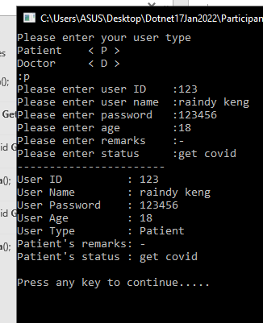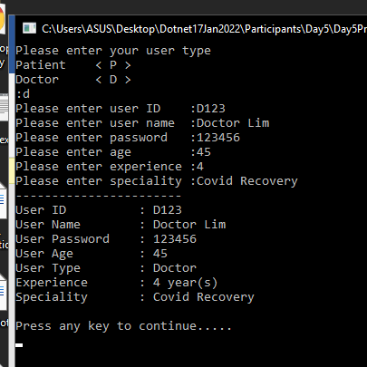

**Program.cs**

using ClinicModelsLibrary;

using System;

using System.Collections.Generic;

using System.Linq;

using System.Text;

using System.Threading.Tasks;

namespace Day5Project

{

internal class Program

{

static void Main(string[] args)

{

//Create the methods to take input in each class

//Override it in the inherited calss so that it takes teh appropriate details

//Hint : Keep the common ones in the base

//Override teh tostring method so that the details printed are complete

ManageUser mu = new ManageUser();

mu.userRegistration();

Console.WriteLine("Press any key to continue.....");

Console.ReadKey();

}

}

}

**User.cs**

using System;

using System.Collections.Generic;

using System.Linq;

using System.Text;

using System.Threading.Tasks;

namespace ClinicModelsLibrary

{

public class User

{

public string id { get; set; }

public string name { get; set; }

public string password { get; set; }

public int age { get; set; }

public string type { get; set; }

public User()

{

type = "Patient";

}

public virtual void userInfoReceiver()

{

Console.Write("Please enter user ID :");

id = Console.ReadLine();

Console.Write("Please enter user name :");

name = Console.ReadLine();

Console.Write("Please enter password :");

password = Console.ReadLine();

Console.Write("Please enter age :");

age = Convert.ToInt32(Console.ReadLine());

}

public virtual void displayUserInfo()

{

Console.WriteLine("-----------------------\n" +

"User ID : {0}\n" +

"User Name : {1}\n" +

"User Password : {2}\n" +

"User Age : {3}\n" +

"User Type : {4}", id, name, password, age, type);

}

}

}

**Doctor.cs**

using System;

using System.Collections.Generic;

using System.Linq;

using System.Text;

using System.Threading.Tasks;

namespace ClinicModelsLibrary

{

public class Doctor : User

{

public int experience { get; set; }

public string speciality { get; set; }

public Doctor()

{

type = "Doctor";

}

public override void userInfoReceiver()

{

base.userInfoReceiver();

Console.Write("Please enter experience :");

experience = Convert.ToInt32(Console.ReadLine());

Console.Write("Please enter speciality :");

speciality = Console.ReadLine();

}

public override void displayUserInfo()

{

base.displayUserInfo();

Console.WriteLine("Experience : {0} year(s)\n" +

"Speciality : {1}\n", experience, speciality);

}

}

}

**Patient.cs**

using System;

using System.Collections.Generic;

using System.Linq;

using System.Text;

using System.Threading.Tasks;

namespace ClinicModelsLibrary

{

public class Patient : User

{

public string remarks { get; set; }

public string status { get; set; }

public Patient()

{

type = "Patient";

}

public override void userInfoReceiver()

{

base.userInfoReceiver();

Console.Write("Please enter remarks :");

remarks = Console.ReadLine();

Console.Write("Please enter status :");

status = Console.ReadLine();

}

public override void displayUserInfo()

{

base.displayUserInfo();

Console.WriteLine("Patient's remarks: {0}\n" +

"Patient's status : {1}\n", remarks, status);

}

}

}