

EQUITY BANK

MTN AGENT FLOAT LIQUIDATION
-
On-Premise
-
MTN B2C-SUB
Release Notes

Project Details
Application Name | B2C-SUB
Project Type | Software Development
Project Version | Prod-release-v1.0
Name of Re-leaser | Kennedy N. Gatimu
File Mode of Delivery | Jar, conf, yml, lib, so
Prepared By | Kennedy N. Gatimu

Release History
Date | Version | Author | Comments
06/10/2022 | Prod-release-v1.0 | Kennedy Gatimu | Initial Release

Confidentiality Disclaimer

DEVELOPER API GUIDE DOCUMENT
PROJECT: MTN AGENT FLOAT LIQUIDATION
Date: 06.10.2022

THIS DOCUMENT AND THE INFORMATION IN IT ARE PROVIDED IN CONFIDENCE, FOR
THE SOLE PURPOSE OF EQUITY BANK LIMITEDAND MAY NOT BE DISCLOSED TO ANY
THIRD PARTY OR USED FOR ANY OTHER PURPOSE WITHOUT THE EXPRESS WRITTEN PERMISSION OF EQUITY BANK LIMITED.
Any form of reproduction, dissemination, copying, disclosure, modification, distribution and or
publication of this material is strictly prohibited. The contents of this document have not been
independently verified and they do not purport to be comprehensive, or to contain all the
information that a prospective investor may need. No representation, warranty or undertaking,
expressed or implied is or will be made or given and no responsibility or liability is or will be
accepted by Equity Bank Limited or by any of its directors, employees or advisors in relation to
the accuracy or completeness of this document or any other written or oral information made
available in connection with the Company.

Table Of Contents

Project Details 2
Release History 3
Confidentiality Disclaimer 4
Pre-Cutover Actions 6
MTN Production URLs And Endpoints 6
Equity Production Database 6
Production Connection Creation 6
Channel Certificates 7
Equity - MTN CSR Generation And Signing 7
Cutover Actions 8
Production Property File Update 8
Deploying Production Files 9
Post - Deployment Actions 10
Table Insert Scripts 10
Start Application Services 10

Pre-Cutover Actions
This is the pre-deployment actions for MTN Agent Liquidation on premise.
The actions include:

- MTN Production urls and endpoints
- Equity Production database connection string and credentials
- Opening production connections
- Channel Certificates
- Equity - MTN CSR generation and signing.

MTN Production URLs And Endpoints
Below endpoints should be provided;

- MTN production base url
- MTN production getaccountholderinfo endpoint
- MTN production debit endpoint
- MTN production gettransactionstatus endpoint
- MTN production refund endpoint
- MTN production Basic auth creditials (username and password)

Equity Production Database
Production database actions include
- Create Oracle database in production, with the name B2C-SUB
- Provide database connection string and credentials

Production Connection Creation
Production port and connection should be opened as follows
- Equity to open port 8017 to MTN
- MTN to open port 9545 to Equity
- MFS to open port 8080 to Equity

Channel Certificates
Below actions should be followed for MFS certificate deployment
- MFS to provide production certificate
- Rename the provided certificate to mfs.cer
- Copy the renamed certificate to path: /home/gwambugu/airtel-b2c/client-certs/mfs/

Equity - MTN CSR Generation And Signing
- System Admin team to generate CSR as follows;
Below is a sample of UAT contents. Replace with production details if needed.
- CSR Generation

  - CSR UAT Content
C=KE
ST=Nairobi
L=Nairobi
O=Equity Bank Ltd
OU=ICT
emailAddress=mcommerce@equitybank.co.ke
CN=m-wallet.ebsafrica.com

CSR output name = mtn-uganda.csr

  - Sample command
openssl req -newkey rsa:2048 -nodes -subj "/C=KE/ST=Nairobi/L=Nairobi/O=Equity Bank Ltd/OU=ICT/emailAddress=mcommerce@equitybank.co.ke/CN=m-wallet.ebsafrica.com/" -keyout mtn-uganda.key -out mtn-uganda.csr

- Send the generated CSR to MTN for signing
- Export the received certificate to a .keystore file and share the password and alias with the production support team. The exported file should be named as mtn-uganda.keystore

- The resulting mtn-uganda.keystore file should be stored in two different locations:
- /home/gwambugu/airtel-b2c/client-certs/mtn_ug/mtn-uganda.keystore
- /home/gwambugu/airtel-b2c/client-certs/mfs/mtn-uganda.keystore

Cutover Actions
This build is available in the form a jar - b2c-sub-0.0.1-SNAPSHOT.jar
All files included in the build are;
- b2c-sub-0.0.1-SNAPSHOT.jar
- sub-b2c
- sub-b2c.java.status
- sub-b2c.pid
- sub-b2c.status
- wrapper
- application-prod.properties
- lib folder
- wrapper.conf
- wrapper.jar
- libwrapper.so

Production Property File Update
- On the application-prod.properties file, update the database details as follows;
i. Update database connection string and database name as provided by dba
ii. Update the DB username and password with the credentials provided by dba
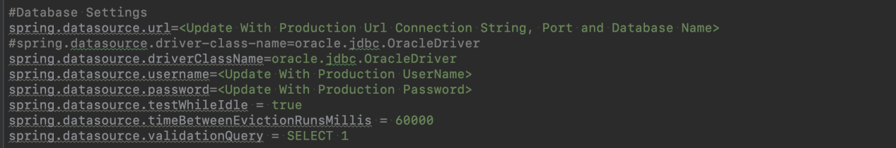
- Update the certificate credentials - password and alias with production credentials provided by sysadmin team.
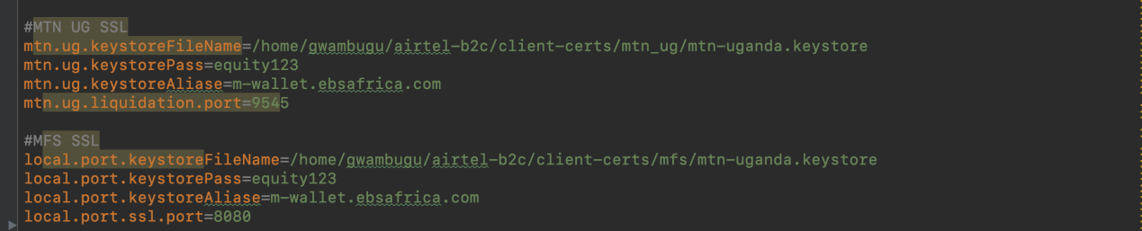

Deploying Production Files
1. Copy Files To Production Paths
Copy the provided files to the below production paths respectively;
- /home/gwambugu/airtel-b2c/bin/b2c-sub-0.0.1-SNAPSHOT.jar
- /home/gwambugu/airtel-b2c/bin/wrapper
- /home/gwambugu/airtel-b2c/bin/sub-b2c
- /home/gwambugu/airtel-b2c/bin/sub-b2c.java.status
- /home/gwambugu/airtel-b2c/bin/sub-b2c.pid
- /home/gwambugu/airtel-b2c/bin/sub-b2c.status
- /home/gwambugu/airtel-b2c/bin/config/application-prod.properties
- /home/gwambugu/airtel-b2c/bin/lib/lib folder
- /home/gwambugu/airtel-b2c/conf/wrapper.conf
- /home/gwambugu/airtel-b2c/lib/wrapper.jar
- /home/gwambugu/airtel-b2c/lib/libwrapper.so

- Update properties file at target location with the supplied prod properties file
  - sudo su - gwambugu
  - cd /home/gwambugu/airtel-b2c/bin
  - jar -uf b2c-sub-0.0.1-SNAPSHOT.jar config/application-prod.properties

Post - Deployment Actions
Post - deployment actions will include;
- Table insert scripts
- Starting application services

Table Insert Scripts
Application configuration data should be inserted in the Table param_configs.
The insert script will be provided in a different file.

Start Application Services
- /home/gwambugu/airtel-b2c/bin
- sudo ./sub-b2c start

