

EQUITY BANK
PESALINK ISO20022 UPGRADE
-
On-Premise

Gateway
Release Notes

Project Details
Application Name | pesalinkV2GW
Project Type | Software Development
Project Version | release-prod-1.0
Name of Re-leaser | Kennedy N. Gatimu
File Mode of Delivery | Jar, conf, yml, lib
Prepared By | Kennedy N. Gatimu

Release History
Date | Version | Author | Comments
12/09/2022 | release-prod-1.0 | Kennedy Gatimu | Initial Release

Confidentiality Disclaimer

DEVELOPER API GUIDE DOCUMENT
PROJECT: Equity Pesalink ISO20022 Upgrade
Date: 12.09.2022

THIS DOCUMENT AND THE INFORMATION IN IT ARE PROVIDED IN CONFIDENCE, FOR
THE SOLE PURPOSE OF EQUITY BANK LIMITEDAND MAY NOT BE DISCLOSED TO ANY
THIRD PARTY OR USED FOR ANY OTHER PURPOSE WITHOUT THE EXPRESS WRITTEN PERMISSION OF EQUITY BANK LIMITED.
Any form of reproduction, dissemination, copying, disclosure, modification, distribution and or
publication of this material is strictly prohibited. The contents of this document have not been
independently verified and they do not purport to be comprehensive, or to contain all the
information that a prospective investor may need. No representation, warranty or undertaking,
expressed or implied is or will be made or given and no responsibility or liability is or will be
accepted by Equity Bank Limited or by any of its directors, employees or advisors in relation to
the accuracy or completeness of this document or any other written or oral information made
available in connection with the Company.

Delivery Details
This build is available in the form a jar - pesalink-v-2-gw-0.0.1-SNAPSHOT.jar
All files included in the build are;
- pesalink-v-2-gw-0.0.1-SNAPSHOT.jar
- pl2-gateway.conf
- application-prod.yml
- wrapper
- pl2-gateway
- wrapper.jar
- libwrapper.so
- lib folder

Production Property File Update
The production application-prod.yml will be updated as follows;
- Eureka property
Replace the localhost on the defaultZone, with the production server ip address;
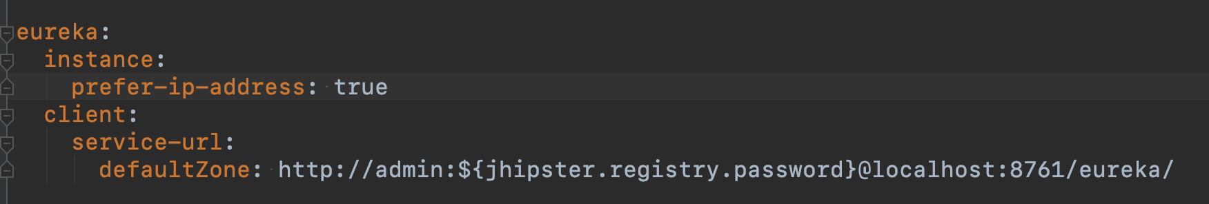

- Using jasypt online tool, encrypt the database username and password as follows;
Go to URL: https://www.devglan.com/online-tools/jasypt-online-encryption-decryption
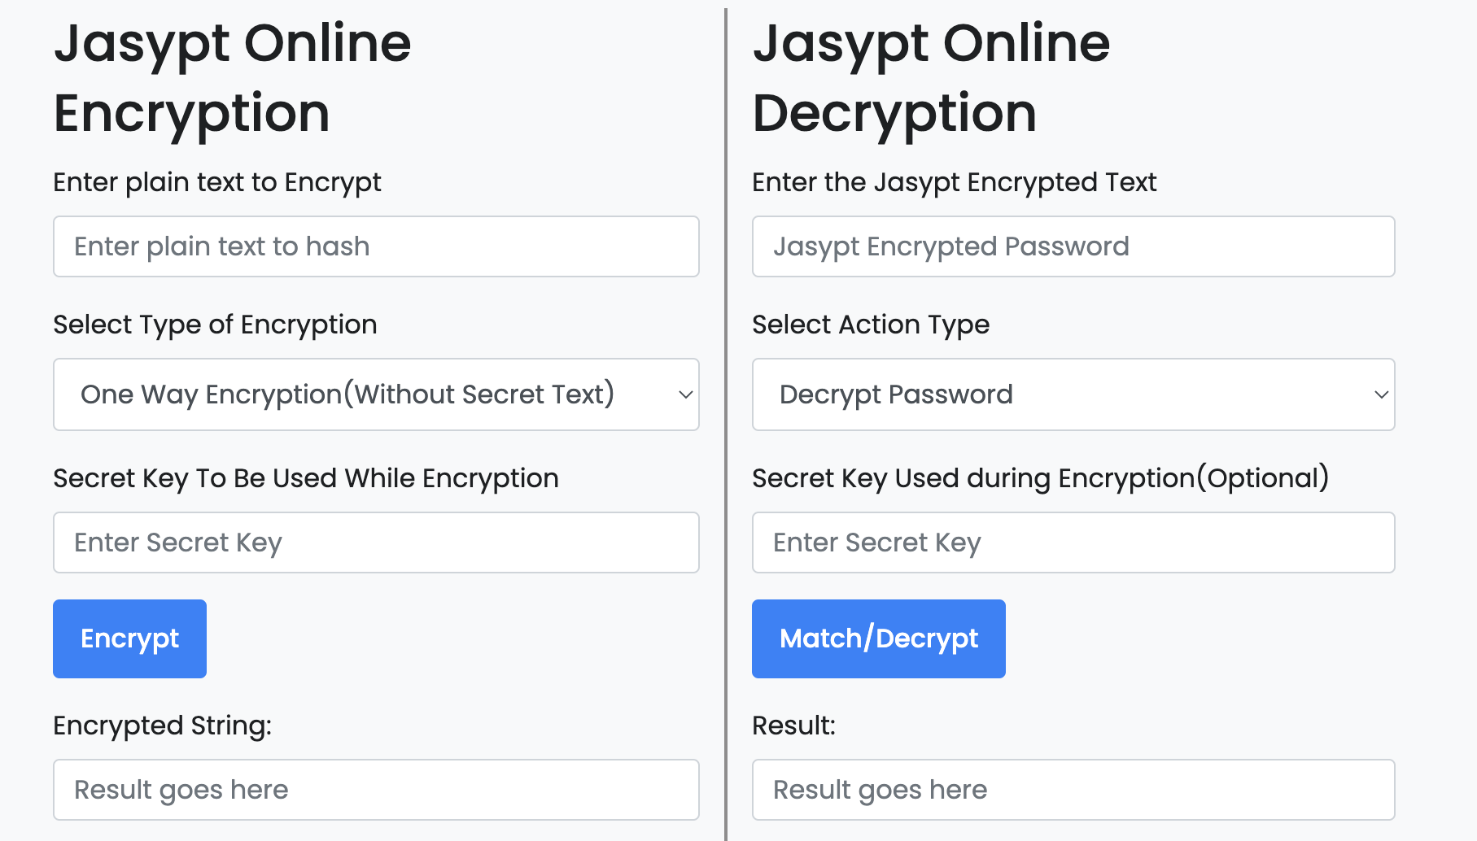
From the site above
i. Enter plain text to Encrypt (username, password)
ii. Select Two Way Encryption as the Type of Encryption
iii. Enter Secret Key To Be Used While Encryption (Here create a secret key)
iv. Encrypt the password
- On the application-prod.yml, update the encrypted database details as follows;
i. Replace the database name from pesalinkV2GW to the production DB name
ii. Update the DB username and passwords as below
username: ENC(jasypt-Encrypted-username)
password: ENC(jasypt-Encrypted-password)
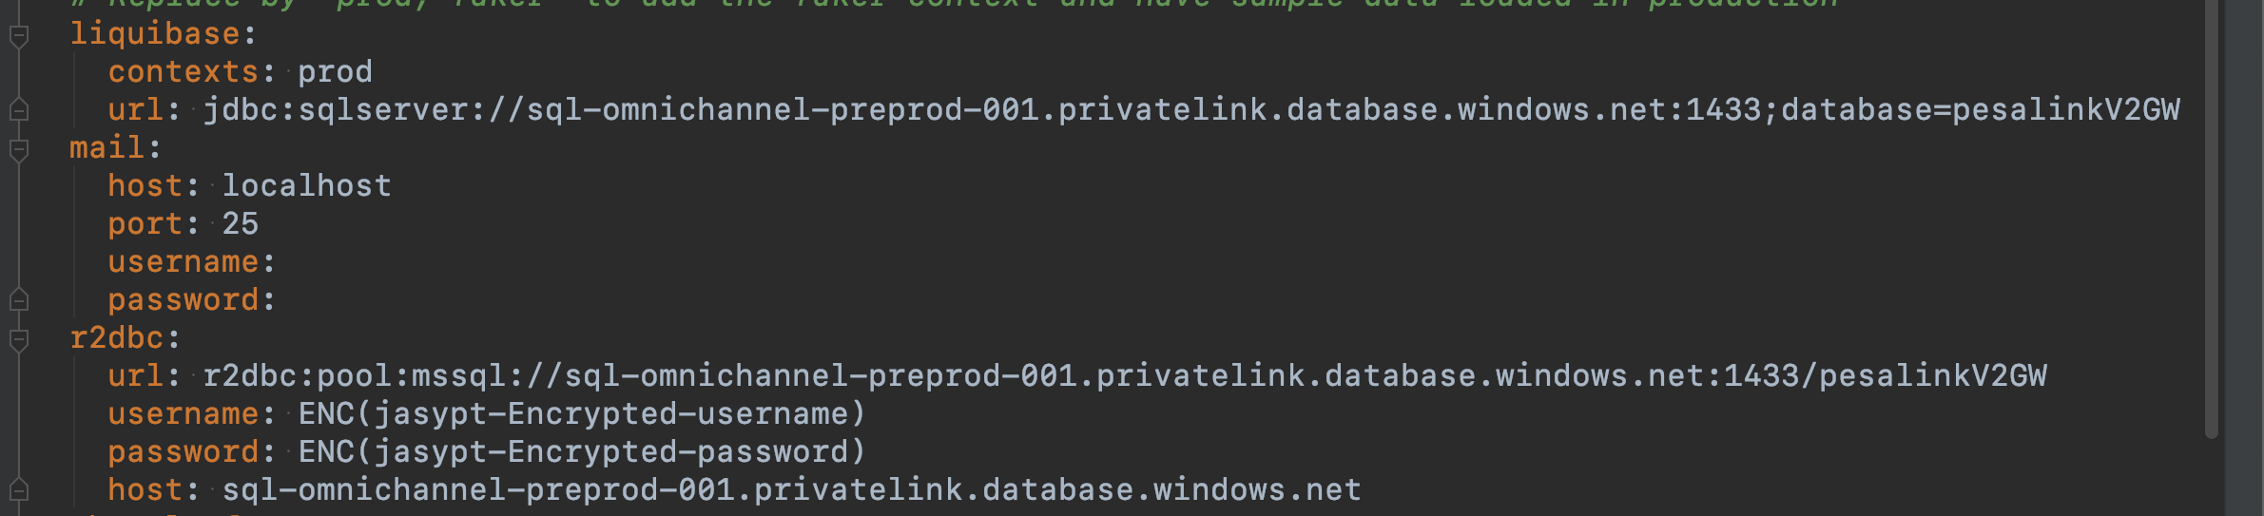

iii. Update the jasypt property with the Secret Key used during Encryption above
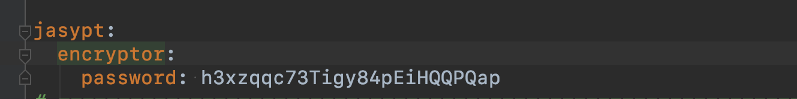

4. If the current server port 8443 is not available, update it with a port number available in production, otherwise leave it as 8443
NOTE: If the port is changed, inform the development team for a code rebuild.

5. Update the ipsl certificate credentials - password and alias with production credentials provided by sysadmin team.
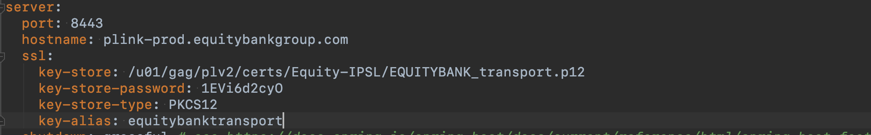

Deploying Production Files
1. Copy Files To Production Paths
Copy the provided files to the below production paths respectively;
- /u01/gag/plv2/gateway/bin/pesalink-v-2-gw-0.0.1-SNAPSHOT.jar
- /u01/gag/plv2/gateway/bin/wrapper
- /u01/gag/plv2/gateway/bin/pl2-gateway
- /u01/gag/iplv2/gateway/bin/config/application-prod.yml
- /u01/gag/plv2/gateway/bin/lib/lib folder
- /u01/gag/plv2/gateway/conf/pl2-gateway.conf
- /u01/gag/plv2/gateway/lib/wrapper.jar
- /u01/gag/plv2/gateway/lib/libwrapper.so

2. Create environment at /u01/gag - Optional
- cd /u01/gag
- source j11_env.sh

3. Update yml file at target location with the supplied prod yml
- cd /u01/gag/plv2/gateway/bin/
- jar uf pesalink-v-2-gw-0.0.1-SNAPSHOT.jar config/application-prod.yml

4. Restart services at /u01/gag/imtv2/core/bin
- sudo ./pl2-gateway restart

