

EQUITY BANK
PESALINK ISO20022 UPGRADE
-
On-Premise

Outbound
Release Notes

Project Details
Application Name | outBoundMS
Project Type | Software Development
Project Version | release-prod-1.0
Name of Re-leaser | Kennedy N. Gatimu
File Mode of Delivery | Jar, conf, yml, lib, so
Prepared By | Kennedy N. Gatimu

Release History
Date | Version | Author | Comments
12/09/2022 | release-prod-1.0 | Kennedy Gatimu | Initial Release

Confidentiality Disclaimer

DEVELOPER API GUIDE DOCUMENT
PROJECT: Equity Pesalink ISO20022 Upgrade
Date: 12.09.2022

THIS DOCUMENT AND THE INFORMATION IN IT ARE PROVIDED IN CONFIDENCE, FOR
THE SOLE PURPOSE OF EQUITY BANK LIMITEDAND MAY NOT BE DISCLOSED TO ANY
THIRD PARTY OR USED FOR ANY OTHER PURPOSE WITHOUT THE EXPRESS WRITTEN PERMISSION OF EQUITY BANK LIMITED.
Any form of reproduction, dissemination, copying, disclosure, modification, distribution and or
publication of this material is strictly prohibited. The contents of this document have not been
independently verified and they do not purport to be comprehensive, or to contain all the
information that a prospective investor may need. No representation, warranty or undertaking,
expressed or implied is or will be made or given and no responsibility or liability is or will be
accepted by Equity Bank Limited or by any of its directors, employees or advisors in relation to
the accuracy or completeness of this document or any other written or oral information made
available in connection with the Company.

Delivery Details
This build is available in the form a jar - out-bound-ms-0.0.1-SNAPSHOT.jar
All files included in the build are;
- out-bound-ms-0.0.1-SNAPSHOT.jar
- pl2-outbound
- wrapper
- application-prod.yml
- lib folder
- pl2-outbound.conf
- wrapper.jar
- libwrapper.so

Production Property File Update
The production application-prod.yml will be updated as follows;
- Eureka property
Replace the localhost on the defaultZone, with the production server ip address;
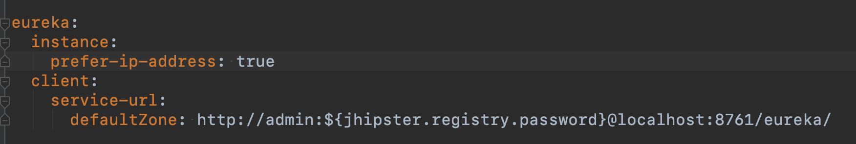

- Using jasypt online tool, encrypt the database username and password as follows;
Go to URL: https://www.devglan.com/online-tools/jasypt-online-encryption-decryption
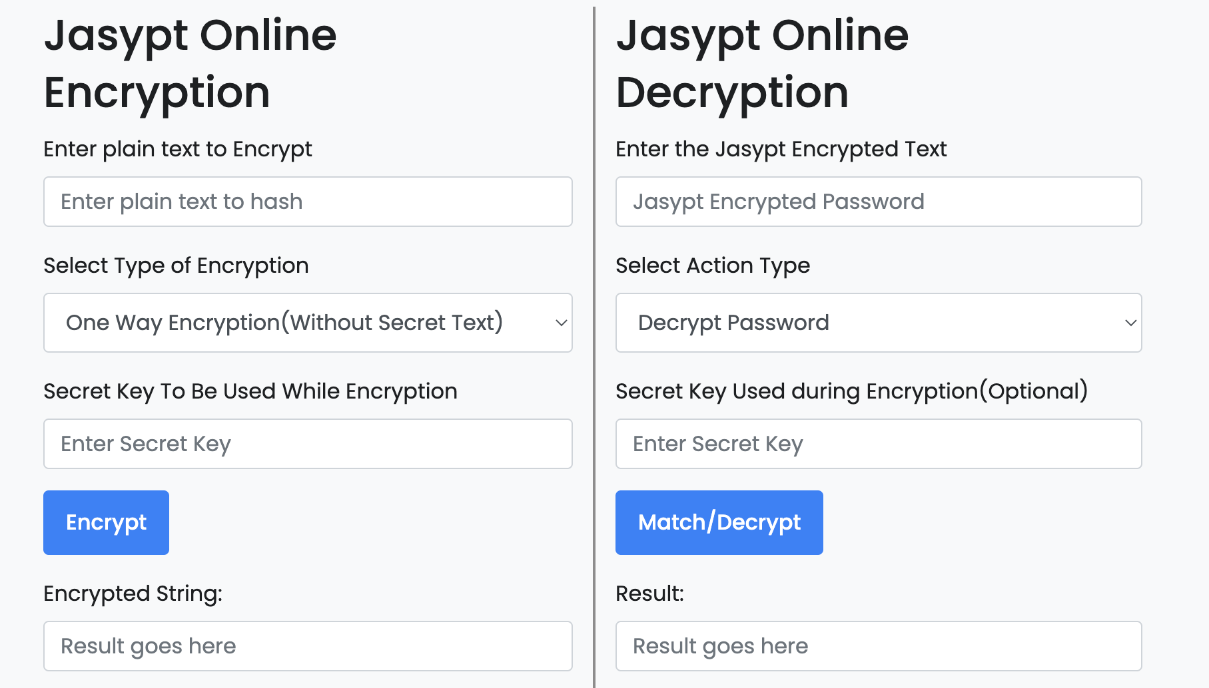
From the site above
i. Enter plain text to Encrypt (username, password)
ii. Select Two Way Encryption as the Type of Encryption
iii. Enter Secret Key To Be Used While Encryption (Here create a secret key)
iv. Encrypt the password
- On the application-prod.yml, update the encrypted database details as follows;
i. Replace the database name from outBoundMS to the production DB name
ii. Update the DB username and passwords as below
username: ENC(jasypt-Encrypted-username)
password: ENC(jasypt-Encrypted-password)
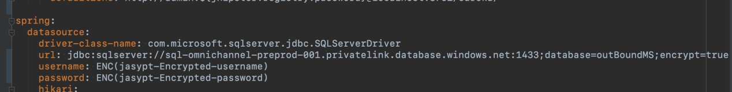

iii. Update the jasypt property with the Secret Key used during Encryption above
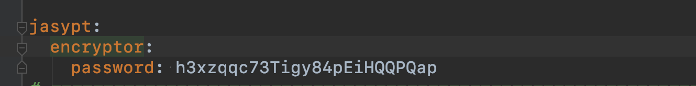

4. If the current server port 8083 is not available, update it with a port number available in production, otherwise leave it as 8083.
NOTE: If the port is changed, inform the development team for a code rebuild.

- Update the ipsl certificate credentials - password and alias with production credentials provided by sysadmin team.
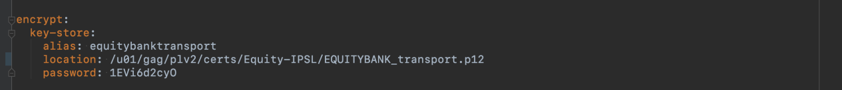

- Update production server ip address here
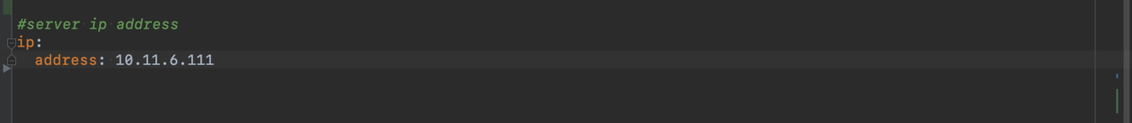

Deploying Production Files
1. Copy Files To Production Paths
Copy the provided files to the below production paths respectively;
- /u01/gag/plv2/outbound/bin/out-bound-ms-0.0.1-SNAPSHOT.jar
- /u01/gag/plv2/outbound/bin/wrapper
- /u01/gag/plv2/outbound/bin/pl2-outbound
- /u01/gag/iplv2/outbound/bin/config/application-prod.yml
- /u01/gag/plv2/outbound/bin/lib/lib folder
- /u01/gag/plv2/outbound/conf/pl2-outbound.conf
- /u01/gag/plv2/outbound/lib/wrapper.jar
- /u01/gag/plv2/outbound/lib/libwrapper.so

2. Create environment at /u01/gag - Optional
- cd /u01/gag
- source j11_env.sh

3. Update yml file at target location with the supplied prod yml
- cd /u01/gag/plv2/outbound/bin/
- jar uf pesa-link-business-ms-0.0.1-SNAPSHOT.jar config/application-prod.yml

4. Restart services at /u01/gag/plv2/outbound/bin/
- sudo ./pl2-outbound restart

Post - Deployment Actions
Post - deployment actions will include;
- Table index creation
- Table insert scripts

Table Index Creation
Run below queries to create indexes in the production database for the given table
names.

- Table: banks
CREATE INDEX index_bankId ON [dbo].[banks] (bank_id);

2. Table: client_limit
CREATE INDEX index_sourceAccount ON [dbo].[client_limit] (source_account);

3. Table: param_configs
CREATE INDEX index_configId ON [dbo].[param_configs](config_id);

- Table: tpg_transactions
CREATE INDEX index_messageId ON [dbo].[tpg_transactions](msg_id);
CREATE INDEX index_endToEndId ON [dbo].[tpg_transactions](end_to_end_id);

- Table: transaction_details
CREATE INDEX index_originalRequestId ON [dbo].[transaction_details](original_request_id);
CREATE INDEX index_endToEndMsgId ON [dbo].[transaction_details](end_to_end_message_id);

Table Insert Scripts
1. Table param_configs
Note: This is not the final insert list for table param_config. We shall update once we get production data.

insert into [dbo].[param_configs] (config_bin_value, config_desc, config_id, config_status, config_value)
values ('xmlns="urn:iso:std:iso:20022:tech:xsd:acmt.023.001.02"', 'ACMT023 NameSpace', 'schema.location.actmt0023','ENABLEB','xmlns="urn:iso:std:iso:20022:tech:xsd:acmt.023.001.02"');

insert into [dbo].[param_configs] (config_bin_value, config_desc, config_id, config_status, config_value)
values ('xmlns="urn:iso:std:iso:20022:tech:xsd:pacs.028.001.04"', 'Pacs028 NameSpace', 'schema.location.pac028','ENABLEB','xmlns="urn:iso:std:iso:20022:tech:xsd:pacs.028.001.04"');

insert into [dbo].[param_configs] (config_bin_value, config_desc, config_id, config_status, config_value)
values ('/api/v1/transaction/process', 'Finacle Debit Credit Url', 'ips.payment.status.url','ENABLEB','/api/v1/transaction/process');

insert into [dbo].[param_configs] (config_bin_value, config_desc, config_id, config_status, config_value)
values ('https://api.ips.pesalink.co.ke/iso20022/sync/v1/verification-request', 'IPSL Verification Request url', 'ips.verification.request.url','ENABLEB','https://api.ips.pesalink.co.ke/iso20022/sync/v1/verification-request');

insert into [dbo].[param_configs] (config_bin_value, config_desc, config_id, config_status, config_value)
values ('https://api.ips.pesalink.co.ke/iso20022/async/v1/credit-transfer', 'IPSL Credit Transfer url', 'ips.credit.transfer.url','ENABLEB','https://api.ips.pesalink.co.ke/iso20022/async/v1/credit-transfer');

insert into [dbo].[param_configs] (config_bin_value, config_desc, config_id, config_status, config_value)
values ('https://api.ips.pesalink.co.ke/iso20022/sync/v1/payment-status-request', 'IPSL Payment Status Url', 'ips.payment.status.url','ENABLEB','https://api.ips.pesalink.co.ke/iso20022/sync/v1/payment-status-request');

insert into [dbo].[param_configs] (config_bin_value, config_desc, config_id, config_status, config_value)
values ('https://102.69.239.82:8443/kba/webservices/v2/LookupDbWS?wsdl', 'Endpoint To IPSL MGW Phone Lookup', 'ipsl.mgw.phone.lookup.url','ENABLEB','https://102.69.239.82:8443/kba/webservices/v2/LookupDbWS?wsdl');

insert into [dbo].[param_configs] (config_bin_value, config_desc, config_id, config_status, config_value)
values ('EQUITY BANK', 'Username To IPSL MGW Phone Lookup', 'kba.inquire.username','ENABLEB','EQUITY BANK');

insert into [dbo].[param_configs] (config_bin_value, config_desc, config_id, config_status, config_value)
values ('123456', 'Password To IPSL MGW Phone Lookup', 'kba.inquire.password','ENABLEB','123456');

- Table banks

insert into [dbo].[banks] (bank_id, bank_name, bank_status)
values ('0001', 'KCB', 'ONLINE');

insert into [dbo].[banks] (bank_id, bank_name, bank_status)
values ('0002', 'Stanchart', 'ONLINE');

insert into [dbo].[banks] (bank_id, bank_name, bank_status)
values ('0003', 'ABSA', 'ONLINE');

insert into [dbo].[banks] (bank_id, bank_name, bank_status)
values ('0005', 'Bank of India', 'OFFLINE');

insert into [dbo].[banks] (bank_id, bank_name, bank_status)
values ('0006', 'Bank of Baroda', 'OFFLINE');

insert into [dbo].[banks] (bank_id, bank_name, bank_status)
values ('0007', 'NCBA', 'ONLINE');

insert into [dbo].[banks] (bank_id, bank_name, bank_status)
values ('0010', 'Prime Bank', 'ONLINE');

insert into [dbo].[banks] (bank_id, bank_name, bank_status)
values ('0011', 'Coop Bank', 'ONLINE');

insert into [dbo].[banks] (bank_id, bank_name, bank_status)
values ('0012', 'NBK', 'ONLINE');
insert into [dbo].[banks] (bank_id, bank_name, bank_status)
values ('0014', 'M-Oriental', 'ONLINE');

insert into [dbo].[banks] (bank_id, bank_name, bank_status)
values ('0016', 'Citi Bank', 'ONLINE');

insert into [dbo].[banks] (bank_id, bank_name, bank_status)
values ('0017', 'Habib Bank AG Zurich', 'OFFLINE');

insert into [dbo].[banks] (bank_id, bank_name, bank_status)
values ('0018', 'Middle East Bank', 'ONLINE');

insert into [dbo].[banks] (bank_id, bank_name, bank_status)
values ('0019', 'Bank of Africa', 'ONLINE');

insert into [dbo].[banks] (bank_id, bank_name, bank_status)
values ('0023', 'Consolidated', 'ONLINE');

insert into [dbo].[banks] (bank_id, bank_name, bank_status)
values ('0025', 'Credit Bank', 'ONLINE');

insert into [dbo].[banks] (bank_id, bank_name, bank_status)
values ('0026', 'Access Bank', 'OFFLINE');

insert into [dbo].[banks] (bank_id, bank_name, bank_status)
values ('0031', 'Stanbic Bank', 'ONLINE');

insert into [dbo].[banks] (bank_id, bank_name, bank_status)
values ('0035', 'ABC Bank', 'ONLINE');

insert into [dbo].[banks] (bank_id, bank_name, bank_status)
values ('0043', 'Eco Bank', 'OFFLINE');

insert into [dbo].[banks] (bank_id, bank_name, bank_status)
values ('0049', 'SPIRE Bank', 'OFFLINE');

insert into [dbo].[banks] (bank_id, bank_name, bank_status)
values ('0050', 'Paramount', 'ONLINE');
insert into [dbo].[banks] (bank_id, bank_name, bank_status)
values ('0051', 'Kingdom Bank', 'ONLINE');

insert into [dbo].[banks] (bank_id, bank_name, bank_status)
values ('0053', 'Gt Bank', 'ONLINE');

insert into [dbo].[banks] (bank_id, bank_name, bank_status)
values ('0054', 'Victoria Bank', 'ONLINE');

insert into [dbo].[banks] (bank_id, bank_name, bank_status)
values ('0055', 'Guardian Bank', 'ONLINE');

insert into [dbo].[banks] (bank_id, bank_name, bank_status)
values ('0057', 'I&M Bank', 'ONLINE');

insert into [dbo].[banks] (bank_id, bank_name, bank_status)
values ('0059', 'Development Bank', 'OFFLINE');

insert into [dbo].[banks] (bank_id, bank_name, bank_status)
values ('0060', 'SBM', 'OFFLINE');
insert into [dbo].[banks] (bank_id, bank_name, bank_status)
values ('0061', 'Housing finance', 'ONLINE');

insert into [dbo].[banks] (bank_id, bank_name, bank_status)
values ('0063', 'DTB', 'ONLINE');

insert into [dbo].[banks] (bank_id, bank_name, bank_status)
values ('0065', 'Mayfair Bank', 'ONLINE');

insert into [dbo].[banks] (bank_id, bank_name, bank_status)
values ('0066', 'Sidian Bank', 'ONLINE');

insert into [dbo].[banks] (bank_id, bank_name, bank_status)
values ('0068', 'Equity Bank', 'ONLINE');

insert into [dbo].[banks] (bank_id, bank_name, bank_status)
values ('0070', 'Family Bank', 'ONLINE');

insert into [dbo].[banks] (bank_id, bank_name, bank_status)
values ('0072', 'Gulf African Bank', 'ONLINE');

insert into [dbo].[banks] (bank_id, bank_name, bank_status)
values ('0074', 'First Community Bank', 'ONLINE');

insert into [dbo].[banks] (bank_id, bank_name, bank_status)
values ('0075', 'DIB Bank', 'ONLINE');

insert into [dbo].[banks] (bank_id, bank_name, bank_status)
values ('0076', 'UBA', 'OFFLINE');

insert into [dbo].[banks] (bank_id, bank_name, bank_status)
values ('0078', 'KWFT', 'ONLINE');

insert into [dbo].[banks] (bank_id, bank_name, bank_status)
values ('0079', 'Faulu Bank', 'OFFLINE');

insert into [dbo].[banks] (bank_id, bank_name, bank_status)
values ('0099', 'Post Bank', 'OFFLINE');

insert into [dbo].[banks] (bank_id, bank_name, bank_status)
values ('9999', 'IPS (Instant Payment Switch)', 'ONLINE');

insert into [dbo].[banks] (bank_id, bank_name, bank_status)
values ('0086', 'Vooma', 'OFFLINE');
insert into [dbo].[banks] (bank_id, bank_name, bank_status)
values ('0087', 'Pesapal', 'OFFLINE');

insert into [dbo].[banks] (bank_id, bank_name, bank_status)
values ('0088', 'Interswitch', 'OFFLINE');

insert into [dbo].[banks] (bank_id, bank_name, bank_status)
values ('0089', 'Stima Sacco', 'ONLINE');

insert into [dbo].[banks] (bank_id, bank_name, bank_status)
values ('0091', 'Flutterwave', 'OFFLINE');

insert into [dbo].[banks] (bank_id, bank_name, bank_status)
values ('0092', 'iPay', 'OFFLINE');

insert into [dbo].[banks] (bank_id, bank_name, bank_status)
values ('0093', 'KCBbulk', 'OFFLINE');

insert into [dbo].[banks] (bank_id, bank_name, bank_status)
values ('0095', 'MFS', 'OFFLINE');

insert into [dbo].[banks] (bank_id, bank_name, bank_status)
values ('0097', 'Telkom Kenya', 'ONLINE');

insert into [dbo].[banks] (bank_id, bank_name, bank_status)
values ('0037', 'Cellulant', 'OFFLINE');

