|  |  |  |  |  |
| --- | --- | --- | --- | --- |
| |  |  | | --- | --- | | Manual |  | |  |  | |
| Setup Mantis System |

# Prerequisite

|  |  |  |  |
| --- | --- | --- | --- |
| No | Description | Specification | Remark |
| 1 | Source Code of Mantis to Container | Ubuntu 16.04 |  |

# Setup Mantis Step-by-Step

1. Access url: <http://x.x.x.x:8010/admin/install.php> and fill-in

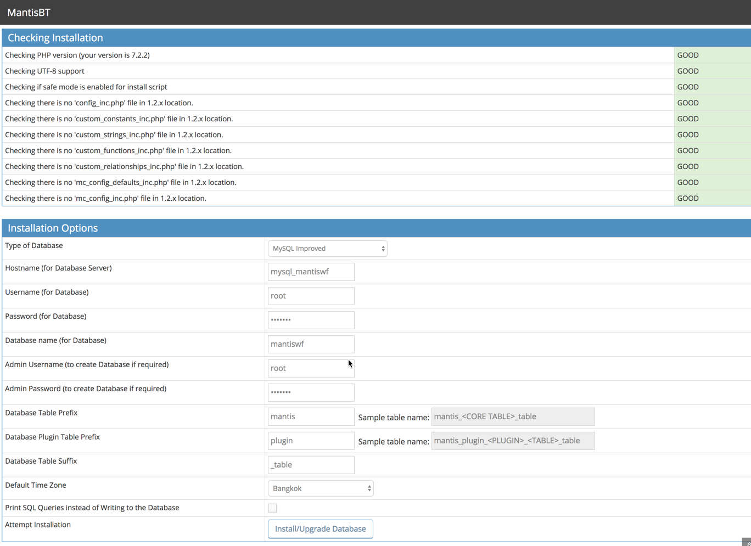

1. Mantis will show result for install and configure database as below:

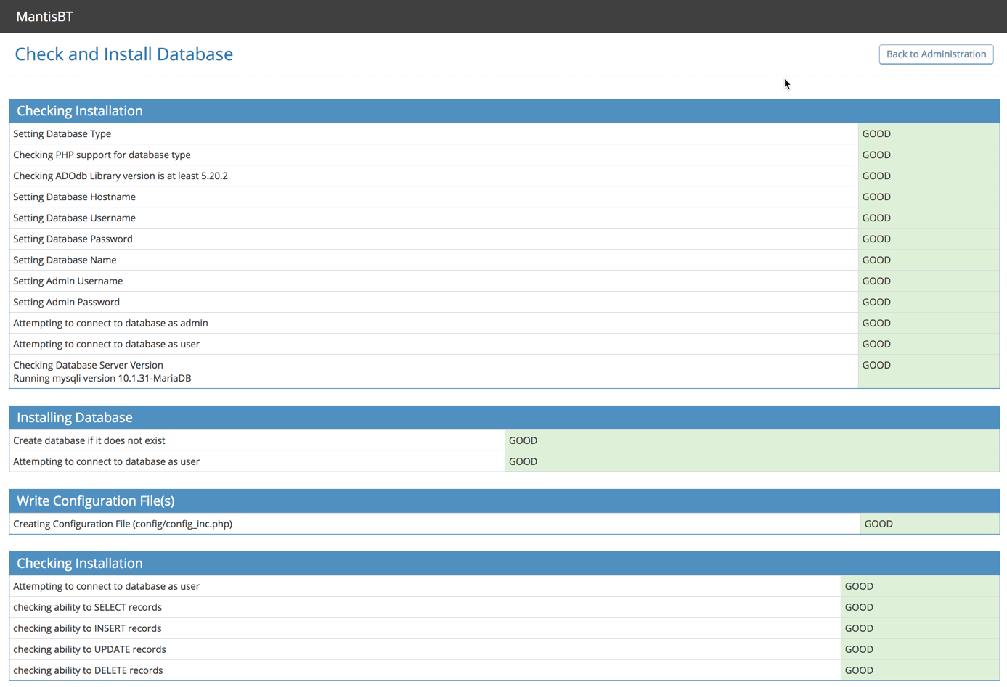

1. Click:”Continute” for start log in

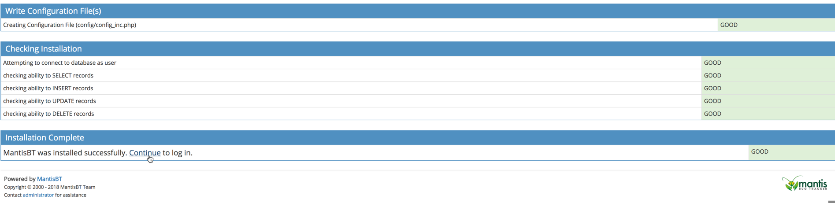

1. Mantis will return login page: (Username: Administrator, Password: root)

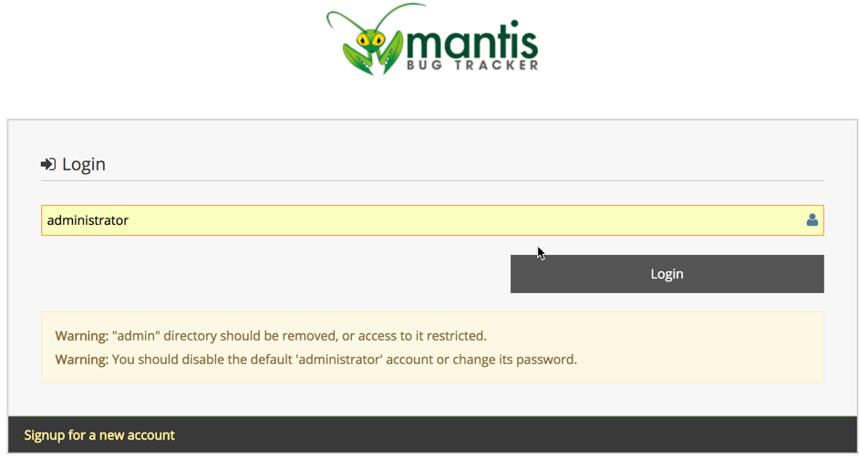

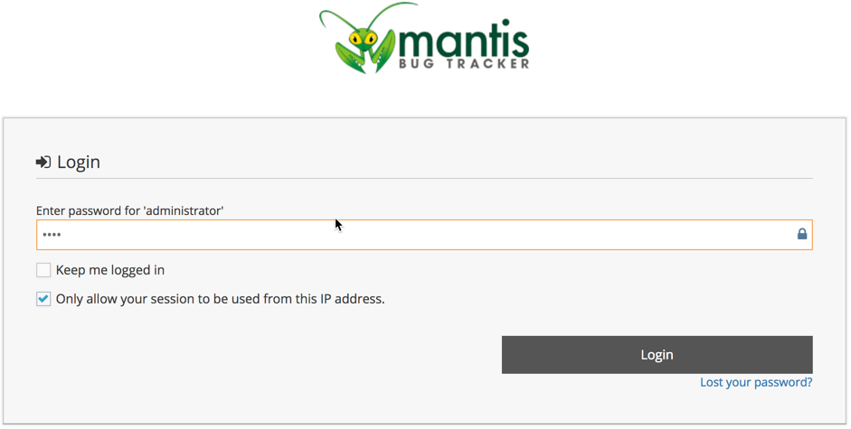

1. Mantis dashboard will represent. Click Administrator 🡺 Logout

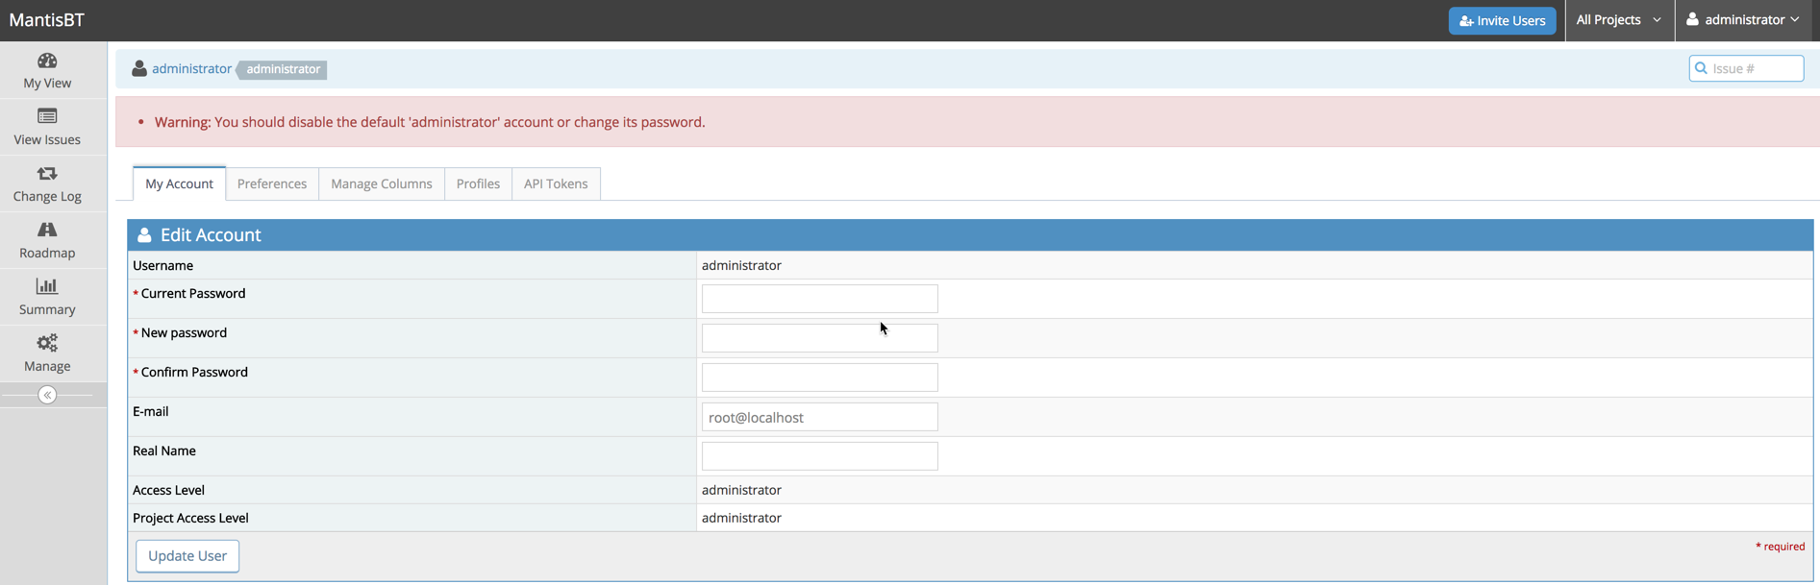

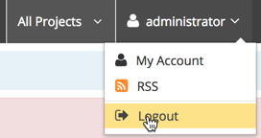

1. Back to Terminal and Change mode to edit file on folder (/config/config_inc.php)

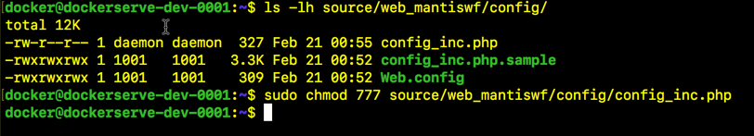

1. Add configure as expect
2. Restart container and relogon system

