QF632 Financial Data Science — Group Project
Milestone 2 · Preprocessing & Exploratory Data Analysis
Group 4 · 6 June 2026

1. Dataset & Pipeline Overview
We test whether the pricing linkage between European (TTF), U.S. (Henry Hub) and Asian (JKM) natural-gas benchmarks — normally disciplined by LNG arbitrage (Law of One Price) — becomes regime-dependent under geopolitical supply stress. This milestone documents the data engineering behind that test: a reproducible ingestion layer, a point-in-time (PIT) alignment that prevents look-ahead bias, and the missing-data and scaling decisions that make the mosaic model-ready.
All series were re-acquired from public sources over 2019-01-02 → 2026-06-05 and reconciled row-for-row against the Milestone 1 proof of ingestion (Appendix A). The aligned master spans 1,870 gas trading days.
Source family | Series (M1 columns) | Freq. | Access | Coverage
Market (Yahoo / yfinance) | HH, TTF, JKM, Brent, EUR/USD | daily | keyless | 2019–2026 · exact
Macro (FRED) | US INDPRO; Euro IP | monthly | keyless | US→2026; euro→2024*
US storage (EIA) | Lower-48 working gas | weekly | keyless | 2019–2026
EU storage (GIE AGSI+) | DE % full; TWh | daily | x-key | 2019–2026 · exact
EU LNG (GIE ALSI) | ES send-out; inventory | daily | x-key | 2019–2026 · exact
Weather (Open-Meteo ERA5) | HDD AMS / CHI / BEI | daily | keyless | 2019–2026
Risk (Caldara–Iacoviello) | GPR / GPRT / GPRA / GPRC_RUS | monthly | keyless | 2019–2026 · exact
Risk (policyuncertainty) | EU EPU | monthly | keyless | 2019–2026

*Euro IP (OECD MEI series) was discontinued in 2024; it is retained but reverts to NaN thereafter (staleness rule, §2). Russian→EU pipeline flow (ENTSOG) is deferred to Milestone 3 (point-key resolution pending) — it is highly collinear with the war-regime indicator and the EU-storage drawdown, so M2 does not depend on it.

2. Time-Series Structural Alignment
Master calendar. The decision grid is the union of gas trading days. Every observation carries two dates: event_date (the period it describes) and available_at (when it was first publishable in reality). All joins use pandas.merge_asof(direction='backward') keyed on available_at — never on event_date — so a value enters the grid only once a market participant could actually have known it.
Publication lags. Each series carries a conservative (upper-bound) release rule and a frequency-based staleness tolerance, beyond which a discontinued series reverts to NaN rather than being carried forward indefinitely:
Series | Freq. | available_at rule | Stale tol.
market | daily (trading) | T+0 exchange settle (known at close of day) | 7 d
us_storage | weekly | EIA weekly report: week-ending Fri released following Thu (≈T+6) | 14 d
de_storage | daily (gas-day) | GIE AGSI+ gas-day published next morning (T+1) | 10 d
es_lng | daily (gas-day) | GIE ALSI gas-day published next morning (T+1) | 10 d
hdd | daily | Open-Meteo ERA5 reanalysis lag ≈ T+5 | 14 d
us_ip | monthly | FRED INDPRO released mid next month (conservative month-end +20d) | 45 d
euro_ip | monthly | Eurostat euro-area IP released ≈ month-end +45d | 45 d
gpr | monthly | Caldara-Iacoviello GPR updated ≈ 10th of next month | 45 d
epu | monthly | EPU Europe published early next month (≈ month-end +7d) | 45 d

Leakage proof. A point-in-time snapshot on 2022-02-25 (first trading day after the Russian invasion) makes the lag structure explicit — on that day the model knew only January macro/risk values, not February's:
Series | Freq. | event_date | available_at | age (d)
market | daily (trading) | 2022-02-25 | 2022-02-25 | 0
us_storage | weekly | 2022-02-18 | 2022-02-24 | 7
de_storage | daily (gas-day) | 2022-02-24 | 2022-02-25 | 1
es_lng | daily (gas-day) | 2022-02-24 | 2022-02-25 | 1
hdd | daily | 2022-02-20 | 2022-02-25 | 5
us_ip | monthly | 2022-01-01 | 2022-02-20 | 55
euro_ip | monthly | 2021-12-01 | 2022-02-14 | 86
gpr | monthly | 2022-01-01 | 2022-02-10 | 55
epu | monthly | 2022-01-01 | 2022-02-07 | 55

A unit-test suite (tests/test_alignment.py) asserts available_at ≤ cutoff and event_date ≤ cutoff for all nine series across all 1,870 days, that T+1 fundamentals are never used same-day, and that no series is stale-forwarded beyond tolerance — all five tests pass.

3. Scale Disparities & Missing Data
Missing data. Values are handled by mechanism, with provenance flags — never silently imputed:
Situation | Treatment | Rationale
Cross-market holidays (price/FX) | forward-fill ≤ 2 trading days, flag stale | short-horizon mean-reverting; 2–3 cells/series
Monthly/weekly before first release | leave NaN (no backfill) | back-filling would fabricate early signal
Discontinued series (euro IP) | NaN past tolerance window | avoid propagating a years-old value
ENTSOG flow = 0 (when added) | keep 0, flag zero | 0 is a real pipeline shut-in, not missing

Outliers. Extremes are flagged, never winsorized — the 2020/2022/2026 regime extremes ARE the object of study. A rolling 30-day robust-MAD screen (k=6) writes 161 flags to outliers.csv; as a sanity check the invasion window (2022-02-24…03-15) surfaces TTF, JKM and both spreads. The screen also exposes JKM's low-liquidity quoting (flat runs punctuated by jumps), an operational caveat carried into the pitch.
Scaling. Dual-track and strictly causal. Levels (with spreads) live in master_clean.parquet; the modelling matrix master_scaled.parquet uses log-returns and a rolling 252-day z-score (min 126) — never full-sample statistics, which would leak the future. Bounded storage % uses a logit; LNG send-out uses log1p; index levels use YoY. TTF is converted to USD/MMBtu (× EUR/USD ÷ 3.41214) so the spreads are unit-consistent.

4. Exploratory Findings
The cross-basin spreads collapse to near-zero in calm periods (Law of One Price) and blow out under supply stress: TTF–HH peaks near 90 USD/MMBtu during the 2022 energy crisis and re-widens during the 2026 Hormuz closure, while U.S. Henry Hub barely moves — it is insulated from the chokepoint.
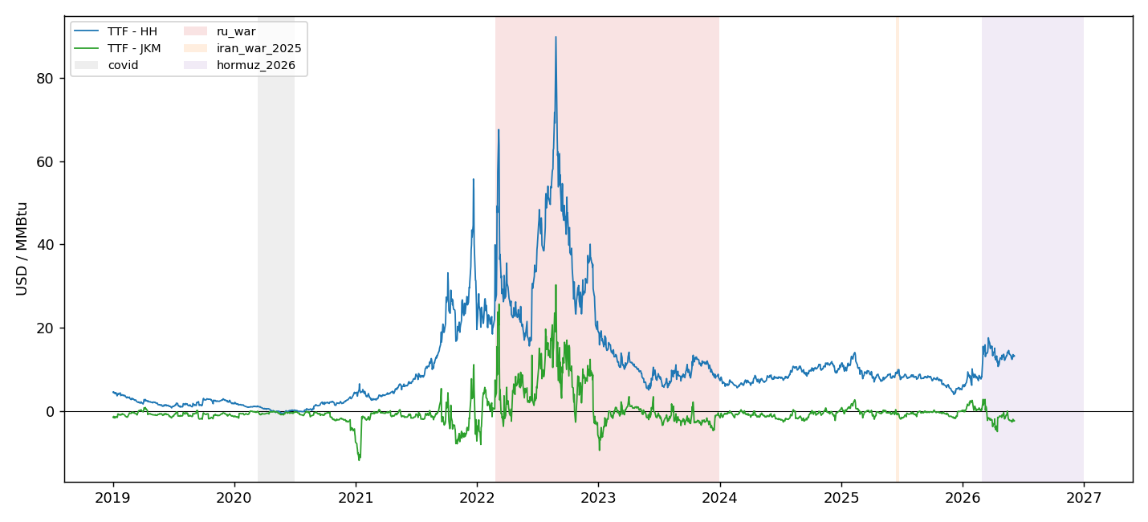
Figure 1. Cross-basin spreads (USD/MMBtu) with regime shading. Near-zero under Law-of-One-Price; TTF–HH blows out to ~90 in the 2022 war and re-widens in the 2026 Hormuz closure.
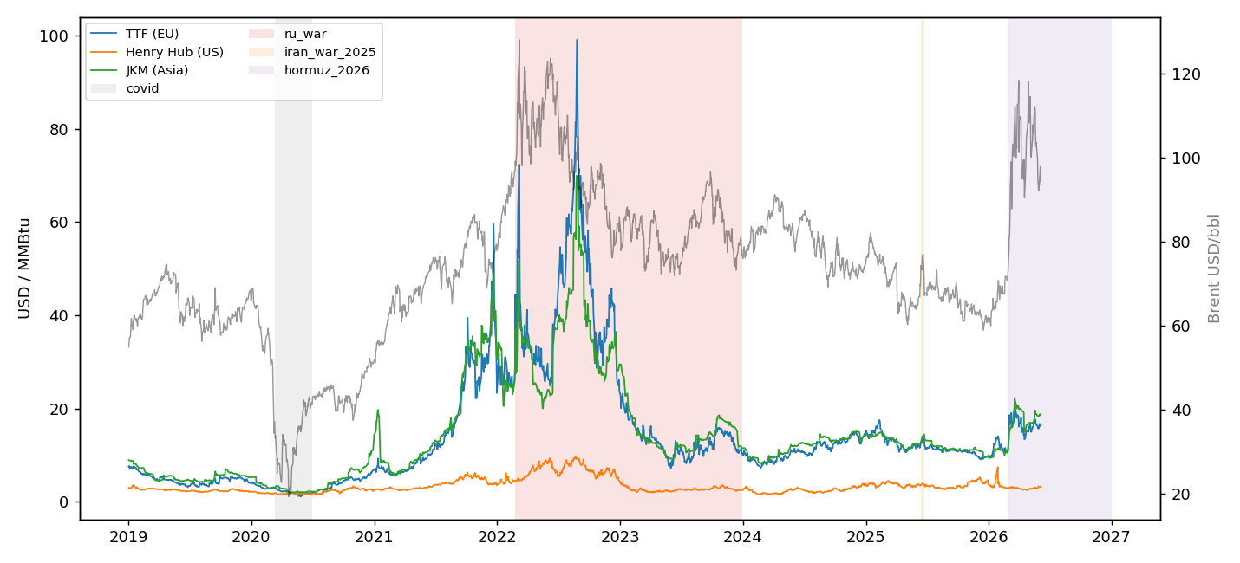
Figure 2. Benchmarks in common units, Brent on the right axis. Henry Hub stays low and stable while TTF and JKM spike together under stress.
Regime means confirm the structure: the European supply premium and Russia-specific geopolitical risk peak in the 2022 war, while the 2026 Hormuz closure lifts TTF, JKM and Brent together as Henry Hub stays flat.
regime | TTF–HH | TTF–JKM | TTF | HH | GPR | GPRC_RUS
normal | 7.44 | -0.88 | 10.46 | 3.02 | 109.45 | 1.17
covid | 0.23 | -0.43 | 1.98 | 1.74 | 74.17 | 0.45
ru_war | 22.22 | 2.80 | 26.85 | 4.62 | 139.07 | 2.88
iran_war_2025 | 9.34 | -0.65 | 13.09 | 3.75 | 166.05 | 1.49
hormuz_2026 | 13.63 | -1.47 | 16.54 | 2.91 | 225.83 | 1.84

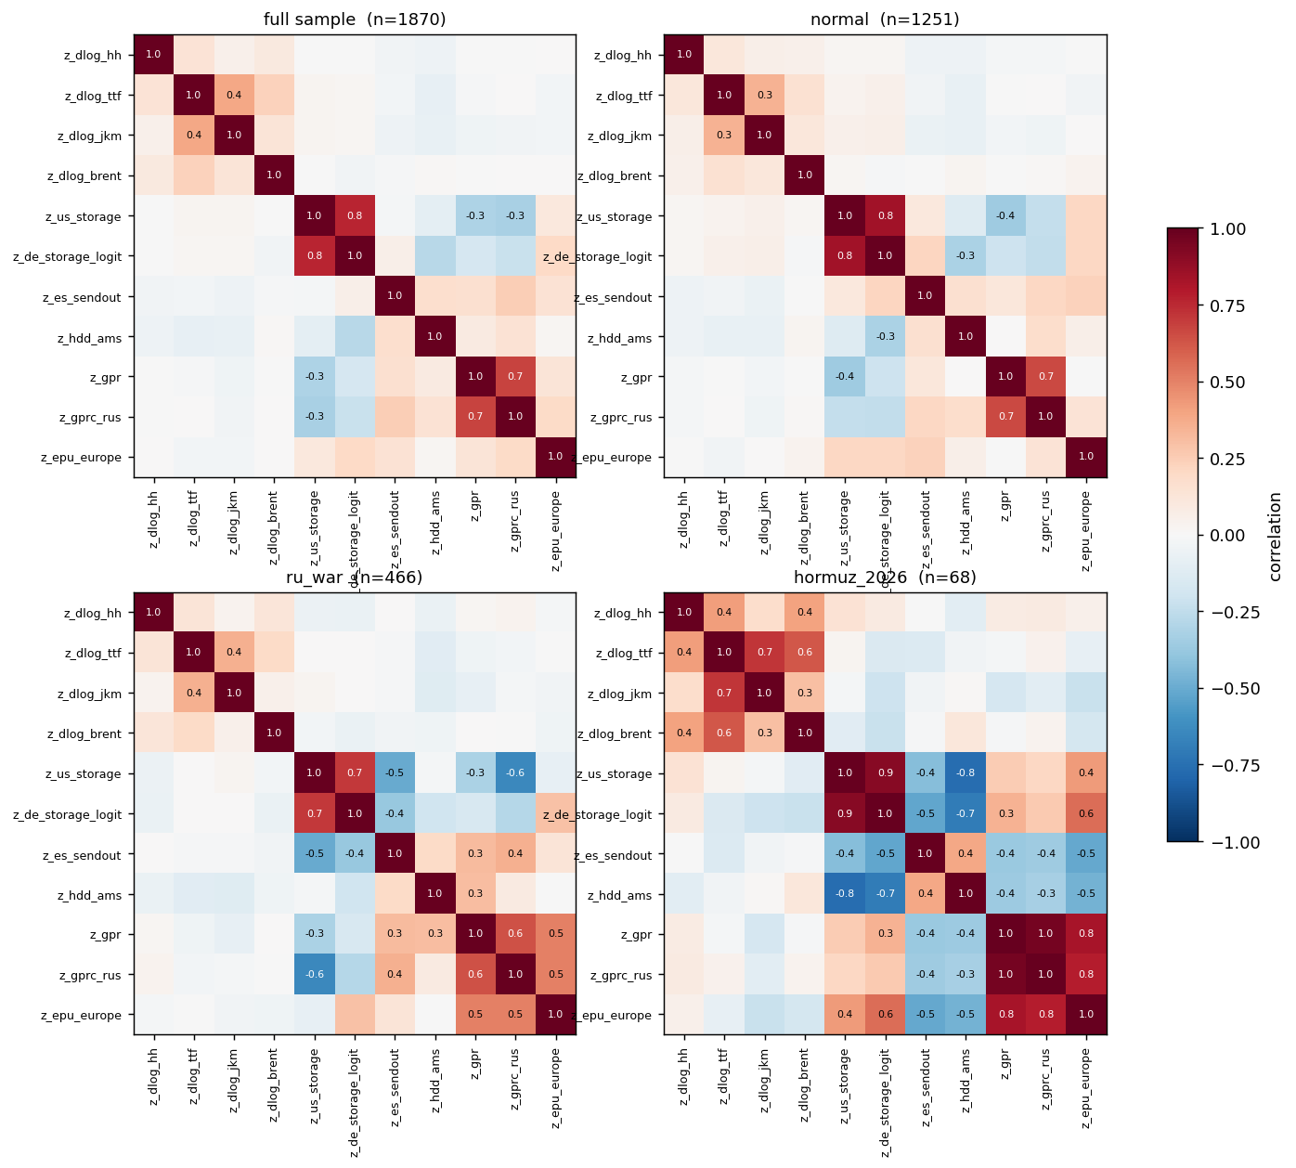
Figure 3. Correlation structure by regime (|r| ≥ 0.3 annotated). Cross-basin co-movement reorganises as supply stress sets in.
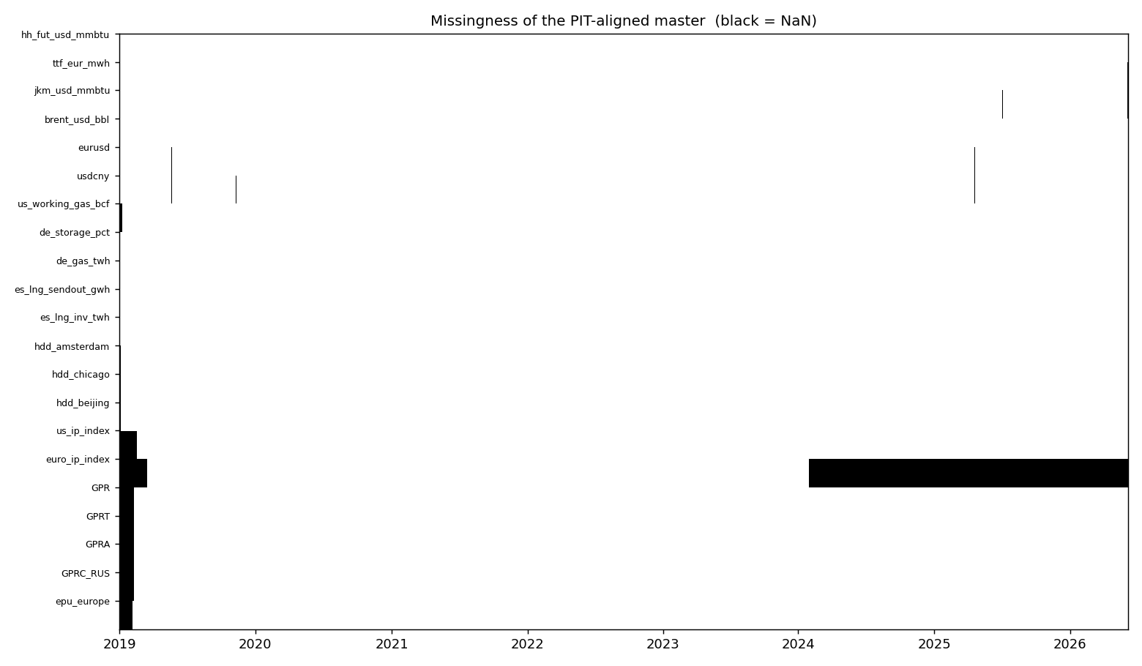
Figure 4. Missingness of the PIT-aligned master (black = NaN): pre-first-release gaps and the euro-IP discontinuation — no fabricated fills.
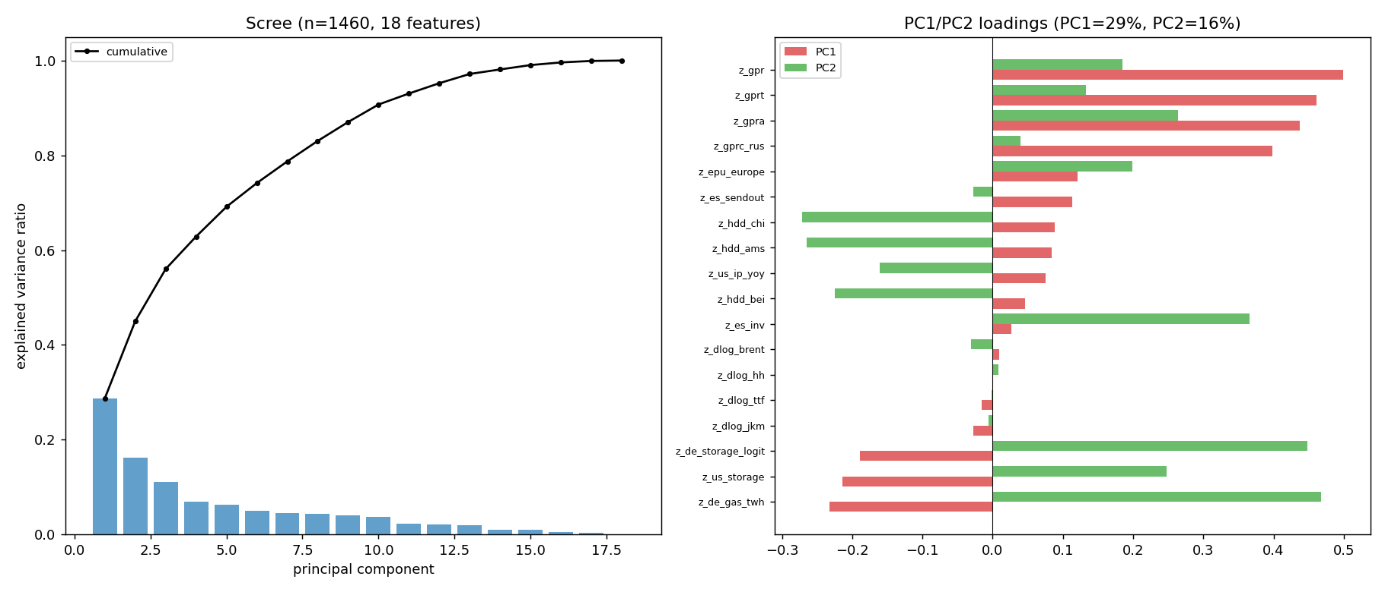
Figure 5. PCA preview (M3). PC1 (~29%) contrasts geopolitical risk with storage; the first three components explain ≈ 56% of variance.
Stationarity (ADF + KPSS, reports/stationarity.csv): spread_ttf_hh is non-stationary in levels (persistent regime level-shifts), so Milestone 3 will difference it or condition on regime; spread_ttf_jkm and all z-scored daily features are stationary. Regime validation (validate_regimes.py): the structural break lands exactly on 2026-03-02 (TTF +39% in one day, Henry Hub −9%), confirming the Hormuz boundary data-drivenly.

5. Operational Notes (pitch readiness)
- JKM is thinly traded — stale quotes punctuated by jumps; any cross-basin strategy faces real execution friction and bid-ask cost on the Asian leg.
- Regimes are calibrated to verified event dates: COVID (control), 2022 Russia (positive control), the Jun-2025 Twelve-Day War (precursor — strait stayed open), and the Feb–Mar 2026 Hormuz closure (candidate chokepoint regime).
- The pipeline is reproducible end-to-end (ingest → align → clean → eda → report); API keys live in .env and are never committed.

Appendix A — Proof of Ingestion (first 5 rows)
Re-ingested from public sources; values match the Milestone 1 submission exactly.
Market — prices & FX (Yahoo)
date | hh_fut_usd_mmbtu | ttf_eur_mwh | jkm_usd_mmbtu | brent_usd_bbl | eurusd
2019-01-02 | 2.958 | 22.475 | 8.970 | 54.91 | 1.1462
2019-01-03 | 2.945 | 22.255 | 8.945 | 55.95 | 1.1318
2019-01-04 | 3.044 | 22.930 | 8.885 | 57.06 | 1.1391
2019-01-07 | 2.944 | 21.530 | 8.830 | 57.33 | 1.1410
2019-01-08 | 2.967 | 22.090 | 8.820 | 58.72 | 1.1480

Physical — EU gas storage, Germany (GIE AGSI+)
date | de_storage_pct | de_gas_twh
2019-01-01 | 75.23 | 189.1272
2019-01-02 | 75.01 | 188.5782
2019-01-03 | 74.47 | 187.2198
2019-01-04 | 74.10 | 186.2821
2019-01-05 | 73.96 | 185.9276

Physical — EU LNG send-out & inventory, Spain (ALSI)
date | es_lng_sendout_gwh | es_lng_inv_twh
2019-01-01 | 338.7 | 2259.35
2019-01-02 | 461.2 | 2297.99
2019-01-03 | 538.6 | 2229.83
2019-01-04 | 547.1 | 2143.05
2019-01-05 | 407.0 | 2359.09

Physical — US Lower-48 weekly storage (EIA)
date | us_working_gas_bcf
2019-01-04 | 2614
2019-01-11 | 2533
2019-01-18 | 2370
2019-01-25 | 2197
2019-02-01 | 1960

Physical — Weather HDD (Open-Meteo)
date | hdd_amsterdam | hdd_chicago | hdd_beijing
2019-01-01 | 10.1 | 18.0 | 23.0
2019-01-02 | 12.1 | 19.8 | 23.3
2019-01-03 | 13.1 | 19.5 | 21.5
2019-01-04 | 12.3 | 16.1 | 21.9
2019-01-05 | 10.5 | 15.1 | 22.2

Risk — Geopolitical Risk incl. Russia (Caldara–Iacoviello)
date | GPR | GPRT | GPRA | GPRC_RUS
2019-01-01 | 87.4241 | 112.9805 | 55.7335 | 0.9987
2019-02-01 | 96.8002 | 127.8574 | 57.5117 | 1.0575
2019-03-01 | 82.3283 | 90.7896 | 66.6412 | 0.5631
2019-04-01 | 79.2534 | 95.4554 | 57.5155 | 0.8058
2019-05-01 | 106.4719 | 134.9725 | 64.6634 | 0.9714

Risk — European EPU (policyuncertainty)
date | epu_europe
2019-01-01 | 247.6771
2019-02-01 | 230.1516
2019-03-01 | 229.3842
2019-04-01 | 214.2044
2019-05-01 | 196.3067

Macro — industrial production (FRED)
date | us_ip_index | euro_ip_index
2019-01-01 | 103.4021 | 106.4
2019-02-01 | 102.8371 | 106.4
2019-03-01 | 102.8757 | 106.6
2019-04-01 | 102.2740 | 106.1
2019-05-01 | 102.3920 | 106.4

