QF632 Financial Data Science — Group Project
Milestone 2: Preprocessing & Exploratory Data Analysis
Date: 6 June 2026 Team: Group 4

1. Time-Series Structural Alignment

1.1 Frequency Inventory
Our dataset combines variables sampled at four distinct frequencies. All series are aligned to a single master spine of business days (pd.bdate_range), spanning 2019-01-01 to 2026-06-05. Table 1 summarises each series, its native frequency, and its publication lag.

Class | Series | Native Freq. | Publication Lag | Source
Market | HH / TTF / JKM futures, Brent, EUR/USD | Daily | T+0 (exchange settle) | Yahoo Finance (yfinance)
Physical | EU gas storage — AGSI+ (EU aggregate) | Daily | T+1 (18:30 UTC) | GIE AGSI+ API
Physical | EU LNG send-out / inventory — ALSI | Daily | T+1 (18:30 UTC) | GIE ALSI API
Physical | Russian → EU pipeline flow (ENTSOG) | Daily | T+1, revised | ENTSOG Transparency API
Physical | Weather HDD (Amsterdam, Chicago, Beijing) | Daily | T+5 (ERA5 reanalysis) | Open-Meteo Archive API
Physical | US Lower-48 working gas storage | Weekly | T+5 (Thu ≈ 14:30 UTC) | EIA Open Data API
Macro | US Industrial Production (INDPRO) | Monthly | T+15 to T+45, revised | FRED API
Risk | Geopolitical Risk (GPR / GPRT / GPRA) | Daily | T+0 (historical file) | Caldara–Iacoviello
Risk | European EPU | Monthly | Monthly | policyuncertainty.com
Table 1. Series inventory: native frequency and publication lag.

1.2 Master Daily Spine & Forward-Fill Rules
All series are reindexed to the business-day spine. The forward-fill limit for each frequency tier is chosen to cover the maximum interval between consecutive releases without propagating stale values beyond one reporting cycle:

Tier | Series | ffill Limit | Rationale
Daily | Prices, HDD, GPR | 2 days | Covers weekends and public holidays only
Weekly | US storage (EIA) | 7 days | Covers full week between Thursday releases
Monthly | INDPRO, EPU | 31 days | Covers full calendar month until next release
Table 2. Forward-fill limits by frequency tier.

1.3 Look-Ahead Bias Prevention
On any given day t, only information publicly available by day t may enter the feature set. Three specific controls are applied:

Weekly EIA storage — timestamp shift
The EIA report is published each Thursday covering the week ending the previous Friday. The timestamp is shifted to the Thursday publication date to prevent future information from appearing early:
# Shift reference Friday → Thursday publication date
us_stor['publish_date'] = us_stor.index + pd.Timedelta(days=5)
us_stor_d = upsample_to_daily(us_stor, spine) # ffill limit=7

Monthly indicators — forward-fill only
Monthly series (INDPRO, EPU) are stamped to the first day of the reference month and forward-filled for up to 31 days. No interpolation is applied, as mid-month values are not observable in real time.

Publish-date tracking (R2)
Each ingested DataFrame carries a publish_date column. When multiple sources are merged, the most conservative (earliest) publish_date is retained. This dual-date structure (event_date / publish_date) allows downstream models to enforce point-in-time correctness:
pub_cols = [c for c in feat.columns if 'publish_date' in c]
feat['publish_date'] = feat[pub_cols].min(axis=1)

1.4 Spread Construction
TTF is quoted in EUR/MWh while JKM and HH are in USD/MMBtu. TTF is converted using the contemporaneous EUR/USD rate before computing spreads:
# 1 MWh = 3.412 MMBtu
feat['ttf_usd_mmbtu'] = feat['ttf_eur_mwh'] * feat['eurusd'] / 3.412
feat['spread_usd_mmbtu'] = feat['jkm_usd_mmbtu'] - feat['ttf_usd_mmbtu']
feat['spread_chg'] = feat['spread_usd_mmbtu'].diff()
feat['target_fwd_spread_chg'] = feat['spread_chg'].shift(-1) # predict tomorrow

Figure 1 shows the resulting JKM–TTF spread over the full sample. The 2022 Russian invasion of Ukraine is marked with a dashed line. The spread turned sharply negative in 2022 as TTF spiked to unprecedented levels, before partially recovering in 2023–24.

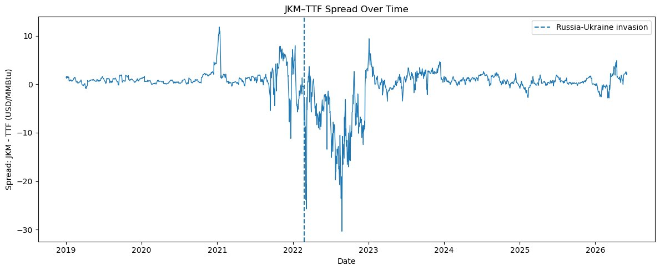
Figure 1. JKM–TTF spread (USD/MMBtu), 2019–2026. Dashed line = Russia–Ukraine invasion (Feb 2022).
Figure 2 shows the forward 1-day spread change (the model target). Volatility increased dramatically around the 2022 regime break and has since returned closer to pre-war levels.

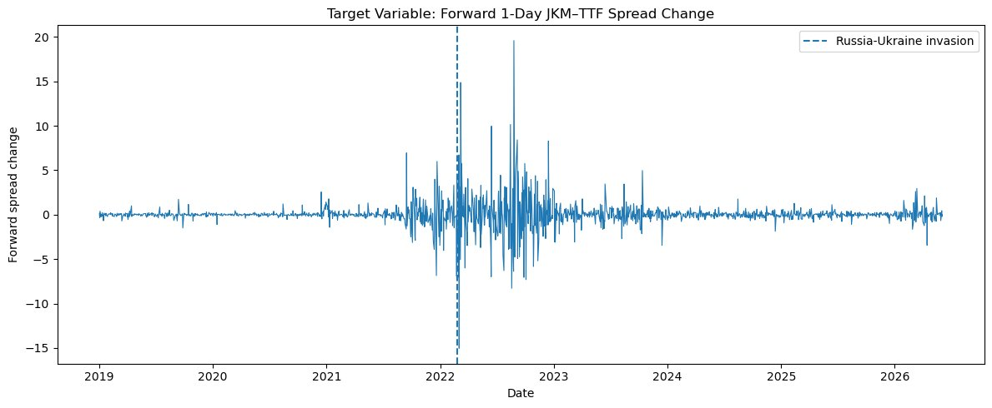
Figure 2. Forward 1-day JKM–TTF spread change (target variable), 2019–2026.

2. Scale Disparities & Missing Data

2.1 Missing Value Audit
After alignment, a systematic audit identifies three distinct causes of missingness. Figure 3 shows the missing-value count by column across the full feature matrix (1,792 business days):

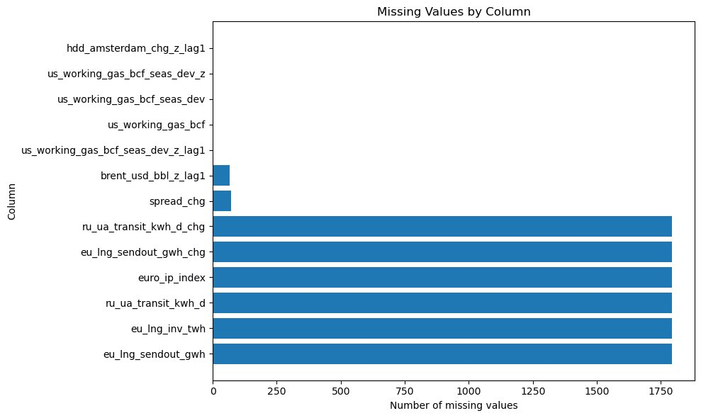
Figure 3. Missing values by column. Six series have 1,792 missing observations due to coverage gaps (see Table 3).

Cause | Affected Series | Missing Obs. | Treatment
Weekend / holiday gaps | All market prices, HDD, GPR | ~0 after ffill | Forward-fill ≤ 2 days
Series coverage gap | eu_lng_sendout_gwh, eu_lng_inv_twh, ru_ua_transit_kwh_d, euro_ip_index | 1,792 each | Retain as NaN; exclude from model specs requiring these features
Structural zero (pipeline ceased) | ru_ua_transit_kwh_d after Jan 2024 | — | Explicitly coded as 0, not NaN
End-of-sample publication lag | eu_storage_pct (T+1), HDD (T+5) | 1–5 | Leave as NaN; prior value used in real-time
First-difference initialisation | spread_chg, brent_usd_bbl_z_lag1 | 67–72 | Drop rows where target NaN; otherwise retain
Table 3. Missing value typology and treatment.

2.2 Anomaly Detection
Price spikes during the 2021–22 energy crisis are genuine market observations and are retained. To distinguish real extremes from ingestion artefacts, any single-day log-return exceeding ±50% triggers a manual inspection flag. No such violations were found across the 2019–2026 sample.
price_cols = ['hh_fut_usd_mmbtu','ttf_usd_mmbtu','jkm_usd_mmbtu','brent_usd_bbl']
flags = (np.log(feat[price_cols]).diff().abs() > 0.50).any(axis=1)
# Result: 0 flagged dates

2.3 Deseasonalisation of Storage Variables
EU gas storage (% full) exhibits a strong annual cycle — Figure 4 shows the raw series, and Figure 5 shows the cross-year seasonality pattern. Raw levels are not directly comparable across months. The deviation from the rolling 5-year same-day-of-year mean is computed instead:

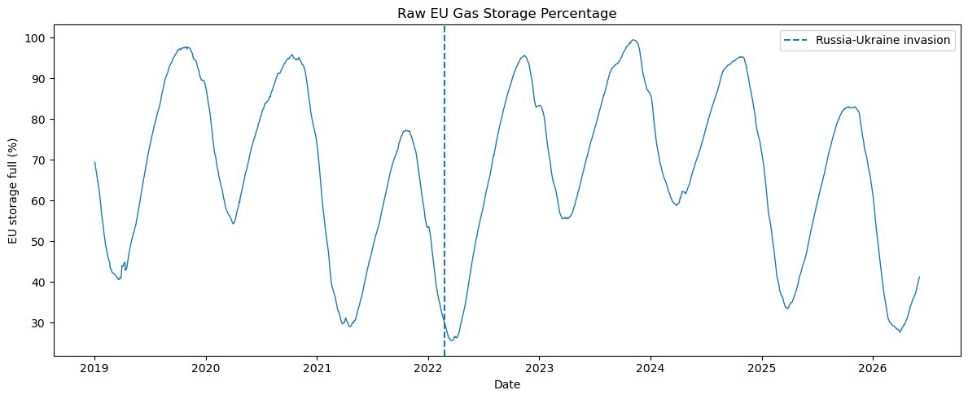
Figure 4. Raw EU gas storage (% full), 2019–2026. The seasonal cycle dominates the level series.

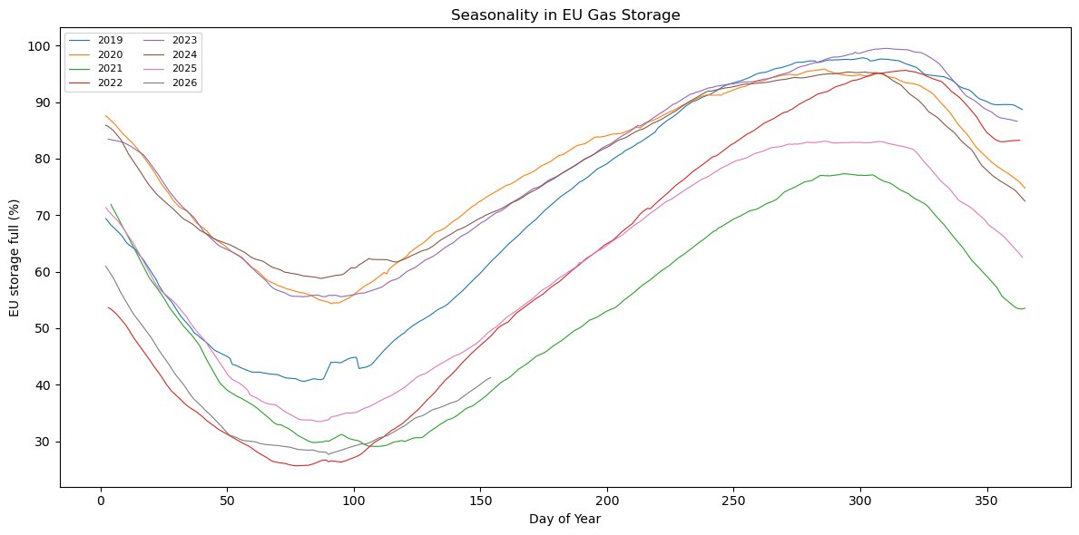
Figure 5. EU gas storage by year overlaid on day-of-year axis. 2022 (red) broke sharply below the seasonal norm.

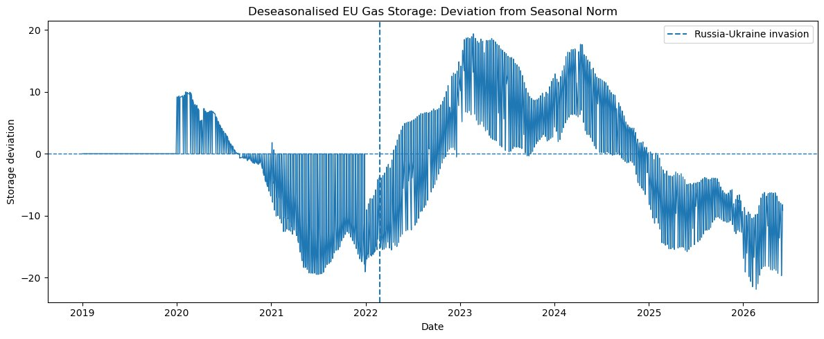
Figure 6. Deseasonalised EU storage (deviation from rolling 5-year seasonal mean). Post-2022 recovery is clearly visible.

def deseasonalise(df, col):
doy = df.index.dayofyear
seas_mean = df[col].groupby(doy).transform(
lambda x: x.rolling(5, min_periods=1).mean())
df[f'{col}_seas_dev'] = df[col] - seas_mean
return df
feat = deseasonalise(feat, 'eu_storage_pct')
feat = deseasonalise(feat, 'us_working_gas_bcf')

2.4 Variable Classification & Scaling
Variables fall into three scaling categories:

Category | Variables | Method | Rationale
Unbounded index / flow | GPR, GPRT, GPRA, EPU, INDPRO, US storage BCF | Z-score | Removes level differences across indices with different base periods
Bounded percentage (deseasonalised) | eu_storage_pct_seas_dev, us_working_gas_bcf_seas_dev | Z-score of deviation | Seasonal deviation is the economically relevant signal
Target spread | spread_usd_mmbtu, target_fwd_spread_chg | Not standardised | Preserves USD/MMBtu interpretability
Weather | HDD Amsterdam, Chicago, Beijing | Daily change + Z-score | Isolates demand anomalies from seasonal cycle
Oil price | Brent USD/bbl | Z-score of level | Stationarity and cross-variable comparability
Table 4. Variable classification and scaling decisions.

Figures 7 and 8 illustrate the before/after effect of Z-score scaling on Brent crude oil. The Z-scored series (Figure 8) centres around zero with unit variance, making it directly comparable to other standardised features.

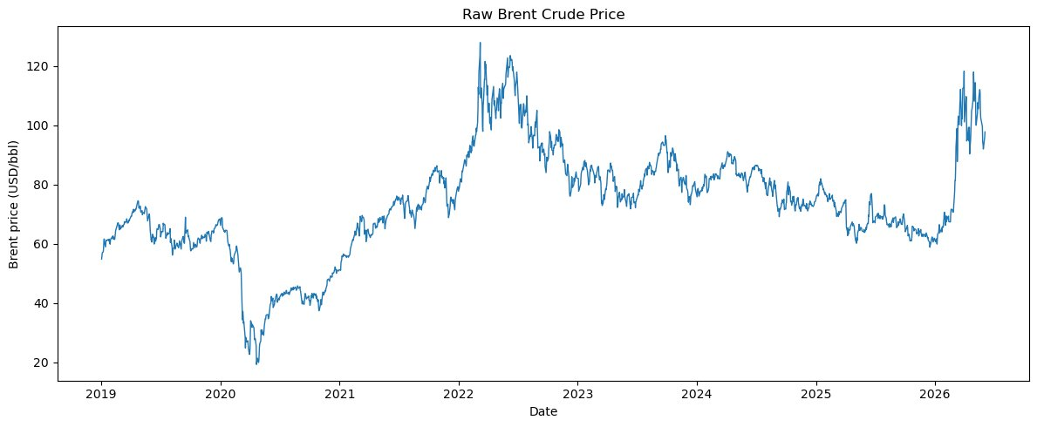
Figure 7. Raw Brent crude price (USD/bbl), 2019–2026. COVID-19 demand collapse (2020) and Russia–Ukraine supply shock (2022) are clearly visible.

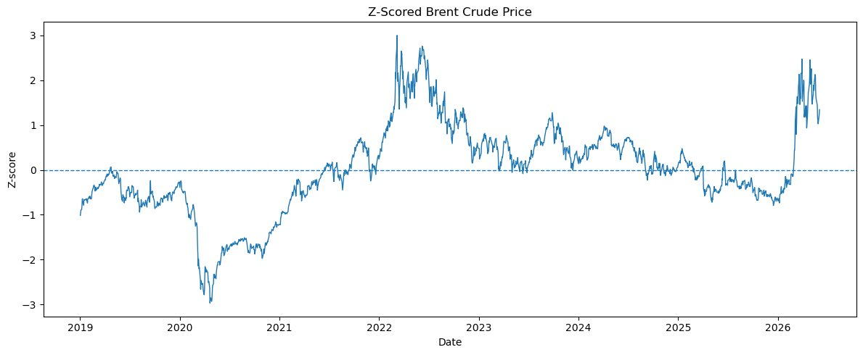
Figure 8. Z-scored Brent crude price. The 2022 spike reaches approximately +3 standard deviations above the 2019–2026 mean.

2.5 Train/Test Split & Scaler Discipline
Z-score parameters are estimated on the training set only and applied to the test set, preventing data leakage. The split is strictly time-ordered:
split_date = '2023-01-01'
train = feat[feat.index < split_date]
test = feat[feat.index >= split_date]
scaler = StandardScaler()
train[z_cols] = scaler.fit_transform(train[z_cols]) # fit on train only
test[z_cols] = scaler.transform(test[z_cols]) # apply same params

2.6 Feature Correlation Structure
Figure 9 shows the Pearson correlation matrix of the four lagged Z-scored features used in the baseline model. EU and US storage deviations are moderately positively correlated (~0.6), reflecting global demand co-movement. HDD Amsterdam change is orthogonal to the storage levels, supporting its inclusion as an independent weather signal.

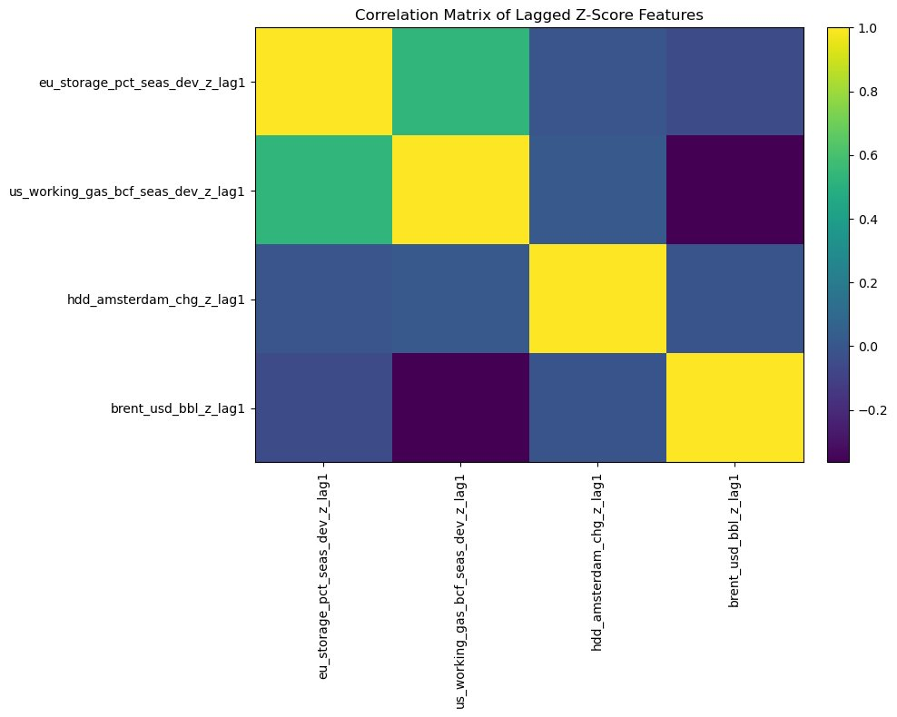
Figure 9. Correlation matrix of lagged Z-score features (lag1). EU and US storage are correlated; HDD and Brent are relatively independent.

2.7 Feature Matrix Integrity Checks
Check | Requirement | Result
R2 | publish_date column present for point-in-time correctness | ✅ Passed
R3 | Lagged feature columns present (no same-day look-ahead) | ✅ Passed — 4 lag columns
R4 | Seasonal deviation columns present for storage variables | ✅ Passed
R5 | Z-score standardised columns present | ✅ Passed
Shape | Feature matrix dimensions | 1,792 rows × 34 columns
Date range | Coverage | 2019-01-02 → 2026-06-05
Table 5. Feature matrix integrity checks. Full output saved as feature_matrix.csv.

Note: Six series with 1,792 missing observations (eu_lng_sendout_gwh, eu_lng_inv_twh, ru_ua_transit_kwh_d, euro_ip_index and their derived columns) are excluded from model specifications in Milestone 3. Their absence is consistent with the coverage caveat noted in Milestone 1.

