**Holloway Prize 2012 - Innovation to Market Competition**

**First Round Submission: Ozel** *(Turkish for private)*

[agk23@wildcats.unh.edu](mailto:agk23@wildcats.unh.edu) | [bsq4@wildcats.unh.edu](mailto:bsq4@wildcats.unh.edu) | [ken.graf@cs.unh.edu](mailto:ken.graf@cs.unh.edu)

1. What is the envisioned product or service and what does it do? (Emphasize benefits to targeted customers.)

Personal secrets are hard to maintain in a shared community like the Internet. Ozel provides for confidential storage of data using public resources without requiring trust. Ozel uses multiple storage providers and is designed to allow providers to fail, disclose or destroy the data provided them without disclosing any of the user’s original data.

1. How is your product or service unique and/or innovative? (Compare to competitive and substitute products.)

Unlike traditional cloud backup storage (Mozy, Dropbox, iCloud, OpenDrive) Ozel uses multiple providers and relies on no single provider to be available, reliable or secure. Ozel: 1) Secures the data without requiring the user to manage encryption keys. 2) Provides failure recovery using less storage resource than a full backup. 3) Leverages the scale and efficiencies of commodity Internet storage. 4) Prevents the disclosure of data to anyone but the actual data owner.

1. How might your product or service contribute to a more sustainable economy, a more sustainable environment or otherwise contribute to society?

For a consumer, the need to secure personal data will be made more evident as time goes on. Identity theft is on the rise, and malware is becoming more and more sophisticated.

For businesses, improved vigilance is needed to keep customer data safe. A recent news article from leading malware research firm FireEye warns that as much as 95% of business will be unable to defend against upcoming malware onslaught. Our product will give business a smaller, more mobile and manageable footprint of data to secure. Allowing offline storage of encrypted data in the cloud will minimize the impact caused by advance persistence threats (APT) by limiting the amount of data that an attacker can exfiltrate. Ultimately this will lead to more stable business, and less chaos caused by hackers.

1. What is the underlying technology for your envisioned product or service and how does it work? How is this technology or service unique/innovative?

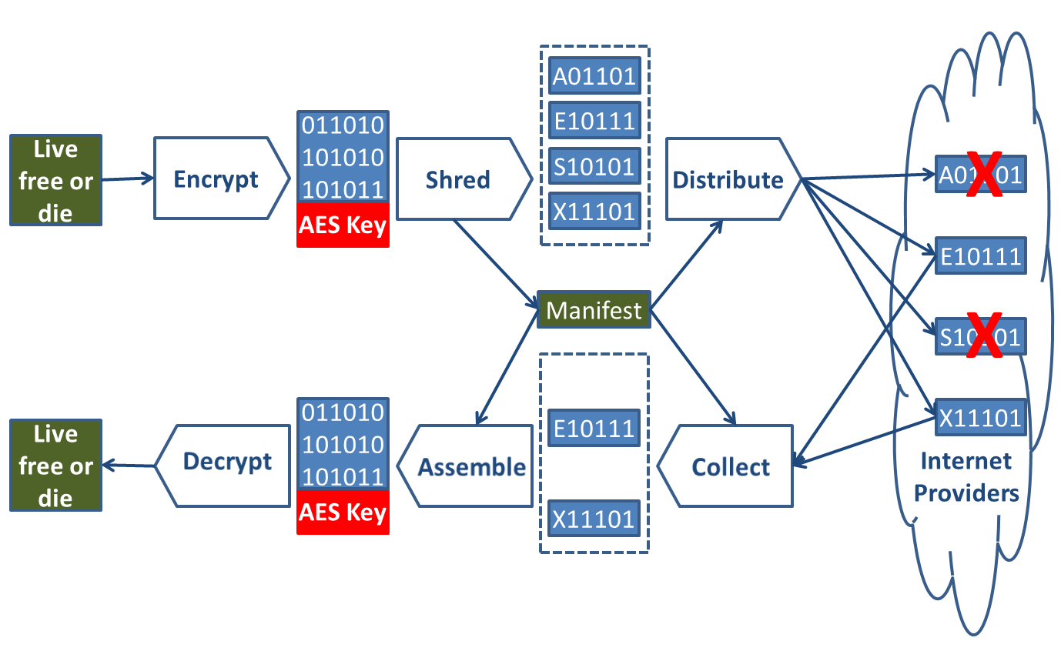 Ozel uses established mathematics—Galois fields, Vandermonde matrices and AES encryption—to shred and distribute data and keys into a set of fragments such that only a random subset of the original fragments is needed to reconstruct the data. The fragmentation is combined with the abstract nature of the Internet to securely scatter the fragments to the four corners of world. Ozel’s innovation is the reconstruction of the fragments based solely on the user controlled manifest.

1. What is the likely intellectual property (IP) protection for your technology/innovation? Who owns (if applicable) the current IP associated with the technology? If your technology is not patentable, how do you propose to protect your product or service from copycats?

We believe the process for managing the distribution, collection and assembly of the fragments across multiple providers using a user controlled manifest is a patentable utility process.

1. What is the current stage of your product/service and what is your plan for making your product/service ready for sale? (Provide estimate of funds and/or hours expended to date and estimated funds for next steps.)

**Current state:** Feasibility research is complete (800 hours) and a limited functionality prototype is in development (200 hours).

**Planned effort:** Initial release development effort (1600 hours), development of product Web site and marketing materials (400 hours).

1. Who are the first customers targeted for your product or service and what are they like? Did you talk to any prospective customers? What did they say about your product/innovation?

The first customers targeted for this service are small, private vendors with sensitive information. For example, we are looking at lawyers, accountants and doctors that are privately owned. They have client information that needs to remain private but it may make their jobs easier if they can reach documents from various access points. Ozel will help by making standard cloud storage much more secure. Limited discovery discussions showed interest, but fragmentation approach requires validation.

1. How much are your potential customers willing to pay for your product/service?

Ozel will embrace a “freeminum” business model. Providing a limited function version for free and an advanced version for personal use at a discretionary one-time purchase price point of ($25-$50). Additional features will be available for corporate customers: support for Hadoop (HDFS), larger file sizes, compression, larger maximum fragments, stronger keys/encryption, encrypted and password based manifests, role based access control and manifest backup.

1. What is the estimated size (addressable market) of the initial customer group (market segment)?

The customer group we are looking at for using our product starts with Internet users who are safety-conscious. Information security is very important to a large number of users and these people are using free programs such as TOR (around 65 thousand users) and Backtrack (around 200 thousand downloads). These security-focused people will then tell professionals like doctors, lawyers and accountants who have legal obligations to maintain the privacy of the client data they collect. In the United States alone, there are over two million private doctors and with similar numbers for privately owned lawyers and accountants, we plan to attract at least 50,000 customers over the first five years of launching Ozel.

1. Is there a clear window of opportunity for the product or service? What are the competitive products or services currently on the market? Why will prospective customers buy your product or service over rivals?

Ozel uses multiple providers and relies on no single provider to be available, reliable or secure. Traditional cloud backup storage (Mozy, Dropbox, iCloud, OpenDrive) providers are unlikely to offer solutions that drive customers to other providers.

1. What are the barriers or challenges associate with entering your initial market?

Creating an effective advertising campaign based on customer referrals or word of mouth.

1. What is the competitive advantage potential for your product or service? How sustainable is your potential competitive advantage?

First mover status is significant, as once users deploy new functionality they are unlikely to replace it with an equivalent product.