

*Data Privacy in the Public Cloud*

*Championship Round Submission to*

**Paul J. Holloway Prize 2012**

Innovation to Market Competition

**Alex MacPherson**

UNH Senior, IT Studies

[agk23@wildcats.unh.edu](mailto:agk23@wildcats.unh.edu)

**Bryan Bickford**

UNH Junior, Interdisciplinary Math/Computer Science

[bsq4@wildcats.unh.edu](mailto:bsq4@wildcats.unh.edu)

**Julia Irwin**

UNH Senior, Communication and IT Studies

[jmx93@wildcats.unh.edu](mailto:jmx93@wildcats.unh.edu)

**Kenneth Graf**

Enterprise Architect, Liberty Mutual

Lecturer and Doctoral Student, Computer Science

[ken.graf@cs.unh.edu](mailto:ken.graf@cs.unh.edu)

**May 1, 2012**

**OZEL**

*Data Privacy in the Public Cloud*

Welcome to the new age of private data storage. Advanced persistent threats are on the rise — the kind of hack where a team of hackers surgically strike an organization for the purpose of exfiltrating customer data and/or trade secrets. Ozel is a unique solution to the age old problem of having too much data to secure. Ozel is a software solution for leveraging cloud storage and state of the art encryption to make managing a user’s data footprint easier and safer than ever before. Any data that a user uploads will be split into small pieces with forward error correction built in, Ozel will then encrypt the fragments of data with state-of-the-art encryption, and then store the encrypted fragments onto multiple cloud storage providers. The end result of this process is that only the user knows the locations of the fragments. In addition, because of the way that we leverage multiple service providers along with the error correction code, a number of fragments could be lost, stolen, or even disclosed without compromising the overall integrity of the data. On top of all this, if a cloud provider gets hacked and loses any data, Ozel’s encryption and fragmentation process prevent it from being a disclosure of the user’s data.

1. What is the envisioned product or service and what does it do? (Emphasize benefits to targeted customers.)

Personal secrets are hard to maintain in a shared community like the Internet. Ozel provides for confidential storage of data using public resources without requiring trust. Ozel uses multiple storage providers and is designed to allow providers to fail, disclose or destroy the data provided them without disclosing any of the user’s original data.

1. How is your product or service unique and/or innovative? (Compare to competitive and substitute products.)

Unlike traditional cloud backup storage (Mozy, Dropbox, iCloud, OpenDrive) Ozel uses multiple providers and relies on no single provider to be available, reliable or secure. Ozel: 1) Secures the data without requiring the user to manage encryption keys. 2) Provides failure recovery using less storage resource than a full backup. 3) Leverages the scale and efficiencies of commodity Internet storage. 4) Prevents the disclosure of data to anyone but the actual data owner.

1. How might your product or service contribute to a more sustainable economy, a more sustainable environment or otherwise contribute to society?

For a consumer, the need to secure personal data will be made more evident as time goes on. Identity theft is on the rise, and malware is becoming more and more sophisticated.

For businesses, improved vigilance is needed to keep customer data safe. A recent news article from leading malware research firm FireEye warns that as much as 95% of business will be unable to defend against upcoming malware onslaught. Our product will give business a smaller, more mobile and manageable footprint of data to secure. Allowing offline storage of encrypted data in the cloud will minimize the impact caused by advance persistence threats (APT) by limiting data exfilration that an attacker can accomplish. Ultimately this will lead to more stable business, and less chaos caused by hackers.

1. What is the underlying technology for your envisioned product or service and how does it work? How is this technology or service unique/innovative?

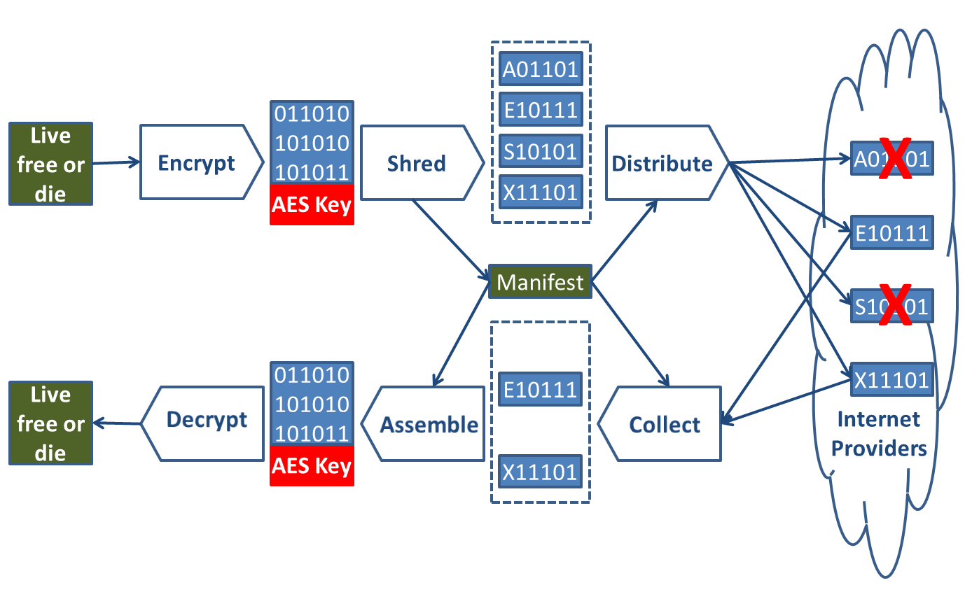

Ozel uses established mathematics—Galois fields, Vandermonde matrices and AES encryption—to shred and distribute data and keys into a set of fragments such that only a random subset of the original fragments is needed to reconstruct the data. The fragmentation is combined with the abstract nature of the Internet to securely scatter the fragments to the four corners of world. Ozel’s innovation is the reconstruction of the fragments based solely on the user controlled manifest.

1. What is the likely intellectual property (IP) protection for your technology/innovation? Who owns (if applicable) the current IP associated with the technology? If your technology is not patentable, how do you propose to protect your product or service from copycats?

We believe the process for managing the distribution, collection and assembly of the fragments across multiple providers using a user controlled manifest is a patentable utility process.

1. What is the current stage of your product/service and what is your plan for making your product/service ready for sale? (Provide estimate of funds and/or hours expended to date and estimated funds for next steps.)

**Current state:** Feasibility research is complete (800 hours) and a limited functionality prototype is in development (200 hours).

**Planned effort:** Initial release development effort (1600 hours), development of product Web site and marketing materials (400 hours).

1. Who are the first customers targeted for your product or service and what are they like? Did you talk to any prospective customers? What did they say about your product/innovation?

The first customers targeted for this service are small, private vendors with sensitive information. For example, we are looking at lawyers, accountants and doctors that are privately owned. They have client information that needs to remain private but it may make their jobs easier if they can reach documents from various access points. Ozel will help by making standard cloud storage much more secure. Limited discovery discussions showed interest, however, we need to ensure customer confidence in the fragmentation process.

1. How much are your potential customers willing to pay for your product/service?

Ozel will embrace a “freemium” business model. Providing a limited function version for free and an advanced version for personal use at a discretionary one-time purchase price point of $10-$15. Additional features will be available for corporate customers ($600): support for Hadoop (HDFS), larger file sizes, compression, larger maximum fragments, stronger keys/encryption, encrypted and password based manifests, role based access control and manifest backup.

1. What is the estimated size (addressable market) of the initial customer group (market segment)?

The customer group we are targeting for using our product starts with Internet users who are safety-conscious. Information security is very important to a large number of users and these people are using free programs such as TOR (around 65,000 users) and Backtrack (around 200,000 downloads). These security-focused people will recommend Ozel to professionals such as doctors, lawyers and accountants who have legal obligations to maintain the privacy of the client data they collect. In the United States alone, there are over two million private doctors and with similar numbers for privately owned lawyers and accountants, we plan to attract at least 20,000 corporate customers over the first five years of launching Ozel.

1. Is there a clear window of opportunity for the product or service? What are the competitive products or services currently on the market? Why will prospective customers buy your product or service over rivals?

Ozel uses multiple providers and relies on no single provider to be available, reliable or secure. Traditional cloud backup storage (Mozy, Dropbox, iCloud, OpenDrive) providers are unlikely to offer solutions that drive customers to other providers.

1. What are the barriers or challenges associate with entering your initial market?

The initial barriers facing the growth of Ozel involve spreading the word of a product that can solve a growing problem in information security. Creating an effective advertising campaign as well as facilitating the spread of customer to customer referrals is crucial to the development of a loyal customer base. Please see our Marketing Strategy for a more in depth discussion.

1. What is the competitive advantage potential for your product or service? How sustainable is your potential competitive advantage?

First mover status is significant, as once users deploy new functionality they are unlikely to replace it with an equivalent product.

1. How much will it cost to produce a unit of product/service for sale? (Please describe in detail your expected cost of goods sold by the 3rd year.)

As a software product using a delivery model based on Internet downloads, the cost of goods is different from traditional products. The majority of expenses come from programmer time. Other upfront costs include an advertising campaign and office space/supplies. These expenses are fixed and not contingent on the number of units sold.

1. How do you plan to sell your product/service to reach your 3 year goals? (Please attach a monthly cash-flow up until you expect to become cash-flow positive.)

Ozel expects to leverage social media to identify and communicate with security professionals to influence recommendations to target professionals. Ozel has 3 distinct product phases.

Phase 1: Freemium version

Provides the basic shred, distribute, collect assemble functions. While free this version needs to be a complete and solid implementation. The version provides the basis for demonstrations, papers and evaluations. The product version is how the customer will evaluate the product. A limited set of storage providers will be available.

Phase 2: Professional version

This version is the upsell to the individual. Adding additional features: More providers, advanced content browser, storage redundancy, caching for improved download speeds, encryption algorithm selection, multiple address (location) retrieval, Secured manifest files.

Phase 3: Corporate version

This version provides team oriented features above what the professional version provides. Role based access controls to allow multiple people access to content, manifest sharing and backups, content ad manifest change notifications.

We are targeting 1,000 professional’s referring Ozel by the end of the first year of operation. The staffing level projected is based on achieving the Professional units’ ramp. Given targets are achieved we are expecting the Corporate version to begin delivery in the second year.

1. What are your expected sales and expenses for the next 3 years? (Clearly state your assumptions behind your estimates and provide a simple 3-5 year Profit and Loss Pro forma Income Statement.)

See attached pro forma statement.

1. How do you plan to finance the start-up and growth of your business? What are your financing needs?

To meet initial staffing operational expenses an angel investment of $700K is required in exchange for a 25% equity stake. Additionally to reduce direct staff compensation 30% equity will be allocated for staff compensation. We are setting the initial pre-money valuation at $2.1M, based in part on expected revenue. We expect to be profitable on a monthly basis within 9 months of prototype launch.

1. What could go wrong? What are the risks involved for potential investors or other financial backers?

While we a have taken a conservative approach to the unit and revenue estimates they are projections, we currently have no customer under contract.

Any patent protection possible for Ozel’s distributed approach will not be provided by the US patent office until 2013 at the earliest, if it is ever provided.

A larger existing organization may decide replicating our design is more advantageous then licensing the technology from us.

|  |  |  |  |  |  |  |  |  |  |  |  |  |  |  |  |
| --- | --- | --- | --- | --- | --- | --- | --- | --- | --- | --- | --- | --- | --- | --- | --- |
| **1st Year** | | | | | | | | | | | | | | | |
| **Revenue ($K)** | | | | | | | | | | | | | | | |
|  | | $/Unit | Units | | | | | | | | | | | | |
| Standard | | $0 | 0 | | 0 | 0 | 0 | 200 | 1,566 | 2,521 | 5,420 | 8,900 | 13,100 | 16,300 | 24,200 |
| Sync | | $10 | 0 | | 0 | 0 | 0 | 0 | 310 | 653 | 1,317 | 2,185 | 3,094 | 4,098 | 5,234 |
| Mobile | | $5 | 0 | | 0 | 0 | 0 | 0 | 155 | 431 | 693 | 1,090 | 1,557 | 2,051 | 2,612 |
| Corporate | | $600 | 0 | | 0 | 0 | 0 | 0 | 0 | 13 | 21 | 43 | 66 | 91 | 142 |
|  | | Total ($K) | **$0** | | **$0** | **$0** | **$0** | **$0** | **$4** | **$16** | **$29** | **$53** | **$78** | **$106** | **$151** |
|  | |  |  | |  |  |  |  |  |  |  |  |  |  |  |
| **Expenses** | | | | | | | | | | | | | | | |
| Staffing | | | | | | | | | | | | | | | |
| Description | | Ave. Month Expense($K) | June'12 | | July'12 | Aug"12 | Sept'12 | Oct'12 | Nov'12 | Dec'12 | Jan'13 | Feb'13 | Mar'13 | Apr'13 | May'13 |
| Development Team | | $10 | 2 | | 3 | 3 | 3 | 3 | 3 | 3 | 3 | 3 | 4 | 4 | 4 |
| Sales Team | | $6.5 | 1 | | 1 | 1 | 2 | 2 | 2 | 2 | 3 | 3 | 3 | 4 | 4 |
| QA/Support Team | | $7.5 | 2 | | 2 | 2 | 2 | 2 | 3 | 3 | 3 | 3 | 3 | 4 | 4 |
| Security Consultants | | $30 | 0 | | 0 | 1 | 0 | 0 | 1 | 0 | 0 | 1 | 0 | 0 | 1 |
| Services | | $4 | 0.5 | | 0.5 | 0.5 | 0.5 | 0.5 | 0.5 | 0.5 | 1 | 1 | 1 | 1 | 1 |
|  | | Total ($K) | **$44** | | **$54** | **$84** | **$60** | **$60** | **$98** | **$68** | **$76** | **$106** | **$86** | **$100** | **$130** |
| Selling, General & Administrative Expense (SG&A) | | | | | | | | | | | | | | | |
| Office Space |  | | | 1.0 | 1.0 | 1.0 | 1.0 | 1.0 | 1.0 | 3.0 | 3.0 | 3.0 | 3.0 | 3.0 | 3.0 |
| Web Site/Internet |  | | | 0.2 | 0.2 | 0.2 | 0.2 | 0.2 | 0.2 | 0.2 | 0.2 | 0.2 | 0.2 | 0.2 | 0.2 |
| Hardware |  | | | 8.0 | 0.0 | 6.0 | 0.0 | 0.0 | 4.0 | 0.0 | 4.0 | 0.0 | 2.0 | 0.0 | 0.0 |
| Software licenses |  | | | 1.0 | 0.0 | 1.0 | 0.0 | 0.0 | 0.6 | 0.0 | 0.6 | 0.0 | 0.3 | 0.0 | 0.0 |
| Conferences |  | | | 0.0 | 0.0 | 2.0 | 2.0 | 4.0 | 4.0 | 4.0 | 4.0 | 6.0 | 6.0 | 8.0 | 8.0 |
| Office Supplies |  | | | 0.4 | 0.2 | 0.2 | 0.2 | 0.2 | 0.2 | 0.2 | 0.2 | 0.2 | 0.2 | 0.2 | 0.2 |
| Referral/Card fees |  | | | 0.0 | 0.0 | 0.0 | 0.0 | 0.0 | 0.0 | 0.5 | 0.9 | 1.6 | 2.3 | 3.2 | 4.5 |
|  | Total SG&A ($K) | | | **$10.6** | **$1.4** | **$10.4** | **$3.4** | **$5.4** | **$10.0** | **$7.9** | **$12.9** | **$11.0** | **$14.0** | **$14.6** | **$15.9** |
|  |  | | |  |  |  |  |  |  |  |  |  |  |  |  |
| **Income** | | | | | | | | | | | | | | | |
| Net Income ($K) | |  | $-54 | | $-55 | $-94 | $-63 | $-65 | $-104 | $-59 | $-60 | $-64 | $-22 | $-9 | $5 |
| Cumulative income ($K) | | | $-54 | | $-109 | $-203 | $-266 | $-332 | $-435 | $-494 | $-554 | $-618 | $-639 | $-648 | $-644 |

|  |  |  |  |  |  |  |
| --- | --- | --- | --- | --- | --- | --- |
| **5 year Pro-forma** | | | | | | |
| **Revenue ($K)** | | | | | | |
|  |  | 2012* | 2013 | 2014 | 2015 | 2016 |
| Standard |  | 0 | 0 | 0 | 0 | 0 |
| Sync ($10/unit) |  | 10 | 236 | 4688 | 10389 | 16451 |
| Mobile ($5/unit) |  | 3 | 118 | 1840 | 5190 | 8222 |
| Corporate ($600/unit) |  | 8 | 2231 | 6819 | 12455 | 19739 |
|  | Total ($K) | **$20** | **$2,585** | **$13,347** | **$28,034** | **$44,412** |
|  |  |  |  |  |  |  |
| **Expenses** | | | | | | |
| Staffing | | | | | | |
|  | Annual Expense($K) | 2012* | 2013 | 2014 | 2015 | 2016 |
| Development Team | $120 | 1.5 | 6.0 | 14.0 | 28.0 | 44.0 |
| Sales Team | $78 | 1.0 | 3.0 | 7.0 | 14.0 | 22.0 |
| QA/Support Team | $90 | 1.5 | 3.0 | 7.0 | 11.0 | 15.0 |
| Security Consultants | $360 | 0.2 | 1.0 | 2.0 | 4.0 | 8.0 |
| Services | $48 | 0.3 | 1.0 | 2.0 | 3.0 | 8.0 |
|  | Total ($K) | **$465** | **$1,632** | **$3,672** | **$7,026** | **$11,610** |
| Selling, General & Administrative Expense (SG&A) | | | | | | |
| Office Space |  | 9.0 | 14.0 | 32.0 | 60.0 | 97.0 |
| Web Site/Internet |  | 1.4 | 1.4 | 3.2 | 6.0 | 9.7 |
| Hardware |  | 18.0 | 28.0 | 64.0 | 120.0 | 194.0 |
| Software licenses |  | 2.6 | 11.2 | 25.6 | 48.0 | 77.6 |
| Conferences |  | 16.0 | 156.0 | 201.0 | 321.0 | 410.0 |
| Office Supplies |  | 1.6 | 8.0 | 18.1 | 34.6 | 57.2 |
| Referral/Card fees |  | 0.5 | 77.6 | 400.4 | 841.0 | 1,332.4 |
|  | Total SG&A ($K) | **$49.1** | **$296.2** | **$744.3** | **$1,430.6** | **$2,177.9** |
|  |  |  |  |  |  |  |
| **Income** | | | | | | |
| Net Income ($K) |  | $-494 | $657 | $8,931 | $19,577 | $30,624 |
| Cumulative income ($K) |  | $-494 | $163 | $9,094 | $28,671 | $59,295 |

*Indicates half year of revenue