Authentication: SSH

## Summary

This lab will create a cloud enabled server running SSH.

## Tools/Resources

AWS account

## Walkthrough

1. Create a launch template

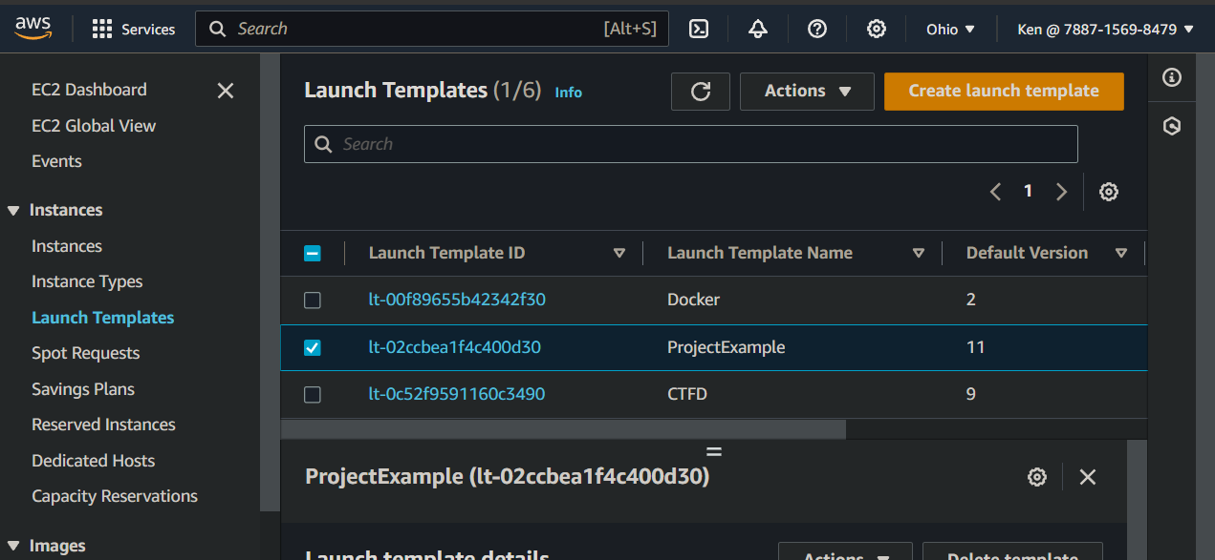

* 1. Set template name
  2. Image: “Quick Start” pick “Amazon Linux”

* 1. Set size to t2.micro

* 1. Set keypair (create if needed)
  2. Network setting: 1) Pick a default subnet 2) Create a security group that allows all traffic from 132.177.0.0/16

* 1. Click Advanced details. Add the following code as “User data”, all the other defaults are fine.

#!/bin/bash

yum -y update

# Setup web server

yum install -y nginx

/bin/systemctl start nginx.service

# Create user

useradd --password $(openssl passwd passwordsAREwrong) kmh722

cd /home/kmh722/

mkdir .ssh

chown kmh722:kmh722 .ssh

cat <<EOT >> .ssh/authorized_keys

ssh-rsa  kmh722@unh.edu

EOT

# Allow password logins

sed -i 's/PasswordAuthentication no/PasswordAuthentication yes/g' /etc/ssh/sshd_config

/bin/systemctl restart sshd

* 1. Click “Create Launch Template” then “View Launch Templates”
  2. Select and launch template. In a few moments you will see a new running instance

* 1. View the web page

* 1. Connect with SSH

## **Tasks**

* Create a launch template for an EC2 t2.micro instance running Amazon Linux 2024.
* Expose at least SSH and HTTP ports to the UNH CIDR block.
* Use the following "User Data" to configure ngnix and SSH access using passwords and my public key.  (It is OK, to customize)

"UserData": ""

* Validate that you can connect via SSH and that the default web page is active.

## **Submission**

Post to Canvas your public IP address.  The instance will need to remain running until graded.

## Additional Thoughts

How does the class decode the user-data? echo <user-data-paste> | base64 -d

Is behavior different if the security group allows all traffic instead of just SSH &amd HTTP? Yes, adding all traffic adds ICMP.

Can the Launch Templates be started from a script? Yes, everything in the cloud is based on an API.