Pi Exam

## Summary

This lab is designed to be attacked by hand, rather than require a set of tools. Five common attacks using just a browser.

**Capture screenshots of your successes for submission.**

## Tools/Resources

A browser with inspect capability.

## Walkthrough

1. Home page: <https://pi.kengraf.com>

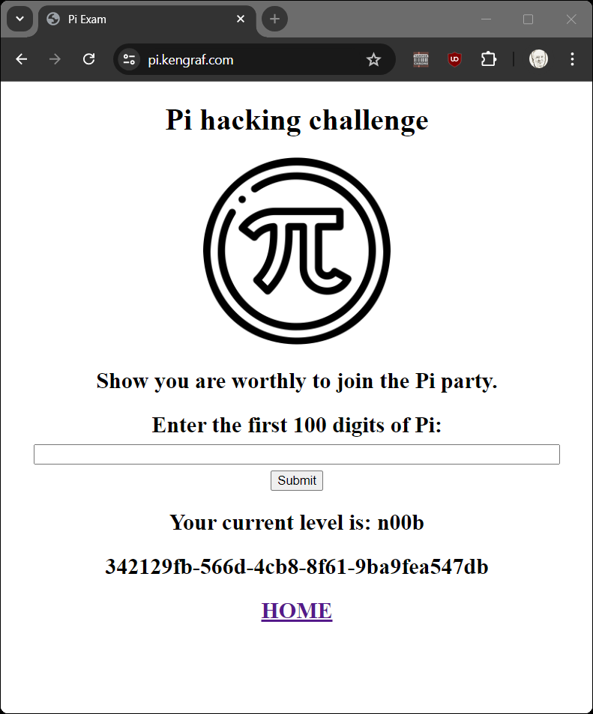

1. Review the source code. Dev can leave interesting comments

1. Get 100 digits from Google

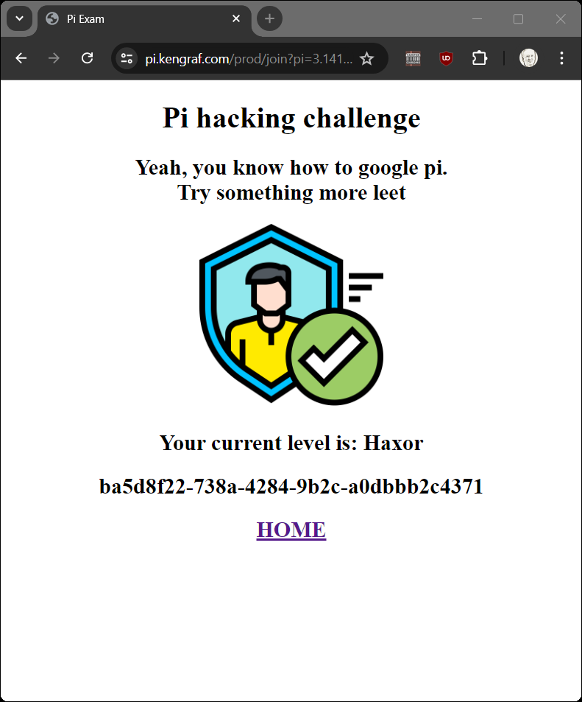

1. Observe in code or the submitted URL the digits parameter. Maybe we don’t need 100 digits

<https://pi.kengraf.com/prod/join?pi=3&digits=1>

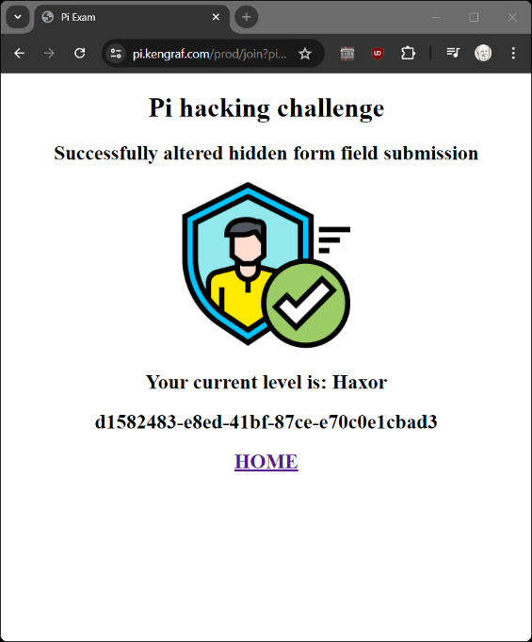

1. The site is looking for a number. Maybe we can add an expression to back the back end code eval to TRUE. This is the basis for SQLi and other forms of injection attacks.

<https://pi.kengraf.com/prod/join?pi=1+or+1%3D%3D1&digits=100>

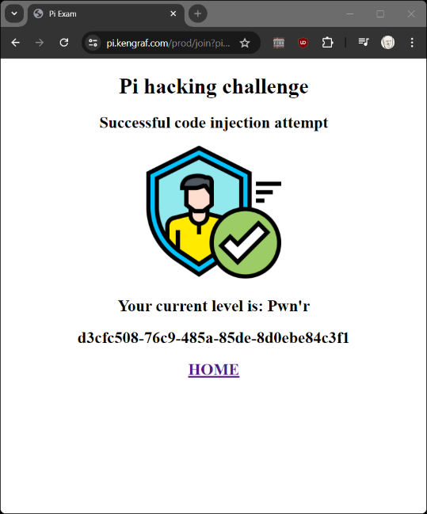

1. Comments in source code refer to an “admin” page we should try that. Real world we would use a tool like dirbuster to automatically guess 100s of common file names

<https://pi.kengraf.com/admin>

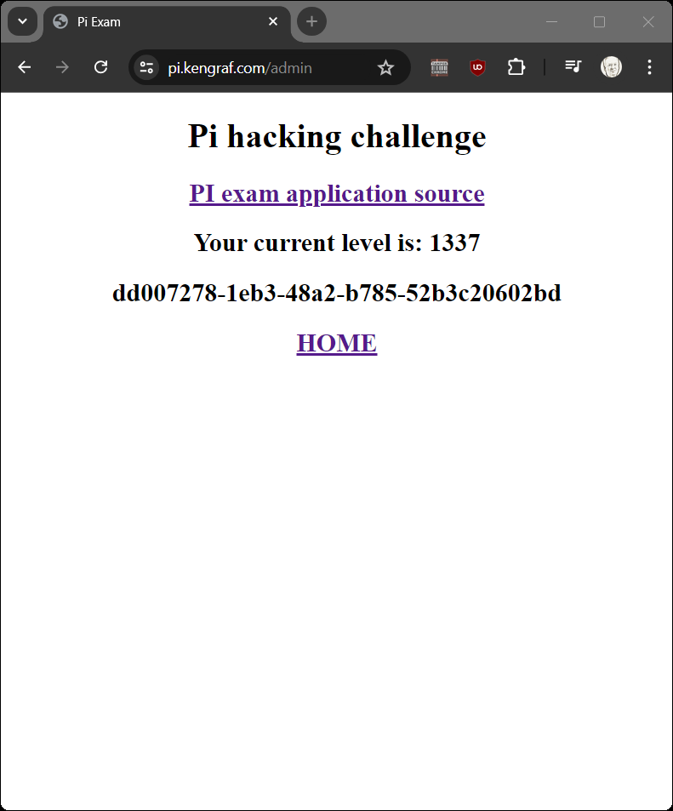

1. Cookies can be manipulated by clients and should not trusted by the application. We have noticed a “level” element has been incrementing as we progressed. Maybe we can just jack it up to 99 and refresh?

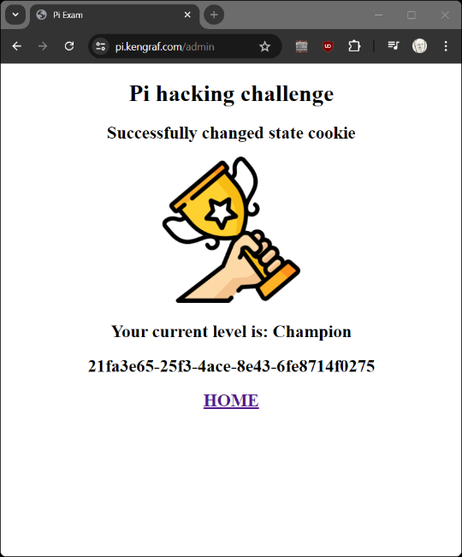

## Submission

Upload to Canvas a docx or pdf containing screenshots showing your (5) successful web submits.

## Additional Thoughts

How does the PI-exam python program support HTTPS?

Is this application vulnerable to OS level attacks?

What is the cost for running this in the cloud?