**NECCDC**

**2014**

**Northeast Collegiate Cyber-Defense**

**Competition Team Packet**

**March 14-16, 2014**

**In Durham, at the University of New Hampshire**



**Table of Contents**

Welcome Letter.......................................................................................................................... 3

Schedule.................................................................................................................................... 4

Travel Information ...................................................................................................................... 5

Driving Directions ................................................................................................................... 5

University of Maine Campus Map ........................................................................................... 6

Hotel Information .................................................................................................................... 7

Competition Overview ................................................................................................................ 8

Team Identification ................................................................................................................. 9

Competition Scenario ............................................................................................................10

Competition Topology............................................................................................................12

Network Description ..............................................................................................................13

CCDC National Competition Rules............................................................................................14

Regional Competition Rules ......................................................................................................19

Scoring Methodology ................................................................................................................20

**Welcome Letter**

Competitors,

On behalf of the University of New Hampshire Department of Computer Science, I would like to welcome you to the seventh Annual Northeast Collegiate Cyber Defense Competition (NECCDC). Cyber security is becoming an ever more important part of our national security efforts and this competition is one of most important events in training our future cyber security experts.

The Department of Computer Science and the University of New Hampshire are excited to be able to host this event. Students who participate in this event uniformly feel that it is a real highlight of their college experience.

We are very grateful to all of our sponsors as well as to The University of Texas at San Antonio (UTSA) for their guidance, event templates and materials. Our staff, volunteers, and sponsors have worked hard to make this an interesting, exciting, and challenging competition. One of the exciting aspects of this competition is that the winner of this contest will receive travel expenses to compete at the National Collegiate Cyber Defense Competition to be held in April 2014 in San Antonio, Texas.

We encourage you to spend some time with members of the other teams to enhance your learning experience. We wish the very best of luck to each of you and your teams! Many thanks to you for participating in this competition.

Kenneth Graf, Associate Director

Department of Computer Science

University of New Hampshire

**Friday – March 14, 2014**

10:00 AM – 11:30 AM Team Registration

11:30 AM – 12:15 PM Opening Announcements and Orientation

12:15 PM – 01:30 PM Lunch

01:30 PM – 07:00 PM **Competition Day 1**

**Saturday – March 15, 2014**

08:15 AM – 08:45 AM Continental Breakfast

08:45 AM – 09:00 AM Announcements

09:00 AM – 07:00 PM **Competition Day 2**

12:00 PM – 01:00 PM Boxed Lunch Available (No break in competition)

07:00 PM – 08:30 PM **Networking Event with Recruiters and Sponsors**

**Sunday – March 16, 2014**

08:15 AM – 08:45 AM Continental Breakfast

08:45 AM – 09:00 AM Announcements

09:00 AM – 12:00 PM **Competition Day 3**

12:00 PM – 01:00 PM Clean Up and Feedback Session

01:00 PM – 03:00 PM Luncheon and Awards Ceremony

The NECCDC is being held in Durham, New Hampshire, at the University of New Hampshire. The building for the event is Kingsbury Hall.

**Directions to University of New Hampshire’s Kingsbury Hall**

**33 Academic Way, Durham, NH 03824**

**UNH is located off NH Route 4**

**From I-95 South (Maine)**, take Exit 5 (in NH) to the Spaulding Turnpike (Route 16N), then take Exit 6W (Route 4 West) towards Durham to the Exit for Route 108. Follow Route 108 until you reach Main Street (intersection where 108 turns East you will stay straight). Refer to Mapquest map below.

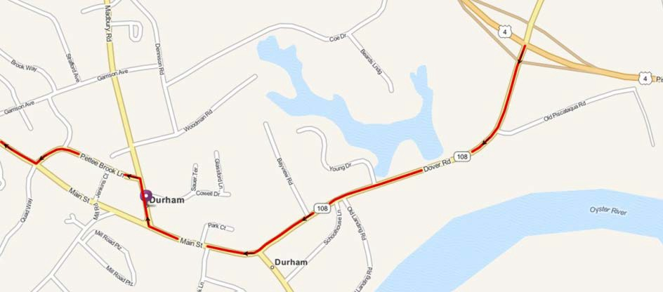

**From I-95 North (Mass.)**, take Exit 4 (in NH) (left hand exit) to the Spaulding Turnpike (Route

16N), then take Exit 6W (Route 4 West) towards Durham to the Exit for Route 108. Same as above.

**From the West**, take Route 101 East to Exit 7 (Route 125 North). Follow Route 125 North to the traffic circle. Take Route 4 East to the Durham Exit (2 miles)(Route 155A). Continue on Main Street until you take a right on College Road.

Additional map/directions can be found at: [http://www.unh.edu/transportation/visitor/directions.htm.](http://www.unh.edu/transportation/visitor/directions.htm)

**University of New Hampshire Campus Map**

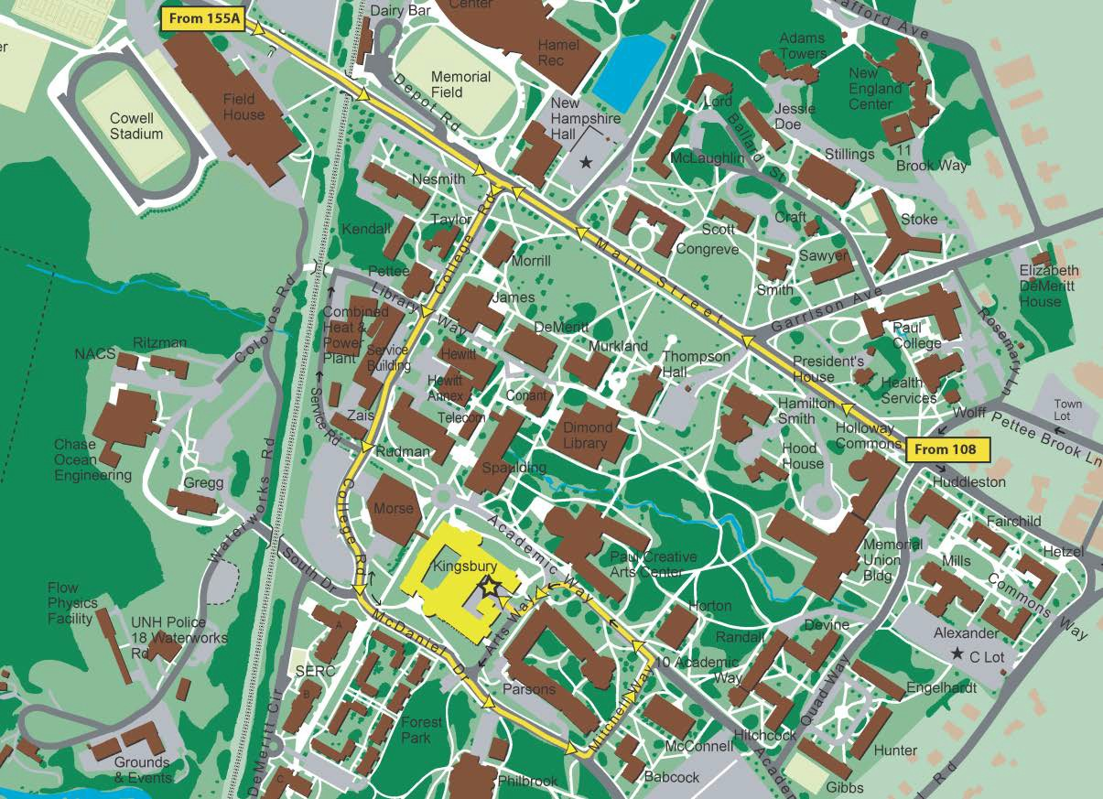

**Hotel Information**

**Below are suggested hotels located less than 10 miles from the University of New Hampshire in Durham, NH.**

Holiday Inn Express Durham

2 Main Street

Durham, NH 03824

(603) 868-1234

Approximately .5 miles from campus

<http://www.ihg.com/holidayinnexpress/hotels/us/en/durham/durnh/hoteldetail>

Homewood Suites Dover

21 Members Way

Dover, NH 03820

Approximately 6 miles from campus

(866) 678-6350

<http://homewoodsuites3.hilton.com/en/hotels/new-hampshire/homewood-suites-by-hilton-dover-PSMDVHW/index.html>

Hampton Inn

9 Hotel Drive

Dover, NH 03820

603-526-5600

Approximately 7 miles from campus

<http://hamptoninn3.hilton.com/en/hotels/new-hampshire/hampton-inn-dover-PSMDOHX/index.html>

Comfort Inn & Suites

10 Hotel Drive

Dover, NH 03820

(603)

Approximately 6.4 miles from campus

<http://www.comfortinndover.com/>

Hampton Inn

99 Durgin Lane

Portsmouth, NH 03801

(603) 431-6111

Approximately 7.6 miles to campus

<http://www.hamptoninnportsmouth.com/>

Residence Inn by Marriot

1 International Drive

Portsmouth, NH 03801

(866) 925-8676

Approximately 8 miles to campus

<http://www.marriott.com/hotels/travel/psmdt-residence-inn-portsmouth-downtown-waterfront/>

Homewood Suites by Hilton

100 Portsmouth Drive

Portsmouth, NH 03801

Approximately 8 miles to campus

<http://homewoodsuites3.hilton.com/en/hotels/new-hampshire/homewood-suites-by-hilton-portsmouth-PSMHWHW/index.html>

The Northeast Collegiate Cyber-Defense Competition (NECCDC) is the regional qualifier for the national Collegiate Cyber-Defense Competition (CCDC). The northeast region represents institutions in the states of New York, Maine, New Hampshire, Vermont, Massachusetts, Rhode Island, and Connecticut.

The NECCDC will select one winner and one alternate to represent the region in the CCDC for

2013. This year’s CCDC is being held in San Antonio, Texas, on April 19-21.

**More information on the CCDC can be found at the CCDC website:**

[**http://www.nationalccdc.org/**](http://www.nationalccdc.org/)

The CCDC represents a collection of defense-only competitions in cyber-security. The competition is designed to test each student team’s ability to secure a networked computer system while maintaining standard business functionality. The teams are expected to manage the computer network, keep it operational, and prevent unauthorized access. Each team will be expected to maintain and provide public services per company policy and mission. Each team will start the competition with a set of identically configured systems.

The objective of the competition is to measure a team’s ability to maintain secure computer network operations in a simulated business environment. This is not just a technical competition, but also one built upon the foundation of business operations, policy, and procedures. A technical success that adversely impacts the business operation will result in a lower score as will a business success which results in security weaknesses.

Student teams will be scored on the basis of their ability to detect and respond to outside threats, including cyber-attacks, while maintaining availability of existing network services such as mail servers and web servers, respond to business requests such as the addition or removal of additional services, and balance security against varying business needs.

**Red Team**

Professional network penetration testers from the security industry. This team actively fills the role of "attacker". Specifically, the Red Team:

• Scans and maps the network of each Blue Team

• Attempts to penetrate the defensive capabilities of each Blue Team network and modify any acquired environment

• Assess the security of each Blue Team network

• Attempts to capture specific files on targeted devices of each Blue Team network

**White Team**

Professionals and representatives from industry who serve as competition judges, room monitors, and security enforcement in the various competition rooms. Judges will assess the competition team’s ability to maintain their network and service availability based upon a business inject and a scoring instrument, delivering inject scenarios, scoring of injects, creating log entries, securing log files, issuing or controlling the timing of injects, etc. Each competing Blue Team will have a White Team member present in their room that will assist judges by observing teams, confirming proper inject completion as well as reported issues.

**Blue Team**

Student team representing a specific academic institution competing in this competition; each team consists of up to 12 competitors. Each competition team may consist of up to eight (8) members chosen from the submitted roster. The remainder of the roster is for substitution in the event a member of the active competition team cannot compete. Substitution in the competition team requires approval from the head judge present at the competition.

**Black Team**

In addition to Red, White, and Blue teams, there is also a Black Team which is tasked with the technical operation of the competition environment. This team is comprised of industry professionals and is tasked with the preparation, deployment, and support of event infrastructure. This team does not interact directly with the Blue Team and is effectively merged with the White Team for the NECCDC.

Your team, along with a new CIO, has been hired to take over IT operations for EnV research, Inc. At the request of major stake holders, including the Department of Energy, the previous IT team was let go after confidential and proprietary EnV research documents surfaced online.

As the new IT department, you will be tasked with securing the EnV network, while maintaining business operations.

**Corporate Profile**

**EnV Research, Inc.**

[**www.env.com**](http://www.env.com/)



**“Powering a greener world though sustainable energy solutions.”**

**“EnV Research is a high-tech green energy startup focused on enabling renewable biofuels. Using the V372 chemical agent developed by EnV, a complex compound biofuel can be stabilized and suitable as a drop-in replacement for traditional petroleum-based fuel sources.**

**Each biofuel is different. For the V372 agent to work, the biofuel must first be tested using the EnV biofuel test kit to determine the proper levels of V372 needed. Test kits and V372 agent are purchased directly from EnV Research though its online store.**

**After the success of V371 which had limited availability, EnV Research commercialized V372, a next-generation agent, which quickly became used by thousands of energy companies world-wide. Today EnV is rapidly becoming one of the leading biofuel research companies in the world.”**



**Welcome,**

**From: Dr. Emory Erickson, CEO**

**To: New Technology Personnel**

**CC: Lewis Zimmerman**

**I wanted to take a moment to welcome you to the EnV family. Your new CIO, Dr. Lewis Zimmerman, has hand-picked each of you for his team. I’m confident that each of you will excel here at EnV Research and look forward to working with a team of your caliber.**

**As you may have heard, the last IT team was unfortunately let go in response to a major breach of security, and pressure for action by major stake holders. Our research is the life of this company. I cannot stress enough how absolutely critical it is that we begin to assess the state and security of technology here at EnV, and begin work to prevent future breaches.**

**Attached you’ll find what little documentation we have from the**

**previous team.**

**Once again, welcome to EnV. Remember: We rely on our network and online services for a significant component of our operating budget, so it is absolutely critical that they remain online, secure, and functional.**

**All the best, Dr. Em**

**Competition Topology**

**EnV Research, Inc.**



**Corporate Network Diagram**

**IIPP::nn..nn..nn..110066**

**IIPP::nn..nn..nn..110088**

**IIPP::nn..nn..nn..11**

**IIPP::nn..nn..nn..33**

**IIPP::nn..nn..nn..44**

**LLaappttoopp**

**Naamee:: SSppiirriitt**

**LLaappttoopp**

**Naamee:: Oppppoorrttuunniittyy**

**CCiissccoo RRoouutteerr**

**Naamee:: RRoouutteerr**



**CCiissccoo SSwiittcchh**

**Naamee:: SSwiittcchh**

**CCiissccoo AAcccceessss PPooiinntt**

**Naamee:: Wiirreelleessss**



**Diirreeccttoorryy aanndd FFiillee SSeerrvveerr**



**Naamee:: EEnntteerrpprriissee**

**DNSS aanndd DHHCCPP Naamee:: CCoolluumbbiiaa**

**EEmaaiill SSeerrvveerr**

**Naamee:: CChhaalllleennggeerr**

**Weebb SSeerrvveerr**

**Naamee:: Diissccoovveerryy**



**IIPP::nn..nn..nn..110000**

**IIPP::nn..nn..nn..1100**

**IIPP::nn..nn..nn..1122**

**IIPP::nn..nn..nn..1144**

**Woorrkkssttaattiioonn**

**Naamee:: AAttllaannttiiss**

**Woorrkkssttaattiioonn**

**Naamee:: EEnnddeeaavvoouurr**

**Proprietary and Confidential**

**IIPP::nn..nn..nn..110022**

**IIPP::nn..nn..nn..110044**

**Network Description**

The EnV corporate network is comprised of four (4) servers, two (2) workstations, and (2)

laptops. The network makes use of a 24-bit public IP network prefix.

The details on your IP network prefix, domain name, and other team-specific configuration will be provided to you in your designated competition room.

**Inventory of EnV systems listed in the topology document:**

|  |  |  |  |
| --- | --- | --- | --- |
| **System** | **IP** | **OS** | **Services** |
| Enterprise | 100 | Windows | Active Directory and File Server |
| Columbia | 10 | Linux | DNS and DHCP |
| Challenger | 12 | Linux | Email (SMTP, POP, IMAP) |
| Discovery | 14 | Linux | Web Server (HTTP, HTTPS, SQL, FTP) |
| Atlantis | 102 | Windows | Workstation Only |
| Endeavour | 104 | Windows | Workstation Only |
| Spirit | 106 | Windows | Laptop Only |
| Opportunity | 108 | Windows | Laptop Only |

Each server is critical to the operation of EnV Research. Note that systems labeled as workstations and laptops must remain end-user systems and cannot be re-provisioned as server systems.

**CCDC National Competition Rules**

**1. Competitor Eligibility**

a. Competitors in CCDC events must be full-time students of the institution they are representing:

i. Team members must qualify as full-time students as defined by the institution they are attending.

ii. Individual competitors may participate in CCDC events for a maximum of five seasons. A CCDC season is defined as the period of time between the start of the first state event and the completion of the National CCDC event. Participation on a team in any CCDC event during a given season counts as participation for that entire season.

iii. A competitor in their final semester prior to graduation is exempt from the full-time student requirement and may compete in CCDC events as a part-time student provided the competitor has a demonstrated record of full-time attendance for the previous semester or quarter.

iv. If a team member competes in a qualifying, state, or regional CCDC event and graduates before the next CCDC event in the same season, that team member will be allowed to continue to compete at CCDC events during the same season should their team win and advance to the next round of competition.

b. Competitors may only be a member of one team per CCDC season.

**2. Team Composition**

a. Each team must submit a roster of up to 12 competitors to the competition director of the first CCDC event they participate in during a given CCDC competition season. Rosters must be submitted at least two weeks prior to the start of that event. All competitors on the roster must meet all stated eligibility requirements. No changes to the team roster will be permitted after the team competes in their first CCDC event. The competition team must be chosen from the submitted roster. A competition team is defined as the group of individuals competing in a CCDC event.

b. Each competition team may consist of up to eight (8) members chosen from the submitted roster. c. Each competition team may have no more than two (2) graduate students as team members.

d. If the member of a competition team advancing to a qualifying, state, regional, or national competition is unable to attend that competition, that team may substitute another student from the roster in their place prior to the start of that competition.

e. Once a CCDC event has begun, substitutions or additions of team members are prohibited. A

team must complete the competition with the team that started the competition.

f. Each team will designate a Team Captain for the duration of the competition to act as the team liaison between the competition staff and the teams before and during the competition. In the event of the Team Captain’s absence, teams must have an identified team liaison serving as the captain

in the competition space at all times during competition hours.

g. An institution is only allowed to compete one team in any CCDC event or season.

**3. Team Representatives**

a. Each team must have at least one representative present at every CCDC event. The representative must be a faculty or staff member of the institution the team is representing.

b. Once a CCDC event has started, representatives may not coach, assist, or advise their team until the completion of that event (including overnight hours for multi-day competitions).

c. Representatives may not enter their team’s competition space during any CCDC event.

d. Representatives must not interfere with any other competing team.

e. Except in the event of an emergency, a representative must avoid contact with their team during

CCDC competition hours and must not attempt to influence their team’s performance in any way.

**4. Competition Conduct**

a. Throughout the competition, Operations and White Team members will occasionally need access to a team’s system(s) for scoring, troubleshooting, etc. Teams must immediately allow Operations and White Team members’ access when requested.

b. Teams must not connect any devices or peripherals to the competition network unless specifically

authorized to do so by Operations or White Team members.

c. Teams may not modify the hardware configurations of competition systems. Teams must not open the case of any server, printer, PC, monitor, KVM, router, switch, firewall, or any other piece of equipment used during the competition. All hardware related questions and issues should be referred to the White Team.

d. Teams may not remove any item from the competition area unless specifically authorized to do so by Operations or White Team members including items brought into the team areas at the start of the competition.

e. Team members are forbidden from entering or attempting to enter another team’s competition

workspace or room during CCDC events.

f. Teams must compete without “outside assistance” from non-team members including team representatives from the start of the competition to the end of the competition (including overnight hours for multi-day events). All private communications (calls, emails, chat, texting, directed emails, forum postings, conversations, requests for assistance, etc.) with non-team members including team representatives that would help the team gain an unfair advantage are not allowed and are grounds for disqualification and/or a penalty assigned to the appropriate team.

g. No memory sticks, flash drives, removable drives, CDROMs, electronic media, or other similar electronic devices are allowed in the room during the competition unless specifically authorized by the Operations or White Team in advance. Any violation of these rules will result in disqualification of the team member and/or a penalty assigned to the appropriate team.

h. All cellular calls, texts, smart phone usage, and so on must be made and received/viewed outside of the team’s competition space and must not be used to receive outside assistance. Any violation of these rules will result in disqualification of the team member and/or a penalty assigned to the appropriate team.

i. Teams may not bring any computer, laptop, tablets, PDA, or wireless device into the competition area unless specifically authorized by the Operations or White Team in advance. Any violation of these rules will result in disqualification of the team member and/or a penalty assigned to the appropriate team.

j. Printed reference materials (books, magazines, checklists) are permitted in competition areas and teams may bring printed reference materials to the competition.

k. Team sponsors and observers are not competitors and are prohibited from directly assisting any competitor through direct advice, “suggestions”, or hands-on assistance. Any team sponsor or observers found assisting a team will be asked to leave the competition area for the duration of the competition and/or a penalty will be assigned to the appropriate team.

l. Team members will not initiate any contact with members of the Red Team during the hours of live competition. Team members are free to talk to Red Team members during official competition events such as breakfasts, dinners, mixers, and receptions that occur outside of live competition hours.

m. Teams are free to examine their own systems but no offensive activity against other teams, the Operations Team, the White Team, or the Red Team will be tolerated. This includes port scans, unauthorized connection attempts, vulnerability scans, etc. Any team performing offensive activity against other teams, the Operations Team, the White Team, the Red Team, or any global asset will be immediately disqualified from the competition. If there are any questions or concerns during the competition about whether or not specific actions can be considered offensive in nature contact the Operations Team before performing those actions.

n. Teams are allowed to use active response mechanisms such as TCP resets when responding to suspicious/malicious activity. Any active mechanisms that interfere with the functionality of the scoring engine or manual scoring checks are exclusively the responsibility of the teams. Any firewall rule, IDS, IPS, or defensive action that interferes with the functionality of the scoring engine or manual scoring checks are exclusively the responsibility of the teams.

o. All team members will wear badges identifying team affiliation at all times during competition hours. p. Only Operations Team/White Team members will be allowed in competition areas outside of

competition hours.

**5. Internet Usage**

a. Internet resources such as FAQ’s, how-to’s, existing forums and responses, and company

websites, are completely valid for competition use provided there is no fee required to access those resources and access to those resources has not been granted based on a previous membership, purchase, or fee. Only resources that could reasonably be available to all teams are permitted. For example, accessing Cisco resources through a CCO account would not be permitted but searching a public Cisco support forum would be permitted. Public sites such as Security Focus or Packetstorm are acceptable. Only public resources that every team could access if they chose to are permitted.

b. Teams may not use any external, private electronic staging area or FTP site for patches, software, etc. during the competition. Teams are not allowed to access private Internet-accessible libraries, FTP sites, web sites, network storage, or shared drives during the competition. All Internet resources used during the competition must be freely available to all other teams. Accessing private staging areas is grounds for disqualification and/or a penalty assigned to the appropriate team.

c. No peer to peer or distributed file sharing clients or servers are permitted on competition networks unless specifically authorized by the competition officials.

d. Internet activity, where allowed, will be monitored and any team member caught viewing

inappropriate or unauthorized content will be subject to disqualification and/or a penalty assigned to the appropriate team. This includes direct contact with outside sources through AIM/chat/email or any other public or non-public services including sites such as Facebook. For the purposes of this competition inappropriate content includes pornography or explicit materials, pirated media files, sites containing key generators and pirated software, etc. If there are any questions or concerns during the competition about whether or not specific materials are unauthorized contact the White Team immediately.

e. All network activity that takes place on the competition network may be logged and subject to release. Competition officials are not responsible for the security of any information, including login credentials, which competitors place on the competition network.

**6. Permitted Materials**

a. No memory sticks, flash drives, removable drives, CDROMs, electronic media, or other similar electronic devices are allowed in the room during the competition unless specifically authorized by the Operations or White Team in advance. Any violation of these rules will result in disqualification of the team member and/or a penalty assigned to the appropriate team.

b. Teams may not bring any type of computer, laptop, tablet, PDA, cell phone, smart phone, or wireless device into the competition area unless specifically authorized by the Operations or White Team in advance. Any violation of these rules will result in disqualification of the team member and/or a penalty assigned to the appropriate team.

c. Printed reference materials (books, magazines, checklists) are permitted in competition areas and teams may bring printed reference materials to the competition as specified by the competition officials.

**7. Professional Conduct**

a. All participants, including competitors, coaches, White Team, Red Team, Operations Team, and Gold Team members, are expected to behave professionally at all times during all CCDC events including preparation meetings, receptions, mixers, banquets, competitions and so on.

b. In addition to published CCDC rules, Host Site policies and rules apply throughout the competition

and must be respected by all CCDC participants.

c. All CCDC events are alcohol free events. No drinking is permitted at any time during competition hours.

d. Activities such as swearing, consumption of alcohol or illegal drugs, disrespectful or unruly behavior, sexual harassment, improper physical contact, becoming argumentative, willful violence, or willful physical damage have no place at the competition and will not be tolerated.

e. Violations of the rules can be deemed unprofessional conduct if determined to be intentional or

malicious by competition officials.

f. Competitors behaving in an unprofessional manner may receive a warning from the White Team, Gold Team, or Operations Team for their first offense. For egregious actions or for subsequent violations following a warning, competitors may have a penalty assessed against their team, be disqualified, and/or expelled from the competition site. Competitors expelled for unprofessional conduct will be banned from future CCDC competitions for a period of no less than 12 months from the date of their expulsion.

g. Individual(s), other than competitors, behaving in an unprofessional manner may be warned against such behavior by the White Team or asked to leave the competition entirely by the Competition Director, the Operations Team, or Gold Team.

**8. Questions and Disputes, Disclosure**

a. PRIOR TO THE COMPETITION: Team captains are encouraged to work with the Competition Director and their staff to resolve any questions regarding the rules of the competition or scoring methods before the competition begins.

b. DURING THE COMPETITION: Protests by any team must be presented in writing by the Team

Captain to the White Team as soon as possible. The competition officials will be the final arbitrators for any protests or questions arising before, during, or after the competition. Rulings by the competition officials are final. All competition results are official and final as of the Closing Ceremony

c. In the event of an individual disqualification, that team member must leave the competition area immediately upon notification of disqualification and must not re-enter the competition area at any time. Disqualified individuals are also ineligible for individual or team awards.

d. In the event of a team disqualification, the entire team must leave the competition area immediately upon notice of disqualification and is ineligible for any individual or team award.

e. All competition materials including injects, scoring sheets, and team-generated reports and documents must remain in the competition area. Only materials brought into the competition area by the student teams may be removed after the competition concludes.

**9. Scoring**

a. Scoring will be based on keeping required services up, controlling/preventing un-authorized access, and completing business tasks that will be provided throughout the competition. Teams accumulate points by successfully completing injects and maintaining services. Teams lose points by violating service level agreements, usage of recovery services, and successful penetrations by the Red Team.

b. Scores will be maintained by the competition officials and may be shared at the end of the competition. There will be no running totals provided during the competition. Team rankings may be provided at the beginning of each competition day.

c. Any team action that interrupts the scoring system is exclusively the responsibility of that team and

will result in a lower score. Should any question arise about scoring, the scoring engine, or how they function, the Team Captain should immediately contact the competition officials to address the issue.

d. Teams are strongly encouraged to provide incident reports for each Red Team incident they detect.

Incident reports can be completed as needed throughout the competition and presented to the White Team for collection. Incident reports must contain a description of what occurred (including source and destination IP addresses, timelines of activity, passwords cracked, access obtained, damage done, etc.), a discussion of what was affected, and a remediation plan. A thorough incident report that correctly identifies a successful Red Team attack may reduce the Red Team penalty for that event by up to 50 percent – no partial points will be given for incomplete or vague incident reports.

In an effort to properly prepare winning teams for the national CCDC, the NECCDC makes use of national CCDC competition rules with the following clarifications:

**1. Software Use**

a. EULA violations are considered a serious offense and may result in disqualification:

i. No personal-only use or non-commercial trial software is allowed.

ii. Commercial trials or free use software (e.g. Apache License, GPL) are allowed.

**2. Service Level Agreement**

a. Physically disconnecting or powering-off of team network infrastructure is seen as a serious offense and will result in a point penalty roughly equivalent to 4 hours of downtime.

i. Reloading of network infrastructure requires notification and approval prior to service disruption.

ii. This policy extends to physical network connections for individual server systems.

This year’s regional introduces changes to how teams are scored. In an effort to create a more balanced assessment model, a weighted point distribution has been put in place. Similar efforts exist in other regions.

**Final scores will be awarded using the following point distribution:**

|  |  |
| --- | --- |
| **40%** | Functional service uptimes and SLA violations as measured by the scoring engine. |
| **40%** | Successful completion of inject scenarios through the ISE. |
| **20%** | Incident Response and Red Team Activity |

A system restore service is available to teams. This service has a minimum of 15 minutes lead time. There will be a **penalty of 5% per restoration** against the final score for this service.

Note: This penalty does not apply to restoration due to hardware failure.