Ken Granderson, System Architect and Developer

Kenneth Granderson is Inner-City Software (ICS)’s founder and Chief Executive Officer. Since founding ICS in 1993, Ken has developed innovative online community and collaboration technologies based on Internet standard protocols and industry standard development technologies.

While ICS’s technologies have often been developed to serve the needs of small businesses, organizations and residents of low-to moderate-income communities, ICS solutions are designed for scalability and robustness throughout and are also in use by larger corporate entities to achieve more traditional business objectives.

Ken is the Chief Software Architect of all of ICS’s technologies, and leverages his MIT engineering background and significant knowledge of the internals of the Microsoft Windows operating system and the Internet to create robust and flexible collaborative solutions that run on PC-based systems.

Ken has a high level of expertise in the Microsoft .NET framework, as well as several legacy development platforms including Active Server Pages and MS Visual Studio 6.0, and uses Unified Modeling Language (UML) to model systems. Ken is proficient in a variety of programming languages and technologies including Visual Basic.NET, C⁺⁺, JavaScript, SQL and XML, and is an expert in integrating new and existing technologies to create novel and effective solutions.

Based on several years of experience building web-based collaborative tools and online communities, Ken has consolidated ICS’s online toolset into a package of reusable software components called Umoja™ (the Swahili word for ‘Unity’).

The Umoja platform is implemented using Microsoft’s .NET technology framework, which is based on standard Internet protocols and specifications such as HTTP and XML to provide optimal interoperability with existing systems built on any standard software platform. With its .NET foundation, Umoja is a high-performance, highly scalable and highly secure Intra- or Internet solution for rapid application development of collaborative web applications that support any number of users.

The Umoja components implement the underlying capabilities of web-based content management, allowing the web application project team to spend the majority of its time defining and refining the feature set and user experience without worrying about the nuts and bolts of how the features will be implemented.

Umoja technologies have been deployed in most of ICS’s web applications, including:
Biz-In-Site | Boston Parent Organizing Network | East Harbor Community Development Corporation
Boston Connects’ EZ-Info | My Calm Spirit | Nellie Mae Education Foundation
Northeastern University School of Education | Rachel Abroms Designs | Roxbury.com

Drawing on his decade of Visual Basic experience and subsequent proficiency in Visual Basic for Applications, Ken is currently building Microsoft Office add-ins to Umoja to enable clients to their web content via Office applications. He is also learning Crystal Reports 9.0 and experimenting with using multi-threaded web components to increase web application performance.

Educational Experience
Ken is a 1985 graduate of the Massachusetts Institute of Technology, with a Bachelor of Sciences degree in Electrical Engineering.

Awards/Recognition
ICS and Ken have been recognized repeatedly for excellence in technology, business and social impact. Some of the recognition awarded to ICS and Ken include:

- 2002 MOBE Influencers and Innovators of the Internet and Technology
- 1999 Honorary Doctor of Human Letters Recipient, Salem State College
- 1998 Black & White Boston Business Profile Awardee
- 1998 University of Massachusetts (Boston) Minority Business Assistance Center Minority Business Entrepreneur of the Year Awardee
- 1997 Microsoft Most Valued Professional Awardee, Frontpage Web Authoring Application

Community Involvement
Ken is on the Board of Directors of:
- D2D (Doorways to Dreams) Fund, an organization developing an online Individual Development Account system for low and moderate-income Americans
- Freedom House, a 50-year old community organization dedicated to developing Leadership, Education and Technology in the Roxbury community
- The Black Alumni of MIT (BAMIT)

Some of ICS’s Web Sites

Web Site | Snapshot
Adam Clayton Powell, Jr.  http://www.adamclaytonpowell.com  Provides information about Congressman and civil rights pioneer, Adam Clayton Powell, Jr. and the activities of his descendants.  ICS built this website pro-bono to help promote “Keep the Faith Baby”, a movie created by Showtime that chronicles the life of Adam Clayton Powell, Jr. | 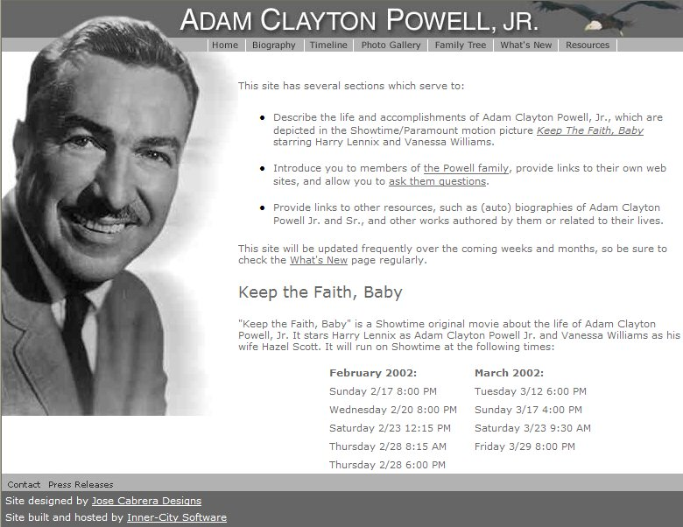
Bay State Banner  http://www.baystatebanner.com  Web application enables client staff to self-publish selected portions of newspaper and provide online archives for research purposes.  Content is made available for syndication and appears in the Roxbury.com community portal.  ICS built this web application pro-bono since the Banner provides content for Roxbury.com at no charge. | 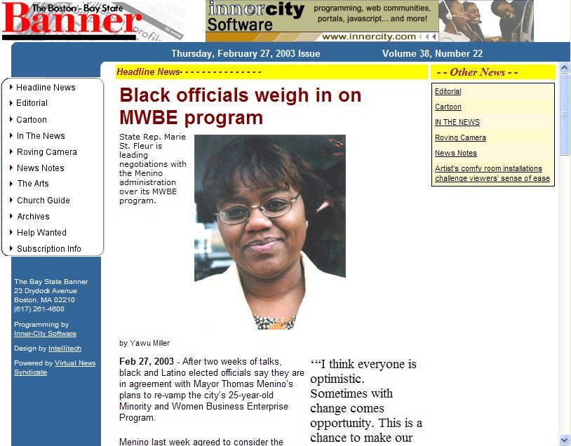
Biz-In-Site  http://www.bizinsite.com  Online business directory and content management system to support outreach and promotion of local businesses by major U.S. bank.  This .NET-based system enables businesses to promote their products and services to their local community via directory-style listing or more full-featured web presence.  System also enables residents to post announcements and events to the web. | 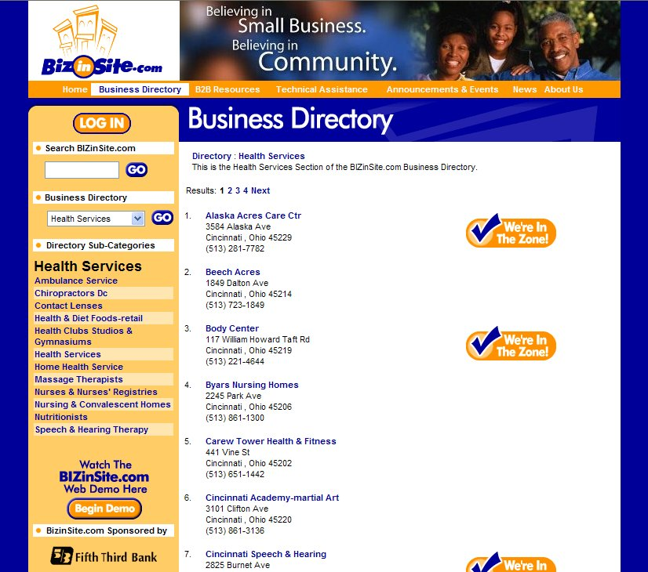
Boston Parent Organizing Network  http://www.bpon.org  Online content management system for organization operating out of Northeastern University.  System enables client to self-publish and self-manage announcement and event content on web site.  System also supports private discussion groups for organization members. | 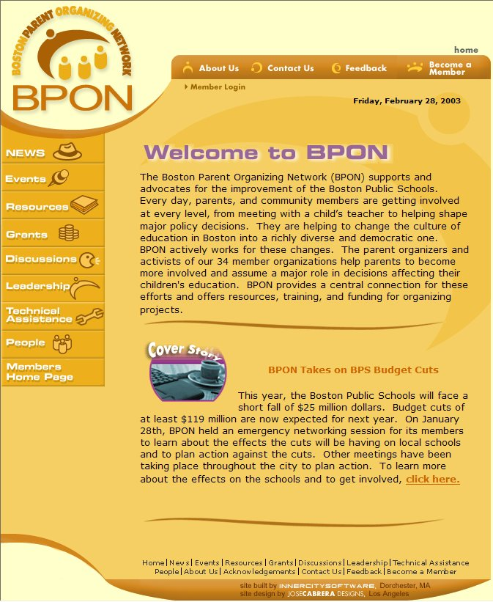
East Harbor Village Community Development Corporation  http://www.ehcdc.org  EHCDC is a community development corporation in Baltimore, Maryland. ICS designed and built a web site that provides basic information about EHCDC as well as private discussion areas for its Board members. | 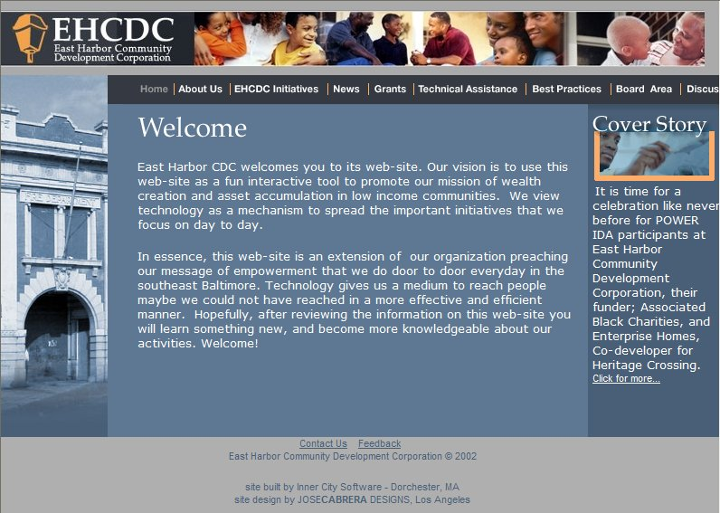
Boston Connects EZ-Info  http://www.ezinfo.org  Online business directory and content management system to support outreach and promotion of local businesses by Boston’s Empowerment Zone.  This .NET-based system enables businesses to promote their products and services to their local community.  System also enables Empowerment Zone to solicit and post announcements and events from the general public. | 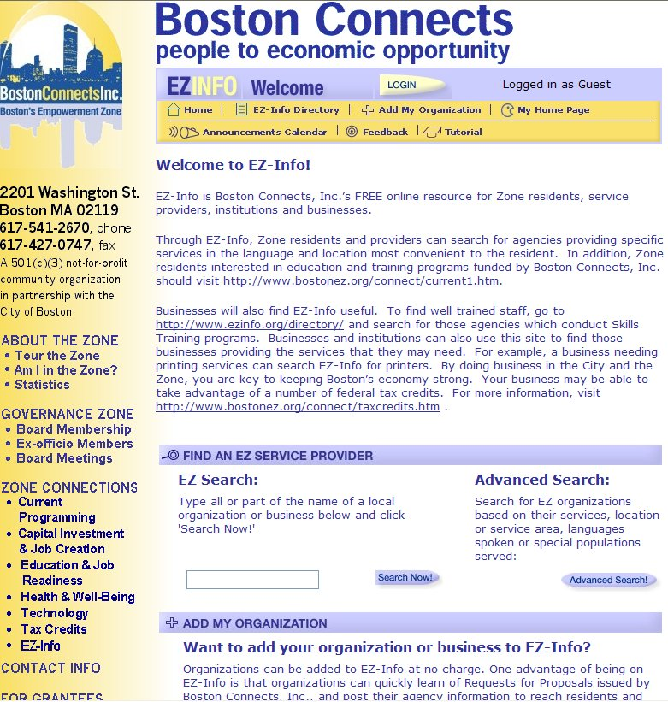
Major Insurance Company Intranet Chargeback System  (No URL Available)  This chargeback system took a custom Outlook solution that took over a minute to open and close forms, and re-engineered it as a web-based ASP application that used Dynamic HTML and client-side scripting to deliver an interface 99% identical to the Outlook form, but opened in a second. | 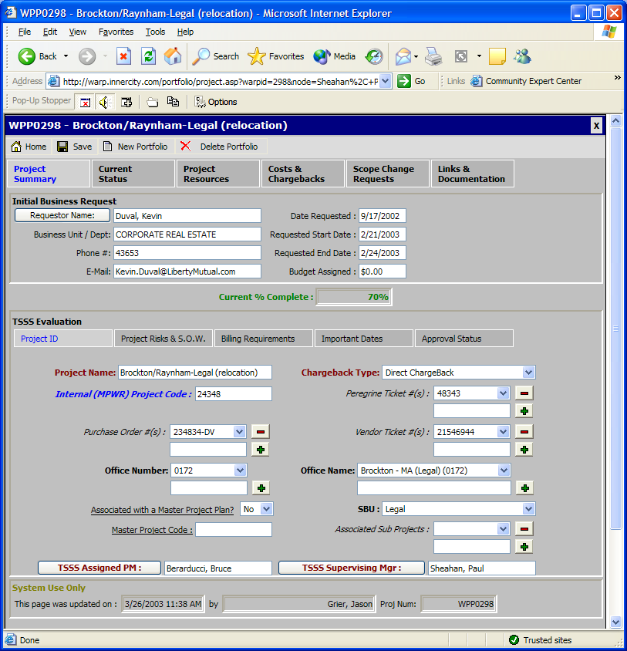
My Calm Spirit  http://www.mycalmspirit.com  My Calm Spirit.com is the online companion to Calm Spirit, a CD-based stress management program by Thulani Stress Management Solutions of Boston.  My Calm Spirit features dynamic listings of wellness events and resources, as well as discussion groups focusing on various stress management and wellness topics. | 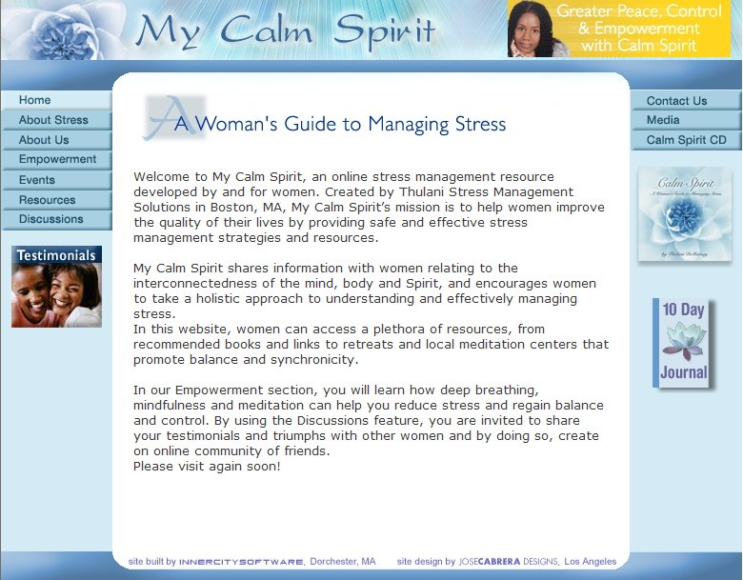
Nellie Mae Education Foundation  http://www.nmefdn.org  The NMEF web site features information about the Foundation along with dynamic modules that enable the Foundation to post announcements, press releases and other documents of interest to the web site.  Private areas are also available for the Foundation’s Board and Associates. | 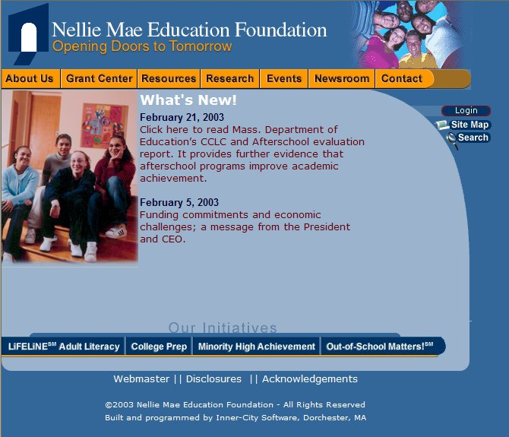
Northeastern University School of Education  http://www.education.neu.edu  The NU School of Education site presents course catalog, staff and faculty information to prospective teachers. ICS designed and built this web site that enables the School of Education staff to manage the staff, faculty and course listings via an easy to use web interface. | 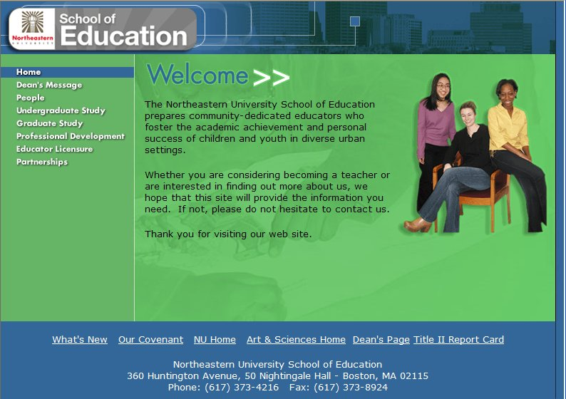
Rachel Abroms Designs  http://www.rachelabroms.com  Rachel Abroms Designs is a popular New Age jewelry firm in Los Angeles. The Rachel Abroms Designs web is a .NET-based web application that enables customers to browse Rachel’s product offerings and purchase products online.  Rachel Abroms representatives also have administrative access to the site that enables them to process credit card transactions and notify customers when orders are shipped. | 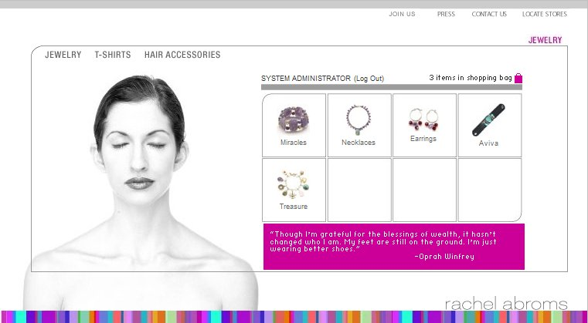
Thulani Stress Management Solutions  http://www2.thulani.com  Thulani Stress Management Solutions is a leading stress management consulting firm located in Boston, MA.  The Thulani.com site will have a Umoja-based Event management engine that will enable the client to manage a variety of aspects of their events, including sending out electronic invitations and processing registrations. | 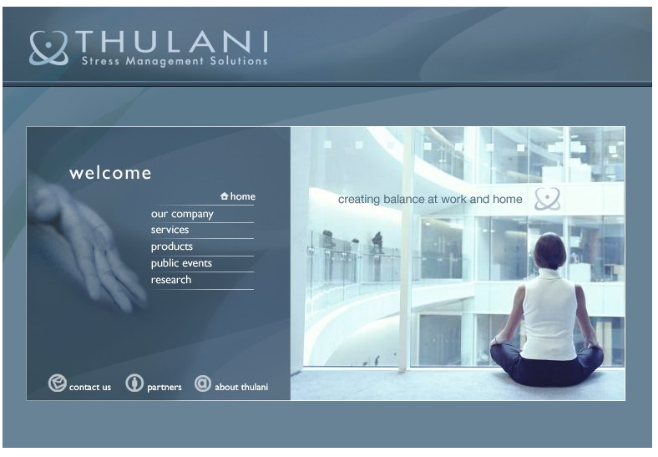
Roxbury.com  http://www.roxbury.com  Roxbury.com is the most complete implementation of Inner-City Software’s Umoja online community building platform. Roxbury.com is a completely dynamic community portal that features news, events, online directories and discussions posted by residents of Boston’s Roxbury neighborhood.  Content is submitted to the site by residents and community organization members, and approved by other members with approval security permissions. | 