ICS Web Site Sampler
The images below are examples of several of Inner-City Software’s web applications. While most of the sites were designed by our own designer, some of them (marked by an asterisk*) were designed by other designers. In all cases, ICS developed all of the back-end software to enable the automation and content management capabilities of the sites.

Web Site | Snapshot
Adam Clayton Powell, Jr.  http://www.adamclaytonpowell.com  Provides information about Congressman and civil rights pioneer, Adam Clayton Powell, Jr. and the activities of his descendants.  ICS built this website pro-bono to help promote “Keep the Faith Baby”, a movie created by Showtime that chronicles the life of Adam Clayton Powell, Jr. | 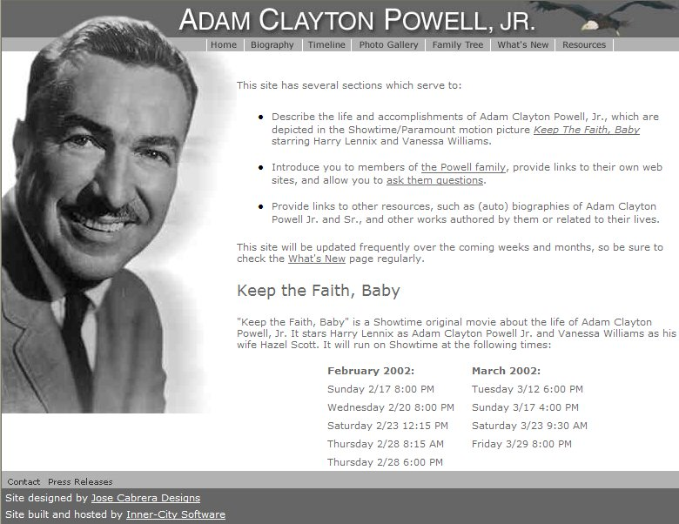
Bay State Banner*  http://www.baystatebanner.com  Web application enables client staff to self-publish selected portions of newspaper and provide online archives for research purposes.  Content is made available for syndication and appears in the Roxbury.com community portal  ICS built this web application pro-bono since the Banner provides content for Roxbury.com at no charge. | 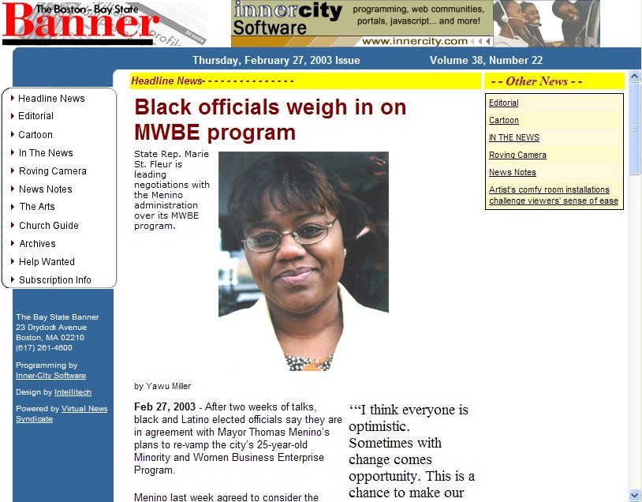
BOND of Color (under development)  http://bond.icsclients.com/  Web application enables local organization staff to self-publish articles and events pertaining to health and nutrition. | 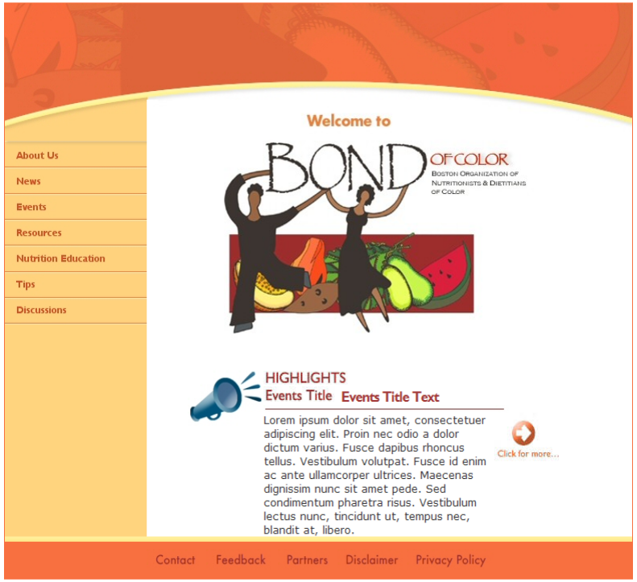
Biz-In-Site*  http://www.bizinsite.com  Online business directory and content management system to support outreach and promotion of local businesses by major U.S. bank.  System enables businesses to promote their products and services to their local community via directory-style listing or more full-featured web presence.  System also enables residents to post announcements and events to the web. | 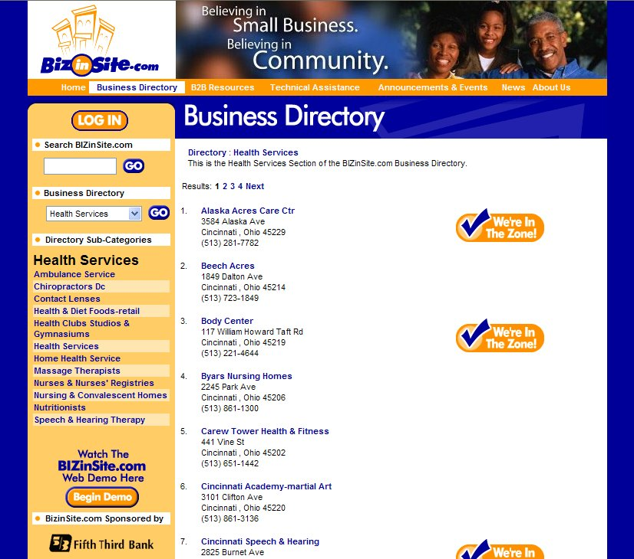
Boston Parent Organizing Network  http://www.bpon.org  Online content management system for organization operating out of Northeastern University.  System enables client to self-publish and self-manage announcement and event content on web site.  System also supports private discussion groups for organization members. | 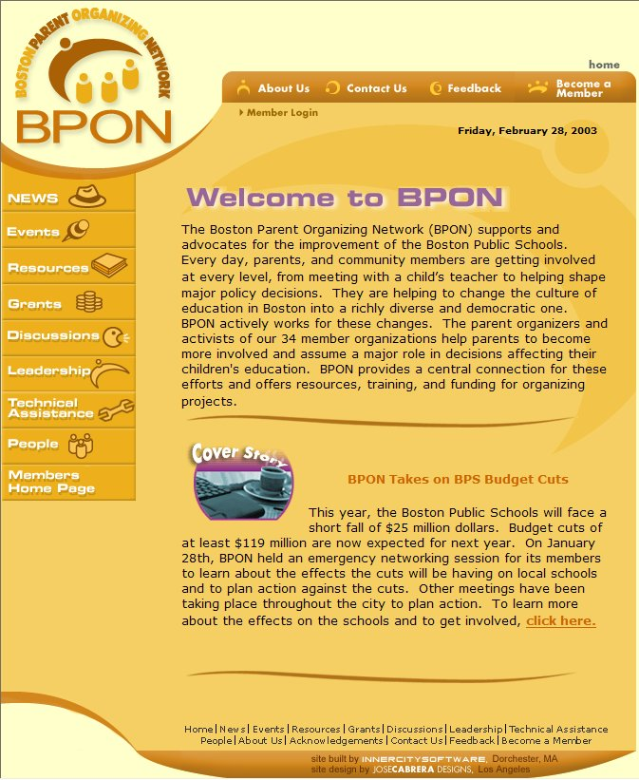
East Harbor Village Community Development Corporation  http://www.ehcdc.org  EHCDC is a community development corporation in Baltimore, Maryland. ICS designed and built a web site that provides basic information about EHCDC as well as private discussion areas for its Board members. | 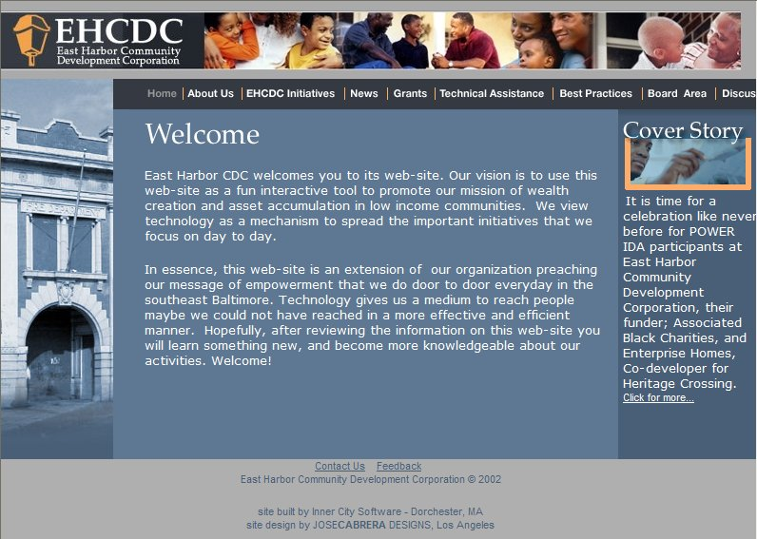
Boston Connects EZ-Info*  http://www.ezinfo.org  Online business directory and content management system to support outreach and promotion of local businesses by Boston’s Empowerment Zone.  System enables businesses to promote their products and services to their local community.  System also enables Empowerment Zone to solicit and post announcements and events from the general public.  ICS was not contracted to do design for this project. | 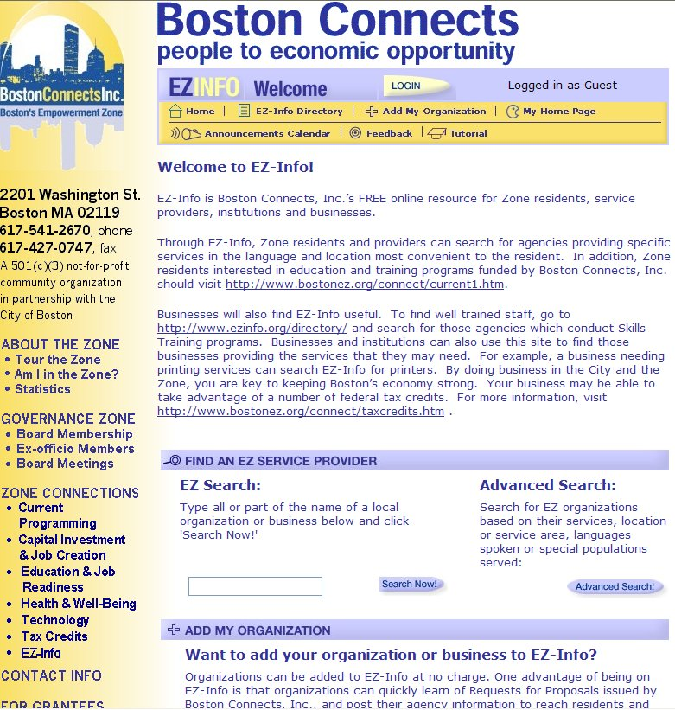
My Calm Spirit  http://www.mycalmspirit.com  My Calm Spirit.com is the online companion to Calm Spirit, a CD-based stress management program by Thulani Stress Management Solutions of Boston.  My Calm Spirit features dynamic listings of wellness events and resources, as well as discussion groups focusing on various stress management and wellness topics. | 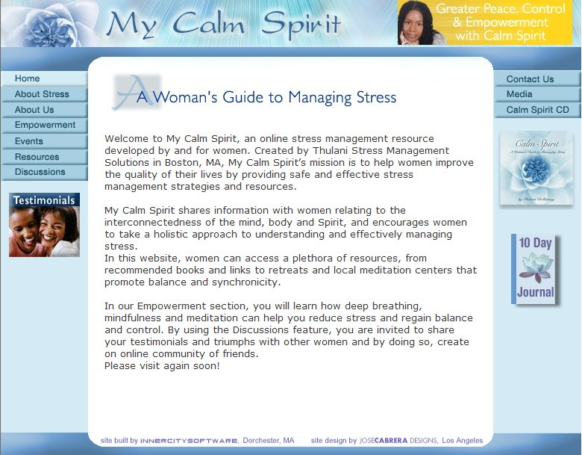
Nellie Mae Education Foundation*  http://www.nmefdn.org  The NMEF web site features information about the Foundation along with dynamic modules that enable the Foundation to post announcements, press releases and other documents of interest to the web site.  Private areas are also available for the Foundation’s Board and Associates. | 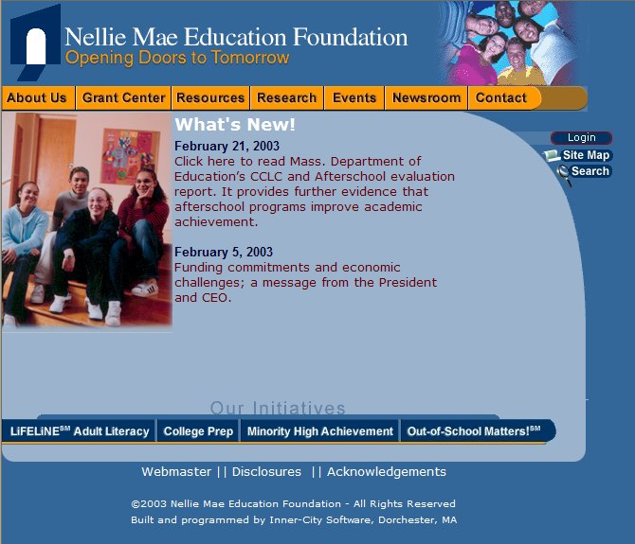
Northeastern University School of Education  http://www.education.neu.edu  The NU School of Education site presents course catalog, staff and faculty information to prospective teachers. ICS designed and built this web site that enables the School of Education staff to manage the staff, faculty and course listings via an easy to use web interface. | 
Rachel Abroms Designs*  http://www.rachelabroms.com  Rachel Abroms Designs is a popular New Age jewelry firm in Los Angeles. The Rachel Abroms Designs web enables customers to browse Rachel’s product offerings and purchase products online.  Rachel Abroms representatives have administrative access to the site that enables them to process credit card transactions and notify customers when orders are shipped. | 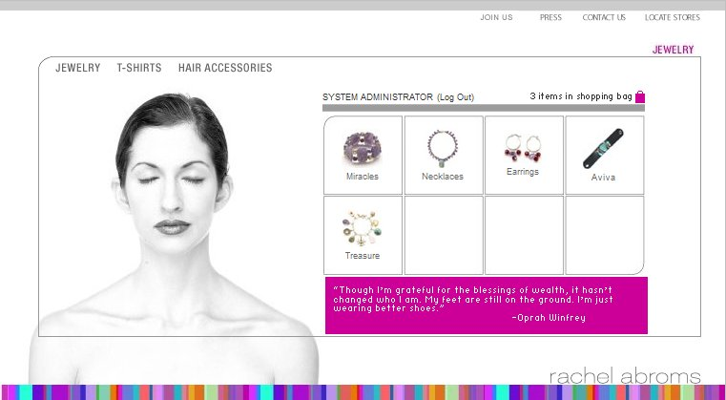
Roxbury.com  http://www.roxbury.com  Roxbury.com is the most complete implementation of Inner-City Software’s Umoja online community building platform. Roxbury.com is a completely dynamic community portal that features news, events, online directories and discussions posted by residents of Boston’s Roxbury neighborhood.  Content is submitted to the site by residents and community organization members, and approved by other members with approval security permissions. | 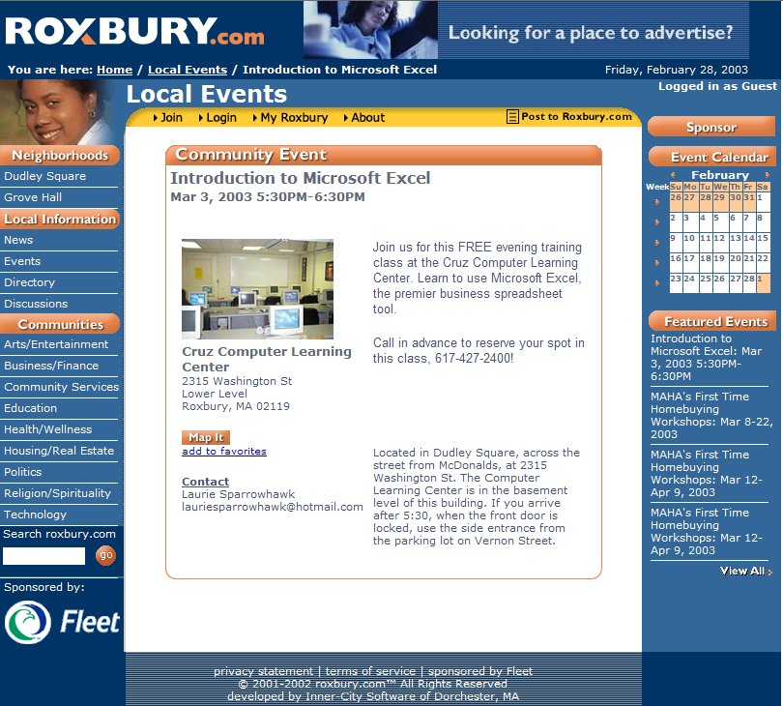
Thulani.com  http://www.thulani.com  Created for stress management firm owned by author of My Calm Spirit web site, this application allows client to self-publish news, events and research paper pertaining to the business and general topic of stress management.  Event content posted via Thulani.com also appears on My Calm Spirit.com automatically. | 