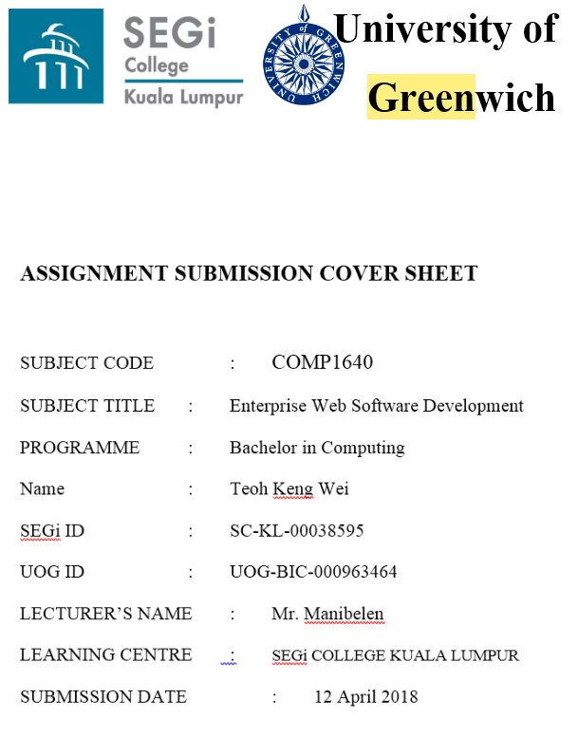

**Individual – Report**



**Student Portal Role-Based System – by Team Kappa**

**Group Repository Report Link (Cloud)**

|  |  |
| --- | --- |
| Sync  (with security password): | <https://ln.sync.com/dl/1772411a0/mbwi687g-6r7gp7dn-2kenk5xp-ab6gpkzf>  Password: teamkappa |
| Google Drive  (BACK UP): | <https://drive.google.com/drive/folders/10OWx8-ueMen4on9MLSxObhx3JCBf3rXs?usp=sharing> |

**Group Repository Artefacts Link**

|  |  |
| --- | --- |
| Artefacts URL: | <https://drive.google.com/drive/folders/1pPRoJh-bV8vciu-c8RLXOzD7lp5EYz54?usp=sharing> |

**Screencast Link (Cloud)**

|  |  |
| --- | --- |
| Sync  (with security password): | <https://ln.sync.com/dl/3478bf980/z8ihncaz-9yipyaaq-f8dfhubs-yym4ejp8>  Password: teamkappa |
| Google Drive  (BACK UP): | <https://drive.google.com/drive/folders/1Bg97ccYQ_krmLIKed5baiuGUkiN1tMNR> |

**Screencast Youtube Link**

|  |  |
| --- | --- |
| Screencast URL: | <https://youtu.be/B3oksszGC5E> |

**Team Members NAME & ROLES**

|  |  |  |  |  |  |  |  |  |  |
| --- | --- | --- | --- | --- | --- | --- | --- | --- | --- |
| **Name & ID** | **Scrum Master** | **Technical team leader** | **Programmer** | **System analyst** | **Database designer** | **Web Designer** | **Technical writer** | **Information architect** | **Tester** |
| MD RAFID HOSSAIN  (000961850) | ✔ |  | ✔ | ✔ |  |  |  |  |  |
| TEOH KENG WEI  (000963464) |  | ✔ | ✔ |  | ✔ |  |  |  |  |
| LIM WEI HONG  (000915588) |  |  |  | ✔ |  | ✔ | ✔ |  |  |
| MOHAMAMAD SAMIUL KHAN  (000963209) |  |  |  |  |  |  | ✔ | ✔ | ✔ |
| CHUNG CHEE HOE  (000961847) |  |  |  | ✔ |  |  |  | ✔ | ✔ |
| AW TA XUAN  (000963466) |  |  |  | ✔ |  |  | ✔ |  | ✔ |
| SANJIVAN A/L KURHANDRAN  (000963454) |  |  |  |  |  | ✔ |  | ✔ | ✔ |

**Table of Content**

Table of Contents

1.0 Evaluation of product and process 1

1.1 Screenshot & Commentary 1 - 10

1.2 Evaluation of Product 11 - 12

1.3 Evaluation of Process 13

2.0 Team Evaluation 14 - 19

3.0 Self-Evaluation 20

# 1.0 Evaluation of product and process

## 1.1 Screenshot & Commentary

**Admin**

* **User Management Page**

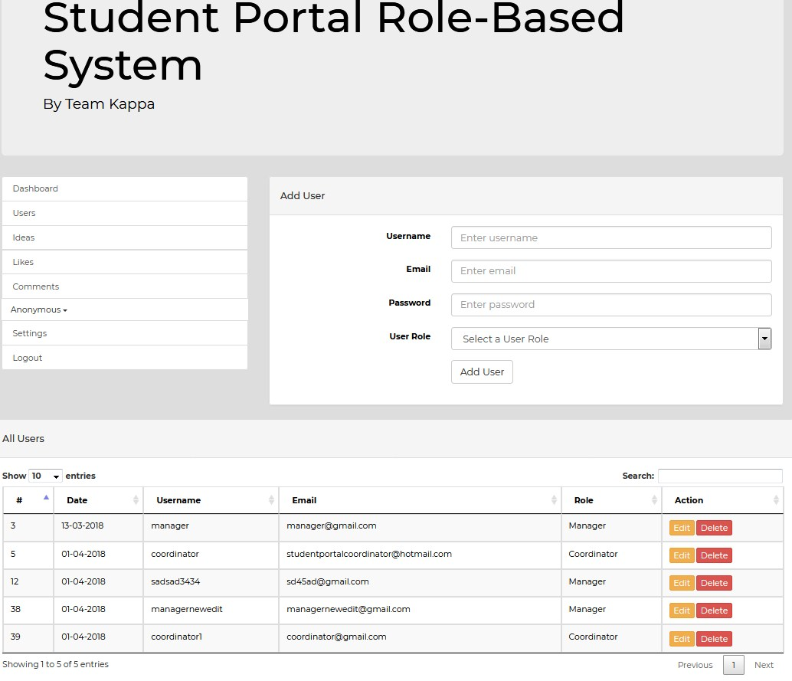

In this user management page, it allows admin to add, edit and delete the user’s account. Besides, while admin adding user account, they must select for particular role for a user. There is duplicate validation for Username and Email. For instance, when admin insert existed username called ‘manager’ and email called ‘manager@gmail.com’, it will display error message.

**Manager**

* **Category Management Page**

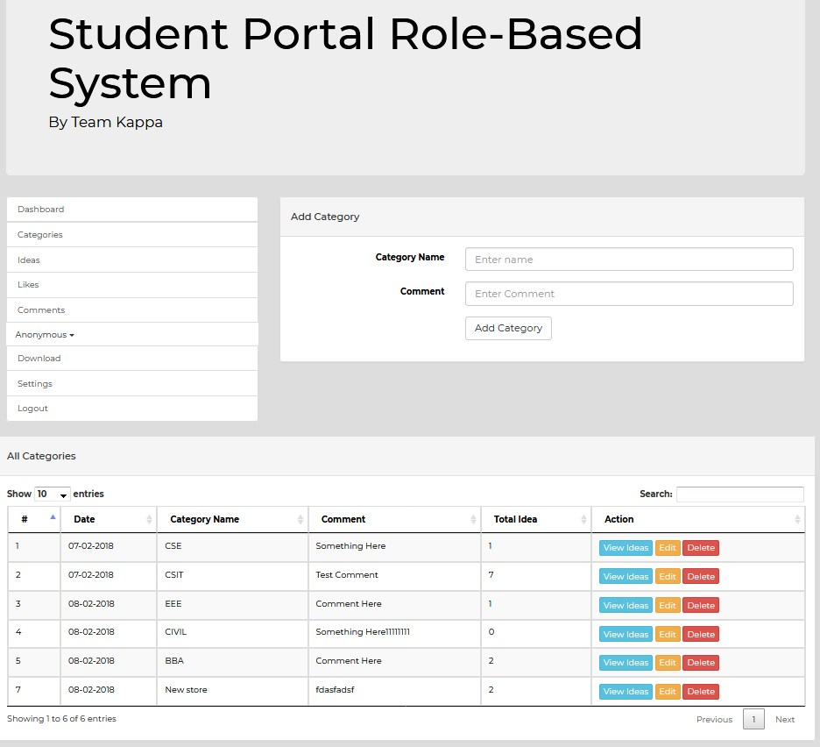

In the category management page, the manager can add, edit and delete for particular category. Besides, there are duplicate validation for category name. For instance, when user insert existed category name called ‘CSE’, it will display an error message.

* **Download Attachment Page**

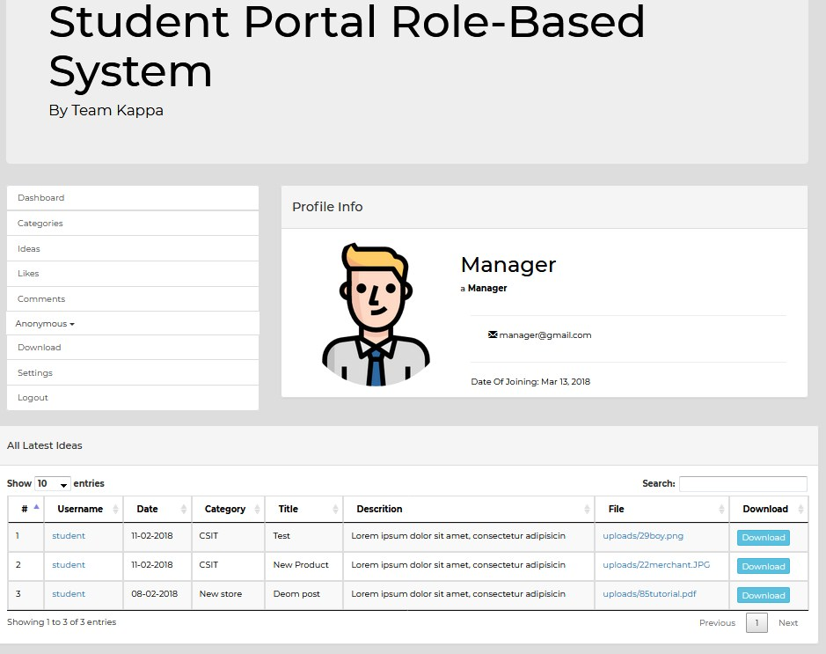

In this download attachment page, it only displays idea that are with attachments and final closure date in a list view table. Once manager click download button, the system will automatically generate the attachment into zip file.

**Coordinator**

* **Student Management Page**

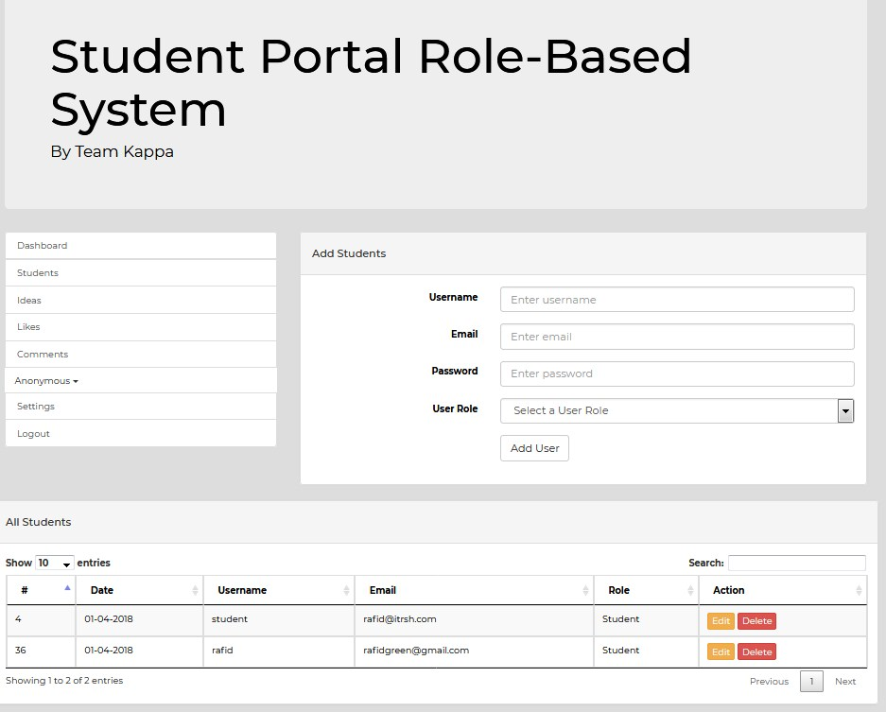

In this user management page, it allows coordinator to add, edit and delete the student’s account. Besides, while coordinator adding student account, coordinator must select for student role for a user. There is duplicate validation for Username and Email. For instance, when admin insert existed username called ‘rafid and email called ‘rafidgreen@gmail.com’, it will display error message.

**Staff (Admin, Manager, Coordinator)**

* **Idea Management Page**

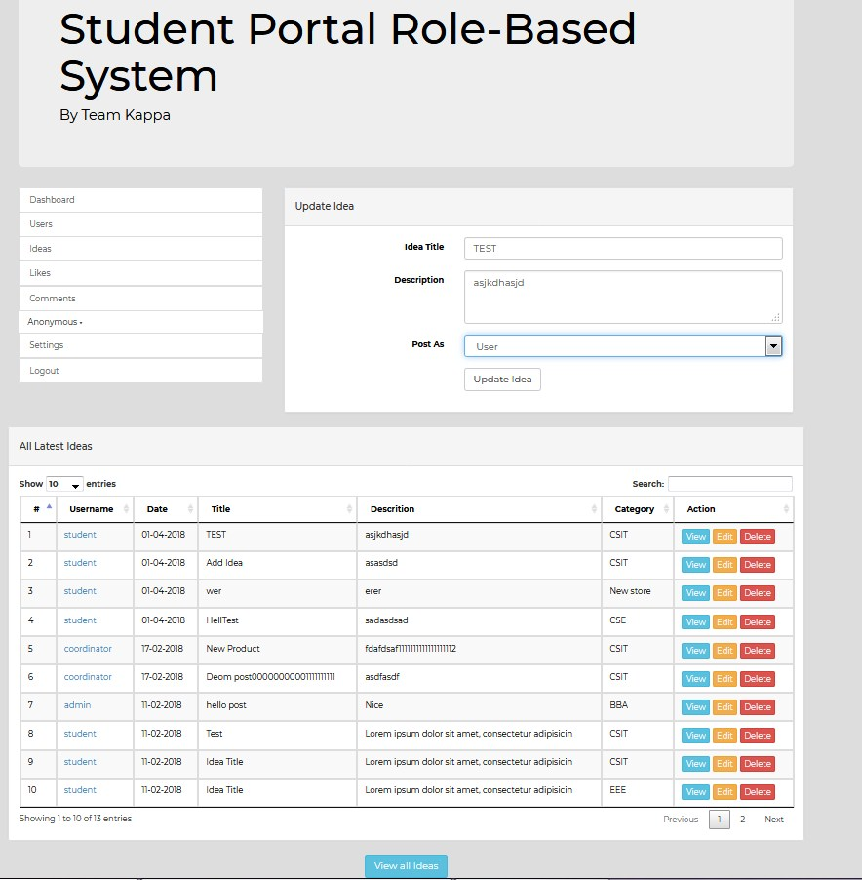

In this idea management page, all the staff are available to add, view, edit and delete for particular idea. Besides, staff can also set post as anonymously or username for particular idea.

* **View Anonymously Post Page**

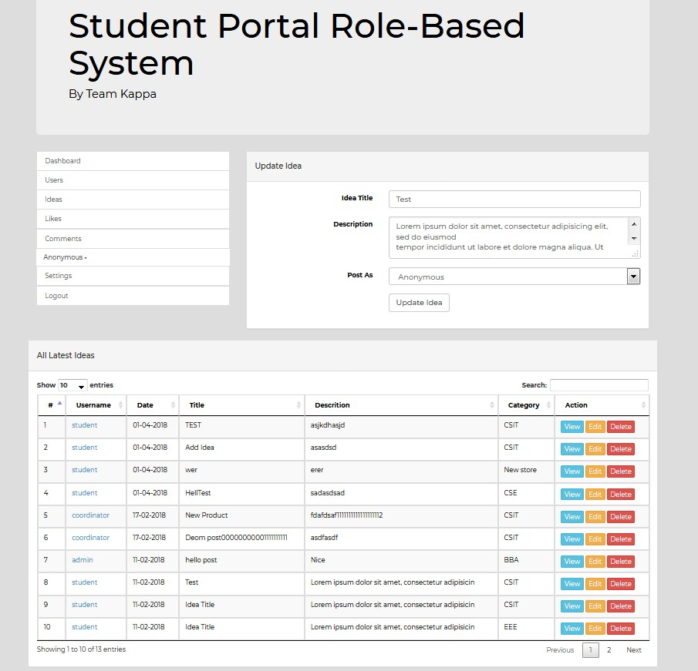

In this view anonymously post page, all of the staff is available to view student post an idea or comment as anonymously. Furthermore, staff still can manage all the ideas, such as view edit and delete the idea or comment.

**Student**

* **Post Idea Page**

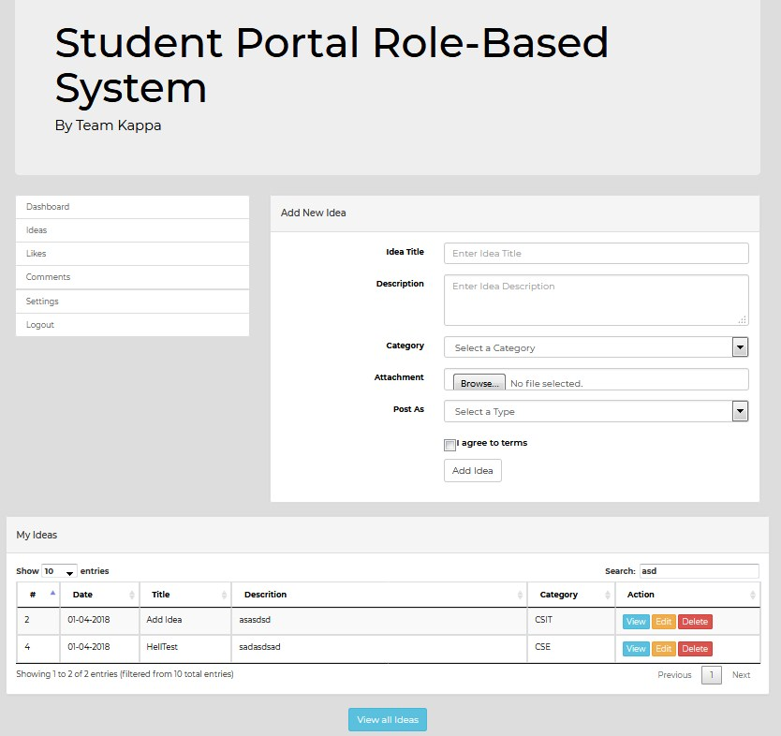

In this post idea page, only student is available to post new idea. There is an optional data entry which is upload attachments, student can post an idea without upload any attachments. Certainly, student must select post as anonymously or user. Furthermore, student must tick the ‘I agree to terms’ only can add the new idea.

* **Post Comment Page**

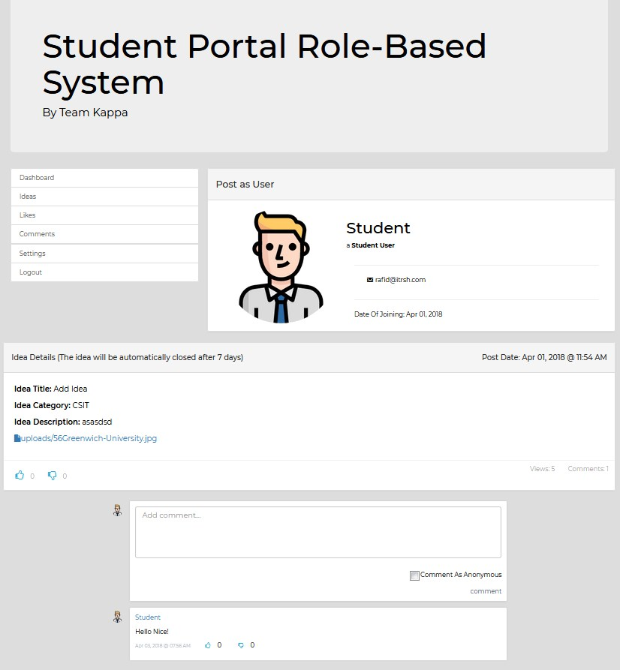

In this post comment page, all user is available to post comment and give rating in particular idea. Users can choose to post comment as anonymously, it is optional. However, student cannot view staff’s comments. Moreover, the user can give thumps up or thumps down for particular idea and comment.

**All Roles of User**

* **Dashboard Page**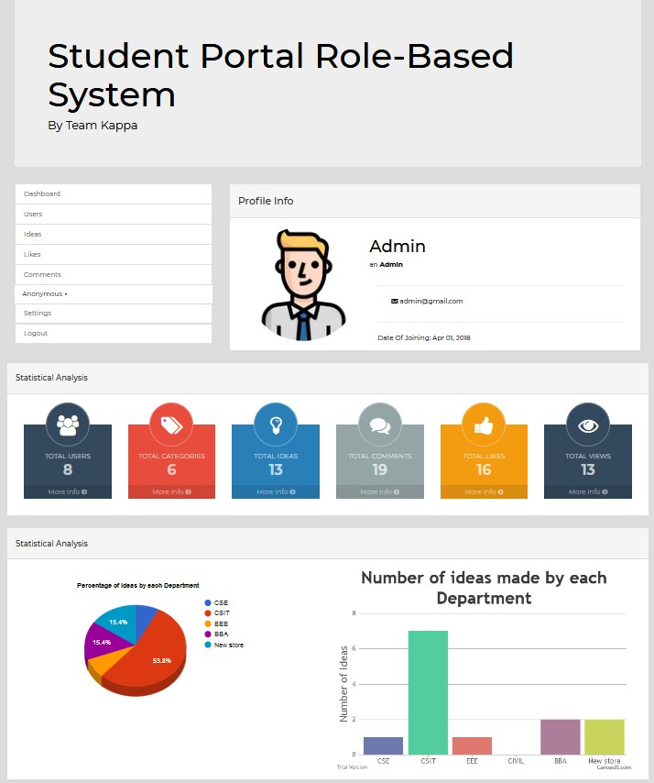

In this dashboard page, all type of users is available to view their profile info and statistical analysis diagram. In the statistical analysis diagram, it shows the ‘percentage of idea by each department’ and ‘number of ideas made by each department’

* **User Setting Page**

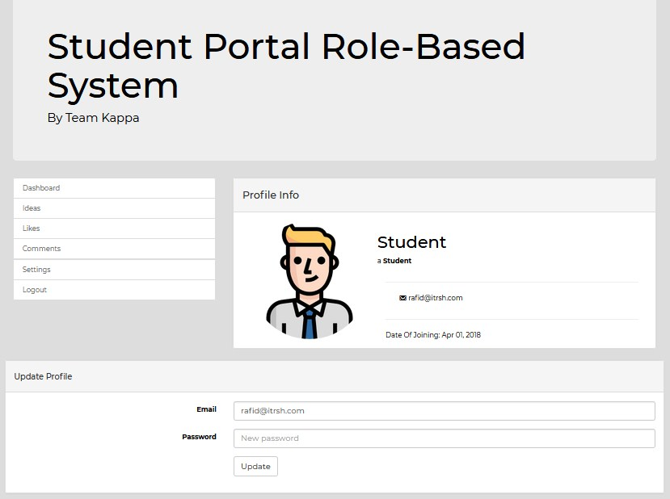

In this user setting page, all type of user is available to view their profile info. Besides, they also can update their profile, such as changing the password.

## 1.2 Evaluation of Product

First of all, this project system is called Student Role-Based System, the purpose of this system is to develop for student to post their own idea in particular category. Our team have fully developed all the functionalities and meet all the requirement from the product end user. This system has 4 roles which are Admin, Manager, Coordinator and Student. Other than that, there are more functionalities that required from end-user, such as Dashboard and Rating info. For Dashboard, all roles of user can view the dashboard, user profile information and all the statistical analysis diagram is list and display in the dashboard page. For rating info, all roles of user are available to give a like or dislike to particular ideas and comments.

Now come to login security part, all roles of user are use the same page to login to this system. The purpose of using login function is to identify which roles the users are belong to. Therefore, after the system identify the role and redirect the user to the page where the particular role is available to access it. For example, student role cannot be access into user account, ideas and comments management page because this is only available for staff to utilize the function. Other than that, when admin add a new user account, the system will auto generate the password it into password hash. Therefore, it will bring high protection account for all the users, as the password hash cannot be decrypt. Furthermore, this system will have duplicate validation while staff adding user account. For instance, they cannot add same username and email for new user account, otherwise it will display error messages. For the web designing part, our team are using the bootstrap to design the html, as it helps the design to look better with standard design. Most importantly, our web design is based on end-user requirements, they want to keep it simple in order to provides end-user a comfortable way to fully utilize the system functionalities. Other than that, this web design also provides them a way to read all the content which mean that the web page stated clearly for user to read content easily. Furthermore, the navigation menu bar was designed at the same place for all the web pages. Besides, the system’s layout was designed in responsive way in order to fits all the screen sizes, such as mobile, desktop, tablet and etc.

For the admin functionalities, their main function is to managing all the user account. The admin can add, edit and delete any user accounts. Certainly, admin can also use the staff functionalities, such as ideas, comments and rating info management. Other than that, admin still can view the anonymously ideas and comments that posted by students. Besides, admin can also post comment and give rating for particular idea and comment.

For the manager functionalities, the manager main functions are managing all the categories and download all the available attachments from particular ideas that are final closure date. Certainly, manager can also use the staff functionalities, such as ideas, comments and rating info management. Other than that, manager still can view the anonymously ideas and comments that posted by students. Besides, manager can also post comment and give rating for particular idea and comment.

For the coordinator functionalities, their main function is to managing all the student account and receive the new idea notification. When students posted new idea, the system will automatically send an email notification to coordinator. Certainly, coordinator can also use the staff functionalities, such as ideas, comments and rating info management. Other than that, coordinator still can view the anonymously ideas and comments that posted by students. Besides, coordinator can also post comment and give rating for particular idea and comment.

For the student functionalities, their main function is to post new idea in particular categories. Certainly, student can also post comment and give rating for particular idea and comment. However, students cannot view the staff comments, while the staff is able to view all the comments, including anonymously ideas and comments that posted by student.

In the conclusion, our project has fully meet all the requirement from our end-user. We have fully implement all the functionalities that end-user required. I personally think that our project system is the best, as our project was designed in responsive way and have high security to protect all of the user’s information.

## 1.3 Evaluation of Process

First of all, our team members are planning to use the agile scrum methods to process and complete the related project. The purpose of using the agile scrum methods is because of it has an ability to rapid delivery, the purpose of this rapid delivery can quickly meet the often updating the requirements from product end users. According to our team project, we are taking almost 2 months to completed it by using the agile scrum method. However, we have total of 7 minutes of meetings in our group project which meaning that we have total of 7 sprints with 7 days for each sprint. The scrum meetings are really helped our team a lot because during the meetings, our team have lot of questions to asked. For instance, their title was like “What is the progress of developing the project?”, “What is the progress of designing the web design?”, “What we should do for next after finish the particular function” and “What is the result for solving the issues?”. Therefore, in our team we are keep asking those questions while others are giving their suggestion and sharing their ideas to each other. In the result, we really need to thanks to this weekly meetings, it helps us to achieved and completed our project quickly because it helps everyone to understand their own product objectives, issues, progress and each of our member performance and progression quickly and effectively. Moreover, team members sharing out their opinion and suggestion would bring huge of benefit for rewarding a best solution, with all our team member’s precious knowledge and previous experience, I believe that we can develop a best solution for our project. When finished our scrum meeting, our scrum master will decide which ideas and suggestion are the best solution to use it on further development. Furthermore, our scrum master is the one who responsible to create the product backlog to show us and explain to us what is the requirement of the product end users. Besides, our scrum master also created minutes of meetings backlog as task schedule for tracking all of our team members’ progress. Overall, with all our team members’ knowledge and agile scrum method, I can ensure that our team can develop a best project with best solution and also ensure that this project will be delivered on time.

# 2.0 Team Evaluation

**2. Scrum Master, Programmer & Technical Writer**

Name: MD RAFID HOSSAIN

Course: Bachelor Degree in Computing

Year: 5

|  |  |
| --- | --- |
| **Commitment** | **Weight** |
| Fully committed | 10 |
| Committed | 8 |
| Contributed substantially | 6 |
| Contributed partially | 4 |
| Minimal contribution | 2 |
| No Contribution | 0 |

Mohd Rafid should get more than 10 (Fully Committed) because he did the most works on this whole project. Other than that, he is the scrum master in this group and he is the one contributes the most. Mohd Rafid’s tasks is to design the project website and also helping others programmer to write some code. Moreover, Mohd Rafid contributes the most in our backlog products and meeting minutes. As a scrum master, he allocates all the tasks to each members and lead us all the way. So that he deserved to get the highest mark.

**2. System Analyst, Web Designer and Technical writer**

**Name:** LIM WEI HONG

**Course:** BIC

**Year:** Five (5)

|  |  |
| --- | --- |
| **Commitment** | **Weight** |
| Fully committed | 10 |
| Committed | 8 |
| Contributed substantially | 6 |
| Contributed partially | 4 |
| Minimal contribution | 2 |
| No Contribution | 0 |

Lim Wei Hong should get 10 weight (Fully Committed) because he contributed more than I expected. As a system analyst, he was willing to take more than 1 role, such as web designer and technical write. Therefore, in these 7 sprints, he has assisted the programmer to design the website and write the report for this group. He always be punctual on every meeting minutes and always follow the tasks that master scrum asked him to do. In every sprints he always submitted his works before the deadline of the backlog. Lim Wei Hong did perfect job in his role, he willing to help each other when time is so rushing. Therefore, I personally think that Lim Wei Hong is the best team member in our group, as he provided all his effort and hard work in this team project.

**3. Technical Writer, Information Architect and Tester**

**Name:** MOHAMMAD SAMIUL KHAN

**Course:** BIC

**Year:** Five (5)

|  |  |
| --- | --- |
| **Commitment** | **Weight** |
| Fully committed | 10 |
| Committed | 8 |
| Contributed substantially | 6 |
| Contributed partially | 4 |
| Minimal contribution | 2 |
| No Contribution | 0 |

Mohammad Samiul Khan should get 10 weight (Fully Committed) because he contributed a lot in this team project, so that he deserved to get Fully Committed. As a Technical Writer, he was willing to take more than 1 role, such as information architect and tester. He always be a bit late on every meeting minutes. However, he always follows the tasks that master scrum asked him to do. In every sprints he always submitted his works before the deadline of the backlog. As a technical writer and Information architect, he did perfect job in his role, he willing to give suggestion to our team member. Therefore, I personally think that Mohammad Samiul Khan is the best team member in our group, as he offers all his effort in this team project.

**4. System Analyst, Information Architect and Tester**

**Name:** CHUNG CHEE HOE

**Course:** BIC

**Year:** Five (5)

|  |  |
| --- | --- |
| **Commitment** | **Weight** |
| Fully committed | 10 |
| Committed | 8 |
| Contributed substantially | 6 |
| Contributed partially | 4 |
| Minimal contribution | 2 |
| No Contribution | 0 |

Chung Chee Hoe supposed to get 10 weight (Fully Committed) because he contributed his effort in this team project. As a system analyst, he was willing to take more than 1 role, such as information architect and tester. He sometimes be a bit late on every meeting minutes. However, he always follows the tasks that master scrum asked him to do. In every sprints he always submitted his works before the deadline of the backlog. As a system analyst, he did perfect job in his role, he willing to give suggestion to our team member. Therefore, I personally think that Chong Chee Hoe is deserved to praised as good team member, as he always gives suggestion and submit his tasks on time.

**5. System Analyst, Technical Writer and Tester**

**Name:** AW TA XUAN

**Course:** BIC

**Year:** Five (5)

|  |  |
| --- | --- |
| **Commitment** | **Weight** |
| Fully committed | 10 |
| Committed | 8 |
| Contributed substantially | 6 |
| Contributed partially | 4 |
| Minimal contribution | 2 |
| No Contribution | 0 |

Aw Ta Xuan supposed to get 10 weight (Fully Committed) because he contributed his effort in this team project. As a system analyst, he was willing to take more than 1 role, such as technical writer and tester. He always be punctual on every meeting minutes and always follow the tasks that master scrum asked him to do. In every sprints he always submitted his works before the deadline of the backlog. As a system analyst, he did perfect job in his role, he willing to give suggestion to our team member, such as designing the analysis diagram (Use Case, ERD, DFD). Therefore, I personally think that Aw Ta Xuan is deserved to praised as good team member, as he always gives suggestion and submit his tasks on time.

**6. Web Designer, Information Architect and Tester**

**Name:** SANJIVAN A/L KURHANDRAN

**Course:** BIC

**Year:** Five (5)

|  |  |
| --- | --- |
| **Commitment** | **Weight** |
| Fully committed | 10 |
| Committed | 8 |
| Contributed substantially | 6 |
| Contributed partially | 4 |
| Minimal contribution | 2 |
| No Contribution | 0 |

Sanjivan A/L Kurhandran deserved to get 5 weight (Contributed partially) because he sometimes barely to contributed his effort in this team project. As a web designer, he was willing to take more than 1 role, such as information architect and tester. He always be late on every meeting minutes. As a web designer, he rarely to give his suggestion in web design. Therefore, I personally think that Sanjivan A/L Kurhandran is deserved to get 5 weight only.

# 3.0 Self-Evaluation

**Technical Team Leader, Programmer & Database Designer**

Name: Teoh Keng Wei

Course: Bachelor Degree in Computing

Year: 5

As a technical team leader, I have the responsibility to lead my team to do their tasks. I will give all the technical instruction to all my team member. For instance, helping team member to solve their technical issues, such as fixing inputs and outputs devices. Other than taking technical team leader as a role, I am willing to take programmer and database designer as part of my roles. In this team, our scrum master and I was being responsible for programming (Software Developer Task).

In sprint 5, I had started planning to design the database. Once I understand all the requirement of this system. Then I start to design the Data Dictionary, Normalization, ERD and Referential Integrity. After I have completely finish the database design, I will have a good inspiration in create the database. During that time, my web designer teammate is facing some issues. Therefore, I helped them to design the user interface of this web system. So that they have more inspiration in designing and can easily to start design the website. In this sprint 5, it was really a good experience for me, as I have done lot of tasks in this sprint 5. The more tasks I’m doing; the more knowledge I will get. Therefore, I’m proud of helping my teammate to solve their problems.

In sprint 6, we have discussed about implementing all the requirement function in the system. Moreover, we help each other to find the solution while implementing the functionalities. Therefore, I had really learned a lot in this sprint 6, as that time we often use online to research about the system and find more solution to implement the requirement functionalities. Therefore, I really had learned lot of PHP programming language. Other than that, I now realize that teamwork is how important in group works.