Program 10

;signed char a,b;

;if (a>b) ; (b<a)

; a++;

;else

; a=a+b;

;b++;

.include "m328Pdef.inc"

.def var_a = r16

.def var_b = r17

.cseg

.org 0x00

rjmp main

main: ldi var_a,-5

ldi var_b, -1

cp var_b,var_a

brlt true

;rjmp false

false: add var_a,var_b

rjmp endif

true: inc var_a

;rjmp endif

endif: inc var_b

end: rjmp end

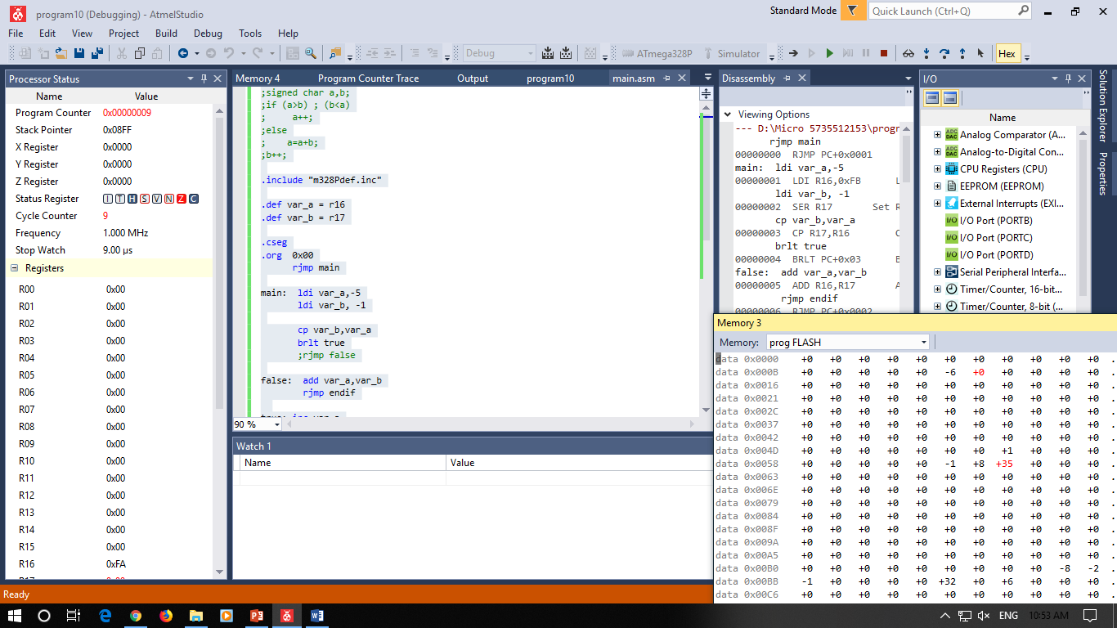

;signed char a,b;

;if (a>b) ;

; a++;

;else

; a=a+b;

;b++;

.include "m328Pdef.inc"

.def var_a = r16

.def var_b = r17

.cseg

.org 0x00

rjmp main

main: ldi var_a,-5

ldi var_b, -5

cp var_b,var_a

breq false

brge true

;rjmp false

false: add var_a,var_b

rjmp endif

true: inc var_a

;rjmp endif

endif: inc var_b

end: rjmp end

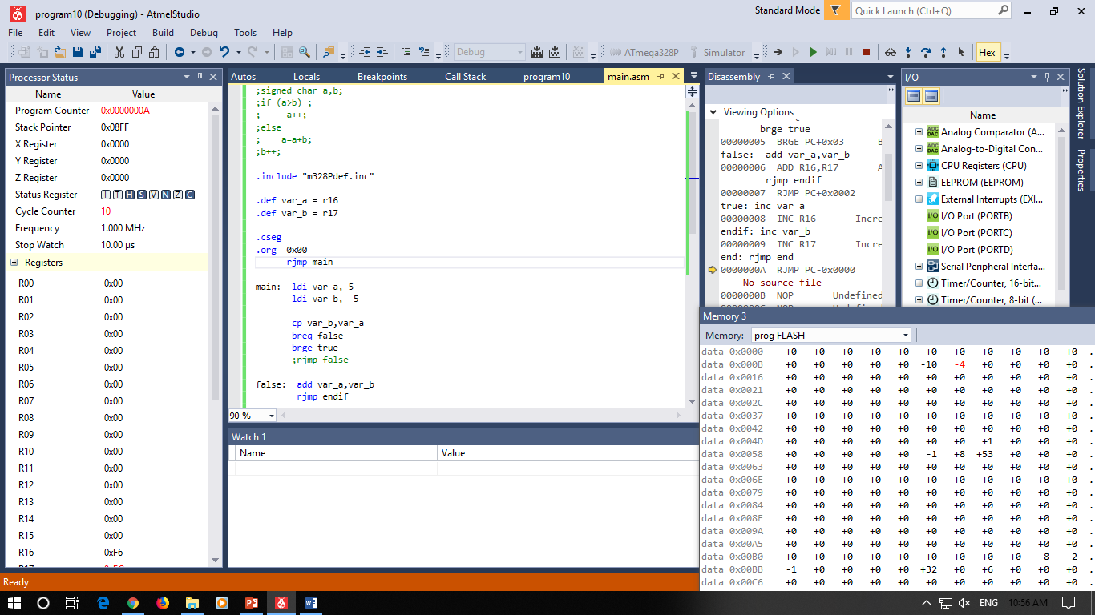

program12

;signed char a, b, c;

; if (a<b)

; c = -1;

; else if (a > b)

; c = 1;

; else

; c = 0;

; a = b*c;

.include "m328Pdef.inc"

.def var_a = r16

.def var_b = r17

.def var_c = r18

.cseg

.org 0x00

rjmp main

main: ldi var_a,-10

ldi var_b, -5

cp var_a,var_b

brlt LESS

breq EQUAL

;rjmp MORE

;brge MORE

MORE: ldi var_c,1

rjmp endif

LESS: ldi var_c,-1

rjmp endif

EQUAL: ldi var_c,0

endif: muls var_b,var_c

mov var_a,r0

end: rjmp end

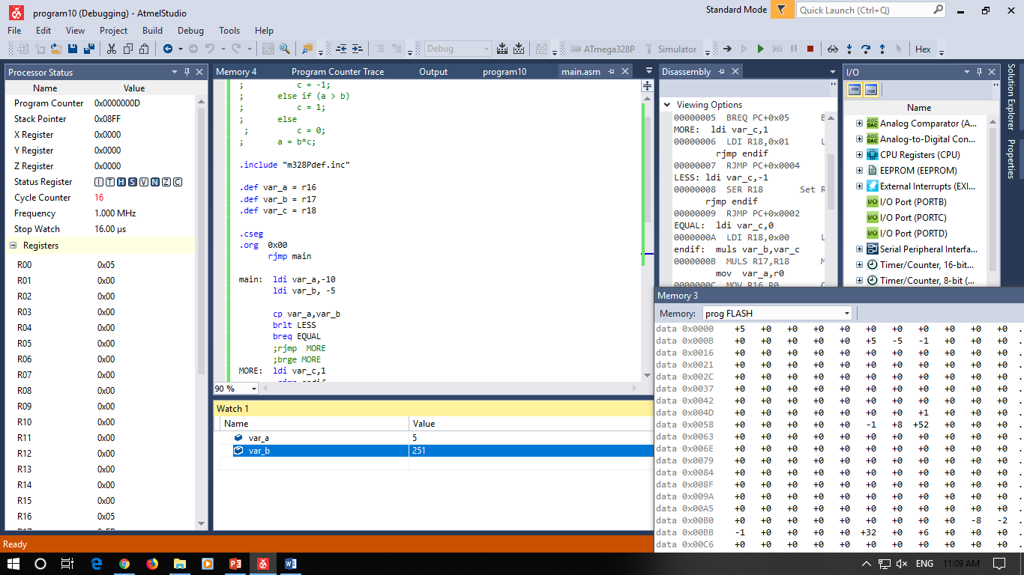

Program 14

;unsigned char a, b=0;

;for (a=0; a<10; a++)

; b++;

;a = b+50;

.include "m328Pdef.inc"

.def var_a = r16

.def var_b = r17

.cseg

.org 0x00

rjmp main

main: clr var_b

clr var_a

for: cpi var_a,10

brlo loop

rjmp endfor

loop: inc var_b

inc var_a

rjmp for

endfor: ldi var_a,50

add var_a,var_b

