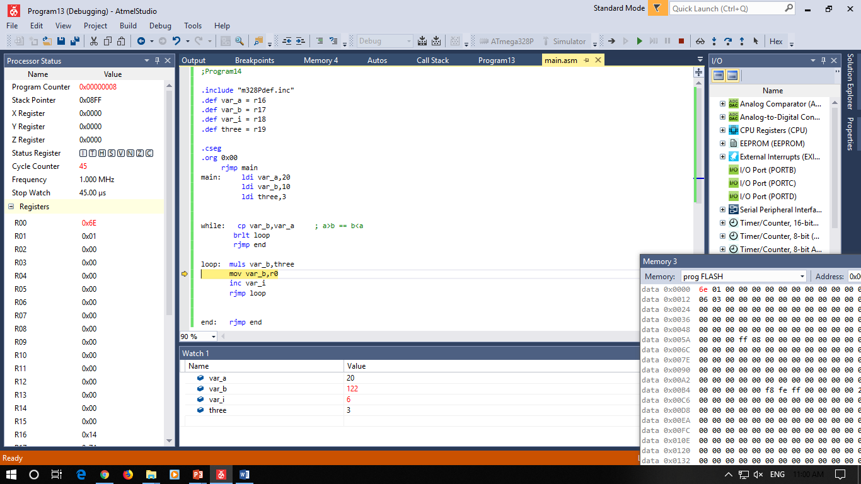

;Program18

.include "m328Pdef.inc"

.def var_a = r16

.def var_b = r17

.def var_i = r18

.def three = r19

.cseg

.org 0x00

rjmp main

main: ldi var_a,20

ldi var_b,10

ldi three,3

while: cp var_b,var_a ; a>b == b<a

brlt loop

rjmp end

loop: muls var_b,three

mov var_b,r0

inc var_i

rjmp loop

end: rjmp end

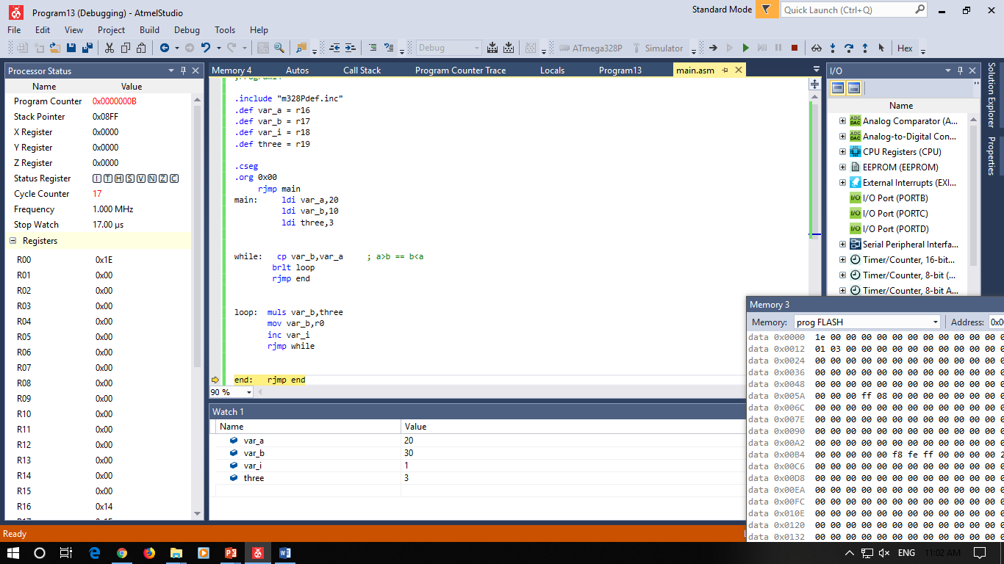

;Program19

.include "m328Pdef.inc"

.def var_a = r16

.def var_b = r17

.def var_i = r18

.def three = r19

.cseg

.org 0x00

rjmp main

main: ldi var_a,20

ldi var_b,10

ldi three,3

while: cp var_b,var_a ; a>b == b<a

brlt loop

rjmp end

loop: muls var_b,three

mov var_b,r0

inc var_i

rjmp while

end: rjmp end

;Program13

.include "m328Pdef.inc"

.def var_a = r16

.def var_b = r17

.def var_cl = r18

.def var_ch = r19

.def zero = r20

.cseg

.org 0x00

rjmp main

main: ldi xl,low(a)

ldi xh,high(a)

ld var_a,x+

ld var_b,x+

ld var_cl,x+

ld var_ch,x+

clr zero

cp var_a,var_b

brlo true

breq true

false: add var_cl,var_b

adc var_ch,zero

rjmp endif

true: add var_cl,var_a

adc var_ch,zero

rjmp endif

endif: ldi xl,low(a)

ldi xh,high(a)

st x+,var_a

st x+,var_b

st x+,var_cl

st x+,var_ch

end: rjmp end

.dseg

.org 0x10A

a: .byte 1

b: .byte 1

c: .byte 2

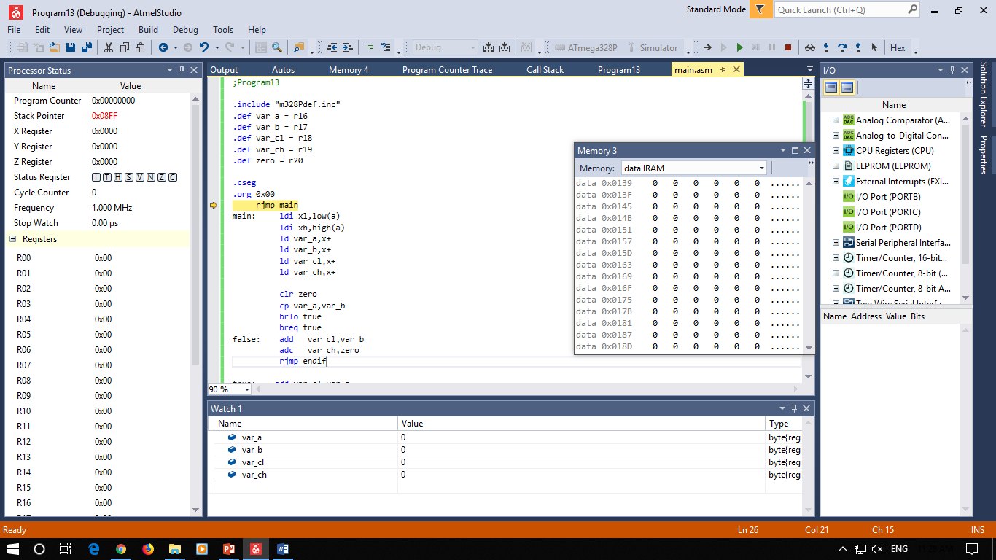

;Program22

;unsigned char i;

;unsigned char NAME[10];

;for (i=0;i<10;i++)

;NAME[i] = 0xff;

.include "m328Pdef.inc"

.def var_i = r16

.def temp = r17

.cseg

.org 0x00

rjmp main

main: ldi yl,low(NAME)

ldi yh,high(NAME)

ldi temp,0xff

clr var_i

for: cpi var_i,10

brlo loop

rjmp end

loop: st y+, temp

inc var_i

rjmp for

end: rjmp end

.dseg

.org 0x100

NAME: .byte 1*10

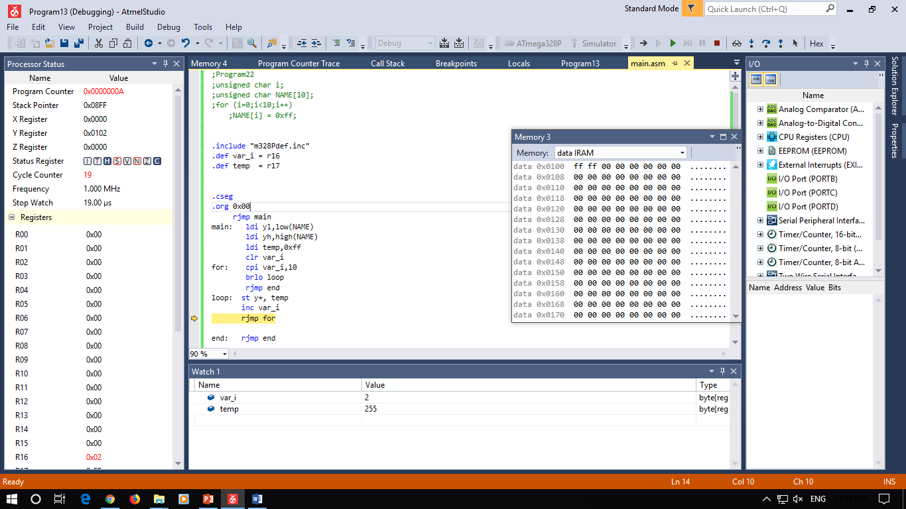

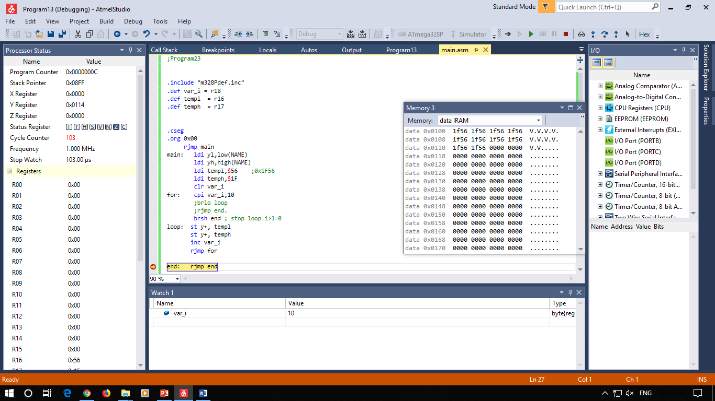

;Program23

.include "m328Pdef.inc"

.def var_i = r18

.def templ = r16

.def temph = r17

.cseg

.org 0x00

rjmp main

main: ldi yl,low(NAME)

ldi yh,high(NAME)

ldi templ,$56 ;0x1F56

ldi temph,$1F

clr var_i

for: cpi var_i,10

;brlo loop

;rjmp end.

brsh end ; stop loop i>1=0

loop: st y+, templ

st y+, temph

inc var_i

rjmp for

end: rjmp end

.dseg

.org 0x100

NAME: .byte 2*10