Program 35

.include "m328Pdef.inc"

.def var_a = r16

.def var_b = r17

.cseg

.org 0x00

rjmp reset

reset: ldi var_a,0x00 ;input

out DDRC, var_a

ldi var_a,0xff ;output

out DDRB,var_a

main: in var_a,PINC

andi var_a, 0b01110000

lsr var_a

lsr var_a

lsr var_a

lsr var_a

ldi zl,low(TB*2)

ldi zh,high(TB*2)

clr var_b

add zl,var_a

adc zh,var_b

lpm r10,z

out PORTB,r10

rjmp main

TB: .db 0b00000000, 0b00000001, 0b00000011, 0b00000111

.db 0b00001111, 0b00011111, 0b00111111, 0b01111111

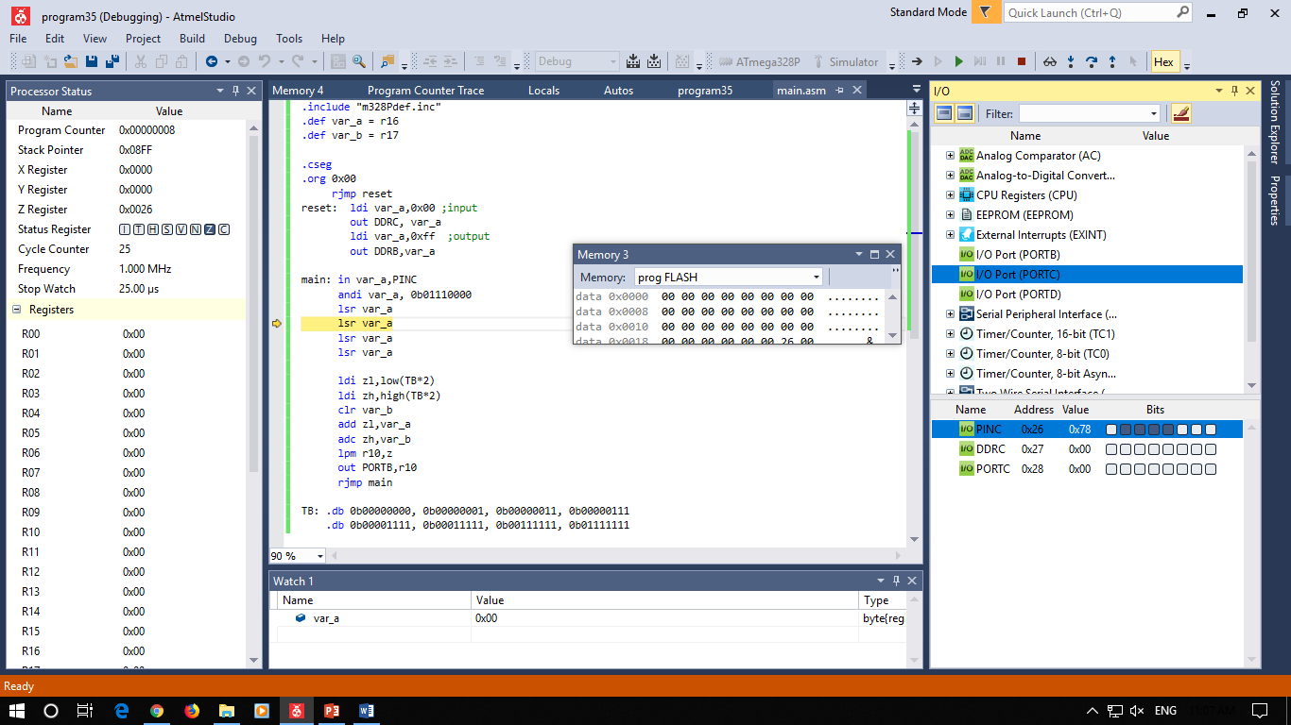

Program 33