Program21

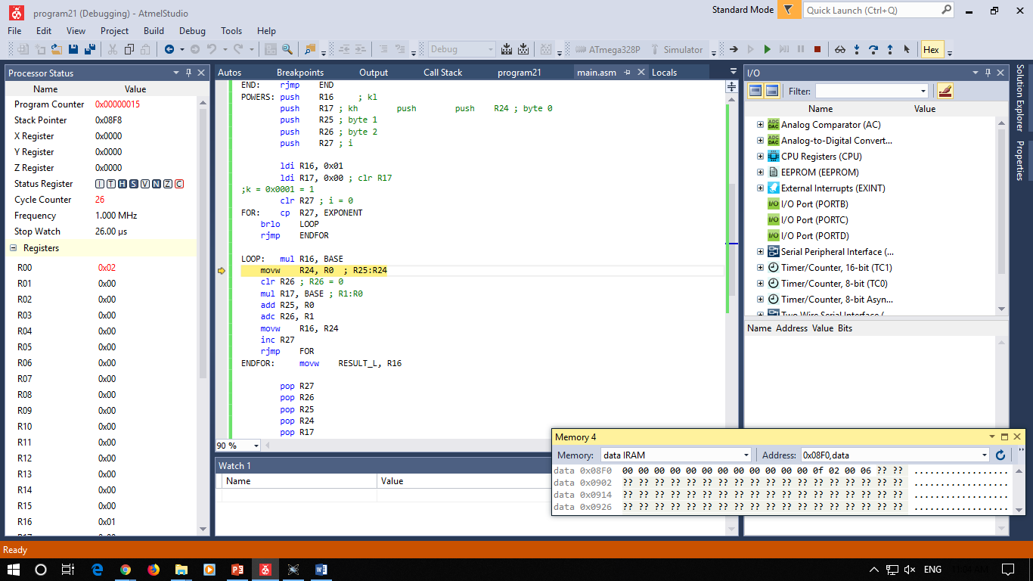

; program21.asm

.INCLUDE "m328Pdef.inc"

.DEF VAR_A = R16

.DEF VAR_B = R17

.DEF VAR_CL = R18

.DEF VAR_CH = R19

.DEF BASE = R20

.DEF EXPONENT = R21

.DEF RESULT_L = R22

.DEF RESULT_H = R23

.CSEG

.ORG 0x0000

rjmp RESET

RESET:

MAIN: ldi VAR_A, 2

ldi VAR_B, 15

mov BASE, VAR_A

mov EXPONENT, VAR_B

rcall POWERS

movw VAR_CL, RESULT_L

mov VAR_A, VAR_B

END: rjmp END

POWERS: push R16 ; kl

push R17 ; kh push push R24 ; byte 0

push R25 ; byte 1

push R26 ; byte 2

push R27 ; i

ldi R16, 0x01

ldi R17, 0x00 ; clr R17

;k = 0x0001 = 1

clr R27 ; i = 0

FOR: cp R27, EXPONENT

brlo LOOP

rjmp ENDFOR

LOOP: mul R16, BASE

movw R24, R0 ; R25:R24

clr R26 ; R26 = 0

mul R17, BASE ; R1:R0

add R25, R0

adc R26, R1

movw R16, R24

inc R27

rjmp FOR

ENDFOR: movw RESULT_L, R16

pop R27

pop R26

pop R25

pop R24

pop R17

pop R16

ret