For detection of tryptic peptides from probe-modified and enriched proteins

*when measuring inhibitor dry stocks for DMSO solutions, do not try to measure less than 2 mg of compound. The error from measuring small amounts of compound can drastically affect the final concentrations tested in your assay.

A-1. START HERE if you are performing inhibitor competition
- Thaw 1 mg proteome aliquots on ice for sample and control
*proteomes are in PBS with no protease or phosphatase inhibitors
*proteome concentrations are 2.3 mg/mL to achieve 1 mg using volumes specified below
- Use 427 µL of proteome from #1 for the preparation below.
- Add 5 µL of 100x compound (1 mM solution in DMSO), and incubate 30 min, 37 ºC
- Follow 3 and 4 in A-2

A-2. START HERE if you are only performing probe labeling
- Thaw 1mg proteome aliquots on ice for sample and control
*proteomes are in PBS with no protease or phosphatase inhibitors
*proteome concentrations are 2.3 mg/mL to achieve 1 mg using volumes specified below
- Use 432 µL of proteome from #1 for the preparation below.
- Add 5 µL of 100x probe (or DMSO to control), gently mix tube.
- Incubate 1 hr, room temperature (RT)
*The time may be adjusted based on the probe.

B. Click chemistry (use only with alkyne probe; for biotin probes go procedure C)
*if you are making a master click chemistry mix (i.e. all compounds premixed before adding to individual samples), do not add CuSO4 until just before you are ready to add master mix to samples.
- Tag: Add 10 µL of 50x (10 mM, 2 mg/410 µL in DMSO) Biotin-N3 or desthiobiotin-N3, giving 200 µM final.
- TCEP: Add 10 µL of 50x (50mM, 7.17 mg/500 µL in H₂O) TCEP (make fresh), giving 1mM final, vortex
- Ligand: Add 33 µL of 16.7x (1.67 mM) TBTA Ligand, giving 100 µM final, vortex
1.67 mM = 20 µL 50x + 180 µL DMSO + 800 µL t-BuOH
8.85 mg into 200 µL in DMSO gives 50x stock
- Cu: Add 10 µL of 50x (50 mM, 12 mg in 960 µL H₂O) CuSO4 (Fisher Scientific CAS 7758-98-7), giving 1mM final, vortex
- Rxn 1 hr (final vol = 500 µL) at RT

C. MeOH/CHCl₃ ppt to remove excess probe (an alternative to MeOH washes)
- Add 2 mL (4x volume) MeOH to 8 mL/2-dram glass vial.
- Add 0.5 mL (1x Volume) CHCl₃
- Add samples into the dram vial. For SILAC samples, add light samples first followed by heavy samples.
- Add 1.0 mL* (3x volume) H₂O to sample microfuge tubes and wash out any residual proteome. Take this 1.0 mL* of H₂O and add to the dram vial already containing MeOH/ CHCl₃/sample
*for SILAC samples (1 mL total sample volume), add 1.0 mL H₂O
*for non-SILAC samples (0.5 mL total sample volume), add 1.5 mL H₂O
- Vortex
- Centrifuge 1,400 g x 3 min
- Remove top and bottom layers, leaving protein interface
- Transfer interface to screw-top microcentrifuge tube (Sarstedt D-51588) in 600 µL MeOH
- Rinse dram vial with 150 µL CHCl₃, and add this 150 µL CHCl₃ to the screw-top microcentrifuge tube. Vortex.
- Rinse dram vial with 600 µL H₂O, and add this 600 µL H₂O to the screw-top microcentrifuge tube. Vortex
- Centrifuge 1,400 g x 3 min
- Remove top and bottom layers, leaving protein interface
- Add 600 µL MeOH, sonicate with probe sonicator 3 pulses (output 3)
- Centrifuge 14,000 rpm 5 min to pellet protein, remove MeOH

D. Reduction, Alkylation
- Re-suspend pellet in 500 µL of 6M urea/25mM ammonium bicarbonate (ambic)
3.6g Urea (MW=60.06) in 1mL 250mM NH₄HCO₃ stock
(MW_NH₄HCO₃=79.06; 198 mg into 10 mL gives 250 mM stock, make fresh)
Bring volume up to 10 mL with mQ water
- Add 5 µL 100x (1M, 15.4 mg/100 µL in H₂O) DTT, giving 10 mM final (make fresh)
- Incubate 65 ºC 15 min, let cool to RT or cool briefly on ice
- Add 40 µL 50x (0.5M, 28 mg/300 µL in H₂O) IAA, giving 40 mM IAA (make fresh)
- Incubate RT 30 min, in the dark
- Add 140 µL 10% (1g/10mL) SDS (giving 2% final), Heat 65 ºC 5 min
- Dilute sample with 5.5mL DPBS in conicals.

E. Avidin Enrichment
- Remove 100 µL aliquot of 50% avidin slurry per sample (in this example, 1 bed volume = 100 µL) and place in 15 mL conical. Wash 3X by adding 10 mL of PBS, centrifuging at 1,400 x g for 1 min and decanting.
- Resuspend washed beads in 1 bed volume of PBS and transfer equivalent amount of beads to all samples in 15 mL conicals. Add PBS for a total volume of 5.5 mL per sample.
- Incubate RT, rotating for 1 hr
- Spin 1,400 x g for 1 min to pellet; remove ~90% of supernatant by decanting ONCE
***Do not decant more than one time!!! Your beads will become re-suspended and you will dump out all of the beads on the second pour!

F. Wash Beads
- Wash 3X with 25 mM ambic by adding 10 mL, decanting ONCE, and centrifuging 1,400 x g for 3 min.
- Wash 3X with LC-MS water by adding 10 mL, decanting ONCE, and centrifuging 1,400 x g for 3 min.

G. Trypsin Digest
- Transfer bead to low-bind microfuge tube with 200 µL of 25 mM NH₄HCO₃.
- Add 4 µL of 0.5 mg/mL sequence-grade trypsin (Promega, 20 µg resuspended in 40 µL Trypsin buffer) giving 2 µg total. Max 10 samples (8 samples recommended)
- Incubate 37 ºC overnight (not more than ~12hrs)

H. Collect Tryptic Peptides
- Transfer supernatant and beads to biospin column, collect in clean microcentrifuge tube by centrifugation (1,400 g x 3 min)
- Acidify eluate with 16 µL formic acid (to 5% final), and then Speedvac samples
- Re-suspend peptides in 50 µL of mobile phase A (LC-MS water + 0.1% FA)
Stage Tip cleanup of peptides

A. Protocol to prepare the StageTip
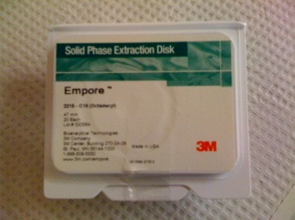
Materials:

Empore Extraction Disks:
Octadecyl (C18)-bonded silica, part no: 2215, Vendor: 3M, St. Paul, MN

200 μl Pipette tips
Needle: Kel-F Hub (KF), point style 3, gauge 16(1.19mm) part no: 90516
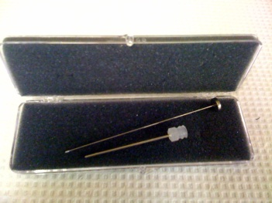
Plunger Assembly: N, RN, LT, LTN for model 1702 (25 μl)

1. Place one Empore extraction disk into a petri dish.
2. Use the Needle to pick up the stationary phase from the disk.
3. Use the plunger to insert into the 200 μl pipette tip.
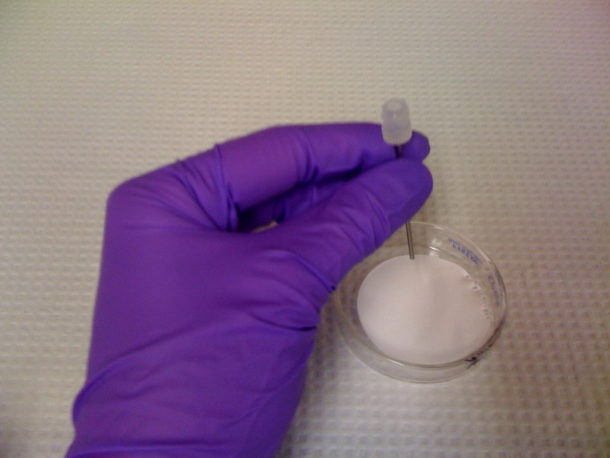

B. C18-StageTips for clean-up and concentration
* Use gel loading tips to be able to load the solvents and the sample right on top of the disk! Do not dry the disk at any time! Disk without any liquid will dry out in 1-3 min! Repeat beginning from Step 1 if you dry the disk.

- Condition column by wetting disk with 20 µL methanol (0.9G for 1 min)
  - Do not let tips dry completely
- Add 20 µL Buffer B (80% ACN + 0.1% FA) to stage tip. Spin at 900 x g for 1 min.
- Add 20 µL Buffer A (Water + 0.1% FA) to stage tip. Spin at 900 x g for 1 min.
- Load sample directly to the disc using gel loading tip. Spin at 900 x g for 1 min.
- Wash using 20 µL Buffer A. Spin at 900 x g for 1 min.
*Repeat step three times. This step might take longer than 1 minute, but check it periodically and ensure the stage tip does not dry.
- Switch to low-bind tube.
- Elute using 20 µL buffer B. Spin at 900 x g for 1 min.
- *Repeat step three times. This step might take longer than 1 minute, but check it periodically and ensure the stage tip does not dry.
- Spike in synthetic peptide standards for normalization and QC purposes: prepare a 100 fmol/µL Angiotensin/Vasoactive (AV) standard solution and add 2.5 µL of peptide mix into each sample. *after re-suspending samples in 50 µL of mobile phase in step 12, the AV concentration in samples is 5 fmol/µL and injection of 2 µL onto the LC-MS results in analysis of 10 fmol of AV peptides.
- Poke holes from inside towards outside of microcentrifuge cap (minimize plastic debris in sample).
- Snap freeze peptides in liquid N2 (speeds up the drying down process) and dry down on speedvac. Do not allow liquid N2 to enter into tube.
*AVOID performing the speedvac drying step overnight because of peptide adsorption issues described in step 10 below
- Re-suspend peptides in 50 µL of mobile phase A (LC-MS water + 0.1% FA) and analyze 3 µL of sample on LC-MS.
*note that 3 µL injection volume is generally recommended; the volume may need to be adjusted based on proteome input and protein/peptide coverage
- DO NOT store peptides in low-bind tubes because peptides will adsorb to the plastic and reduce signals on the LC-MS. After reconstituting peptides with mobile phase A, transfer 25 µL aliquots of peptides into 2X amber vials with spring-loaded glass inserts for storage. One vial is stored as backup while the other vial will allow 2X injections on the QE+ protein nanoLC-MS.

*sample queue templates are available at: Xcalibur/methods/Standard_Sequence_Queue

