FASP Protocol
[30 kDA MWCO filter, tryptic digestion at 37°C; max. 250 μg total protein]

1. Solutions and Reagents
DTT solution: 50 mM (3 μl per 1 sample)
UA: 8 M urea (Sigma, U5128) in 0.1 M Tris/HCl pH 8.5. Prepare 1 ml per 1 sample.
IAA solution: 0.05 M iodoacetamide in UA. Prepare 0.1 ml per 1 sample.
Trypsin, Stock 0.4 μg/μl
ABC: 0.05 M NH4HCO3 in H₂O. Prepare 0.4 ml per 1 sample
(0.5 M NaCl in water. Prepare 0.05 ml per 1 sample)

Note:
UA and IAA solutions must be freshly prepared and used within a day.

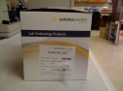
Equipment

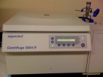
Vivacon 500 30 kDa MWCO Filter (No: 14558347 Fischer Scientific)
Refrigerated bench-top centrifuge (Eppendorf 5415R), temperature const. 20°C
Incubator with a rack for micro centrifuge tubes at 37°C and 56 °C
Vortexer

2. Protocol
1. Reduce 27 μl protein by adding 3 μl of 50 mM DTT to a final conc. of 5 mM in the 56 °C incubator for 30 min.
2. Mix with 200 μl of UA in the filter unit and centrifuge at 14,000 x g for 15 min.
3. Add 200 μl of UA to the filter unit and centrifuge at 14,000 x g for 15 min.
4. Discard the flow-through form the collection tube.
5. Add 100 μl IAA solution, mix at for 1 min and incubate for 20 min in the dark.
6. Centrifuge the filter units at 14,000 x g for 10 min.
7. Add 100 μl of UA to the filter unit and centrifuge at 14,000 x g for 15 min. Repeat this
step twice.
8. Add 100 μl of ABC to the filter unit and centrifuge at 14,000 x g for 10 min. Repeat this
step twice.
9. Change the vial and add 40 μl ABC with trypsin (enzyme to protein ratio 1:100), mix for 1 min.
10. Incubate the units in a wet chamber at 37°C for 4 -18 h.
11. Add 40 μl ABC and centrifuge the filter units at 14,000 x g for 10 min.
(12. Add 50 μl 0.5 M NaCl and centrifuge the filter units at 14,000 x g for 10 min.
13. Acidify with 5% Acetic acid and desalt the filtrate using Stage tips or desalting cartridges.) These steps only if no ion exchange is going to be performed!

StageTip Protocol

1. Protocol to prepare the StageTip
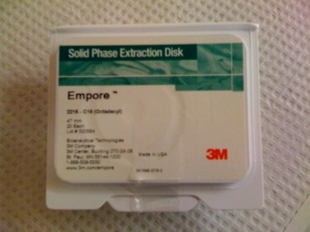
Materials:

Empore Extraction Disks:
Octadecyl (C18)-bonded silica, part no: 2215, Vendor: 3M, St. Paul, MN

10 μl Pipette tips
Needle: Kel-F Hub (KF), point style 3, gauge 20(.58mm) part no: 90520
Plunger Assembly: N, RN, LT, LTN for model 1701 (10 μl)

200 μl Pipette tips
Needle: Kel-F Hub (KF), point style 3, gauge 16(1.19mm) part no: 90516
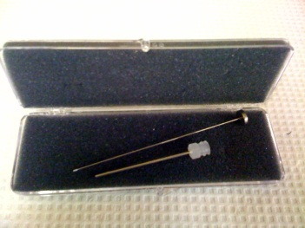
Plunger Assembly: N, RN, LT, LTN for model 1702 (25 μl)

1 ml Pipette tips
Needle: Metal Hub, point style 3, gauge 10 part no: 91010
Plunger Assembly: N, RN, LT, LTN for model 1710 (100 μl)

1. Place one Empore extraction disk into a petri dish.
2. Use the Needle to pick up the stationary phase from the disk.
3. Use the plunger to insert into the 200 μl pipette tip.
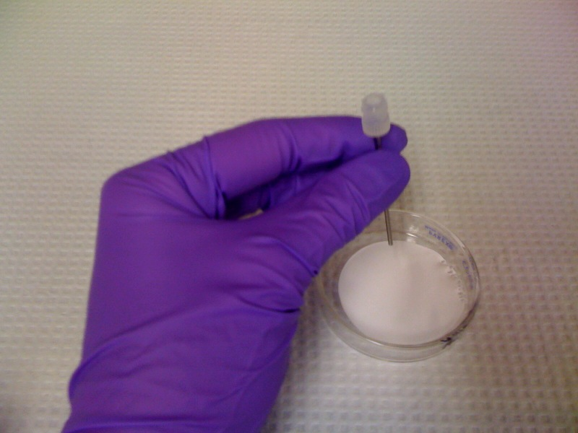

Protocol for C18-StageTips for clean-up and concentration

95% recovery of 25 μg for a 200 μl pipette tip (0.9×0.5, 320 nl bead volume)
(Volume can be doubled by stacking 2 disks on top of each other)
and 4.5 μg for a 10 μl pipette tip (0.4×0.5, 60 nl bead volume)

Solutions:

Buffer A: 0.5% Acetic acid
Buffer B: 0.5% Acetic acid, 80% ACN

Important:
Use gel loading tips to be able to load the solvents and the sample right on top of the disk! Do not dry the disk at any time! Disk without any liquid will dry out in 1-3 min! Repeat beginning from Step 1 if you dry the disk.
1. Conditioning. Wet the disks by passing 20 μl methanol through the StageTip.
2. Add 20 μl buffer B to the StageTip just before the last remainder of methanol has left the tip, and pass buffer B through the tip.
3. Add 20 μl buffer A to the StageTip just before the last remainder of buffer B has left the tip, and pass buffer A through the tip. Stop before the last remainder of buffer A has left the tip to avoid the tip drying completely.
4. Sample loading. Load the desired sample volume acidified by the addition of sufficient Acetic acid from a 5% stock solution onto the tip. As the C18 disk serves as a desalting platform, the salt concentration in the sample is not important.
Critical step: The amount of Acetic acid needed should be tested on an equal amount of digestion buffer to that used for the sample. Do not attempt to directly measure the pH of the digest solution as this would result in the loss of peptides.
5. Wash. To wash the tip add 20 μl buffer A just before the last remainder of the sample has left the tip, and pass the buffer A through. Pause Point: The peptide-loaded, washed C18 StageTips can be stored in buffer A in the fridge or at - 20 or - 80 °C.
6. Elution. Apply 10 μl buffer B two times, collect the combined eluate in a well of a 96-well plate and prepare for LC–MS/MS (Step 2).

Protocol for StageTip Anion fractionation and StageTip cleanup

For 20-100ug of total protein digest:

Materials:
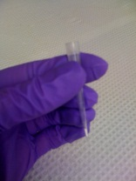
- Anion exchanger tip-column (in pipette tip). Stack 6 layers of Empore
Disk Anion Exchange (Varian, 1214-5012) in a 0.2 mL pipette tip.
- StageTip: Stack 3 layers of Empore/C18 in a 0.2 mL pipette tip. (StageTip).
Prepare 6 StageTips for each separation.
- Eppendorf deep well plate rotor equipped with 2 Greiner pipette tip boxes robust up to 1,800 × g.

Solutions:

- Britton & Robinson Universal Buffer: Solution containing 0.02 M CH3COOH, 0.02 M H3PO4, and 0.02 M H3BO3 and adjusted with 1 M NaOH to the required pH. Following pHs are recommended: pH 3, 4, 5, 6, 8, and 11. Add NaCl to the solution pH 3 to final concentration of 0.25M. The buffer can be bought at Fischer Scientific.
- 1M NaOH
- Methanol
- 80% (v/v) CH3CN containing 3% (v/v) CF3COOH
- HPLC grade water
- 60% (v/v) CH3CN

Sample preparation:

Peptides have to be desalted or eluted during FASP procedure only with 40 mM (NH)4HCO3. Dissolve peptides or dilute peptide solution with buffer pH 11. Do not exceed 0.2 mL final volume of the sample solution. Check pH of the solution.

Anion exchanger tip-column conditioning

1. Assemble the tip-column in the pipette tip box. (Always balance the centrifuge!)
2. Add 0.1 mL of methanol to the tip-colum and centrifuge at 1,800 × g for 2 min;
3. Add 0.1 mL of 1 M NaOH to the tip-colum and centrifuge at 1,800 × g for 2 min;
4. Add 0.1 mL of the buffer pH11 to the tip-colum and centrifuge at 1,800 × g for 2 min;
5. Repeat 4 once more. (Make sure to have always some liquid on top of the tip left.)

StageTip conditioning

1. Assemble the StageTip in the pipette tip box;
2. Wash the stage tip subsequently with:
a. 0.05 mL of CH3OH;
b. 0.05 mL 80% (v/v) CH3CN containing 3% (v/v) CF3COOH;
c. 0.05 mL of water.

Sample loading and separation

1. Assemble the C18 StageTip in the pipette tip box. Cut the top part of the the anion exchange Tip column and place on top of the C18 StageTip.
2. Load the sample.
3. Centrifuge at 1,800 × g for 1 min.
4. Add 0.1mL of the buffer pH 11 to the tip-colum and centrifuge at 1,800 × g;
5. Transfer the tip-column to the next StageTip
6. Continue in 1-4 eluting subsequently with the buffers of pH 8, 6, 5, 4, and 3 into
individual StageTips.
7. Wash the stage tips with 0.05 mL 0.1% (v/v) CF3COOH in water.
8. Elute fractions with 100 µl 60% (v/v) CH3CN by using a syringe into vials.

Protocols are adopted with minor changes from following references [1-4]:
[1] Y. Ishihama, J. Rappsilber, M. Mann, J.Proteome Res. 5 (2006) 988.
[2] J. Rappsilber, Y. Ishihama, M. Mann, Anal. Chem. 75 (2003) 663.
[3] J. Rappsilber, M. Mann, Y. Ishihama, Nat. Protoc. 2 (2007) 1896.
[4] J.R. Wisniewski, A. Zougman, M. Mann, J. Proteome Res. 8 (2009) 5674.
Last update: 7/21/11

