Designing the primer (read here if you are a beginner)
This is the most crucial and intensive part of this process. The other steps proceed according to directions, but designing primers carries an element of art. I will give general guidelines for the design of primers, but there’s no substitute for the act of actually designing them. I have nearly a decade of experience with this, so feel free to email me if you need advice, even if I’m not in the lab anymore. SeanCampbellChemist@gmail.com will get to me.
Determining your sequence
Anyway, design. The first thing to do is determine your actual sequence. First, you should find your gene of interest on Uniprot, which contains the canonical protein sequences for most known proteins. This will help you locate your DNA sequence in further steps. Next, you need to locate the actual DNA sequence. This depends highly on the provenance of said sequence. I have several plasmid maps for genes we have in the lab, notably rDGKa, rDGKb, hDGKa-Flag and Flag-hDGKa, hDGKI, hDGKe, and mDGLB. These can be accessed with a program called SerialCloner. However, that is the minority of plasmids in the lab. An increasingly likely place is from Genscript. If you know the plasmid is from Genscript, try to find the ‘Clone ID’. It will likely start with the letters ‘OHu’ (ORF clone, human). If you have that number, searching genscript’s site will pull up the relevant RefSeq number:
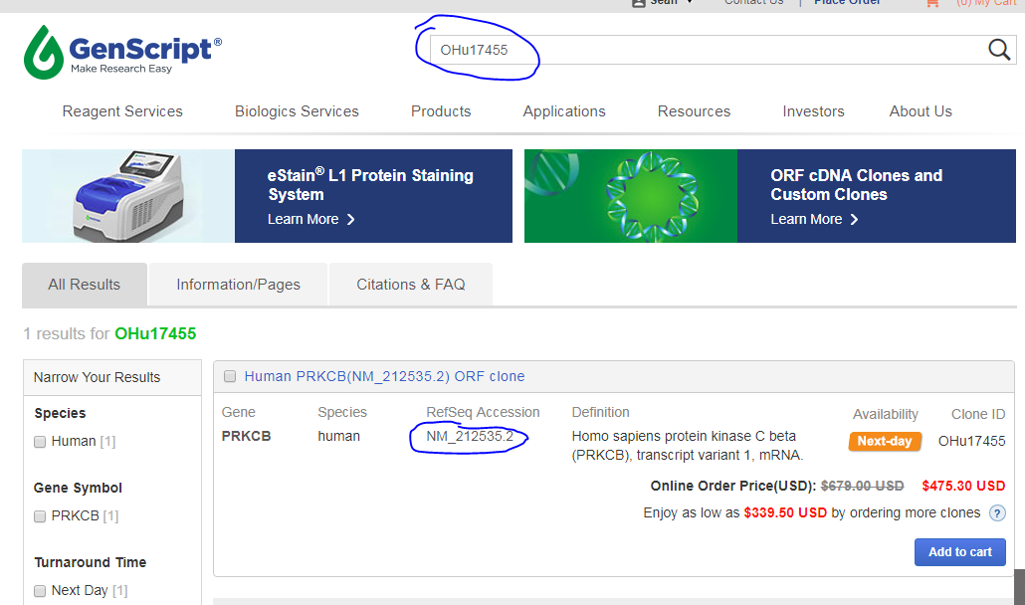
You can then search that number in google to find the NCBI page associated:
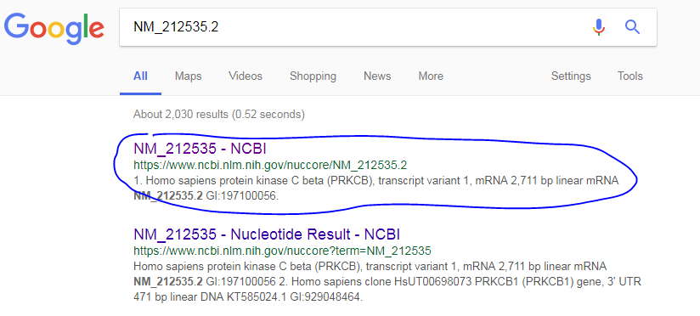
This page gives both the proper ORF translation (line starts with “/translation=") as well as the full cDNA (the very last section, it starts with “ORIGIN”). Once you find this, you may copy the DNA sequence and proceed to the section on translation, below, keeping the page open to refer to the translation.
Another likely place is Addgene, especially as our Kinase Library is from Addgene. Addgene houses the full gene sequences for the majority of it’s plasmids, so if the plasmid was originally from Addgene there’s a good chance it is there. If you know it was from Addgene, get the full name of the plasmid and search for it on Addgene’s site (addgene.org). Most plasmids offer choices of Partial or Full sequences with links under the “SEQUENCE INFORMATION” portion of the page. If ‘Full’ is available, click that link and copy the sequence information. If it is not, choose a relevant partial sequence (typically there is one whose name includes ‘fwd’ or ‘forward’, choose that if available),as shown for pDONR-PRKCB2:
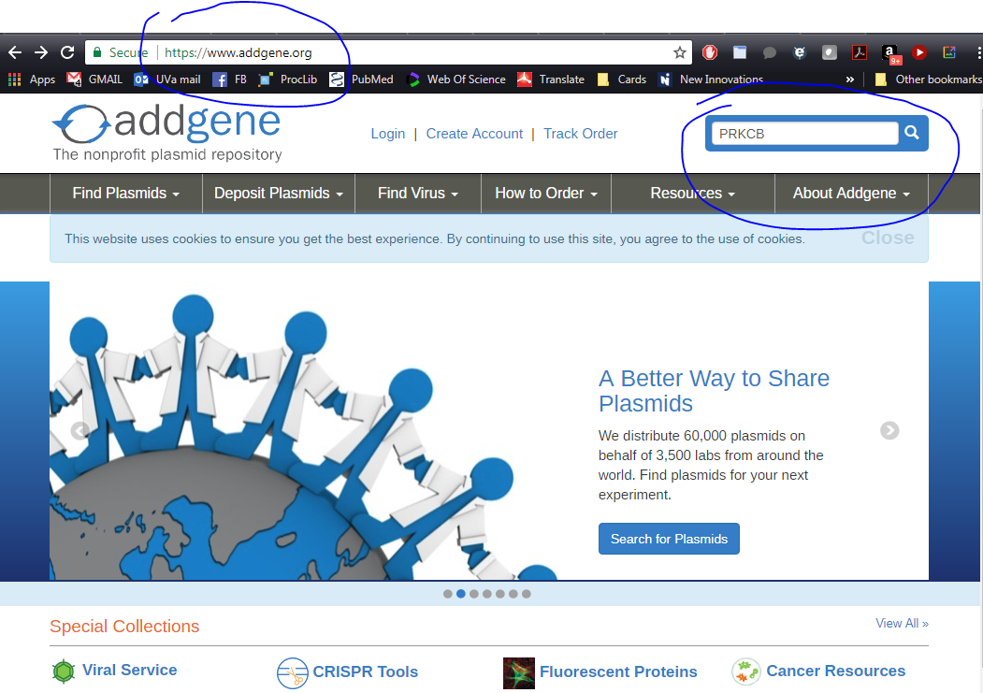
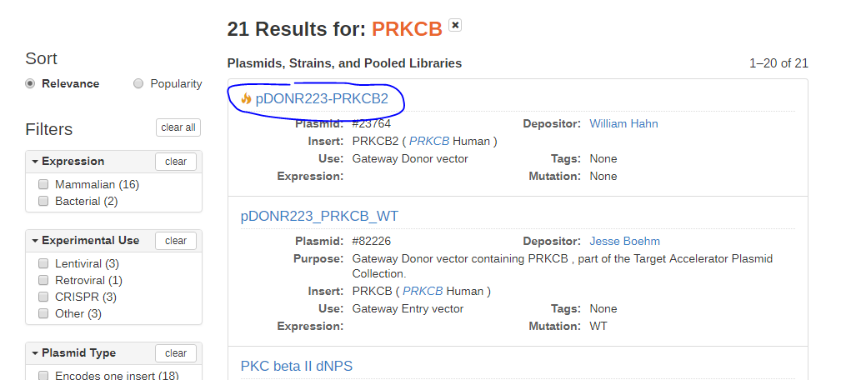
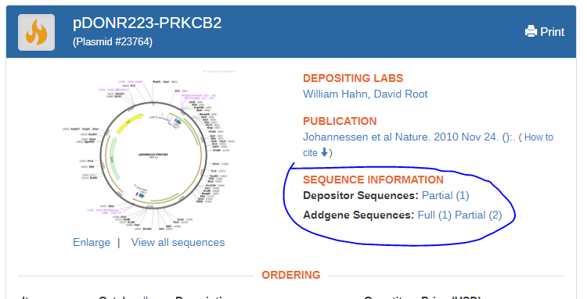
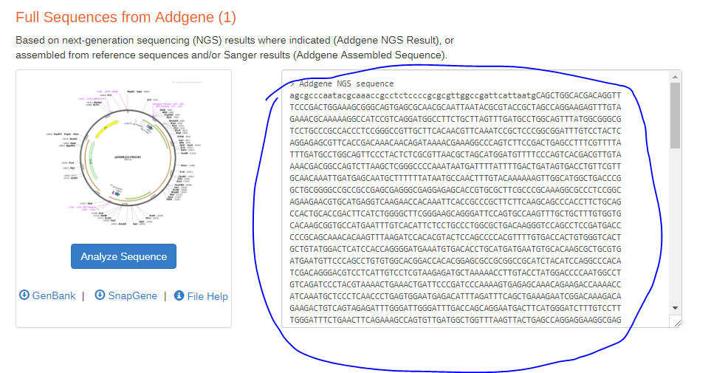
OR

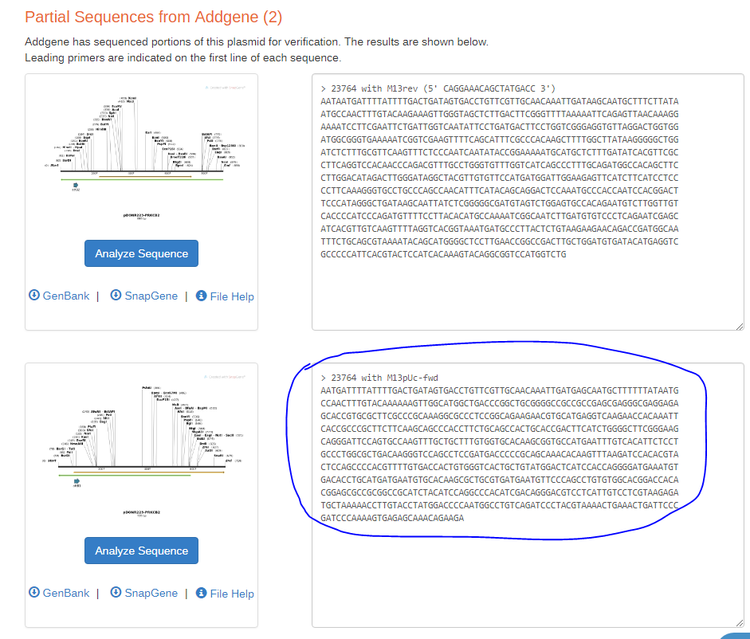

With sequence in hand, translate it to protein with https://web.expasy.org/cgi-bin/translate/, using the ‘compact’ setting, as shown:

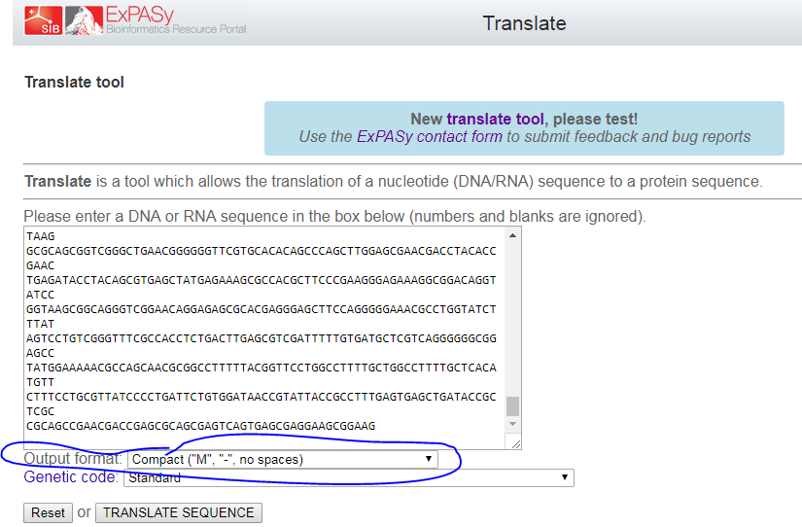

It will output six sequences, for the six possible frames (three forward, three reverse). There is a very good chance your sequence is in the forward frames, but if you don’t find your candidate also check the reverse. This is where the Uniprot or NCBI sequence will come in handy. From Uniprot, the PRKCB2 protein starts with ‘MADPAAGPPP…’.
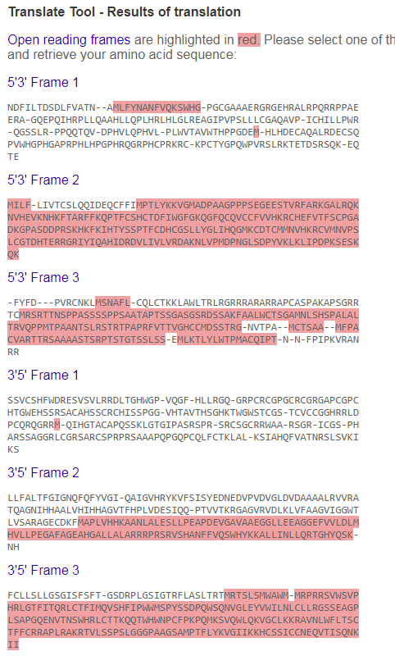
This can be seen in frame 2 (ctrl+F is very useful here). This tells you that you have the right gene, the proper frame, and the start of your open reading frame, or ORF. Now, we want to find the exact start of our ORF in the DNA. I suggest at this point opening a new word doc to copy sequences to for easy access later.
Take note of the start of your sequence. Here, it’s MADPAA. Back up in Translate to the input screen, and re-paste sequence if necessary. Change the Output Format to “Includes nucleotide sequence”, and translate again. Above, we found that our ORF was in 5’3’ (aka ‘forward’) frame 2. So we find that again, then scan for the start of our gene. If you have a long sequence, cntl+F will again be helpful, this time adding two spaces between letter (For instance, “M A D P A A”):
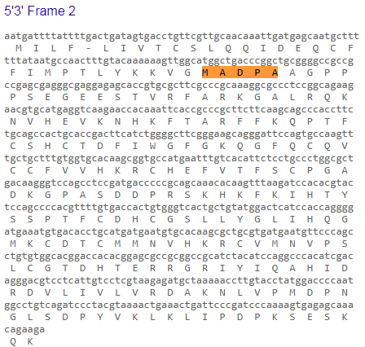
Now you have your DNA sequence! At least, the start. Go back to your primary sequence and search for that (in this case, it’s “ATGGCTGACCCGGCT…”). If you have the end of your sequence (it will terminate in an – on expasy), do the same, and isolate the full sequence. If not, like above, simply take the whole thing.
Unfortunately, the next steps get a little complicated, based on where you got your sequence. If the sequence is from me or GenScript, you can skip to “Designing the primer”, as you should have the full sequence. If it’s Addgene but you were able to find a ‘full’ sequence, you may also skip ahead. However, if you were only able to find the partial Addgene sequence, you need to either determine that you have the codon you wish to mutate or find the rest of the sequence.
Take a look at your chunk of sequence and see whether it covers the particular codon. The above sequence runs through K211 (position found with uniprot, by searching for “SESK”):
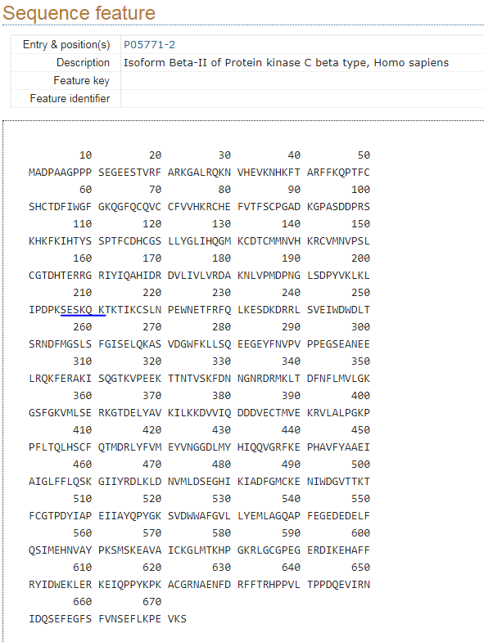
So, if your target residue is less than 211, congrats! You have your sequence and can move on to “Designing the primer”. However, in this example, PRKCB2 is a 673 residue protein, so chances are you’ll need more sequence. Unfortunately at this point, if you don’t have direct sequence data it’s possible you’ll use an incorrect sequence. But we’ll try our best. The best resource for this is NCBI Blast: https://blast.ncbi.nlm.nih.gov/Blast.cgi. Specifically nBlast, for nucletides, on the left. Take as much of your sequence as you have (I’ve used the whole sequence above starting with “ATGGCTGACCCGGCT…”, and hit ‘Blast’ at the bottom. You may also restrict this to human results if you know your gene is human, by entering ‘Homo sapiens’ or ‘9606’ into the ‘Organism’ field:
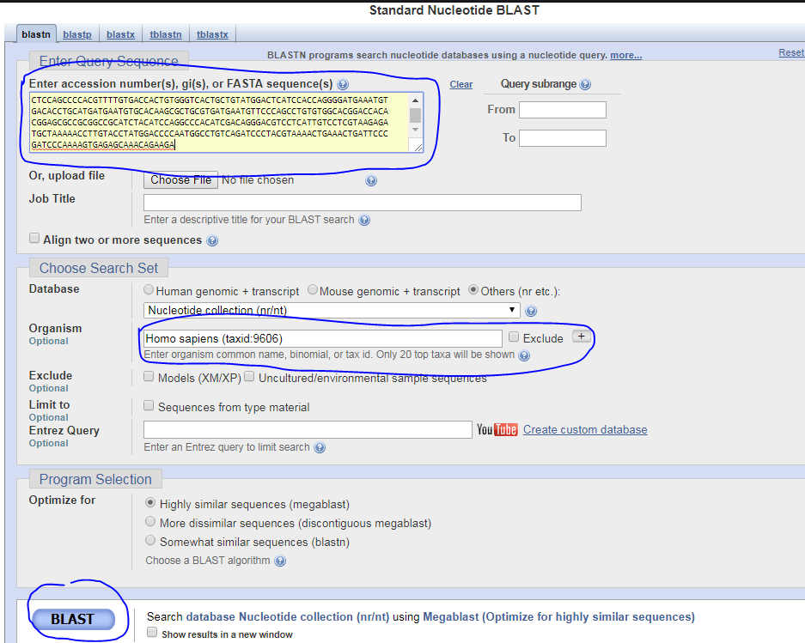
This will result in a list of hits. Look for the top hits (highest Identity), and for one that matches the protein name you think you have. ‘synthetic constructs’ should be ignored.
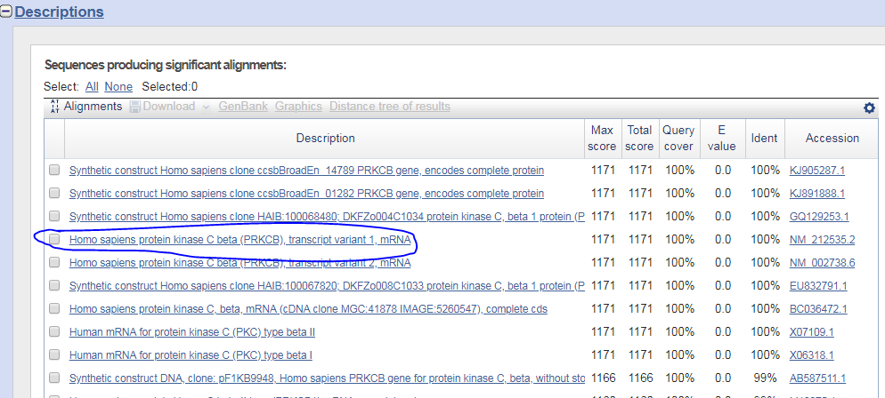
Click on the NCBI number on the right (“NM_...”) to be taken to the NCBI page, same as if you had your gene from GenScript. Congrats! Follow the same steps as earlier to determine your ORF sequence, and proceed.

Designing the primer
Method 1: Now that you have your full sequence, things get easier. First, isolate the whole DNA sequence and send it back through Translate, this time with the “Include Nucleotide Sequence” setting. This will give you your whole ORF and associated sequence. I will continue with my PRKCB1 example:
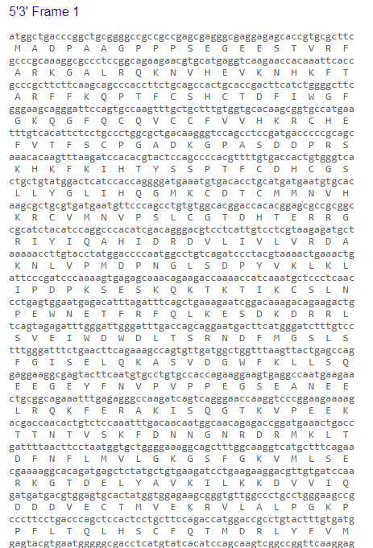
(sequence continues. It’s a long one).
So copy that all into a work doc. Next, determine the residue you wish to mutate. Again, Uniprot will be useful on this count. Typically you should have at least a residue type and position. If you’re using MS data you may have a whole stretch of sequence, which is even better. Let’s say we have a type and number: Y285. We simply go to uniprot and find it:
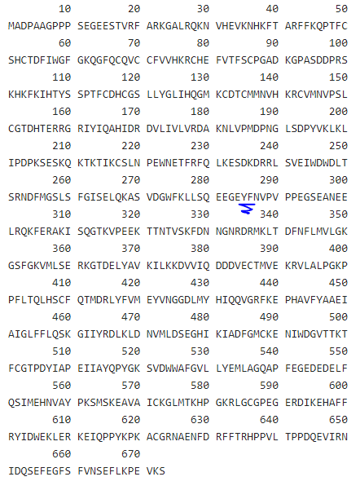
We get the surrounding residues, and then find those on our translated sequence, again spacing letters so it’s found (i.e. “G E Y F N”): 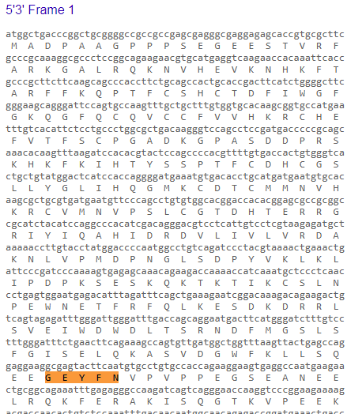
You then want to grab the sequence, at least five residues on either side. In this case, I’ll grab the whole upper line, because it’s easier:
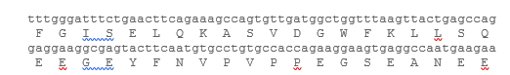
Now, isolate some sequence. There are some general rules, and we’ll get in to specifics after finding a promising bit. So, rules:
- Sequence must terminate in a G or C.
- Sequence should be no less than five (5) residues on either side of the residue to be mutated
- More Gs and Cs are better, so extending the primer to include a G/C rich region is generally a good idea.
So, with those in mind, we’ll take from the Serine before Y285, through the third Proline, to give us those extra Cs and Gs in that region:
Now, isolate the residue of interest. Here, it’s the ‘tac’ in the middle:
And now we decide how exactly to mutate. Also some general rules:
- Less disruption is better. If you can do the mutation in one base, don’t take three
- If they’re the same degree of disruption, a more human-compatible codon is better.
To the second point, codons are used in varying levels in different species. So we want to stick to ones used in human DNA more regularly. To this, I present this chart:
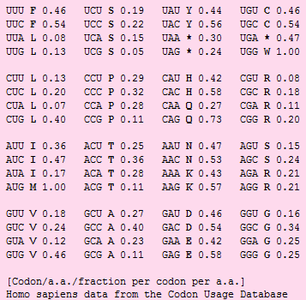
The higher the fractional number, the more common the codon. Keep in mind that this is actually an RNA chart, so U = T. In this case, we can find our Y codon, TAC (UAC in the chart), at a fractional usage of .56. If we’re doing a tyrosine mutation, we’d typically like to mutate it to Phenylalanine, as they have nearly identical structures except for the hydroxy group on Tyrosine. So our final mutant will be denoted as Y285F. There are several notations used for mutants, however this is the most widespread (and by far the simplest and easiest to use) so I would highly suggest you stick to that.
So, we need Y285F, so what are out possible codons? There’s only 2, TTT and TTC. The easiest transformation would be TAC -> TTC. That’s only one base change, and it also gives us the most common codon. Though the difference of .56 and .46 is minor. It’s codons like ACG (.11) that I would avoid. Anyway, we now have our mutant codon. So let’s insert that into the sequence, and then check that it was done properly with Translate:
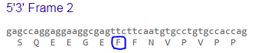
It worked! We’re almost done. The last thing we need to do is check the specifics of the design, to ensure everything is good: size and annealing temperature of the primer:
- Sequences must be longer than 25 bases and should be longer than 45. This latter can be stretched but only when strictly necessary.
- Sequence should have an annealing temperature above 78º C.
Primers that are too short or with an annealing temperature that is too low will not work well in the PCR reaction, and too long can inhibit the reaction by forming structure. We’re at 44 bases, so okay there. For temperature, we use the following equation is taken from the Agilent QuikChange II-E Kit, available here: https://www.agilent.com/cs/library/usermanuals/Public/200555.pdf, on page 6:
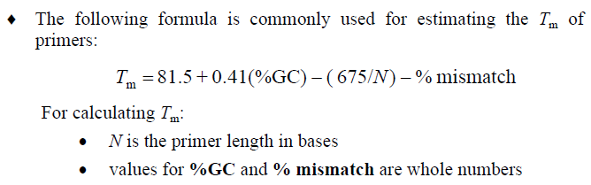
For me, N is 44.
% GC is 26/44*100 = 59.1% (literally just counted them. It’s annoying, I know).
% Mismatch is 1/44*100 = 2.3% (1 changed base)
The final equation is 81.5 +.41*59.1-675/44-2.3 = 88.1º C. That’s great!
So my primer is in the right range in all respects. We’re almost done with design!
If your primer does not meet both requirements, do the following:
Length: Just take more or less bases (as appropriate). Make sure to respect the other rules.
Temp: Shorter or lengthen your primer to have less As and Ts or more Gs and Cs, respecting the length limits, until you hit something usable.
There may be times that you cannot optimize both the length and temp appropriately. In that case, I would suggest making the primer the highest temp possible while staying within 25 to 45 bases and hoping for the best. Breaking one rule will not guarantee failure.
The last step is to make your second primer. Mutagenesis primers are always designed in pairs, so you need your second. Luckily, this is very easy, as it is simply the reverse complement of your designed strand. There are many reverse complement ‘calculators’ out there, I happen to use one from bioinformatics.org: https://www.bioinformatics.org/sms/rev_comp.html. Simply input your sequence, make sure it’s selecting ‘reverse-complement’, and hit ‘Submit’:
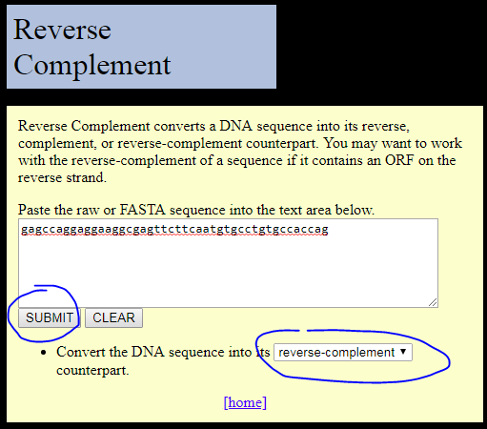
It will pop up a new window, like so:
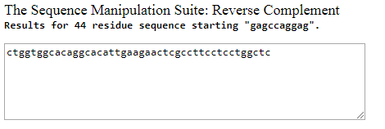
Simply save that new sequence, and you’re good to go. No need to check temp on this, as it will be exactly the same as the forward primer.
I would also now name your primers for future identification. My system is to use initials, gene target, mutation, and direction. So that first primer would be ‘SC-PRKCB-Y285T-Fwd’, and the new one is ‘SC-PRKCB-Y285T-Rvs’. This will help keep you organized if you ever do more.
IMPORTANT LAST NOTE!
The only reliable way to determine if a mutagenesis was successful is through sequencing, and so you must have relevant primers for sequencing! Relevant means: in lab or offered for free by genewiz, and it lies at a distance of no less than 50 and no more than 700 bases (that’s bases, not residues) from your mutation site. For instance, if you’re mutating a gene in the pGCFlag plasmid (most any Gateway-cloned expression vector in our lab), the SP6 and T7 primers (offered for free by genewiz) lie ~50 residues from the start and end of the gene, respectively. So, you can reliably sequence ~650 bases into the start or end of your gene with those primers. So if your mutation is either in the first or last ~216 residues of your protein (650 bases ≈ 216 residues), you’re good. However, if it’s outside of that range, you must have another primer to sequence! Otherwise there’s essentially no good way to tell if the reaction worked. So, at this point, check your primers.
If you do not have a good sequencing primer, simply design and order a new one. This is quite simple if you have the full gene sequence, which you should by this point:
- Travel up the gene about 150 bases from your point of mutagenesis. This extra room is simply to give us the best chance to see the mutant.
- Select 25 bases of the gene sequence.
- Congrats, that’s your primers.
That’s all that’s required. I would name this primer as follows: Initials-Gene-Seq-MidFwd. Or, if you wish to be more descriptive, use the starting residue # instead of Mid. However, either should be fine. For instance, if I needed a sequencing primer for PRKCB-Y285T above (which I would, since it’s more that 215 residues into the protein, ~base 855), I’d choose a primer that annealed around base 750 (~residue 250) of PRKCB. And I would name that primer either SC-PRKCB-Seq-MidFwd or SC-PRKCB-Seq-250Fwd.

Method 2 (Simpler method for experienced users): Agilent has a tool for site directed mutagenesis (https://www.agilent.com/store/primerDesignProgram.jsp). Using QuickChangeII, insert your DNA sequence and translate either the region of interest or the entire protein. I would recommend the entire protein. Hit “upload translated” button. Then select the check box to change an amino acid in 5. Enter the residue that you would like in the final sequence and select the residue you would like to change. In the picture below, serine at position 21 will converted into aspartic acid. Then, hit design primers. Paste these primers into IDT using the instructions below.
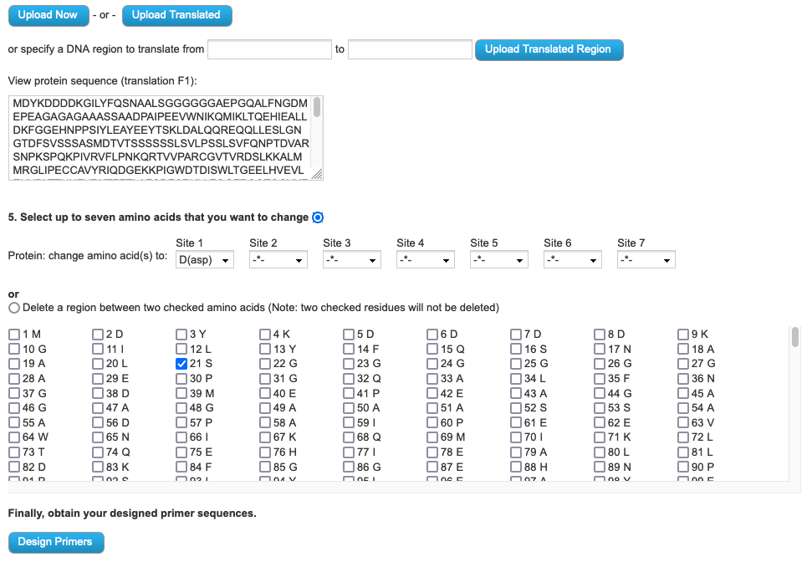

Ordering your primers
We order primers from IDTDNA, and the fastest way to order is to get a quote from them to sent to Chm-Pur. You can use my old account aka the lab account, with the following login info:
Username: stc2m
Password: hsulabforever42
If you wish to create your own account (free), using these shipping and billing addresses:
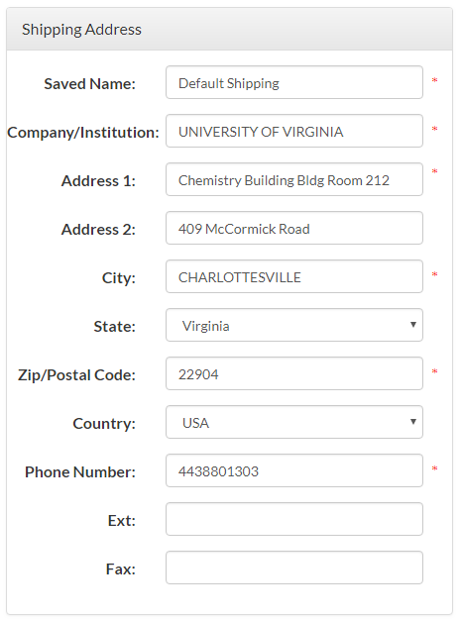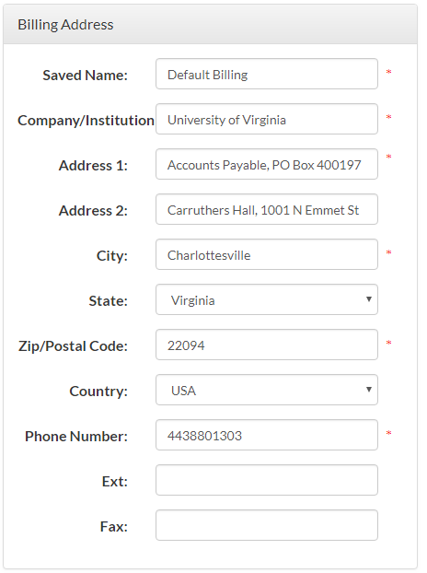
Once you’ve got your account set up, on the main page, select the ‘Products & Services’ tab and then ‘Custom DNA oligos’, then hit ‘Order now’->’Order in tubes’ under ‘DNA oligos’ on the next screen:
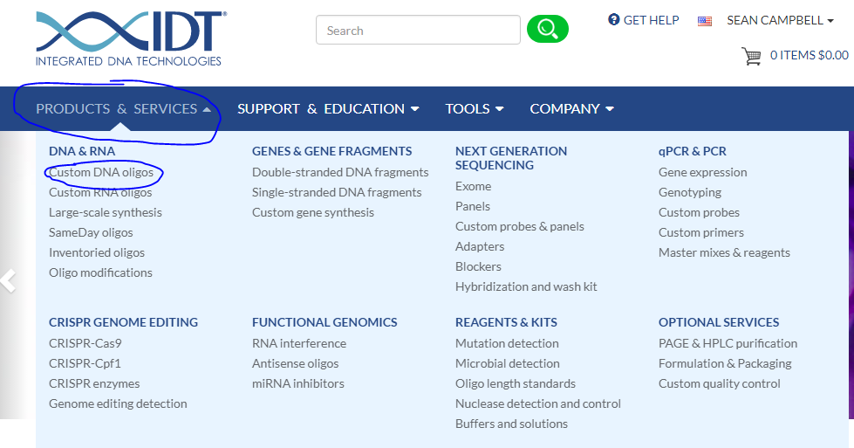
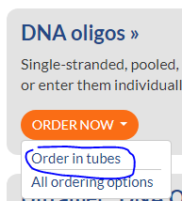
On the next page, give the number of Primers you are ordering in the ‘# of items’ box and it will create that many order boxes. Then start putting your primer names and sequences in the given areas, being careful that your names and sequences are all correct.
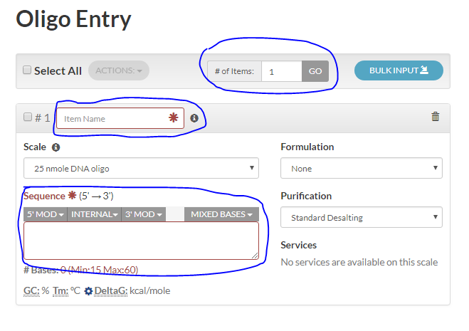
Hit ‘Add to order’ on the right when you are finished, and you’ll be brought to the shopping cart screen. On that screen, press ‘Email Cart/Quote on the right hand side to be brought to the quote screen.
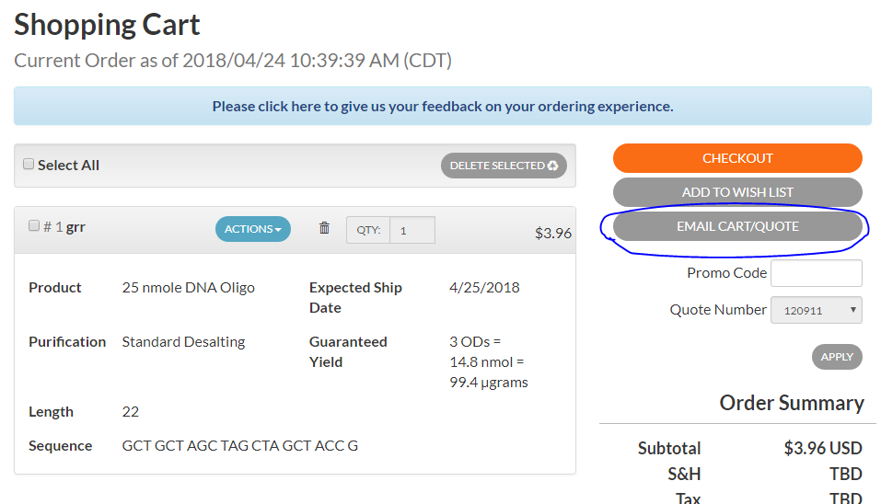
Selecting ‘Request Quote’ should autopopulate the email field with your account’s address. For my account, this will be the hsulabuva@gmail.com, but you can change it to a different address. It automatically checks ‘Save item(s) in wishlist for later reference’ as well, which I suggest you keep. It’s generally harmless and may be helpful if anything is lost. Hit ‘Send Email’
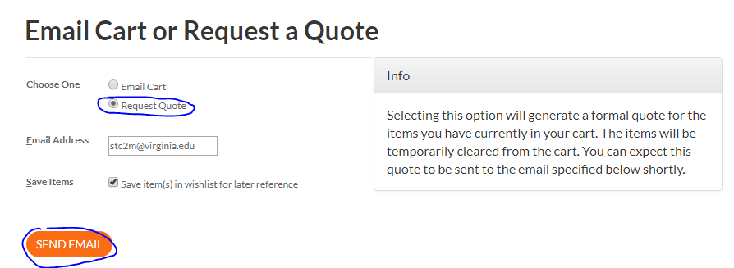
In a very short time, you should receive a quote from IDT Customer Care, with costs, quote #, and shipping charges. Check this carefully! Make sure there were no copy/paste issues when you filled out the form. I found a quick and good check is to send them all through Translate to check that they’re all still the proper sequence. Remember that ‘Rvs’ primers will show the proper sequence in the 3’5’ fields.
If it’s all correct, use this information to fill out an LPO (I do not individually submit primer sequences on the LPO, I simply fill in ‘sequences are referenced in quote #XYZ’ and give the overall total. They’ve never had a problem with that.)
Once the quote an LPO is submitted to chm-pur@virginia.edu, it should be ordered shortly. The quote is associated with your email, so you should get notifications regarding ordering and shipping when it’s on it’s way. Congrats, you ordered primers!

Day 1: The Mutagenesis Reaction
Once your primers come in, which should be in about a week or less, you’ll be ready to start the actual mutagenesis. You’ll need to gather some materials:
- Primers – These will be delivered dry, and the vial will state the nanomoles of primer in each. Dilute them to 100 uM in MilliQ H₂O, and then dilute an aliquot to 10 uM (Do not dilute the whole thing to 10 uM, the volume will be too large).
- PfuUltra Enzyme (HS or HF; pay attention)
- 10x PfuUltra Buffer (match with Pfu type)
- dNTP mix – equal mix of all four dNTPs, solutions of which are in the main -20º C freezer if needed. This mix should have each dNTP at 10 mM.
- Template – the plasmid you are hoping to mutate. An aliquot should be diluted to 10 ng/µL for ease of use.
- PCR tubes
And make sure you have these for after the PCR:
- DpnI enzyme – Cat # R0176S from NEB
- XL-1 Blue cells. There will be two controls per plasmid mutated, so you will need N + 2 40 µL aliquots per plasmid, where N is the number of mutants.
- Electroporation cuvettes – same number as XL-1 blue aliquots
- Blank (no antibiotic) media
- Antibiotic spiked agar plates

- Dilute your samples. Primers should be at 10 µM and plasmid DNA templates should be at 10 ng/µL.

- Prepare Master Mix on ice. Quiksolution contains DMSO and will take a while to thaw, set on lab bench if necessary. Leave the Pfu enzyme in the -20 freezer until the other reagents are thawed. You will need a primer control (-P) and a Dpn1 control (-D) in addition to your samples.

Sample # + 2 controls + 3 extra = the number of reactions you need to prepare for.

Reagents | 1 reaction | 8 reactions
Rxn Buffer (match with Pfu type) | 5 µL | 40 µL
dNTPs | 1 µL | 8 µL
Quiksolution | 3 µL | 24 µL
Pfu Ultra (HS or HF; pay attention) | 1 µL | 8 µL
DNA-free water | 36 µL | 288 µL
Total Volume | 46 µL | 368 µL

- Aliquot 46 µL of master mix into each PCR tube. Label tubes prior to adding DNA and primers. I usually stick the controls on opposite ends of the PCR strip. Keep these tubes on ice!

- Add 1 µL of DNA template (at 10 ng) to each tube. The -P and -D controls should receive the same template plasmid.

- Add 1.5 µL of Forward primer (at 10 µM) to each sample tube and the -D control. Exclude the -P control.

- Add 1.5 µL of Reverse primer (at 10 µM) to each sample tube and the -D control. Exclude the -P control.

- Add 3 µL of DNA-free water (either Millipore or MS-grade) to the -P control tube.

- Briefly centrifuge PCR strip(s) to pull all solution down. Place in Thermocycler and run one of Larry’s Quik protocols. They are titled “QUIK” with the plasmid length in kB, make sure to choose the correct one for your template lengths. The extension step will be longer/shorter depending on how many nucleotides are in the plasmid.

Segment | Cycles | Temperature (Celsius) | Time
1 | 1 | 95 | 1 min
2 | 12 - 18 | 95 | 30 sec
3 |  | 72 | 1 min
4 |  | 68 | 1 min/kb of plasmid length
5 | - | 4 | Hold

- Following PCR, add 1 µL of Dpn1 enzyme to each tube EXCEPT the -D control. Incubate the samples at 37 C for one hour to allow the parent DNA to digest.

- Desalt 5 µL of each sample for 15 minutes on a dialysis membrane (ask Larry how to use these if you want help).

- After the incubation, create a sterile area (Bunsen burner and ~1’ radius clear around it) and bring over reactions, pipettes/tips and ice bucket. Pipet all 5 µL of DNA into 40 µL of XL-1 Blues and transfer to electroporation cuvette. reaction and bacteria can also be mixed in the cuvette, whichever is easier, but be careful to avoid contamination in all directions. Recap cuvette, label, and place on ice. Repeat for each reaction you performed, being careful to label each one appropriately.

- Once all cuvettes are loaded, bring ice bucket to the gel bench. Retrieve electroporator (last drawer down on the right side of the gel bench) and plug in to the red outlet. This is very important, if you plug it into a grey socket it will not work properly and will likely blow a breaker. Turn it on (green button on the right), and make sure the screen reads 1200V, using the black knob to adjust as needed.

- Insert your first cuvette into the holder on the left, making sure to properly align the knob on the side of the cuvette with the notch in the holder. Make sure to push the cuvette all the way in (the metal sides should be fully inside the holder) and swing the clear plastic rectangle over the top. For the orange/yellow cuvettes, you’ll only be able to get it partially over the top, this is fine.

- Press the green button in the middle and wait for it to beep. If you hear a loud pop, your sample has arced and something is wrong, please ask me for assistance. Otherwise, remove the cuvette, press the green button again to switch the screen back to read HV 1200V again (check this, sometimes the voltage changes between runs), and proceed to each cuvette you have in turn until all have been electroporated.

- Add 400 µL of SOC media to bacteria and shake at 37 C for 45 minutes.

- Retrieve cuvettes from incubator, and bring them, the agar plates, minicentrifuge tubes (aka eppindorf/eppi tubes) and glass balls (on Larry’s bench) to the sterile area. Plate out all 400 µL of culture on antibiotic agar plates (match the antibiotic to your plasmid resistance).

- Add ~5 glass balls to the plate and cover.

- Repeat for up to five plates. Once enough are ready, shake the plates gently to let the glass balls spread the bacteria around the plate. After around a minute, the pellet should be smoothly distributed across the plate. If not, continue shaking.

- Repeat until all reactions have been plated. Allow plates to sit for 10 minutes before inverting and placing in 37º C incubator overnight.

- Discard all cuvettes and plastic spreaders in the biological waste.

Day 2 (~24 hours after plating out)
Retrieve your plates from the incubator. If everything went well, you should have many small colonies on your plates. There should be a distinct pattern of controls if everything was working properly:
- The ‘-D’ reaction should have by far the most colonies. Possibly so many that you can’t see individual colonies (colloquially called a ‘lawn’). That’s because DpnI destroys the template plasmid. Without that, your template plasmid will be replicated at a rate far exceeding that of your mutated plasmid.
- The ‘-P’ reaction should be completely empty (or very few colonies). This is because you should have created no ‘new’ plasmids from the PCR since there were no primers to replicate off of.
- All mutagenesis reactions should have a number of colonies in between these two extremes. Plasmids created from the PCR reaction are shielded from the effects of DpnI because they are not methylated, and so those should be the only surviving plasmids. Good numbers are typically between 10 and 100, depending on the reaction. But you only need one to succeed! So even if the colonies are sparse, I’d recommend continuing if you have more than the ‘-P’ plate, even if it’s only by one or two.
The controls can now be discarded and you can continue if they look good. If not, go to ‘troubleshooting’, below. Now decide how many plasmids you’d like to grow for each mutagenesis. I suggest 3-5 per mutation, as long as there are that many available.
- Proceed to picking colonies. Retrieve either 10 or 200 µL autoclaved tips, a number of 10 mL culture tubes and autoclaved antibiotic-spiked Terrific or LB broth. Bring all to a sterile area.
- Open and label a number of culture tubes depending on how many colonies you wish to grow.
- Put 5 mL of doped media into each culture tube. Using a sterile pipette tip, pick a single colony from a plate and drop it into the appropriately-labeled culture tube. Cup the tube, but make sure cap is still loose and not pushed fully down. Repeat for each culture tube.
- Move the tubes to the shaking incubator and shake at 225 rpm at 37° C overnight.
- Agar plates may be stored at 4° C after sealing the sides with parafilm. Plates stored this way can be used again for up to ~2 weeks. If all controls look good but sequences show there was no mutation, it may be worth picking and sequencing additional colonies from the plate.
- Recover plasmid DNA using the Qiagen Mini-prep kit. Sequence with Genewiz alongside the wild-type plasmid to confirm the correct mutation is present.

Day 3:
- If cultures grew successfully, they should now be opaque with bacteria. If they are not, check the incubator temperature and your antibiotic selection, or re-transform if these colonies were from an old plate, as the colonies may have died.

- If they grew well, retrieve colonies and proceed with mini prep.

- Proceed with sequencing, using either genewiz primers or your own primer if it was necessary to create a new one.

Troubleshooting
If the reaction is not proceeding, here are a few tips to improve the reaction, based on results. Most of these tips are taken from the Agilent Quickchange protocol linked earlier, and if these do not work I suggest you look deeper into that manual for answers.
Issue | Possible Solutions
All plates are full of colonies to the level of ‘-D’ plate. | DpnI enzyme is bad. Reorder.
Mutagenesis plates have no colonies | PCR may not have worked. Several things to look into:  - Check that primer sequences are appropriate. Double check IDTDNA quote.  - Change PCR temperature. Check the Agilent guide for help on optimizing the PCR temps.  - Check that you have the right plasmid!  - If all above is fine, reorder PfuUltra.
No plates have colonies | Check that you’re using the right antibiotic.  If you are, check that your template is correct.  If it is, consider sequencing the template to be sure.
Wild type sequence is seen on sequencing | Grow and sequence more colonies (if available).
Strange results are seen on sequencing (for instance, primer doubling in sequence, nonsense results) | Grow and sequence more colonies (if available).  If not, check template and redo PCR.

