Processing proteomes for optimal diacylglycerol lipase (alpha and beta) activity
Paper for training: https://www.ncbi.nlm.nih.gov/pubmed/23103940

Question you should be able to answer after training:
1. How do the HT-01 ABPP profiles of RAW264.7 membrane fraction compare in samples lysed by standard sonication versus dounce homogenization?
2. Can you propose a hypothesis for why cell/tissue processing would affect our ability to measure DAGLB activity?

STOCK SOLUTIONS
Sucrose (2.5 M) 4°C
HEPES (1 M) 4°C
DTT (1 M) -20°C
BSA (2 mg/ml, in 20 mM HEPES) -20°C

LYSIS BUFFER
44 ml Deionized H₂O
5 mL Sucrose (2.5 M) 0.25 M
1 mL HEPES (1 M) 20 mM
100 µL DTT (1 M) 2 mM

ASSAY BUFFER
49 mL Deionized H₂O
1 mL HEPES (1 M) 20 mM

SETUP – PUT THESE ITEMS ON ICE
  - Lysis Buffer
  - Assay Buffer
  - 15 mL Dounce homogenizer (for tissues)
  - 7 mL Dounce homogenizer (for cell pellets)
  - 15 ml falcon tube

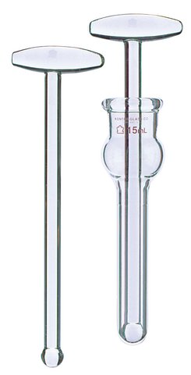(picture of dounce homogenizer)

SAMPLE PROCESSING
- Sacrifice animal and remove brain
- Place 1/2 brain into 1.5 ml tube
- Rinse brain with Lysis buffer 2x to remove blood
- Place brain into dounce homogenizer (15 mL)
- Add 2 ml of Lysis buffer and dounce
- Allow homogenate to sit on ice for 15 min
- Transfer homogenate to 1.5 ml eppendorf tubes and spin
  - 3300 RPM, 5 min, 4°C (cold room)
  - There should only two layers at this stage
- Transfer supernatant to ultracentrifuge tubes and spin
  - 100,000g, 45 min, 4°C
- Wash pellet 1x with Assay Buffer
- Re-suspend pellets in 1X Assay buffer by pipetting once and then passing membrane homogenate through 26-gauge needle.
- Determine protein concentration
  - 2 mg/mg BSA stock must be in assay buffer
  - Make dilutions using assay buffer
- Make appropriate dilutions and perform ABPP activity assays

For RAW264.7 or macrophage cell pellets:

1. Add 1 mL of lysis buffer to cell pellet in a 1.5 mL tube
2. Transfer cells to a 7 mL dounce homogenizer and dounce
3. Follow steps 6-12 above

