Preparation of cell proteomes for analysis of native DAGLB activity:
*background paper for training
*background paper for chemical proteomics

Questions you should be able to answer at the end of training:

1. What are the chemical structures of HT-01 and fluorophosphonate (FP)-rhodamine?
2. Why use both HT-01 and FP-Rh for the described training?
3. Which fraction (membrane or soluble) is appropriate for analyzing endogenous DAGLB activity?
4. Why use both KT109 and KT195 as inhibitors for the described competitive activity-based protein profiling (ABPP) studies?

- Aspirate cell media.
- Wash 2X with warm PBS
  - For RAW264.7 cells, wash off cells in the first PBS wash, centrifuge at 400 x g for 5 min to pellet and resuspend pellet again in PBS for 2X total washes.
  - For suspension cells: use a serological pipette to pull up media with cells and wash the bottom of T-flasks briefly and transfer to conical tubes. Centrifuge at 400 x g for 5 min to pellet and resuspend pellet again in PBS for 2X total washes.
- Re-suspend in minimal volume for lysing:
  - 1X 6 cm plate = resuspend cell pellet in 200 µL
  - 1X 10 cm plate = resuspend cell pellet in 500 µL
  - 1X 15 cm plate = resuspend cell pellet in 700 µL
*scale for multiple plates based on the ratios above.
- Lyse cells by sonication at 20% amplitude using the small tip on sonicator (please validate that you are using the small tip). 3 pulses for 1 second each is sufficient for cell lysis.
- If you are separating membrane and soluble fractions, transfer lysates to ultracentrifuge tube and counterbalance to 0.01 grams (if you only have 1 sample, counterbalance with water in another ultracentrifuge tube).
- Centrifuge at 100,000 x g for 45 min at 4 °C.
*the rotor will be kept in the ultracentrifuge tube at all times to avoid damage to spindle from constant removal/install. Please turn on ultracentrifuge 30 min prior to use, seal the door, and cool the rotor to 4 °C before use. The high centrifugal force generates heat, which can denature enzymes in your sample.
- Carefully remove supernatant into a standard 1.5 mL microfuge tube.
*please label both tubes with detail: date, cell line or tissue, mem or sol. If these proteomes are from treated cells, please also include the treatment conditions (e.g. DMSO or X µM of compound and treatment time).
*resuspend membrane pellet using equivalent volume of PBS (amount used for initial lysis) and sonicating at 20% amplitude (2-3X 1 second pulses should be sufficient).
- Take protein concentration of samples on our Clariostar plate reader using the Bio-Rad DC protein assay. Protein concentrations of 1-10 mg/mL are acceptable. If concentrations are > 10 mg/mL, please dilute 1:5 and retake [protein] to validate concentrations.
- Samples are ready for ABPP analysis or can be frozen in -80 °C freezer for analysis later.
* in general, freeze-thaw cycles will compromise enzyme activity. If you have a sensitive enzyme, please plan your experiments accordingly.

ABPP analysis:

- Dilute membrane and soluble proteomes to 1 mg/mL for FP-Rh- and 2 mg/mL for HT-01-labeled samples. The reaction volume is 50 µL final. Please leave volume for ABPP probe (1 µL of 50X stock) and/or compound pretreatments (1 µL of 50X stock). For example, the final volume would be 48 µL if you pretreat with compound followed by labeling with ABPP probe.
*You will add DMSO as the control, which gives 2% (v/v) final concentration.
- Reactions are performed in 1.5 mL microfuge tubes. Please label tubes carefully.
*You can provide a number key for the samples but make sure to write this into your notebook.
- Add DMSO or compound, gently flick tube to mix, and incubate for 30 min at 37 °C in incubator.
* for in vitro inhibition, you can perform a dose response for both KT109 and KT195 inhibitors: 50, 10, 1, 0.1 µM final for KT109 and KT195 inhibitor
- Add 1 µL of ABPP probe (50 µM of FP-Rh or HT-01 stock) to a final concentration of 1 µM and incubate for 30 min at 37 °C in incubator.
- Quench with 20 µL of 4X SDS-PAGE loading buffer + βME and vortex tubes.
* βME in the 4X buffer can go bad at room temp or repeated freeze-thaws. Please be sure to store your 4X at -20 °C.
- Samples are ready for SDS-PAGE analysis or can be stored at room temp in the dark overnight if needed.

Gel-loading:

- Flush out each well with running buffer using the Hamilton syringe.
- Skip the first lane, load the MW marker (10 µL Bio-rad all blue standards), followed by a spacer (mouse brain proteomes at 1 mg/mL, no ABPP probe labeling, and quenched at an equivalent ratio with 4X SDS-PAGE loading buffer + βME).
- Load 50 µL for HT-01 samples and 30 µL for FP-Rh samples. It is a good idea to frame your sample sets with the spacer at equivalent volumes. For example:

Lane:
- MW marker (10 µL)
- Spacer – RAW264.7 proteome not labeled with fluorescent probe (50 µL)
- HT-01 sample 1 (50 µL) – vehicle
- HT-01 sample 1 (50 µL) – 50 µM KT109
- HT-01 sample 2 (50 µL) – 10 µM KT109
- HT-01 sample 3 (50 µL) – 1 µM KT109
- HT-01 sample 3 (50 µL) – 0.1 µM KT109
- HT-01 sample 1 (50 µL) – 50 µM KT195
- HT-01 sample 2 (50 µL) – 10 µM KT195
- HT-01 sample 3 (50 µL) – 1 µM KT195
- HT-01 sample 3 (50 µL) – 0.1 µM KT195
- Spacer (30 µL)
- FP-Rh sample 1 (30 µL) – DMSO
- FP-Rh sample 1 (30 µL) – 50 µM KT109
- FP-Rh sample 2 (30 µL) – 10 µM KT109
- FP-Rh sample 3 (30 µL) – 1 µM KT109
- FP-Rh sample 3 (30 µL) – 0.1 µM KT109
- FP-Rh sample 1 (30 µL) – 50 µM KT195
- FP-Rh sample 2 (30 µL) – 10 µM KT195
- FP-Rh sample 3 (30 µL) – 1 µM KT195
- FP-Rh sample 3 (30 µL) – 0.1 µM KT195
* you should analyze both soluble (1 set of 21 samples) and membrane (a separate set of 21 samples) fractions for training

- Gels are run at 300V for 850 Vhrs. Be sure to attach an aluminum heat sink to the front of the gel to prevent running front from “smiling.”
- Analyze gel on the Bio-Rad ChemiDoc.

Analyzing gels on ChemiDoc:

- Image gel with the following filters:
  - Fluorescein (HT-01 probe)
  - Rhodamine (FP-Rh probe)
  - Dylight 650 (Bio-rad MW markers)
- Save the .mscn file. You should have a file that looks like the following screenshot:
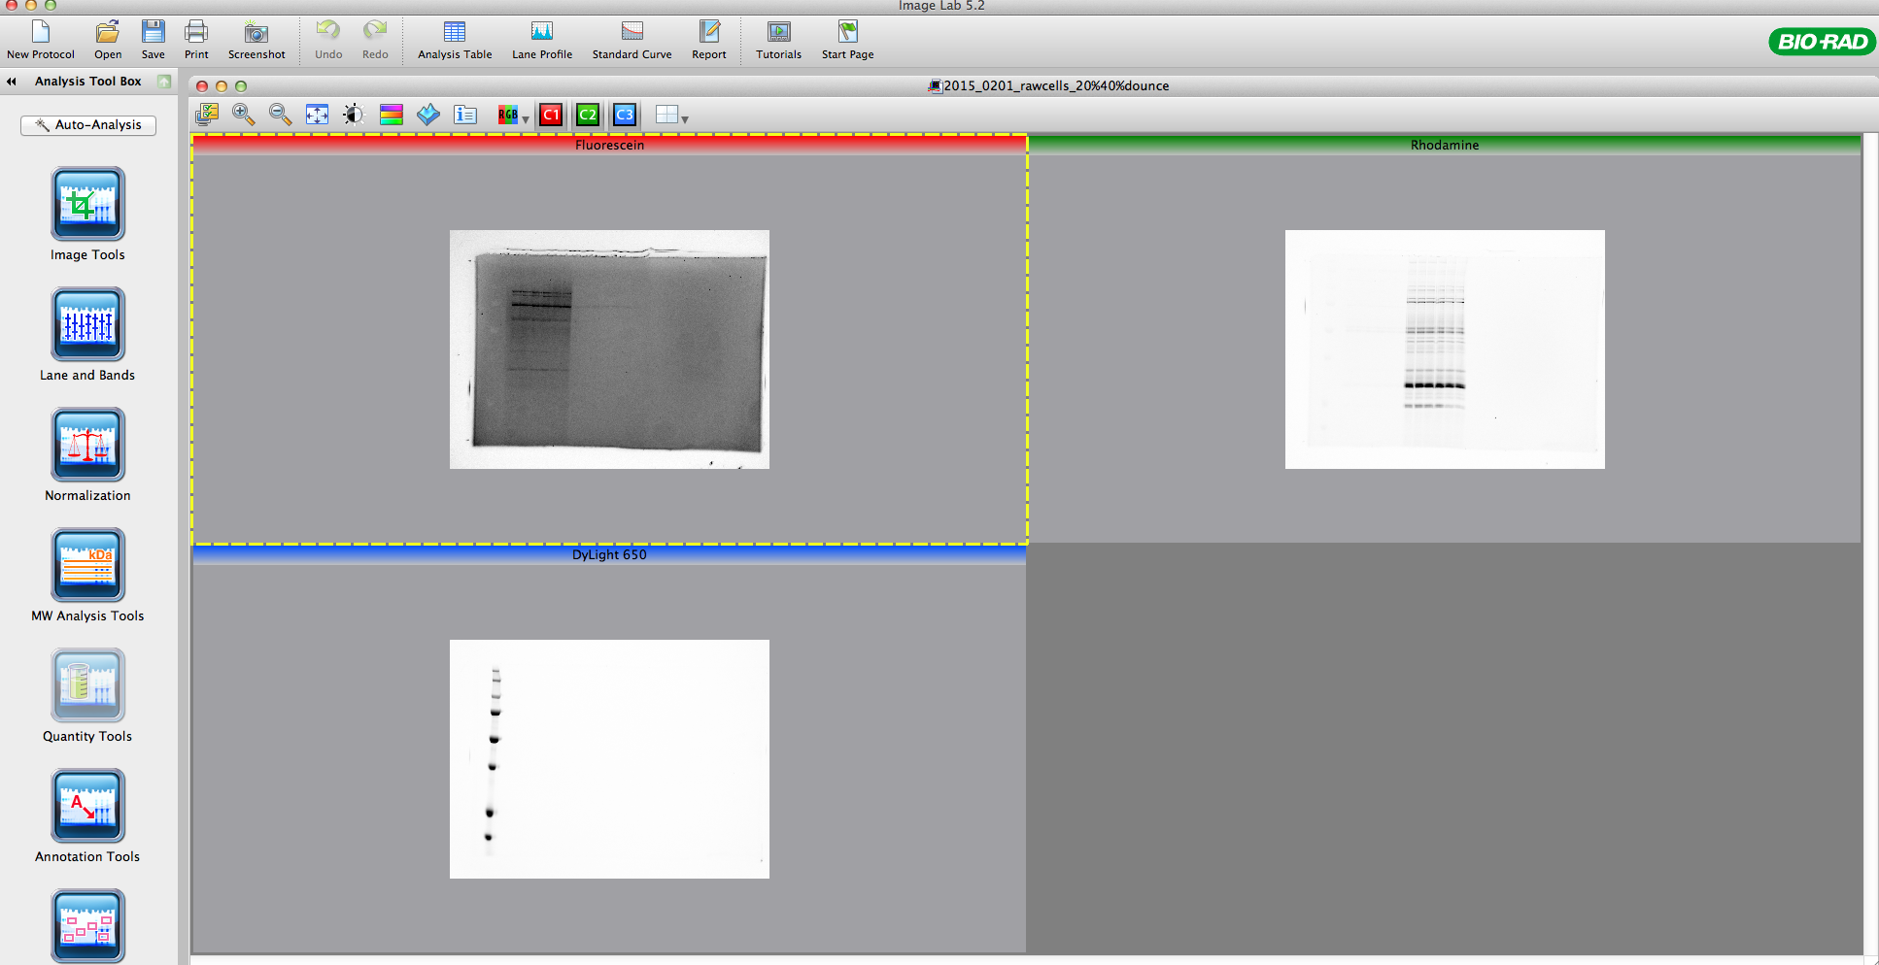

- Please open the “image info” tab and enter the following information for the experiment in the notes section:

- Experiment: Brief statement about goal of experiment. in vitro, live cell, or animal treatment? What compounds were used at what dose? How long were treatment times? Any changes that deviate from our standard protocol needs to be noted here. Also, any other relevant information that may help with interpretation of data.

What are the samples on each lane. Please also list the protein MW standard used (for the most part, this will be Bio-rad all blue standards).

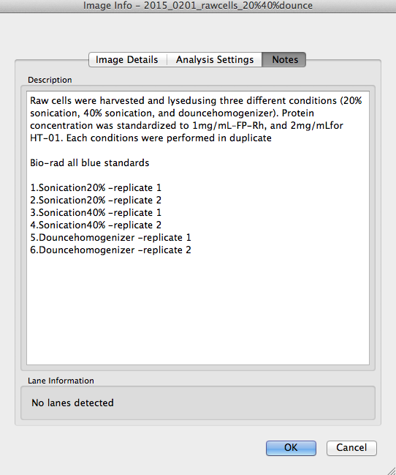

- A PDF of annotated data (please see example below):

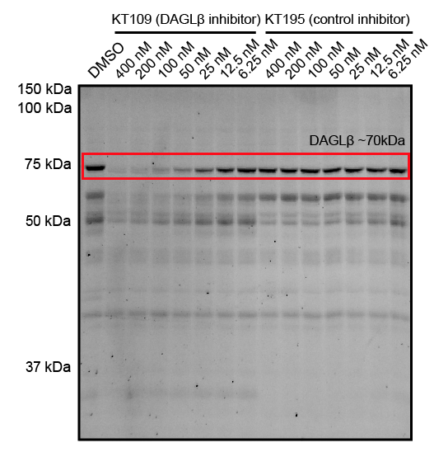

*You can use photoshop to enhance the contrast of the HT-01 gels. Remember that you must enhance the entire gel and not just one section.

- Upload the PDF file back into the “lab data” folder with the raw data of the analysis you are currently processing.

