Day 1:
First of all, you will need the requisite supplies. First, software wise, you need something capable of reading .ab1 files. I suggest FinchTV, which is available for free here: https://digitalworldbiology.com/FinchTV. The rest of the SOP will be written in reference to this program.
Next, you will need the plasmid to be sequenced. This should be at 80 ng/ul concentration, or as high as possible if your stock is lower than that. You will need 10 uL per reaction aka per primer.
You will also need to know what primers to use. You have a choice between adding your own primer or using one from GeneWiz. A list of primers that Genewiz has is here: https://www.genewiz.com/Public/Resources/Free-Universal-Primers. Most primers you need will be available here. However, if you need to add your own primer, you will also need your primer at 5 uM, at least 5 uL per reaction.
How do you know what primer you need? For Gateway expression plasmids (pGCFlag or pEZY), SP6 and T7 work. Which plasmid you are using will also determine which reads were. For pGCFlag (the most common), SP6 reads forward at the start of the gene, and T7 reads reverse at the end. For pEZY it’s the opposite.
If you aren’t doing these, it becomes more difficult. For most plasmids, T7 will read from the beginning of the gene, but not all. I suggest finding your plasmid map (I have nearly all plasmid sequences for all lab plasmids in the Box folder). If you have the sequence, you can simply search the sequence for the genewiz primers to find one that fits. You want a primer that is 100% the same as your plasmid and sits between 100 and 600 bases from the sequence you want to see. If genewiz does not have an appropriate primer, you can also search through the lab primers, also in the Box folder. I would suggest searching the ones labeled as ‘sequencing’ first, however any primer in lab is potentially useful as a sequencing primer if needed.
If that is still not enough, you will need to create your own. See the Mutagenesis SOP page 18 for sequencing primer design.

Once you have all the plasmids, primers ready, log in to genewiz. The account details are:
Username: stc2m@virginia.edu
Password: hsulabforever42
Once logged in, you can chose ‘plasmid’ under the ‘sanger sequencing’ tab:
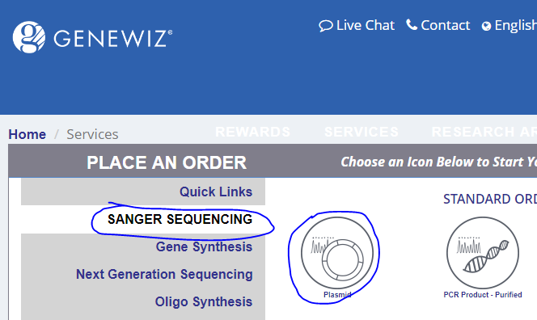
For DNA type, plasmid will be selected already. Change ‘Service type’ to ‘Premix’, and add the number of reactions you will have (each plasmid/primer pair is one reaction) in ‘# of samples’ and hit ‘apply. The fields will be created:
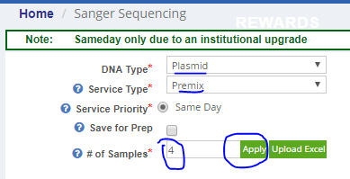
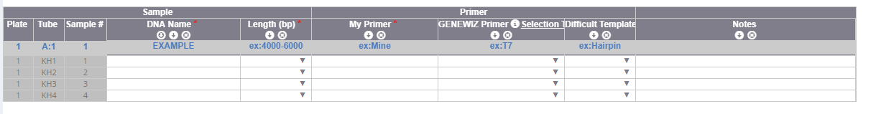
In ‘DNA Name’, write the plasmid to be sequenced. Again, each Plasmid/primer pair is one reaction, so if you’re sequencing a plasmid with two primers (say a forward and reverse), you would write the same plasmid name in two rows. Also, be specific! Especially if this is to check the results of a mutagenesis or gateway reaction, you need to know exactly which plasmid is being sequenced.
Next, length. This doesn’t really matter. I always select ‘6001-8000’. If you put that in the top box and then click the little arrow button, it will auto-fill all rows.
In ‘My Primer’, put the name of the primer you’re using only if you are supplying the primer. If you are using a genewiz primer, that is the next step.
In ‘GENEWIZ Primer’, select the primer you want to use if it’s a genewiz primer.
‘Difficult Template’ should be ignored, and the ‘Notes’ section is purely for if you want to add notes to remind yourself of something later.
So for this, let’s say I’m trying to see if my Gateway reaction of Sphingosine Kinase 1 worked. I have two plasmids which I want to sequence the front and end, to be sure it went in properly. So I’ll have two reactions for each plasmid, T7 and SP6. The final order would look like this:
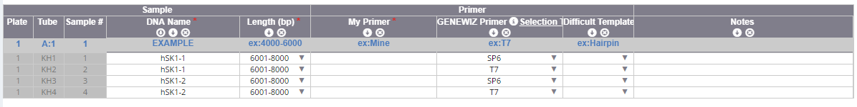
When finished, hit ‘Save and Review’ at the bottom. Check the next page and use the costs to fill out an LPO and send it to the stockroom. If you need assistance with this, ask whoever is in charge of ordering. Then hit ‘Add to Cart’ at the bottom.
Give the next page a second, and it should autopopulate the ‘Select from my dropboxes’ option and the PLSB pickup box. It should look like so:
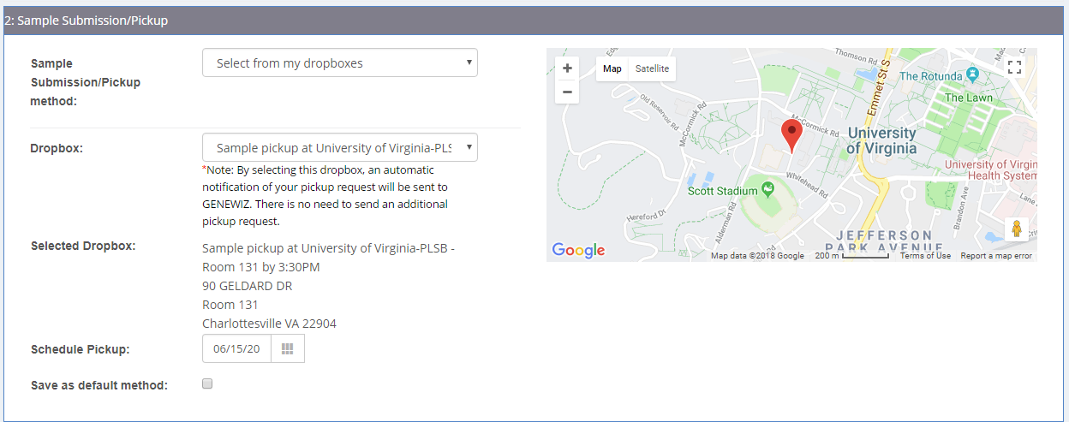
In ‘Payment type’, ensure ‘PO’ is selected, then add a random number to PO. The stockroom will send the PO directly as long as you sent the LPO properly. Hit ‘Check Out’
The next page will pop up a window with a printable PDF of your order. Print this and save it for the next part.
To prepare your samples, look at the order sheet. Each reaction will have a code, probably KH##, starting at KH01 and advancing for each of your samples. Take a PCR tube strip (Caroline’s bench) and label a strip (or several if needed) and label the side of the tubes with these codes. Then add the appropriate plasmid (80 ng/uL stock) to each tube, 10 uL per tube. If you are using your own primers, subsequently add 5 uL of each 5 uM stock to the appropriate tube as well (hence the ‘premix’ sample option).
Seal the tubes tightly and then add both the PCR tubes and order form you just printed to a plastic bag. Take these down to the dropbox, which is located on the first floor PLSB, right in front of the Columbus lab. Drop it in and you’re done. The sequences should be done by ~6 pm the following day

Day 2/3: Analysis
When you get confirmation of sequences being finished (this will be sent to the hsulabuva@gmail.com address), you can finish the sequencing. Clicking the link in that email will take you directly to the results, or go to ‘My orders’ on the genewiz main page and find your order, then click the green ‘View Results’ button on the right. This will bring you to a page with the results, like so:
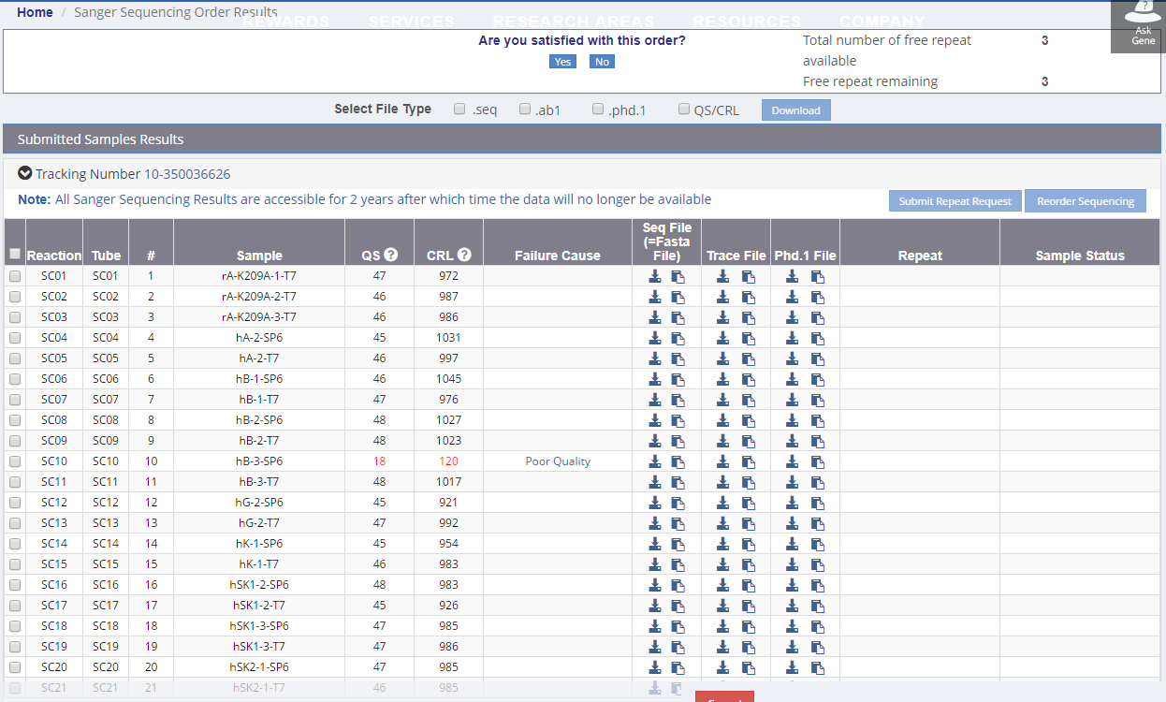
The main things to look at the the ‘CRL’ number, which gives you a general read length. If it’s around 700-1000, it’s pretty good. Lower than that, especially much lower (like the 120 on this page) denotes one of several kinds of failures. Most likely, this means your plasmid is bad, and hopefully you have more.
Assuming all yours didn’t fail, you can download your files. Either download select files by clicking the little down arrow icon under the ‘Trace File’ column, or download several at once by selecting them on the left, selecting ‘.ab1’ on the top, and then hitting ‘download’, like so:
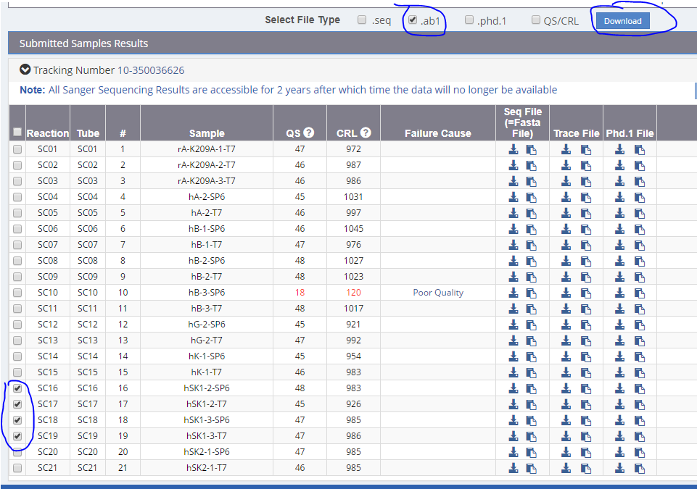
This will download as a zip file that you can extract. Now load a single file in FinchTV, and it should look something like this:
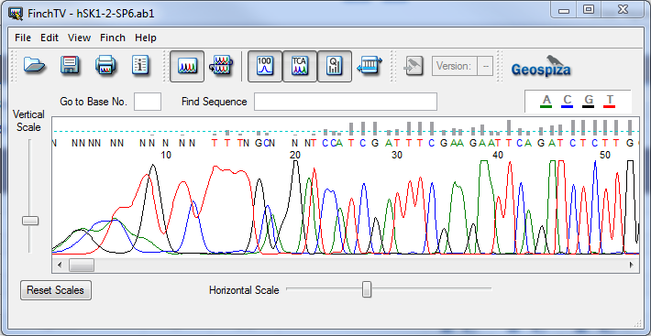
This is a trace of the results of the sanger sequencing. Each colored trace is a signal from a single nucleotide. Red for Thymine, black for Guanosine, green for Adenosine, and blue for Cytosine. Finch will automatically read these and give an output of the sequence. That is the letters at the top. You will notice that ‘N’ is also used. This is the symbol given when Finch knows a base should be present, but cannot determine what it is. It’s common to have many Ns at the beginning of a sequence, as shown, as the very first bases are hard to parse. Then it will calm down and should give a few hundred (600-900) bases of good reads before the signal becomes too low to be well parsed, and Ns will show up again, like so:
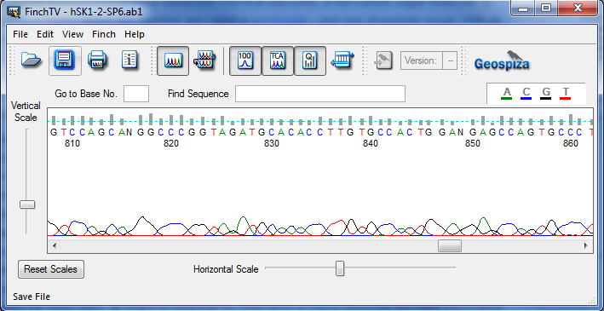
I usually get a quick read by simply searching for Ns. After the initial bunch it should jump out to 600 to 1000. Select a good base and use shift-click back at the start and copy to get a large chunk of good sequence. Then, go to expasy translate (http://web.expasy.org/translate/) and enter the sequence to translate it. In this case, we get a nice looking sequence in frame 3 of what I copied:
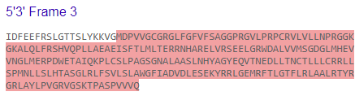
That looks promising. The next step is to compare this against the expected sequence. For gateway, you can use either the pDONR sequence (given by Addgene) or the protein sequence given by Uniprot. For mutagenesis, I suggest using the sequence in the plasmid map, which should be the base. Here, I’ll use Uniprot’s sequence for Sphingosine kinase 1. Get some protein sequence, and then use an alignment program. I prefer Emboss Water (https://www.ebi.ac.uk/Tools/psa/emboss_water/). Enter your sequence in one window, proceeded by ‘>NAME’ in the first line (with something in place of name, such as ‘>Uniprot’ for the uniprot sequence). Then do the same with the other sequence in the other window, and hit submit:
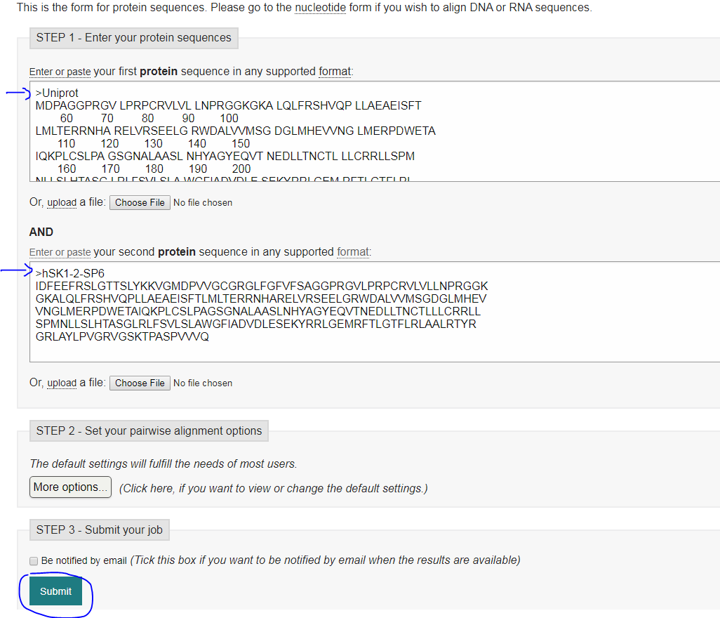
Emboss will spit out an alignment. If your reaction succeeded, you’ll see a fully concordant sequence. Here there was actually a slight difference:
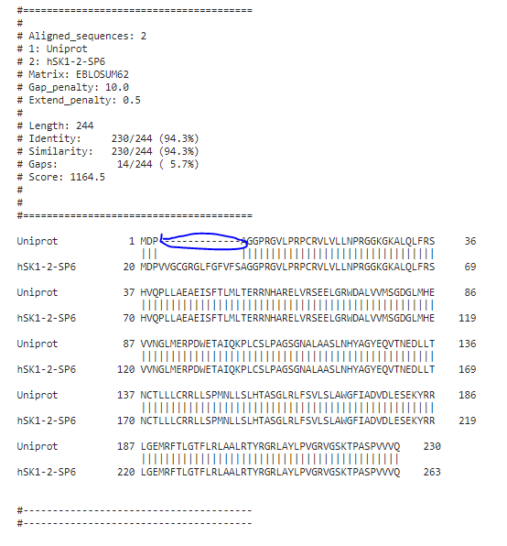
This is the result of this being a different isoform, specifically Sphingosine Kinase 1 isoform 3, according to Uniprot. This is not uncommon with the Kinase Kit plasmids, they’re not super well curated. However, this is still SK1, so the difference should be noted but it was otherwise successful!
If you were doing a mutagenesis reaction, you’d be instead looking for almost complete concordance, but with a single change. That might look like this if we were mutating SK1:
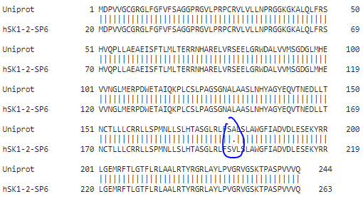
If the sequence aligns and/or has your expected mutation, you succeeded! Good work. If not, start troubleshooting your assay.
The only last wrinkle is reverse primers. These will actually read the opposing strand to the expected, so you’ll get the reverse complement sequence. Here, T7 is our reverse primer. There are two ways to deal with this. The first easy way is to simply look in the 3’5’ frames in Translate. That should have a sequence that cooresponds to the gene you’re looking for (as always, use Uniprot or another reference to get your sequence. The other way is to flip it in Finch, which has a button for reverse complements:
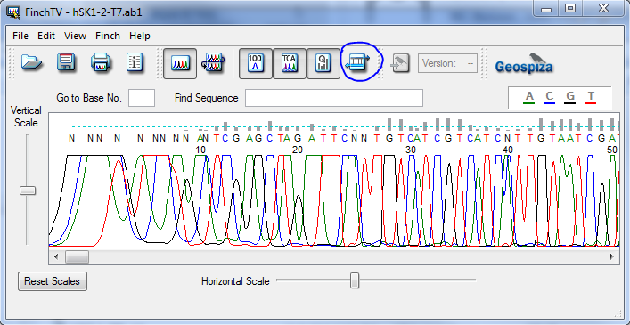
This will flip your sequence, so it will read in the 5’3’ frame when translated.

Troubleshooting –
There are a few ways sequencing can fail. The simplest is that the primer/plasmid pair doesn’t match. Recheck sequences if you see a mess like this:
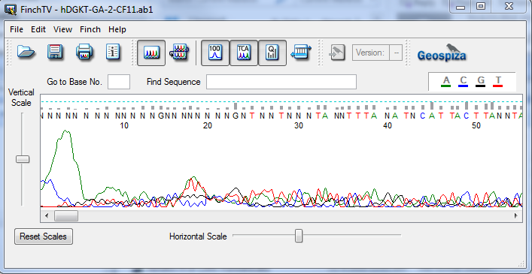
Or
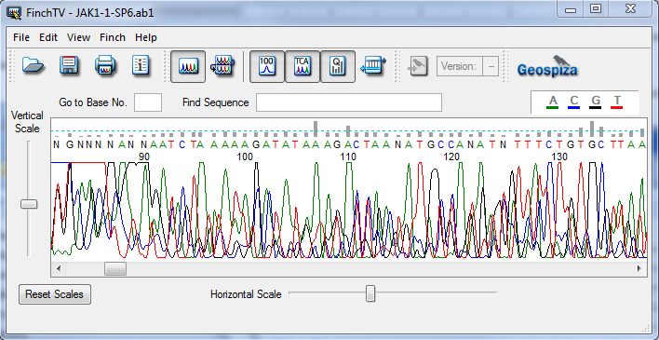

Mixed plasmids: typically, we should only have colonies with a single plasmid. However, occasionally this fails, either because you accidentally grab two colonies or it just happens a single bacterium has multiple. In that case you’ll see overlapping signals like this:
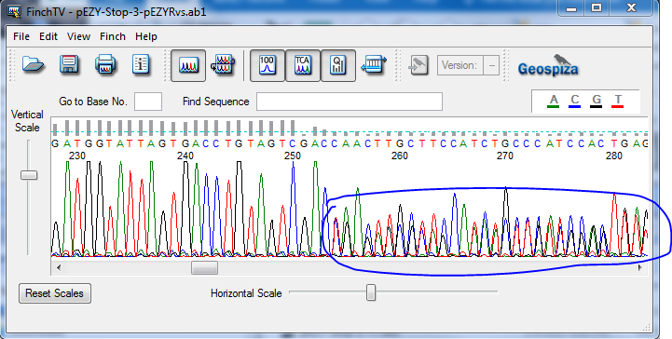
You should isolate more colonies and sequence, errors like this are uncommon.

Plasmid damage: It’s possible for a plasmid to be non-circular for some reason, such as incorrect ligation. In that case, you may see a rapid die-off of signal, like so:
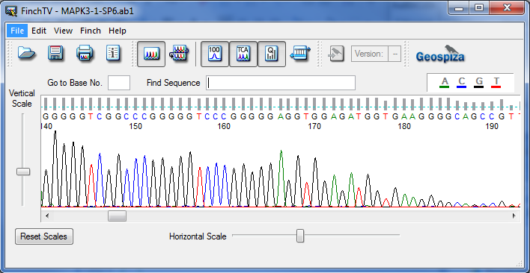
This level of decrease should happen over hundreds of bases, and 190 is really early for this to be so low. I’d suggest re-transforming (bacteria can fix broken plasmids) and re-sending.

