AIVSS 1.0 — Agentic AI Vulnerability Scoring System
Version: 1.0
Status: Reference specification
Reference calculator: `tools/aivss-calc` (93 tests, exact assertions)
Canonical risk taxonomy: OWASP Top 10 for Agentic Applications 2026 (ASI01–ASI10)
This document is a standalone specification. It assumes no prior reading of earlier AIVSS drafts, review memos, or Appendix E. Every normative term is defined here or cited to an external authority.

1 Executive Summary
The Agentic AI Vulnerability Scoring System (AIVSS) is a reference framework and open-source calculator for rating the cybersecurity severity of vulnerabilities in agentic AI systems — deployed software that can plan, use tools, retain context, and act with some autonomy.
AIVSS extends CVSS v4.0 with agent-specific interpretation rules and a parallel Agentic AI Profile, then maps findings to federal remediation timelines. The specification scores all ten OWASP Agentic AI risk categories (ASI01–ASI10); representative findings range from ASI01 Agent Goal Hijack (AIVSS 9.2) to ASI07 Insecure Inter-Agent Communication (7.1) — see Section 2.1 and Section 14.
Version 1.0 adopts the OWASP Top 10 for Agentic Applications 2026 as its risk classification taxonomy. Eight of ten ASI categories trace their research lineage to the original Agentic AI Core Risks taxonomy developed by the OWASP AIVSS project team [5] as community-driven, open-source security research; OWASP extended coverage with ASI09 Human–Agent Trust Exploitation and ASI10 Rogue Agents. AIVSS is a scoring tool, not a taxonomy authority — it retires its parallel category list for v1.0 and credits the project team's contribution in Section 5. EPSS is recorded in every assessment where available but does not modify scores or remediation timelines — rationale in Section 12.3.1. The specification is self-contained: every normative term is defined in the Introduction (Section 2) and Definitions (Section 3), or cited to an external authority.

2 Introduction
This section introduces the concepts a reader needs before the normative parts of the specification. Each term is defined first, then elaborated with its role in an AIVSS assessment.

2.1 What AIVSS assesses
Definition — Agentic AI system. A deployed software system that combines a language or reasoning model with tool access, execution autonomy, persistent state, and network reach. (Full definition: Section 3.1.)
Elaboration. AIVSS scores the security consequences of vulnerabilities in such systems, classified under the OWASP Top 10 for Agentic Applications 2026 (ASI01–ASI10) [4]. That Top 10 synthesizes cross-industry open-source security guidance — prominently including the OWASP AIVSS project team's original Agentic AI Core Risks taxonomy [5]. Eight of ten OWASP ASI categories trace their research lineage directly to that AIVSS work (ASI01–ASI08); ASI09 and ASI10 are OWASP additions with no AIVSS predecessor. Full credit, research lineage, and the complete category list are in Section 5.
Representative findings — one per OWASP category, each scored in Section 14:
- ASI01 Agent Goal Hijack — attacker redirects a planning agent's objectives through injected instructions (AIVSS 9.2).
- ASI02 Tool Misuse & Exploitation — agent applies a legitimate tool in an unsafe way, enabling data exfiltration (AIVSS 8.3).
- ASI03 Identity & Privilege Abuse — stolen service credential drives lateral actions across agent workflows (AIVSS 8.5).
- ASI04 Agentic Supply Chain Vulnerabilities — compromised MCP plugin supplies malicious tool definitions at runtime (AIVSS 8.8).
- ASI05 Unexpected Code Execution — code interpreter executes attacker-supplied shell commands (AIVSS 8.9).
- ASI06 Memory & Context Poisoning — adversarial data planted in the agent's context store biases later sessions (AIVSS 7.8; worked example Section 15).
- ASI07 Insecure Inter-Agent Communication — unsigned agent-to-agent messages allow instruction relay (AIVSS 7.1).
- ASI08 Cascading Failures — faulty planner triggers downstream orchestration failures (AIVSS 7.9).
- ASI09 Human–Agent Trust Exploitation — forged agent summaries social-engineer a human approver (AIVSS 7.0).
- ASI10 Rogue Agents — compromised worker agent operates outside policy with legitimate credentials (AIVSS 8.6).
AIVSS does not assess whether a model is "safe" or "aligned" in the broader AI-safety sense; it measures cybersecurity impact using the same 0–10 severity scale as CVSS v4.0 [1].

2.2 Assessment outputs
Every conformant AIVSS assessment produces four outputs. Each is defined below, then explained in context.
2.2.1 Severity score
Definition — Severity score. A numeric rating from 0.0 to 10.0 on the scale defined by the Common Vulnerability Scoring System (CVSS) version 4.0 [1], representing the technical severity of a vulnerability finding. In AIVSS output it is always prefixed `AIVSS:` (for example, `AIVSS:7.8`) to distinguish it from a vendor-supplied or NVD-published CVSS score for the same underlying flaw.
Elaboration. The severity score is the primary output of Mode 1 (normative) scoring. It equals CVSS-BTE — the CVSS score computed from Base, Threat, and Environmental metric groups without organizational modifiers (Section 3.2). AIVSS applies agent-specific interpretation rules when building the CVSS vector (Section 9) but does not arithmetically add agentic factors on top of the finished number. An ASI06 memory-poisoning finding assessed at CVSS-BTE 7.8 remains `AIVSS:7.8`; agentic context is recorded separately in the Agentic AI Profile.
2.2.2 Agentic AI Profile
Definition — Agentic AI Profile. A structured extension to the CVSS vector string consisting of five named dimensions — LC (Language-Mediated Control), CP (Context Persistence), AP (Agentic Propagation), SR (Stochastic Exploit Reliability), and TD (Traceability Deficit / Agent Untraceability) — that describe agent-specific properties not already captured by CVSS Base metrics. The first four drive AI Effect Class; TD is a mandatory risk factor from the original OWASP AIVSS taxonomy [5] and does not affect the Mode 1 severity number (Section 5.6, Section 10.5).
Elaboration. CVSS v4.0 was designed for traditional software vulnerabilities. Agentic systems introduce properties that CVSS can partially represent but does not name explicitly — illustrated by ASI categories such as ASI01 (language-mediated goal hijack → LC), ASI06 (persistent poisoned context → CP), ASI07 (cross-agent instruction relay → AP), and Agent Untraceability (no OWASP ASI equivalent → TD). The Agentic AI Profile records residual agentic properties after everything mappable into CVSS has been scored there (Section 2.3, Section 9). TD is always assessed because OWASP Top 10 has no ASI category for Agent Untraceability (Section 5.6). The Agentic AI Profile does not modify the Mode 1 severity number; it provides parallel metadata for prioritization, forensic response, remediation escalation, and optional extended scoring.
2.2.3 AI Effect Class
Definition — AI Effect Class. A three-level boolean classification — A0 (none), A1 (present), or A2 (substantial) — derived from the values of LC, CP, AP, and SR. It summarizes whether the Agentic AI Profile indicates agentic amplification beyond a baseline software vulnerability, without performing arithmetic on the ordinal metric levels (Section 11).
Elaboration. The AI Effect Class condenses four ordinal dimensions into a single decision-relevant label. A2 is assigned in calculator examples such as ASI01 (goal hijack with LC:D and SR:R), ASI06 (memory poisoning with LC:D, CP:C, and AP:L), and ASI07 (unsigned inter-agent messages with AP:L). A1 appears in ASI02 (tool misuse contained within the agent's scope) and ASI09 (human–agent trust exploitation). A0 means all metrics are at their benign values, or no Agentic AI Profile was supplied — in which case AIVSS equals CVSS-BTE exactly. The class affects remediation timeline escalation (Section 12.4) and optional Mode 2 scoring (Section 13.2); it does not change the Mode 1 severity number.
2.2.4 Remediation timeline recommendation
Definition — Remediation timeline recommendation. A categorical urgency label — Fix on System Upgrade, 60 days, 14 days, 3 days, or 3 days with forensic triage (3DF) — derived from CISA Binding Operational Directive 26-04 (BOD 26-04) [3], optionally advanced by one tier when the AI Effect Class is A2. AIVSS escalation never produces 3DF (Section 12.4).
Elaboration. Severity alone does not determine how quickly a vulnerability must be remediated. Since June 10, 2026, BOD 26-04 [3] has been the federal remediation standard for Federal Civilian Executive Branch agencies, replacing CVSS-severity-driven timelines with a four-variable decision model (KEV status, public exposure, automatable, technical impact). AIVSS consumes BOD 26-04 verbatim as a 16-row lookup table (Section 12.2) and adds the AI Effect Class as a fifth decision input. When the class is A2, the recommended timeline advances one tier (for example, 60 days → 14 days), stopping at the 3-day ceiling. The unmodified BOD result is always reported alongside the AIVSS recommendation; for FCEB agencies, BOD 26-04 is the compliance obligation.

2.3 Core architectural rule — Mode 1
Definition — CVSS-BTE. The CVSS v4.0 score computed from the Base, Threat, and Environmental metric groups, excluding organizational (Modified Base / Modified Threat / Security Requirements) overlays. Computed using proper CVSS v4.0 interpolation per FIRST `cvss_lookup.js` [1, 7].
Definition — Mode 1 (normative scoring). The default AIVSS scoring mode in which `AIVSS = CVSS-BTE`. AI metrics are recorded in the Agentic AI Profile as parallel metadata and do not arithmetically modify the severity number.
Elaboration. AIVSS 1.0 adopts Jeff Williams' Appendix E Option 3 [8] as its governing architecture: map everything possible into CVSS; score only the AI-specific residual as named metrics (LC, CP, AP, SR, TD); integrate any extension through a lookup table, not arithmetic uplift. This means the primary severity number is always a score that exists within the CVSS measurement model — AIVSS never invents a number the CVSS SIG's process did not produce. Agentic properties already representable in CVSS (tool reach → SC/SI/SA; agent credential → PR; autonomous execution → UI:N) must be scored in CVSS, not duplicated in the Agentic AI Profile (Section 9.3). A separate provisional Mode 2 uses MacroVector promotion from FIRST's lookup table (Section 13.2); it is not suitable for compliance gates.

2.4 Taxonomy rule
Definition — Risk taxonomy. A canonical list of named risk categories used to classify security findings for traceability, reporting, and worked examples. In AIVSS 1.0, the taxonomy is the OWASP Top 10 for Agentic Applications 2026 (ASI01–ASI10) [4].
Definition — Taxonomy authority. The organization responsible for maintaining, peer-reviewing, and updating a risk taxonomy over time.
Elaboration. AIVSS is a scoring tool, not a taxonomy authority. Version 1.0 adopts OWASP ASI01–ASI10 [4] for primary risk classification and retires the parallel ten-category list — except Agent Untraceability, which OWASP did not adopt and which AIVSS retains as the mandatory TD risk factor (Section 5.6). The earlier taxonomy was developed by the OWASP AIVSS project team [5] as community-driven, open-source research; that work established the foundational risk themes that informed the OWASP Top 10. Eight categories became ASI01–ASI08; ASI09 and ASI10 are OWASP additions; Agent Untraceability lives on as TD. See Sections 5.1–5.5 for full credit and crosswalk.

2.5 What AIVSS does not score
Definition — Out-of-scope measurement domains. The following are explicitly excluded from AIVSS scoring:
Table 1 lists measurement domains explicitly excluded from AIVSS — alignment, jailbreak resistance, content safety, bias, and fairness — and what each domain measures, clarifying why they are out of scope for cybersecurity severity scoring.
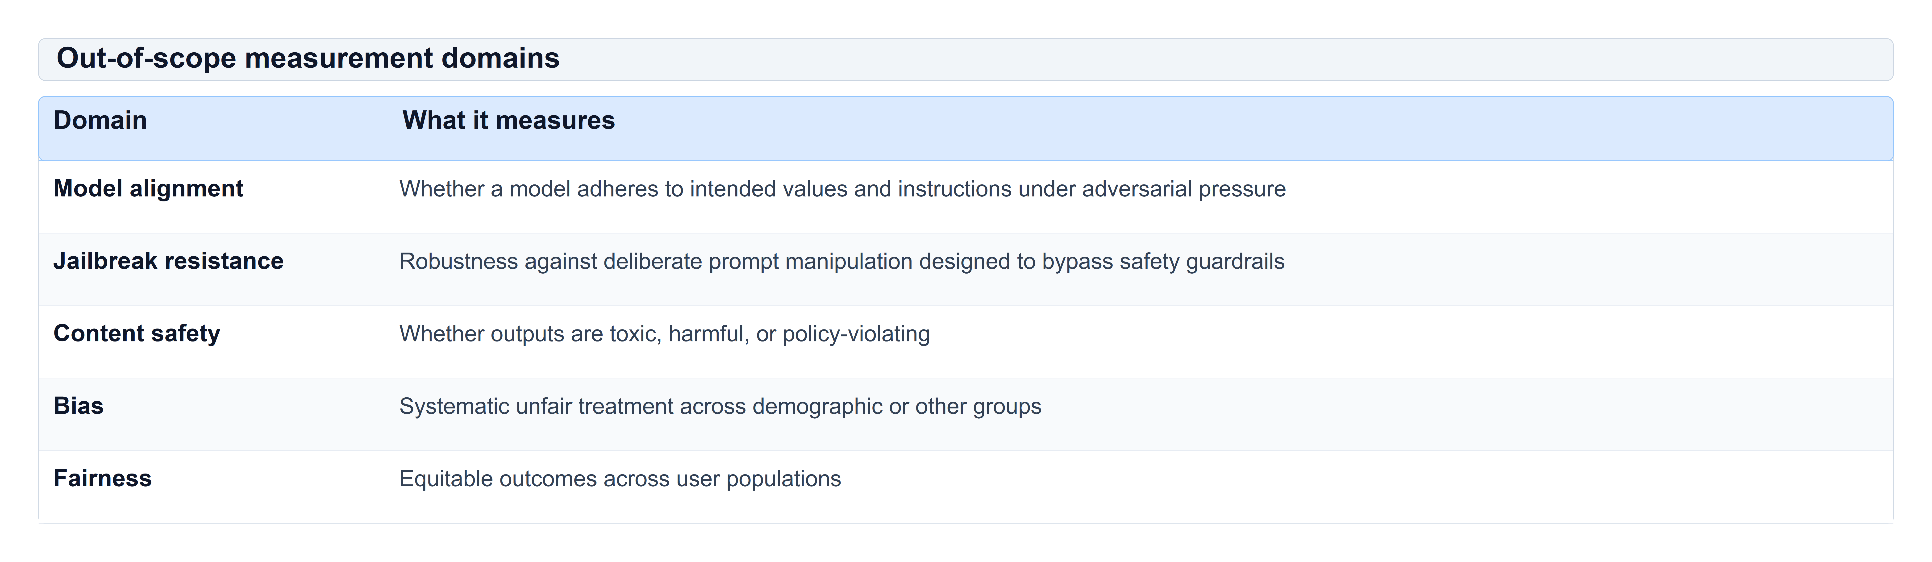
Table 1: Out-of-scope measurement domains
Elaboration. These are distinct measurement problems with distinct methodologies and evidence bases. The CVSS Special Interest Group has cautioned that merging software quality, ethics, privacy, and cybersecurity into a single severity number "creates dangerously misleading perceptions" [2]. AIVSS follows that guidance: it scores cybersecurity severity only. Where a model-behaviour assessment is in use elsewhere in an organization, its output may inform the exploitation evidence ladder (Section 12.3) but does not enter any AIVSS score. Full scope and non-goals are in Section 4.

3 Definitions and Terminology
This section defines every acronym and concept used normatively in later sections.

3.1 Systems and findings
Agentic AI system. A deployed software system that combines a language or reasoning model with tool access (APIs, databases, code execution, messaging), execution autonomy (can invoke tools without per-action human approval), persistent state (memory, vector stores, conversation history), and network reach (can interact with external services or other agents). Examples mapped to OWASP ASI risk surfaces: a sales agent with CRM write access (ASI02 tool misuse, ASI03 identity abuse); a coding assistant with repository and shell access (ASI05 unexpected code execution); a multi-agent orchestration platform (ASI07 insecure inter-agent communication, ASI08 cascading failures).
Vulnerability. A weakness in a system's design, implementation, or configuration that can be exploited to cause a security-relevant impact, as defined by CVSS v4.0 [1].
Finding. A specific instance of a vulnerability assessed in a particular deployment context (a named agent, tenant, and tool configuration).
Risk category (ASI). One of the ten categories in the OWASP Top 10 for Agentic Applications 2026 [4], identified ASI01 through ASI10. Classification is for traceability and worked examples only; the category label does not enter any score formula.

3.2 CVSS v4.0 concepts
CVSS (Common Vulnerability Scoring System). An open framework maintained by FIRST [1] for describing the severity of software vulnerabilities on a 0–10 scale. CVSS v4.0 uses a vector string of metric abbreviations and values.
CVSS vector string. A machine-readable representation such as `CVSS:4.0/AV:N/AC:L/...`. Each slash-separated pair is one metric.
Base metrics measure intrinsic properties of the vulnerability independent of environment or threat:
Table 2 defines each CVSS v4.0 Base metric abbreviation used in AIVSS assessments, its full name, and what intrinsic vulnerability property it captures before environmental or agentic extensions are applied.
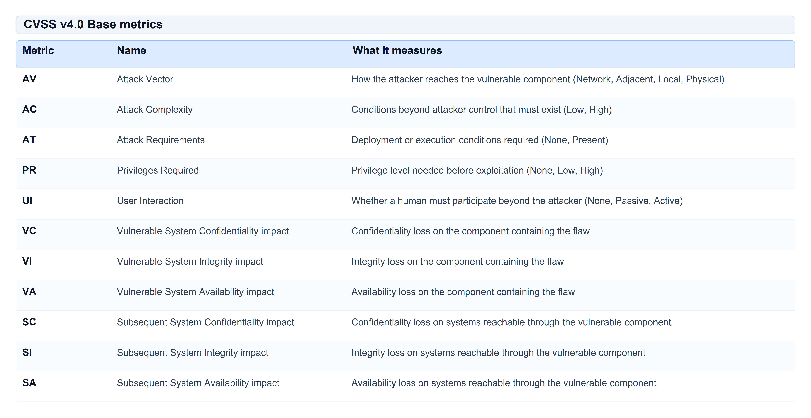
Table 2: CVSS v4.0 Base metrics
Impact values are None, Low, or High. FIRST defines precise scoring rules in the CVSS v4.0 specification [1].
Threat metrics describe observed exploitation:
Table 3 documents the CVSS Threat metric group — currently Exploit Maturity (E) — and the allowed values assessors use when encoding observed exploitation on the vector string.
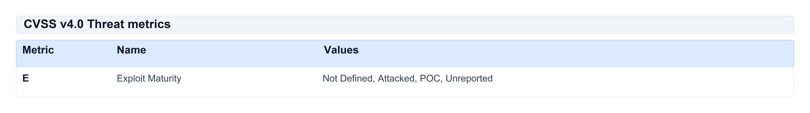
Table 3: CVSS v4.0 Threat metrics
Environmental metrics adjust severity for a specific deployment. AIVSS uses environmental metrics when computing CVSS-BTE but does not require organizational modifiers for conformance Level 1.
CVSS-BTE. The CVSS score computed from Base + Threat + Environmental metric groups, without organizational (Modified Base / Modified Threat / Modified Environmental / Security Requirements) overlays. This is the standard "full" CVSS score before per-organization tailoring. AIVSS uses proper CVSS v4.0 interpolation per FIRST `cvss_lookup.js` [1], not merely the MacroVector ceiling.
MacroVector. CVSS v4.0 collapses the 2,048 possible Base metric combinations into 270 equivalence classes (MacroVectors), each assigned an expert-ranked severity score [1, Section 8.2]. A MacroVector is identified by six equivalence-group indices EQ1–EQ6.
Equivalence groups (EQ1–EQ6). CVSS v4.0 groups Base metrics that have similar severity effect:
Table 4 groups CVSS Base metrics into the six equivalence classes (EQ1–EQ6) that define MacroVector identity in CVSS v4.0 and underpin Mode 2 promotion in Section 13.2.
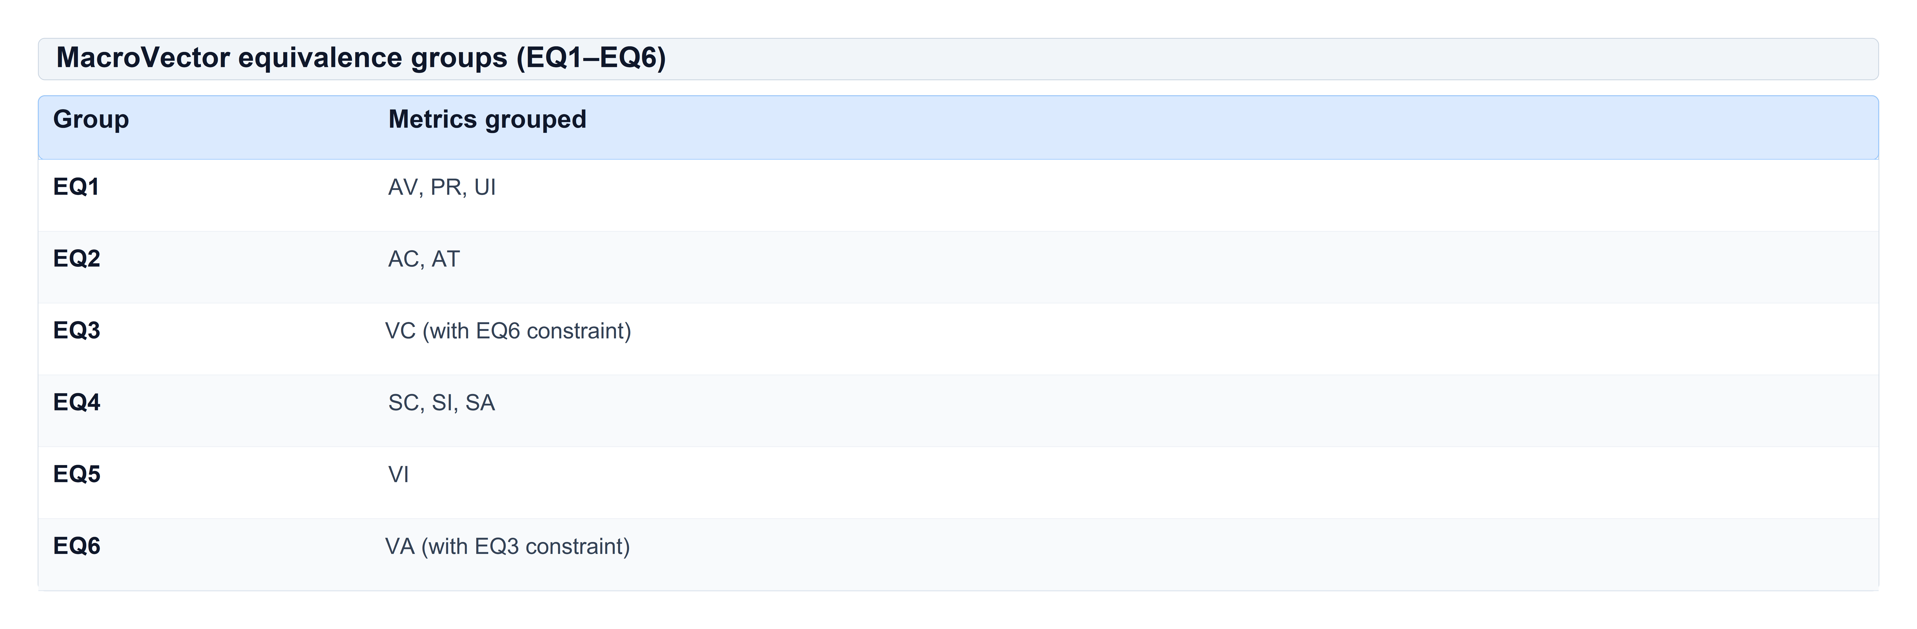
Table 4: MacroVector equivalence groups (EQ1–EQ6)

3.3 AIVSS-specific concepts
Agentic AI Profile. The structured extension to a CVSS assessment comprising the AI metric group (LC, CP, AP, SR, TD), its vector fragment, and the derived AI Effect Class. In JSON report output, serialized as the `ai_profile` object (Appendix A).
AI metric group. The five-metric vector extension (LC / CP / AP / SR / TD) that forms the core of the Agentic AI Profile (Section 10).
AI Effect Class (A). A boolean classification A0, A1, or A2 derived from the AI metric group (Section 11). It affects remediation escalation and optional Mode 2 scoring; it does not change the Mode 1 severity number.
Mode 1 (normative). `AIVSS = CVSS-BTE`. The default and only mode suitable for compliance gates, contracts, and SLAs.
Mode 2 (provisional). `AIVSS-BTEA = Lookup_AIVSS(EQ1..EQ6, A)` — a MacroVector promotion lookup (Section 13.2). Provisional pending expert calibration; not for compliance gates.
AIVSS-P. An optional organization-internal priority index (Level 3 only) combining technical severity with business context (Section 16). Not portable across organizations.

3.4 Federal and industry inputs
CISA. Cybersecurity and Infrastructure Security Agency (United States).
BOD 26-04. CISA Binding Operational Directive 26-04, *Prioritizing Security Updates Based on Risk*, effective June 10, 2026 [3]. It replaces CVSS-severity-driven federal remediation timelines with a four-variable decision model for Federal Civilian Executive Branch (FCEB) agencies.
KEV (Known Exploited Vulnerabilities catalog). CISA's authoritative list of CVEs with confirmed active exploitation in the wild [3].
Vulnrichment. CISA's program that enriches CVE records with structured fields including Automatable and Technical Impact, used by BOD 26-04 [3].
EPSS (Exploit Prediction Scoring System). A FIRST-maintained probability estimate that a CVE will be exploited in the wild within 30 days [11]. In AIVSS, EPSS is recorded in every report where available (`epss` + mandatory `epss_date`) but is metadata only: it does not select an exploitation-ladder rung, set CVSS `E` (Exploit Maturity), modify the Mode 1 severity score, or change the BOD 26-04 timeline lookup. Why: see Section 12.3.1 — this is a deliberate architectural choice, not an omission.
FCEB. Federal Civilian Executive Branch agencies subject to BOD 26-04.

4 Scope and Non-Goals

4.1 In scope
AIVSS scores the security consequences of vulnerabilities in deployed agentic systems — systems with tool access, execution autonomy, persistent state, and network reach, as defined in Section 3.1.

4.2 Out of scope
AIVSS does not score:
- Model alignment or value adherence
- Jailbreak resistance or prompt-injection robustness as a standalone safety metric
- Content safety, toxicity, bias, or fairness
- Privacy impact beyond what CVSS confidentiality metrics already capture
- Expected financial loss or business risk quantification (that is AIVSS-P's separate, optional domain)
These are distinct measurement problems. Combining them with cybersecurity severity produces misleading single numbers, as noted in the CVSS FAQ [2].

4.3 What AIVSS does not claim
1. Endorsement by, compatibility with, or authority from CVSS, FIRST, CISA, or CERT/CC.
2. Probability semantics — no AIVSS output is a calibrated exploitation probability.
3. Empirical validation — no claim is made that any AIVSS output predicts exploitation.
4. Standalone federal remediation authority — for FCEB agencies, BOD 26-04 [3] is the compliance obligation; AIVSS recommendations are a non-binding overlay.
5. Cross-organization comparability of AIVSS-P scores.
6. Endorsement of the OWASP Risk Rating Methodology or CWSS as current practice (see Section 16.1 lineage note).

4.4 Parameter provenance
Each parameter is derived (from an external calibrated source), asserted (chosen by the working group), or calibrated (fitted to data). Nothing in AIVSS 1.0 is calibrated.
Table 5 traces every normative AIVSS parameter to its source — whether derived from FIRST or CISA, asserted by the working group, or calibrated — so readers can see what is externally anchored versus project-chosen.
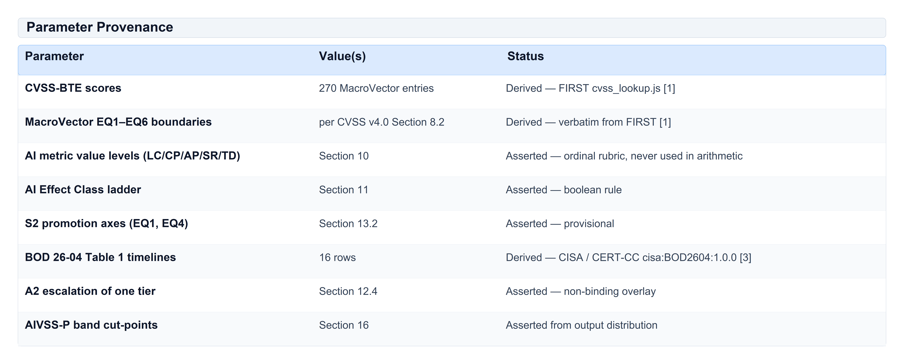
Table 5: Parameter Provenance

4.5 Statistical caveat
AI metric levels are ordinal rubric categories, not measured quantities. The letter codes carry no claim that "Indirect" sits exactly halfway between "None" and "Direct." AIVSS performs no arithmetic on ordinal AI values. The AI Effect Class is a boolean ladder; Mode 2 is a table lookup. Ordinal factors must not be averaged or multiplied into a severity formula [8].

5 Risk Taxonomy — OWASP Agentic AI Top 10

5.1 Credit — OWASP AIVSS project team
The Agentic AI Core Risks taxonomy — the original ten-category classification of security risks in autonomous and agentic AI systems — was developed by the OWASP AIVSS project team [5] as community-driven, open-source security research. That work established the foundational risk themes that shaped subsequent industry understanding of agentic threat models and informed the broader OWASP GenAI Security ecosystem.
Eight of ten OWASP ASI categories trace their research lineage directly to the original AIVSS core risk taxonomy (see crosswalk in Section 5.5). OWASP extended coverage with two categories that had no AIVSS predecessor: ASI09 Human–Agent Trust Exploitation and ASI10 Rogue Agents. A ninth original category — Agent Untraceability — has no OWASP ASI equivalent; AIVSS retains it as a mandatory risk factor carried forward as the TD (Traceability Deficit) metric (Section 5.6, Section 10.5).

5.2 Cross-industry research leveraged by the OWASP Top 10
The OWASP Top 10 for Agentic Applications 2026 [4] (published December 9, 2025) was developed through peer review with more than 100 industry experts, researchers, and practitioners. It synthesizes cross-industry open-source security guidance, including:
- The OWASP AIVSS project's Agentic AI Core Risks taxonomy [5]
- OWASP GenAI LLM Top 10 (2025/2026) [4]
- OWASP *State of Agentic AI Security and Governance* [4]
- OWASP Solutions Landscape — Red Teaming Taxonomy [4]
- Real-world incident disclosures and practitioner field reports

5.3 OWASP Top 10 — complete list
The table below lists all ten categories in the canonical taxonomy AIVSS 1.0 adopts. Eight of ten (ASI01–ASI08) trace to the OWASP AIVSS project team's original Agentic AI Core Risks taxonomy [5]; ASI09 and ASI10 were added by OWASP during peer review [4].
Table 6 is the canonical OWASP Agentic AI risk taxonomy adopted by AIVSS 1.0: all ten ASI01–ASI10 categories with a one-line description of each risk for classification and traceability.
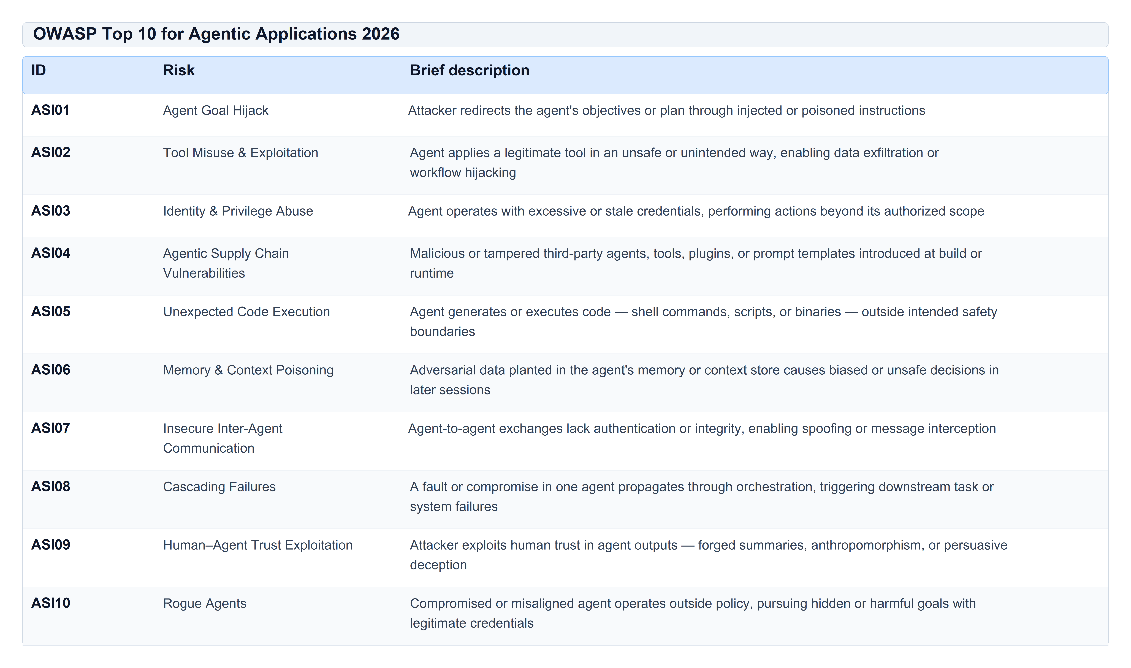
Table 6: OWASP Top 10 for Agentic Applications 2026

5.4 AIVSS mission — scoring tool, not taxonomy authority
The primary mission of AIVSS is to provide a reference scoring and remediation tool for agentic AI vulnerabilities — not to maintain an independent risk taxonomy. A parallel category list would duplicate OWASP's community-maintained taxonomy without adding scoring value.
For AIVSS version 1.0, we adopt OWASP ASI01–ASI10 as the sole canonical risk taxonomy and retire the bespoke AIVSS Agentic AI Core Risks list. Findings are classified to an ASI category for traceability and worked examples; the category label does not enter any score formula.
Table 7 records the version 1.0 taxonomy decision — adopting OWASP ASI01–ASI10, retiring the parallel AIVSS core-risk list, and retaining Agent Untraceability as the TD metric.
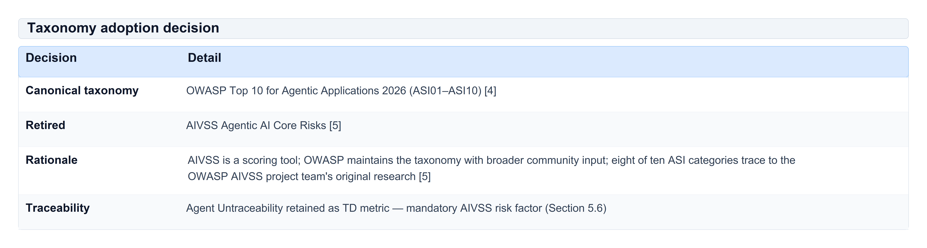
Table 7: Taxonomy adoption decision

5.5 Crosswalk from retired AIVSS categories
Table 8 crosswalks each retired AIVSS Agentic AI Core Risk category to its OWASP ASI successor (or to TD for Agent Untraceability), preserving lineage from the OWASP AIVSS project research.
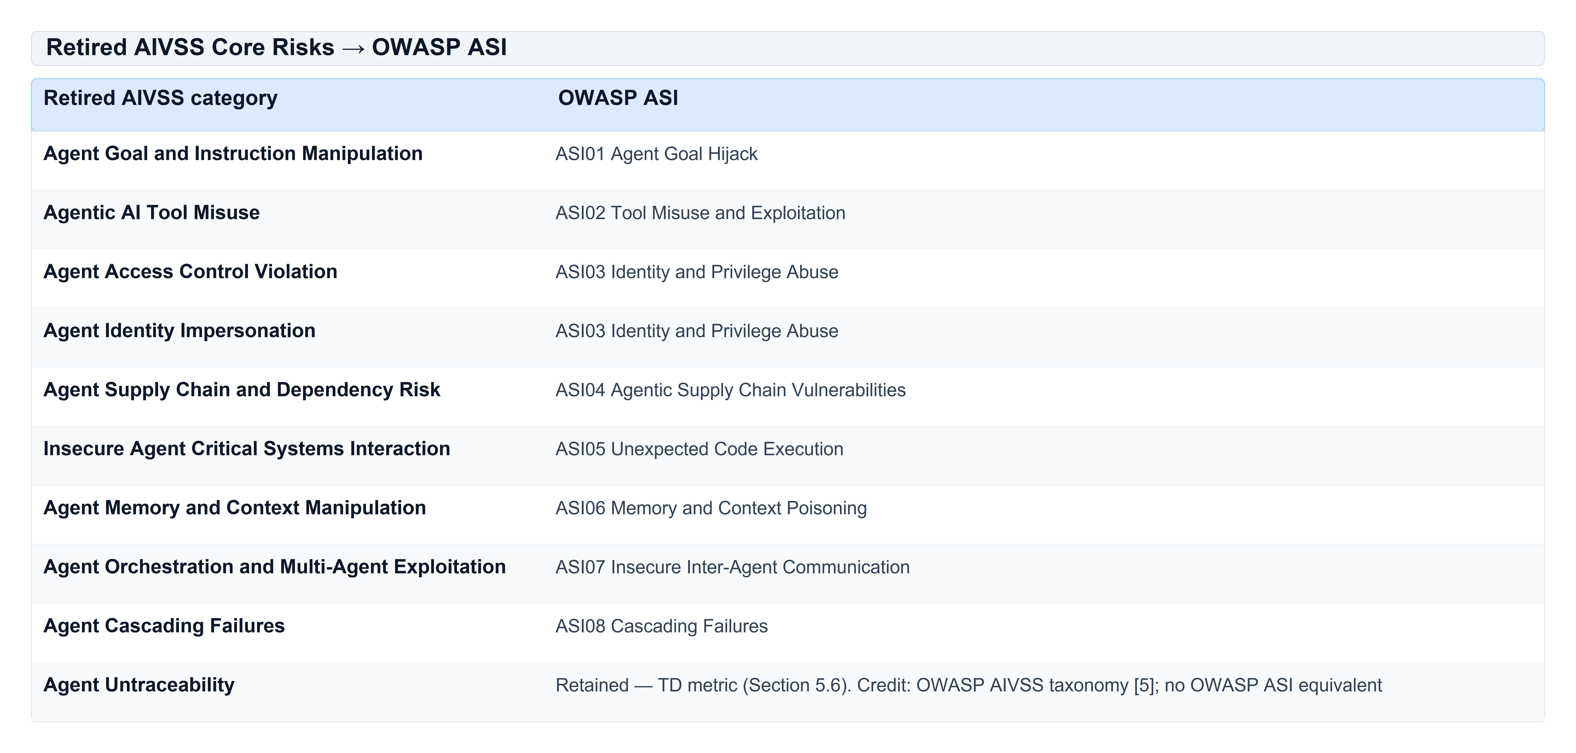
Table 8: Retired AIVSS Core Risks → OWASP ASI
New OWASP categories with no retired predecessor: ASI09 Human–Agent Trust Exploitation, ASI10 Rogue Agents.

5.6 Agent Untraceability — retained AIVSS risk factor
Credit. The risk of Agent Untraceability — the inability to reconstruct what an agent did, why it did it, and which tools it invoked — was identified as a distinct agentic security concern by the OWASP AIVSS project team in the original Agentic AI Core Risks taxonomy [5]. OWASP Top 10 for Agentic Applications 2026 [4] does not include a separate ASI category for this risk. AIVSS 1.0 retains it because untraceable agent behaviour materially worsens incident response, forensic triage, regulatory accountability, and safe rollback after compromise.
Definition — Agent Untraceability. A deployment condition in which post-incident reconstruction of an agent's reasoning chain, prompt history, and tool invocations is infeasible or unreliable, preventing defenders from determining scope of impact, attacker intent, or whether remediation succeeded.
How AIVSS measures it. Agent Untraceability is assessed through the TD (Traceability Deficit) metric in the Agentic AI Profile (Section 10.5). TD is a mandatory risk factor in every conformant assessment (Section 7): assessors MUST evaluate and record TD even though it does not change the Mode 1 severity number. This preserves the AIVSS taxonomy contribution while respecting the architectural rule that severity equals CVSS-BTE.
Why it matters for agentic systems. Unlike traditional software, agents may take dozens of autonomous tool actions per task with stochastic intermediate steps. Without prompt logging, reasoning traces, and tool-call audit trails, a successful attack can be non-attributable and non-reversible — the agent may have exfiltrated data or modified systems with no recoverable evidence. High TD (TD:H) SHOULD trigger enhanced incident-response procedures: assume worst-case scope, preserve ephemeral logs immediately, and block further autonomous actions until traceability controls are restored.
Relationship to ASI categories. Agent Untraceability often co-occurs with ASI01 (goal hijack), ASI06 (memory poisoning), and ASI10 (rogue agents), but it is orthogonal to those categories: a finding may be ASI02 Tool Misuse with TD:H if the deployment lacks auditability. Classify the primary flaw under ASI01–ASI10; always assess TD separately.

6 Architecture Overview
Figure 1 maps the AIVSS 1.0 architecture: Layer 1 computes honest CVSS-BTE severity, Layer 2 records the Agentic AI Profile and AI Effect Class, and Layer 3 applies the BOD 26-04 timeline model with optional Mode 2 extended severity and internal AIVSS-P priority.

Figure 1: AIVSS 1.0 system layers
AIVSS is organized into three normative layers plus two optional extensions:
Layer 1 — Severity (Part I, Section 9). Honest CVSS v4.0 scoring with agent-specific interpretation rules. Output: `AIVSS = CVSS-BTE` in Mode 1.
Layer 2 — Agentic AI Profile (Section 10). Five dimensions describing language-mediated control, context persistence, agentic propagation, stochastic exploit reliability, and traceability deficit. Output: vector extension and AI Effect Class (Section 11).
Layer 3 — Timeline (Section 12). CISA BOD 26-04 [3] decision model plus AI Effect Class escalation. Output: BOD timeline and AIVSS recommendation.
Optional Mode 2 (Section 13.2). MacroVector promotion for extended severity — provisional.
Optional AIVSS-P (Section 16). Organization-internal priority index — Level 3 only.
The ten historical AIVSS amplification factors resolve into either CVSS Base metrics or the five AI metrics:
Table 9 shows how each historical agentic amplification factor is scored — wholly in CVSS, wholly as an AI metric (LC/CP/AP/SR/TD), or split — so assessors do not double-count the same property.
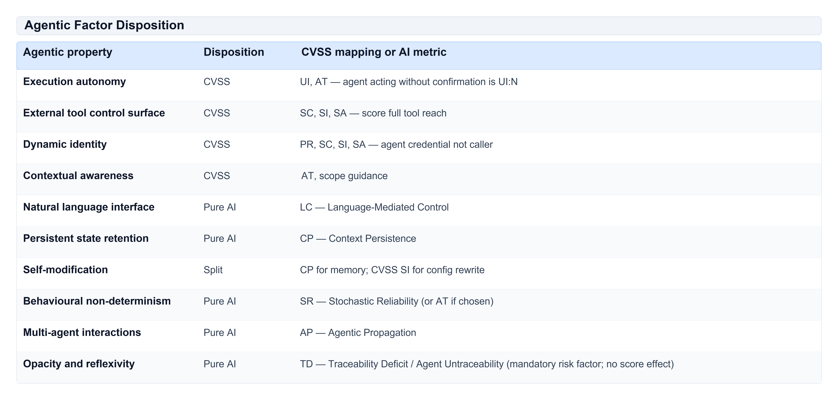
Table 9: Agentic Factor Disposition

7 Conformance Levels
Level 1 — Severity and Agentic AI Profile. Sufficient to claim "AIVSS 1.0 conformant."
- MUST supply a CVSS v4.0 Base vector (MAY be imported from NVD or an advisory).
- MUST supply all four scored AI metrics (LC, CP, AP, SR), or explicitly none.
- MUST assess TD (Agent Untraceability) for every finding — record TD:H, TD:M, or TD:L in the Agentic AI Profile (Section 5.6, Section 10.5). TD does not modify the severity number but is a required risk-factor consideration.
- MUST classify the finding to an ASI01–ASI10 category [4].
- MUST emit a conformant vector string (Section 10.6).
- MAY omit the decision track and AIVSS-P.
Level 2 — Level 1 plus decision track. MUST supply asset exposure (`publicly_exposed`) and MUST report the unmodified BOD 26-04 [3] timeline alongside any AIVSS recommendation.
Level 3 — Level 2 plus organizational priority. AIVSS-P outputs are organization-internal. A Level 3 producer MUST NOT publish AIVSS-P outside the assessing organization.
Consumer conformance. MUST parse all vector strings at its declared level; MUST NOT display an AIVSS score in a field that also carries CVSS scores without the `AIVSS:` prefix; MUST NOT substitute a missing AI metric group for an all-benign one.

8 End-to-End Assessment Flow
Figure 2 walks through the end-to-end assessment path — from CVSS vector and optional Agentic AI Profile through Mode 1 AIVSS scoring, parallel remediation timeline resolution, and optional Mode 2 BTEA lookup — showing where each output is produced.

Figure 2: Assessment flow
An AIVSS assessment proceeds in five steps:
1. Classify the finding under ASI01–ASI10 [4].
2. Build a CVSS v4.0 vector with honest agent credential, tool-reach, and subsequent-system scoring (Section 9).
3. Add the AI metric group (LC, CP, AP, SR, and TD for Agent Untraceability) per Section 10.
4. Run the calculator to obtain AIVSS severity (Mode 1), AI Effect Class, and optionally Mode 2 extended severity.
5. Supply exposure and exploitation evidence for the remediation timeline (Section 12).
[ BASH / CLI COMMAND ]
cd tools/aivss-calc && pip install -e ".[dev]"
aivss-calc assess examples/asi01-example.json

When AI metrics are present, they are parsed as an optional extension group in fixed order: LC / CP / AP / SR / TD. The tool computes an interpolated CVSS-BTE score, classifies the AI Effect Class, and emits Mode 1 (normative) and optionally Mode 2 (provisional) scores. At Level 2, the decision track runs in parallel.

9 CVSS Interpretation for Agentic Systems (Normative)
Core rule: `AIVSS = CVSS-BTE`. AI metrics are reported as an Agentic AI Profile and do not modify the numeric score in Mode 1.
Agentic properties already representable in CVSS MUST be scored in CVSS, not duplicated in the AI metric group (Section 9.3).

9.1 Agent-specific interpretation rules
Per CVSS v4.0 [1] and AIVSS interpretation guidance:
PR (Privileges Required). Score the agent's effective credential, not the human end-user's. In an ASI03 Identity & Privilege Abuse finding, if an attacker steals the agent's service account and the agent holds database write access, PR reflects that service account's privilege level — not the end user's login.
UI (User Interaction). If human approval is nominally required but routinely granted without meaningful review, the honest value is UI:N (no interaction required). In ASI09 Human–Agent Trust Exploitation, forged agent summaries that humans approve without review also imply UI:N for the underlying attack path.
SC / SI / SA (Subsequent System impacts). Score against the full reach of the agent's tool set — every API, database, filesystem, and downstream system the agent can invoke — not merely the process boundary of the agent runtime. In an ASI02 Tool Misuse finding, score SC/SI/SA against every downstream system the misused tool can reach.
AT (Attack Requirements). When model stochasticity is a necessary condition for exploitation (the attack succeeds only when the model produces a particular output distribution), encode that here as AT:P — as in ASI08 Cascading Failures where a faulty planner intermittently triggers downstream errors. If AT already captures stochasticity, do not also score SR (Section 9.3).
E (Exploit Maturity). Set from the exploitation evidence ladder (Section 12.3): authoritative Active (KEV or Vulnrichment) → `E:A`; organization-observed Active (unverified) or PoC → `E:P`; no evidence → `E:U`.

9.2 The four most common CVSS scoring errors in agentic systems
1. Under-scoring Subsequent System metrics. SC/SI/SA must reflect full tool reach — e.g., scoring ASI02 at Low when the misused tool can exfiltrate customer records via a downstream CRM API.
2. Scoring PR at the human's privilege. Score the agent's credential — e.g., in ASI03, the agent's service-account privilege, not the caller's SSO session.
3. Scoring UI:P because a human is nominally in the loop. Routine rubber-stamp approval is UI:N — common in ASI09 where humans trust forged agent summaries.
4. Treating retrieval-sourced injection as requiring user interaction. Content ingested autonomously is not user interaction — e.g., ASI01 indirect goal hijack via poisoned documents the agent retrieves without user action.

9.3 Non-overlap rule
AI metrics MUST NOT rescore a condition already represented in CVSS. If model stochasticity was encoded as AT:P, do not also score SR. Record which representation was used in assessment notes.

10 AI Metric Group (Normative)
The AI metric group captures agent-specific properties that CVSS Base metrics do not separately name. Scored metrics: LC, CP, AP, SR. Mandatory non-scoring metric: TD (Agent Untraceability; Section 5.6, Section 7).
All four scored metrics MUST be present together or all absent. TD is required in every conformant assessment (Section 7). An unknown key MUST cause a parse failure.

10.1 LC — Language-Mediated Control
Definition. Whether attacker-controlled natural language can influence security-relevant behaviour without passing through a constrained interface.
Example (ASI01). Direct prompt injection that hijacks a planning agent's goals is LC:D — attacker text reaches the privileged planning path without mediation.
Table 10 defines the LC metric levels (Direct, Indirect, Mediated, None) and when attacker-controlled natural language can influence security-relevant agent behaviour.
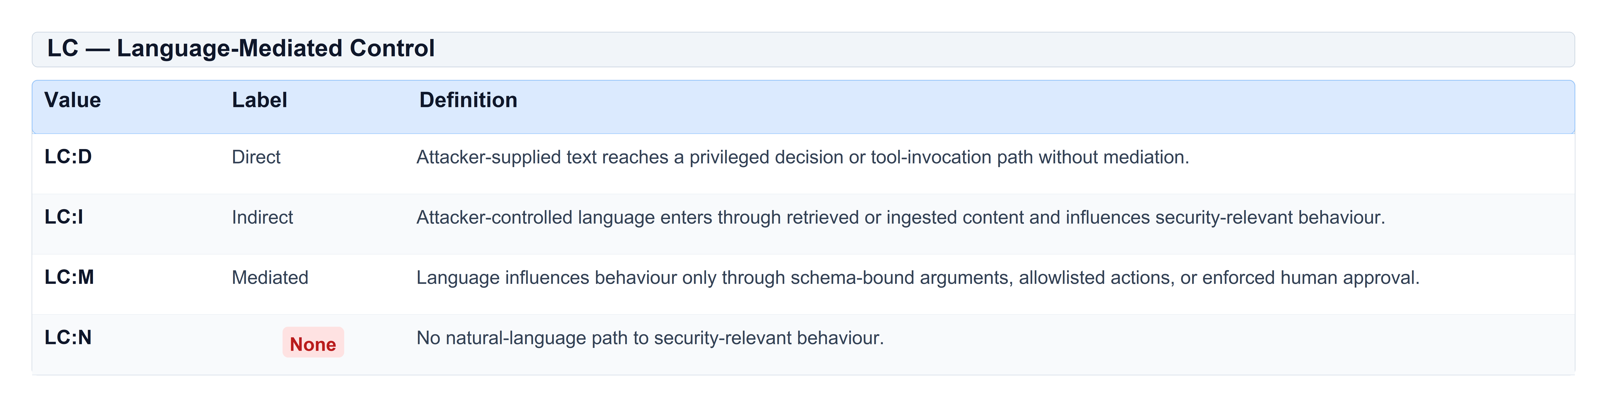
Table 10: LC — Language-Mediated Control

10.2 CP — Context Persistence
Definition. Whether attacker-controlled context survives beyond a single interaction.
Example (ASI06). Adversarial data planted in the agent's memory or context store biases decisions in later sessions — CP:C (cross-session context poisoning).
Table 11 defines the CP metric levels (Cross-session, Session, None) describing how long attacker-planted context survives and whether it can affect later sessions or other users.
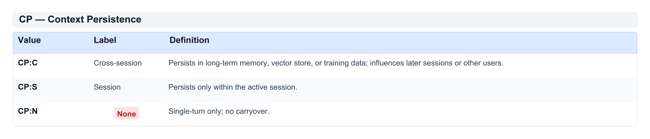
Table 11: CP — Context Persistence

10.3 AP — Agentic Propagation
Definition. Whether compromised intent, instructions, memory, or authority crosses a trust boundary.
Example (ASI07). Unsigned agent-to-agent messages that allow an attacker to relay instructions to sibling agents are AP:L — lateral propagation across a trust boundary.
Table 12 defines the AP metric levels (Lateral, Contained, None) for whether compromise spreads across trust boundaries to other agents, tenants, or downstream systems.
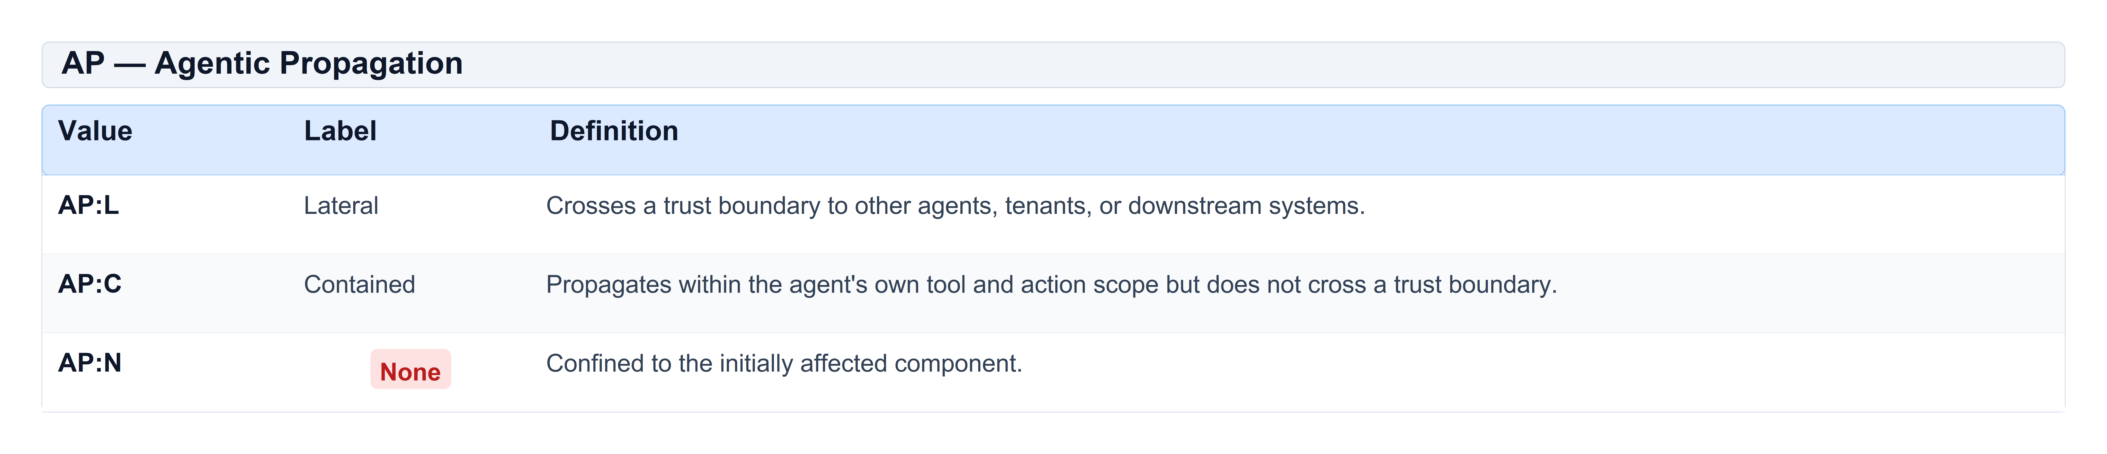
Table 12: AP — Agentic Propagation

10.4 SR — Stochastic Exploit Reliability
Definition. How reliably an attacker can reproduce the exploit, independent of whether stochasticity is already encoded in CVSS AT.
Example (ASI05). A code interpreter that executes attacker shell commands on every attempt is SR:R — reliable reproduction.
Table 13 defines the SR metric levels (Reliable, Probabilistic, Unreliable) for how reproducibly an attack succeeds and whether the attacker can retry freely.
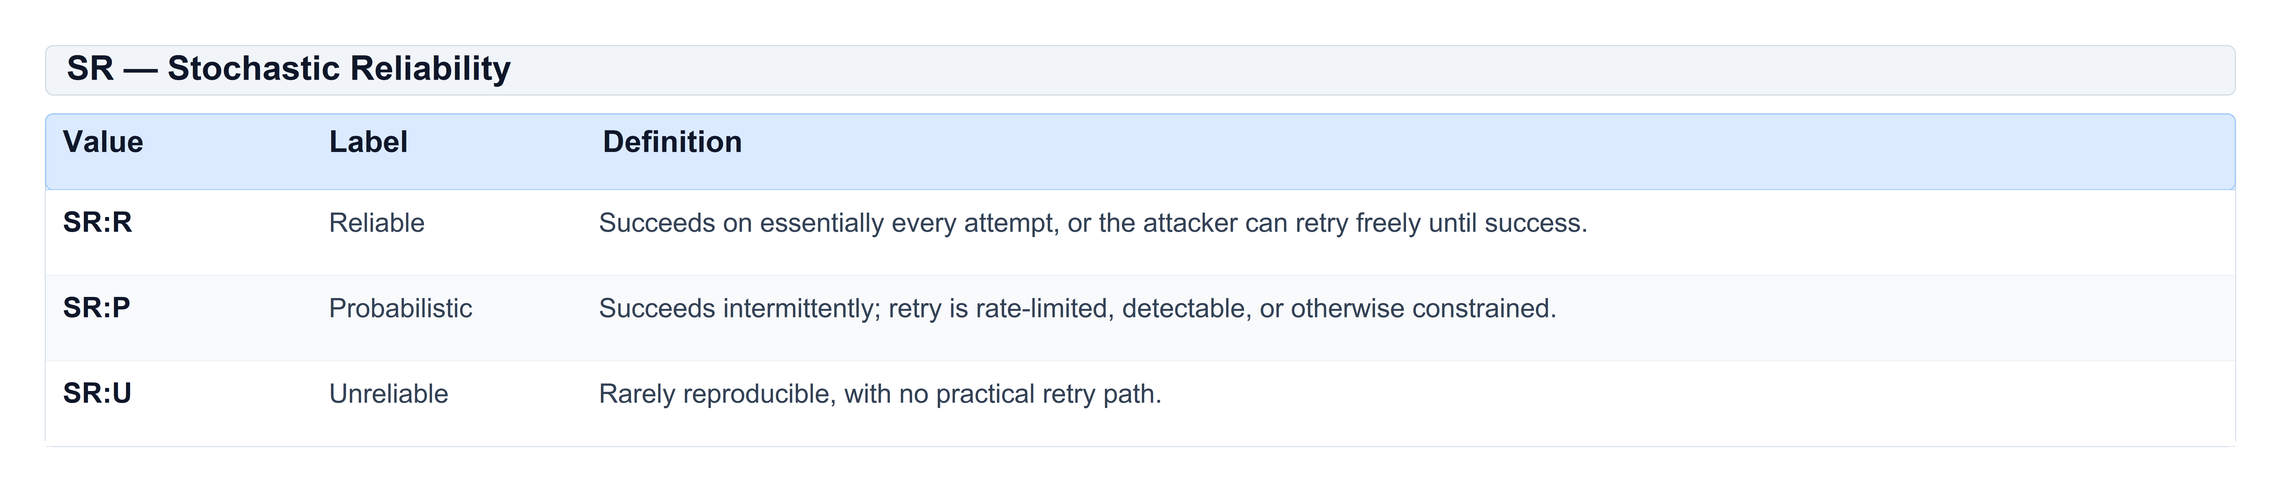
Table 13: SR — Stochastic Reliability
Non-overlap rule: If stochasticity is already encoded as CVSS AT:P, do not also score SR.

10.5 TD — Traceability Deficit (Agent Untraceability)
Credit. TD implements Agent Untraceability, the tenth category of the original OWASP AIVSS Agentic AI Core Risks taxonomy [5]. OWASP Top 10 [4] has no ASI equivalent; AIVSS retains this as a mandatory risk factor because agentic systems without audit trails create non-attributable, non-reversible security incidents.
Definition — TD (Traceability Deficit). The degree to which post-incident reconstruction of an agent's reasoning, prompts, and tool actions is infeasible. High traceability deficit means the deployment exhibits Agent Untraceability: defenders cannot reliably determine what the agent did, why, or on whose behalf.
Scoring rule. TD is recorded in every conformant assessment. TD never affects the Mode 1 severity number (AIVSS = CVSS-BTE). It informs response priority, forensic procedures, control requirements, and release gating. When TD:H, assessors SHOULD treat scope of compromise as unknown until proven otherwise.
Table 14 defines the TD metric levels (High, Medium, Low) for Agent Untraceability — a mandatory AIVSS risk factor retained from the original OWASP AIVSS taxonomy that does not change the Mode 1 severity number.
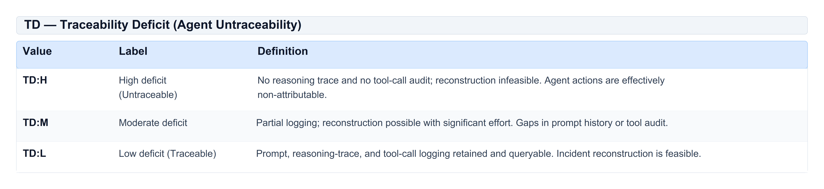
Table 14: TD — Traceability Deficit (Agent Untraceability)
Assessment guidance. Evaluate TD from deployment architecture, not attack technique alone. Ask: if this exploit succeeded, could we reconstruct the full chain of agent decisions and tool calls within 24 hours? An ASI10 Rogue Agent deployment with TD:H and no reasoning trace is especially dangerous — scope of compromise cannot be bounded after detection.

10.6 Vector syntax
AIVSS extends the CVSS v4.0 vector with an optional AI metric group:
[ TELEMETRY / TRANSCRIPT ]
CVSS:4.0/AV:N/AC:L/AT:N/PR:N/UI:N/VC:H/VI:H/VA:N/SC:H/SI:N/SA:N/E:P/LC:D/CP:S/AP:C/SR:R/TD:M

A score MUST be rendered as `AIVSS:8.3`, never as a bare number in prose or UI labels. In structured JSON output the numeric value lives in `scores.mode1_interpretation.aivss`; consumers MUST prefix with `AIVSS:` when displaying to humans.

11 AI Effect Class
Figure 3 summarizes the boolean AI Effect Class ladder: A2 (substantial agentic amplification), A1 (present but not substantial), and A0 (no profile or all benign), including the rule that A2 may advance remediation by one BOD tier.

Figure 3: AI Effect Class rules
The scored AI metrics produce an AI Effect Class by boolean ladder. No arithmetic is performed on ordinal metric levels.
- A2 (Substantial) — AP:L, or (LC in {D, I} and CP:C), or (LC:D and SR:R)
- A1 (Present) — not A2, but any scored metric above its benign value (LC≠N, CP≠N, AP≠N, or SR≠U)
- A0 (None) — LC:N and CP:N and AP:N and SR:U, or the AI metric group is absent
Identity rule: A0 implies `AIVSS = CVSS-BTE` exactly, in both Mode 1 and Mode 2. Verified in the reference implementation over representative vectors and exhaustive A0 promotion invariance across all 270 MacroVector classes.
Rationale for A2 clauses:
- AP:L — propagation across a trust boundary is categorically the most severe agentic effect.
- LC {D,I} + CP:C — persistent cross-session context poisoning reachable by language is the signature agentic attack pattern.
- LC:D + SR:R — direct, reliable language control of a privileged path is a dependable injection primitive.

12 Remediation Timelines (Normative at Level 2)
Figure 4 shows how the five BOD 26-04 decision inputs feed a 16-row lookup to yield 3-day, 14-day, 60-day, or defer timelines, and how an A2 AI Effect Class advances the recommended tier while the unmodified BOD baseline is always reported.

Figure 4: Remediation decision inputs
Severity does not determine remediation urgency. Since June 10, 2026, BOD 26-04 [3] has replaced CVSS-severity-driven federal remediation with a four-variable model. AIVSS consumes that model verbatim and adds one decision point: the AI Effect Class.

12.1 BOD 26-04 decision inputs
Table 15 lists the five inputs to the BOD 26-04 remediation model — KEV status, public exposure, automatable, technical impact, and AI Effect Class — with definitions and authoritative sources.
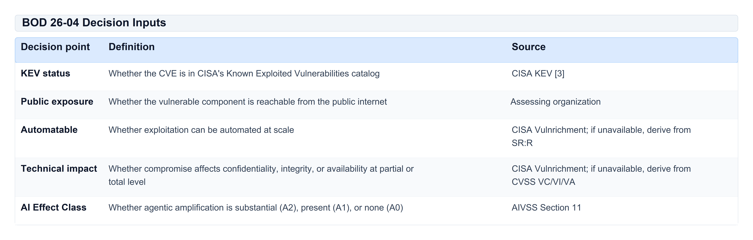
Table 15: BOD 26-04 Decision Inputs
Where CISA has published neither Automatable nor Technical Impact and the CVE is not in KEV, BOD 26-04 directs that they be treated as "no" and "total" respectively. SR/CVSS derivations apply only for non-CVE findings without Vulnrichment data.

12.2 BOD 26-04 Table 1 (16 rows)
All sixteen rows, transcribed from `cisa:BOD2604:1.0.0` [3]. Held as a lookup table, not boolean logic: the fast tier requires exposure or automatability in addition to KEV.
Table 16 reproduces CISA's full 16-row BOD 26-04 lookup: every combination of KEV, exposure, automatable, and technical impact maps to Fix-on-upgrade, 60-day, 14-day, or 3-day (plus forensic) timelines.
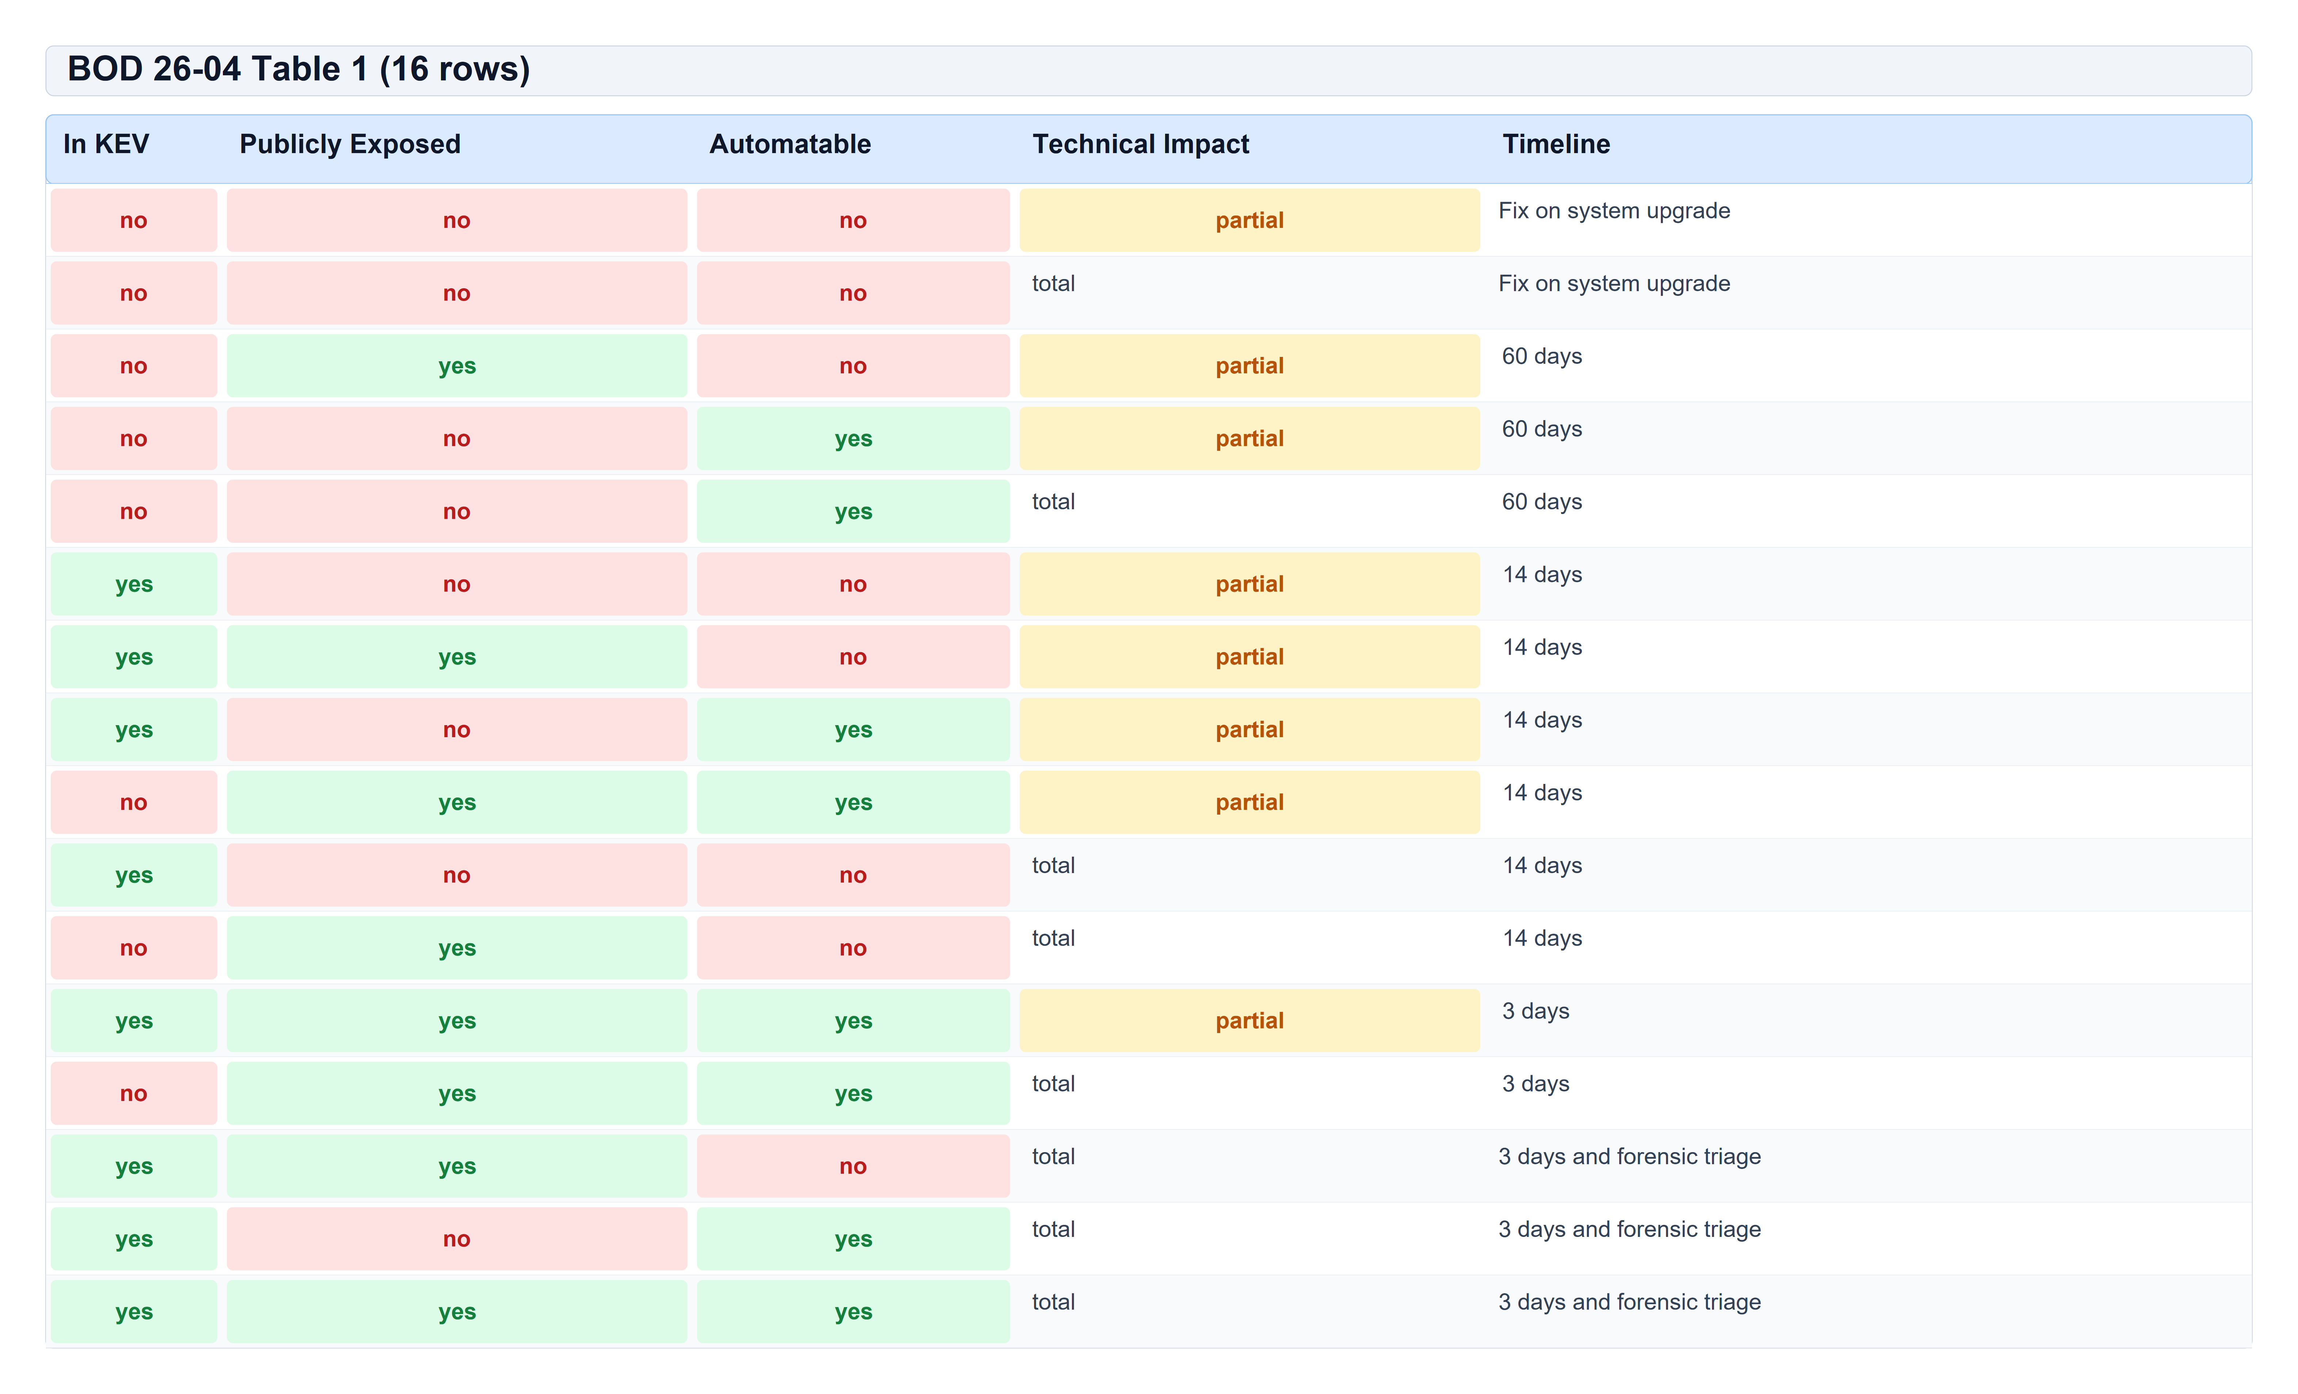
Table 16: BOD 26-04 Table 1 (16 rows)

12.3 Exploitation evidence ladder
Figure 5 ranks exploitation evidence from strongest to weakest — CISA KEV, Vulnrichment active exploitation, organization-observed activity, proof-of-concept, and no evidence — and notes that EPSS is recorded as dated metadata only, not as a ladder rung (Section 12.3.1).

Figure 5: Exploitation evidence ladder
Strict precedence, highest authority first. Replaces withdrawn multiplier-based threat models (`max(ThM_discrete, ThM_EPSS, ThM_KEV)` from earlier AIVSS drafts). The ladder selects factual exploitation evidence only.
1. CVE listed in CISA KEV → Active (authoritative)
2. CISA Vulnrichment reports Exploitation: active → Active (authoritative)
3. Exploitation observed and documented by the assessing organization → Active (unverified) — essential for non-CVE agentic findings
4. Proof-of-concept exists → PoC
5. No evidence → None
The selected rung sets CVSS `E` (Exploit Maturity) for the assessment: authoritative Active (items 1–2) → `E:A`; Active (unverified) or PoC (items 3–4) → `E:P`; None (item 5) → `E:U`.
EPSS is not on this ladder. Published EPSS scores are recorded alongside the ladder result (`epss`, `epss_date`) but never override a rung selected from items 1–5 above. See Section 12.3.1.
Withdrawn constructs: `EPSS_AI`, `AI-KEV`, `SSVC-AI`. Each borrowed an owning organization's name for an artifact lacking the property the name asserts.

12.3.1 Why EPSS is recorded but not used in scoring or ladder selection
EPSS is valuable intelligence. AIVSS requires recording it when available and prohibits using it to change any normative output. Five reasons:
1. BOD 26-04 does not use EPSS. The federal remediation model that AIVSS consumes verbatim (Sections 12.1–12.2) keys on KEV status, public exposure, automatable, and technical impact [3]. EPSS is not an input to the 16-row BOD lookup. Folding EPSS into AIVSS timeline or severity would depart from the cited compliance model without adding a defensible mapping.
2. Forecast ≠ fact. EPSS estimates the *probability* of future exploitation. The exploitation ladder selects *documented* signals: CISA-confirmed active exploitation (KEV, Vulnrichment), organization-observed exploitation, or a proof-of-concept. Treating a 0.42 EPSS score as "PoC" or "Active" would substitute a statistical forecast for factual evidence and misrepresent what was actually observed.
3. Prior AIVSS integration was mathematically inert. Earlier drafts combined EPSS with a Threat Multiplier via `max(ThM_discrete, ThM_EPSS)` where `ThM_discrete(PoC) = 0.97` and `ThM_EPSS = 0.50 + 0.50 × EPSS`. Under `max()` selection, EPSS could change the result only when EPSS > 0.94 — a tiny fraction of the published distribution, most of which is already KEV-listed. Maximum achievable effect on severity: 0.3 points at the low end of the scale, and 0.1 points for findings above CVSS 7.0. The draft's own worked example showed EPSS 0.42 producing `ThM_EPSS = 0.71`, which was discarded. The integration appeared to use EPSS but did not.
4. `EPSS_AI` is withdrawn and must not return. Agentic findings are often non-CVE or lack NVD coverage. The withdrawn `EPSS_AI` construct — four booleans substituted into a transform designed for a calibrated probability — would misrepresent EPSS's measurement model and violate AIVSS's probability disclaimer (Section 4.3). Organizations may apply EPSS (or their own models) in separate prioritization workflows; AIVSS does not invent a parallel probability score.
5. Reproducibility requires an observation date. EPSS is revised daily. An assessment that used EPSS to set exploitation state without `epss_date` would not be reproducible. Recording EPSS as dated metadata preserves auditability without letting a moving forecast rewrite a scored finding retroactively.
What practitioners should do with EPSS in an AIVSS assessment:
Table 17 contrasts appropriate uses of EPSS alongside an AIVSS assessment with prohibited uses — EPSS must not select the exploitation ladder rung, set CVSS E, modify Mode 1 severity, or change the BOD timeline lookup (Section 12.3.1).
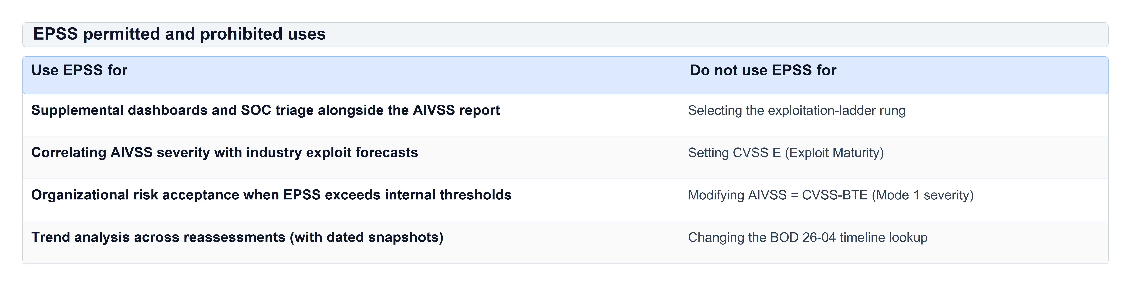
Table 17: EPSS permitted and prohibited uses
Record via: `aivss-calc decide --epss 0.42 --epss-date 2026-08-27` (or equivalent fields in the assessment JSON). The reference implementation always emits `epss` and `epss_date` in the decision output when supplied; the ladder `rung` is determined solely by items 1–5 above.

12.4 AI Effect Class escalation
When the AI Effect Class is A2, the recommended timeline advances by exactly one tier: FSU → 60D → 14D → 3D. Escalation stops at 3D. AIVSS never escalates into forensic triage (that is a CISA determination tied to KEV listing [3]).
The unmodified BOD 26-04 result MUST always be reported alongside the AIVSS recommendation. For an FCEB agency, the BOD value is the compliance obligation.

13 Scoring Modes

13.1 Mode 1 — Interpretation (normative)
`AIVSS = CVSS-BTE`. AI metrics are reported as an Agentic AI Profile. Immediately usable, zero score inflation, identity trivially preserved. Scoring uses proper CVSS v4.0 interpolation per FIRST [1], not MacroVector ceiling values.

13.2 Mode 2 — MacroVector extension (provisional)
Figure 6 explains optional Mode 2 (AIVSS-BTEA): A0 leaves severity unchanged, A1 promotes subsequent-system impact (EQ4), and A2 also promotes attack-surface metrics (EQ1), with every output drawn from FIRST's existing MacroVector lookup table.

Figure 6: Extended severity (Mode 2)
[ CODE ]
AIVSS-BTEA = Lookup_AIVSS(EQ1, EQ2, EQ3, EQ4, EQ5, EQ6, A)

EQ1–EQ6 are the CVSS v4.0 equivalence groups (270 valid classes). A is the AI Effect Class.
An AI Effect Class does not add a free-form numeric uplift. Mode 2 promotes the vector's MacroVector equivalence class (EQ4 at A1; EQ4 and EQ1 at A2) and applies the expert-ranked ceiling delta from FIRST `cvss_lookup.js` [1] to the vector's interpolated CVSS-BTE base:
[ CODE ]
AIVSS-BTEA = min(10.0, CVSS-BTE + (score(promoted_MV) − score(base_MV)))

This preserves the vector's position within its MacroVector class while transferring only the expert-ranked gap to the promoted neighbour — it does not return the promoted MacroVector ceiling alone (which would ignore within-class interpolation).
Table 18 states the provisional Mode 2 MacroVector promotion rules by AI Effect Class: which equivalence groups (EQ4 and, at A2, EQ1) advance and when promotion is a no-op.
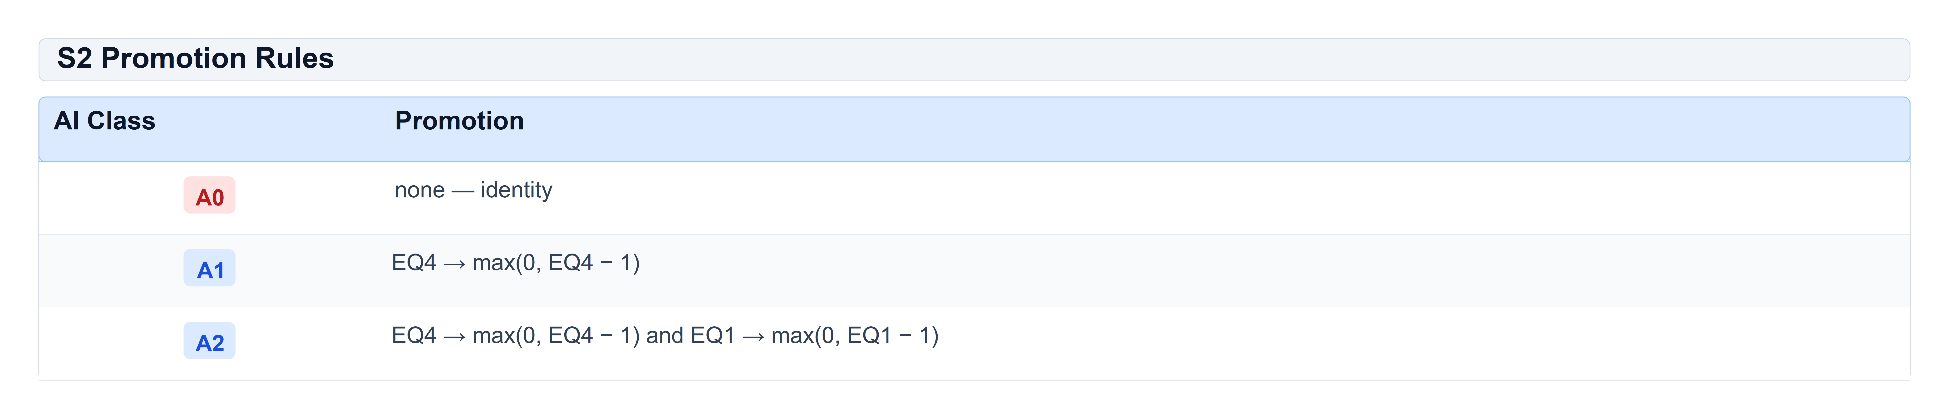
Table 18: S2 Promotion Rules
EQ4 (SC/SI/SA) is promoted because subsequent-system impact is the dimension agentic persistence and propagation extend. EQ1 (AV/PR/UI) is additionally promoted at A2 because substantial language-mediated control effectively removes privilege and interaction barriers.
Verified properties (reference implementation): Identity at A0 (0 sample violations), Monotone promotion (0 violations), Bounded (≤ 10.0), Ordered (A2 ≥ A1 ≥ A0 on representative vectors). Every delta is drawn from FIRST's published MacroVector scores.
Known limitation: A1 is a no-op for MacroVectors already at EQ4 = 0; A2 is a full no-op for 11% of the space. Saturation is reported in tool output.
Provisional pending expert calibration; not for use in contracts, SLAs, or compliance gates.

14 OWASP Top 10 — Calculator Results
Every row scored with `aivss-calc assess`. Example files in `tools/aivss-calc/examples/`.
Table 19 presents reference-calculator outputs for one worked example per ASI01–ASI10 category — showing AIVSS severity, AI Effect Class, and both BOD and AIVSS-recommended remediation timelines.
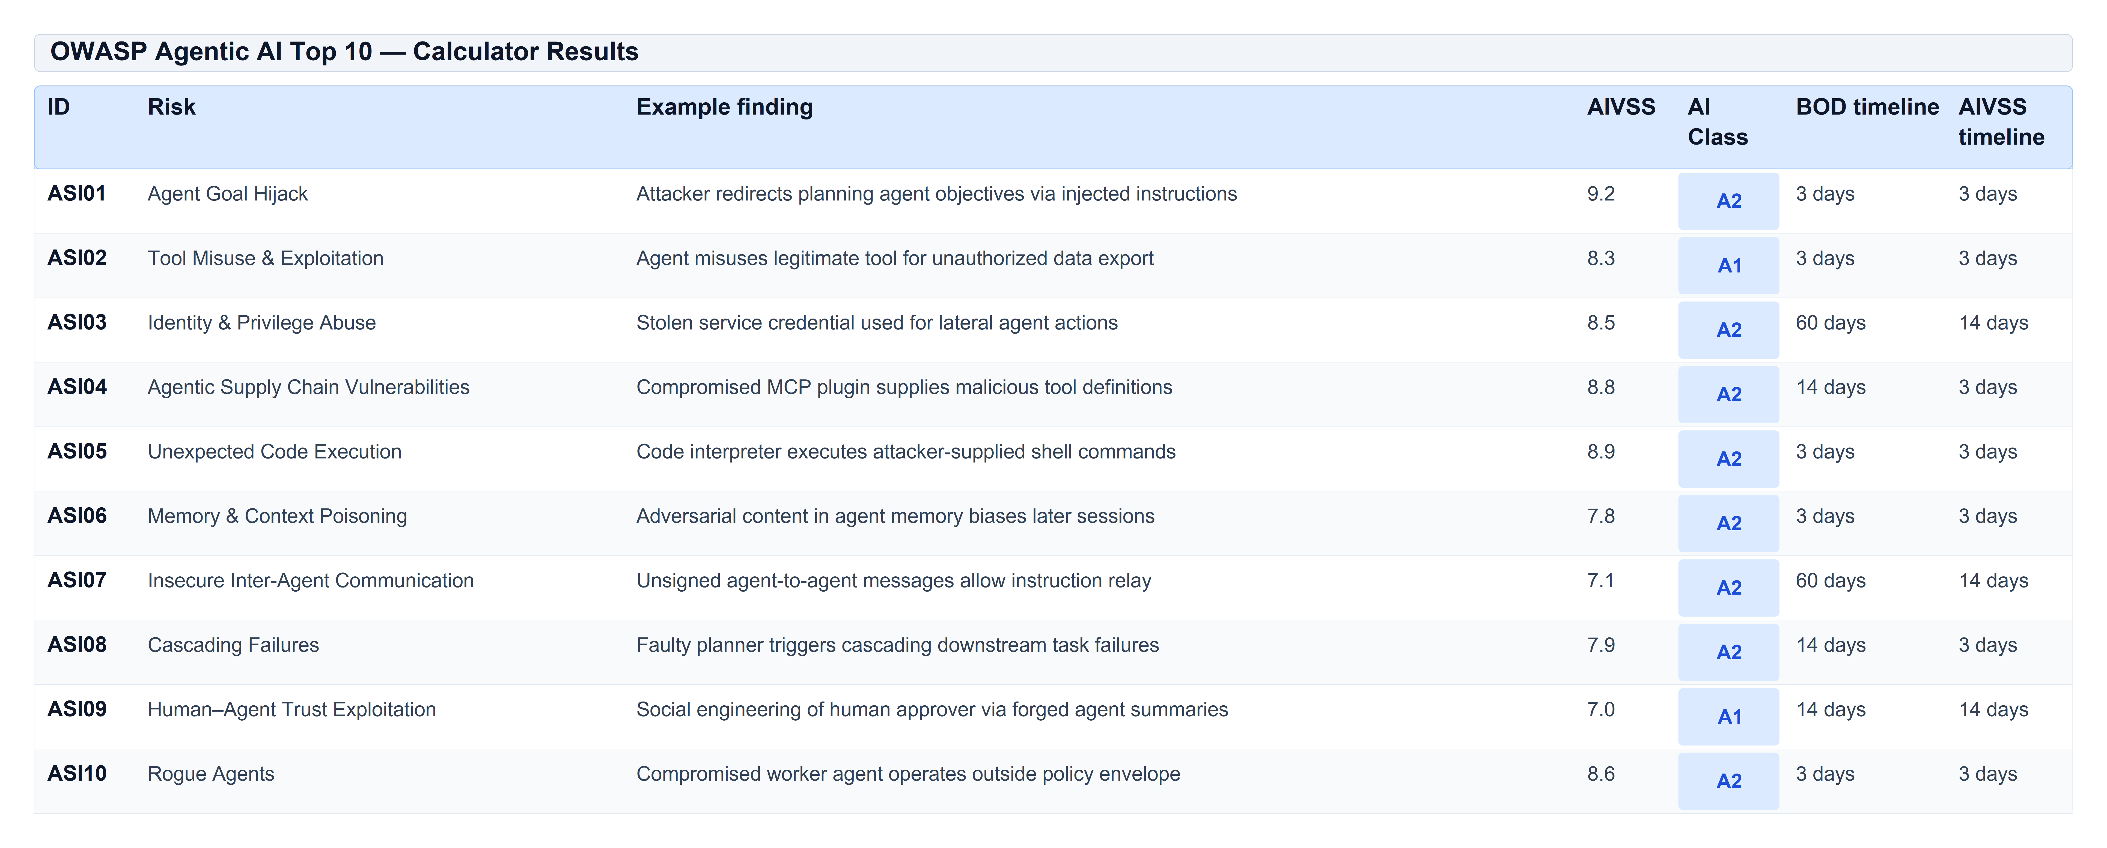
Table 19: OWASP Agentic AI Top 10 — Calculator Results

15 Worked Example — ASI06 Memory and Context Poisoning
Finding narrative. ASI06 Memory and Context Poisoning. Adversarial content is planted in the agent's shared context store, reaches a tool-invocation path directly, propagates to sibling agents, and reproduces reliably. No reasoning trace is retained.
Input vector:
[ TELEMETRY / TRANSCRIPT ]
CVSS:4.0/AV:N/AC:H/AT:N/PR:N/UI:N/VC:H/VI:L/VA:L/SC:H/SI:N/SA:N/E:P/LC:D/CP:C/AP:L/SR:R/TD:H

Table 20 tabulates the full calculator output for the ASI06 memory-poisoning worked example — MacroVector, interpolated CVSS-BTE, AI class, Mode 1 and Mode 2 scores, exploitation rung, and timelines.
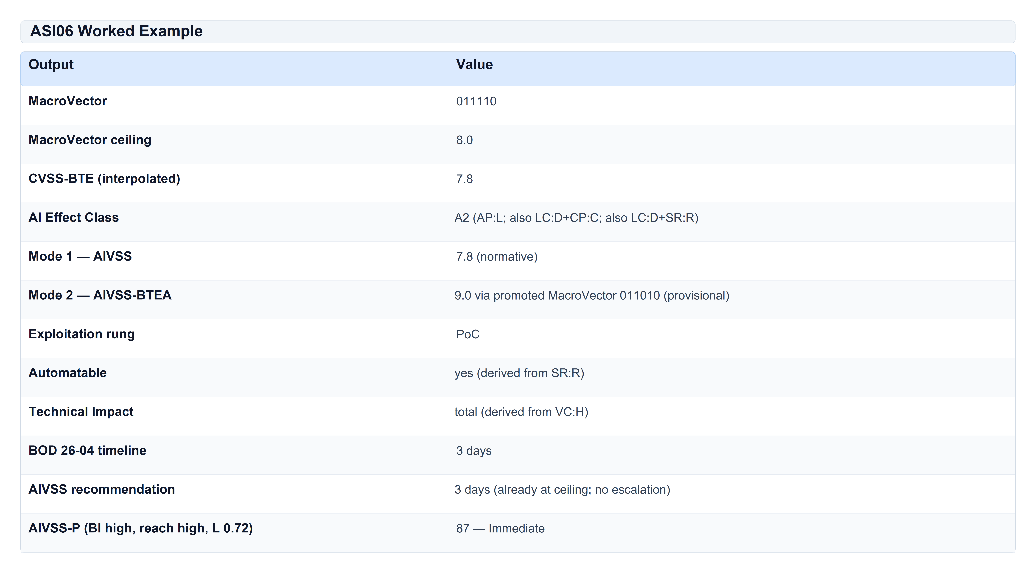
Table 20: ASI06 Worked Example
Mode 1–2 and decision-track rows are emitted by:
[ BASH / CLI COMMAND ]
aivss-calc assess examples/asi06-example.json

The AIVSS-P row uses `examples/asi06-memory-poisoning.json` (likelihood 0.72):
[ BASH / CLI COMMAND ]
aivss-calc assess examples/asi06-memory-poisoning.json

16 AIVSS-P — Organizational Priority (Level 3, Optional)
AIVSS-P is an organization-internal priority index. It MUST NOT be published outside the assessing organization.
[ CODE ]
AIVSS-P = 100 × geometric_mean(S/10, BI, REACH, L)

Table 21 defines the four symbols in the AIVSS-P organizational priority formula — technical severity (S), business criticality (BI), deployment reach (REACH), and likelihood (L) — each priced once.
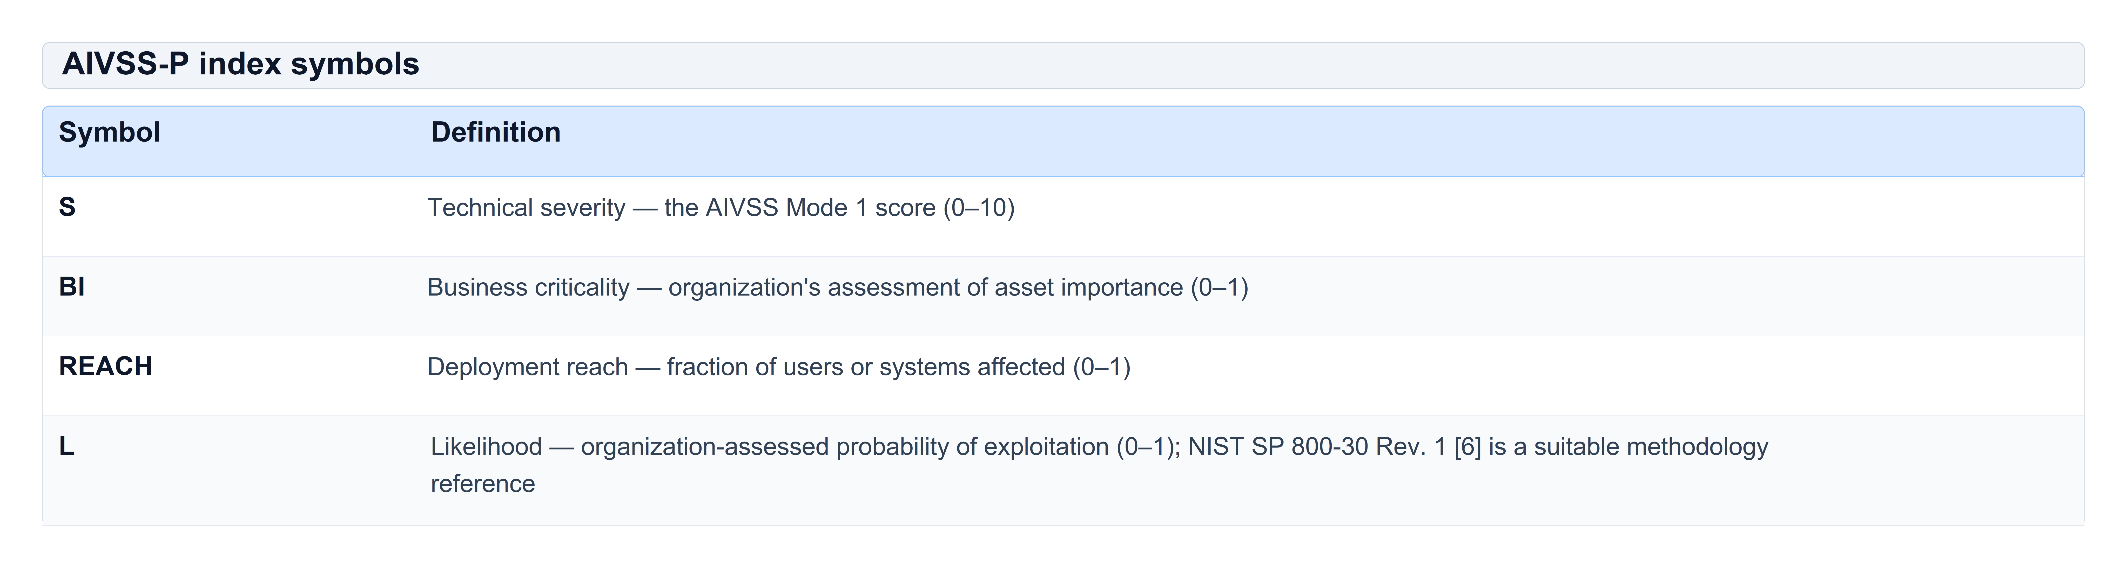
Table 21: AIVSS-P index symbols
Each quantity is priced exactly once. Exploitation evidence belongs to the decision track (Section 12), not AIVSS-P.
Band cut-points (p90 / p65 / p35 of a uniform grid, n = 10,980, severity 4.0–10.0): Immediate ≥ 78, This sprint ≥ 64, Scheduled ≥ 53, Backlog below 53. The grid over-represents high-severity findings relative to a real portfolio; organizations SHOULD recalibrate cut-points against their own assessment corpus (Section 22).

16.1 Intellectual lineage (non-normative)
AIVSS-P's likelihood × impact decomposition descends from the OWASP Risk Rating Methodology; its separation of environmental context from intrinsic severity descends from CWSS v1.0. Both are cited as design lineage, not current authority. AIVSS grounds normative likelihood guidance in NIST SP 800-30 Rev. 1 [6].

17 Governance and Calibration Commitments
The working group commits to publishing:
1. A conformance test-vector file with exact expected outputs and zero tolerance.
2. A score distribution over a corpus of at least 200 assessed findings.
3. An inter-rater reliability study: at least 20 findings × 8 assessors, with Krippendorff's α reported per AI metric.
4. A change-control policy: semantic versioning, public issue tracker, minimum 12-month deprecation notice.
5. An expert-ranking exercise to replace the Mode 2 strawman generator (Section 13.2).

18 Reference Implementation
[ BASH / CLI COMMAND ]
cd tools/aivss-calc && pip install -e ".[dev]"
aivss-calc taxonomy # OWASP ASI01–ASI10
aivss-calc profile "<vector>" # Mode 1 severity + Agentic AI Profile
aivss-calc lookup "<vector>" # Mode 2 AIVSS-BTEA (provisional)
aivss-calc decide --vector "<vector>" --publicly-exposed [--kev] ...
aivss-calc assess examples/asi01-example.json
aivss-calc priority --severity 7.8 --business-criticality high --reach high --likelihood 0.72
aivss-calc verify # MacroVector property checks
aivss-calc legacy --factors <file> # withdrawn uplift model (deprecated)
python examples/generate_asi_examples.py
pytest # 93 tests

Implementation Guide — AIVSS-Agentic (Informative)
This section is informative guidance for practitioners integrating AIVSS 1.0 into engineering workflow, governance, and risk programs. It does not change any normative rule in Sections 1–18. Organizations MAY adopt these practices wholly or in part.

19 AIVSS-Agentic Implementation Guide
The implementation guide answers: where, when, and how to run an AIVSS assessment in the lifecycle of an agentic system, and what outputs gate release or trigger escalation.

19.1 Lifecycle Integration
AIVSS assessments SHOULD be performed at every phase where agentic attack surface or autonomy changes. The table below maps lifecycle phases to assessment activities, primary outputs, and conformance level.
Table 22 maps SDLC phases (design through production) to recommended AIVSS activities, required artifacts, and minimum conformance level so teams know when to assess and what to store.
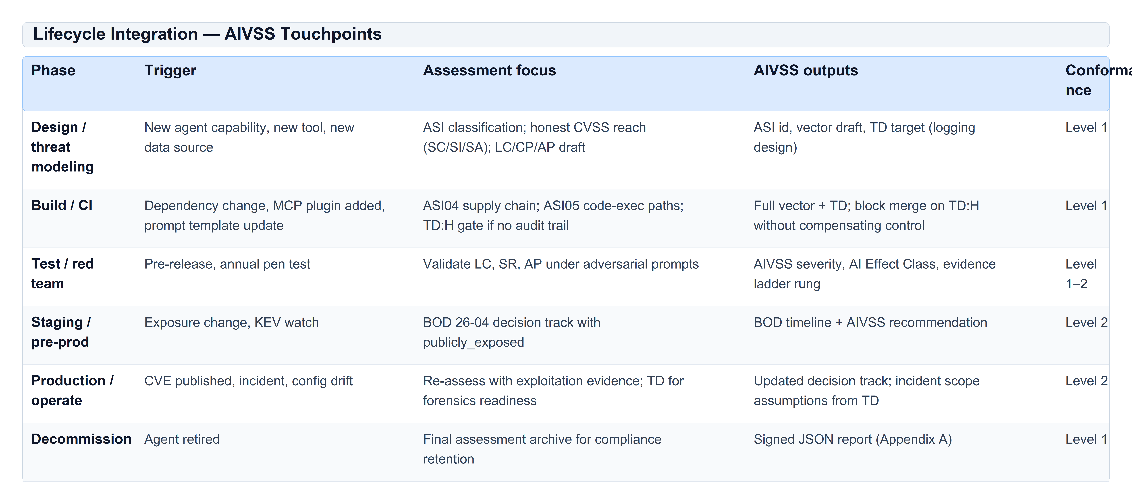
Table 22: Lifecycle Integration — AIVSS Touchpoints
Integration with MAESTRO. The Cloud Security Alliance (CSA) MAESTRO framework (Multi-Agent Environment, Security, Threat, Risk, and Outcome) [10] provides a seven-layer architecture for agentic threat modeling: Foundation Models, Data Operations, Agent Frameworks, Deployment Infrastructure, Evaluation and Observability, Security and Compliance (vertical), and Agent Ecosystem. MAESTRO's threat taxonomy uses ASI threat IDs (T1–T15) and cross-layer analysis; practitioners map validated threats to OWASP ASI01–ASI10 for AIVSS classification. Use MAESTRO to discover findings; use AIVSS to score them consistently (Section 20.1).
Minimum viable integration. At minimum, every production agent release SHOULD produce one AIVSS assessment per material security finding, stored as a versioned JSON report (Appendix A) linked to the deployment configuration hash and model/tool manifest.

19.2 Release Gates and Approval Mechanisms
Release gates translate AIVSS outputs into allow / remediate / block decisions. Gates MUST be defined by the deploying organization; the table below is a recommended starting point.
Table 23 recommends release-blocking conditions keyed to AIVSS score bands, AI Effect Class, TD level, and specific ASI/SR combinations — translating severity into deploy-or-hold guidance.
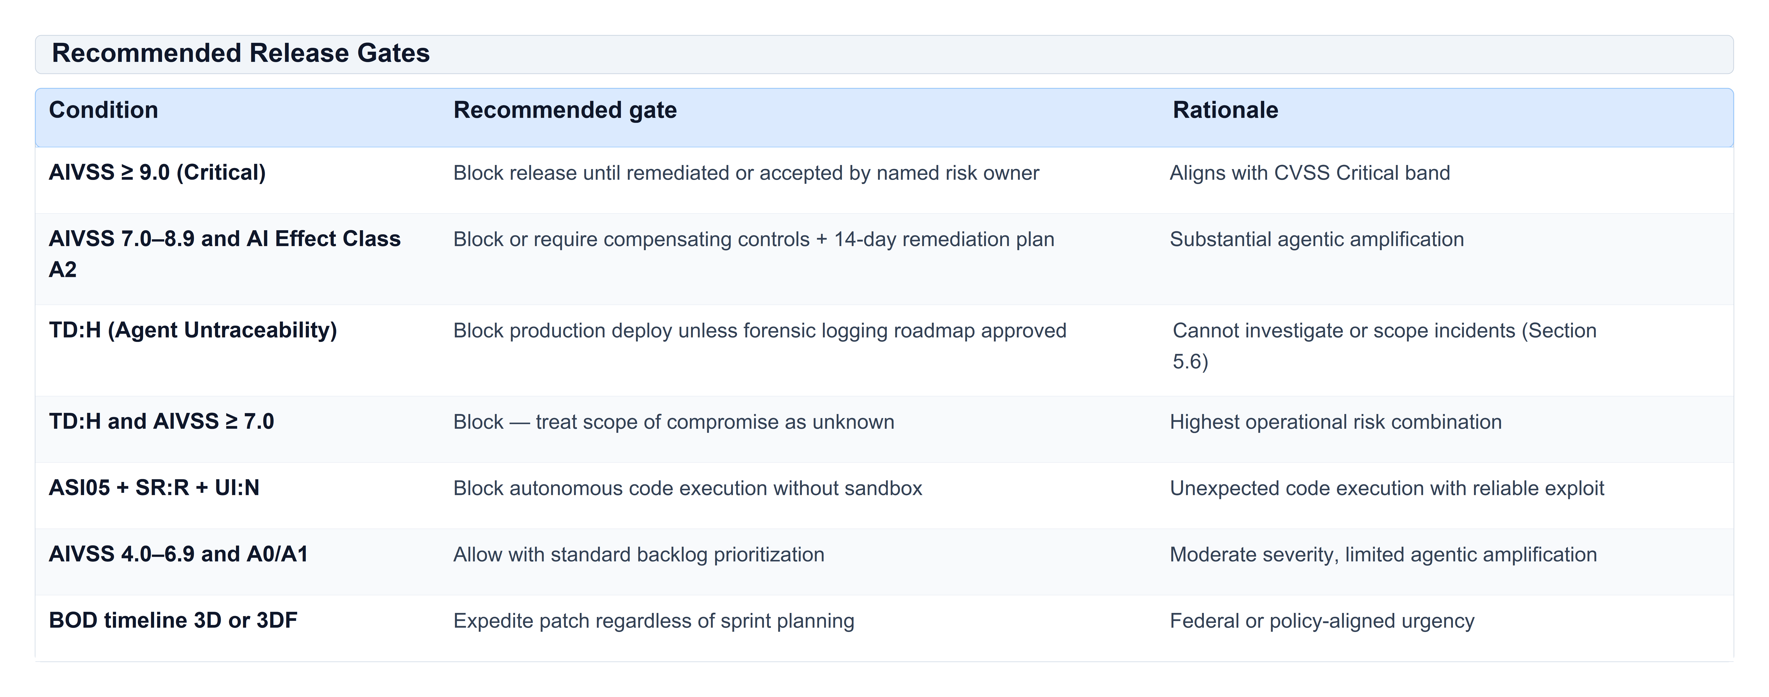
Table 23: Recommended Release Gates
Human approval mechanisms. When CVSS `UI:P` or `UI:A` is scored honestly, the human approval step itself becomes part of the attack surface (ASI09). Release gates SHOULD require:
1. Dual control — security reviewer independent of feature team signs AIVSS vector.
2. Approval audit — if the agent can act on human approval, log approver identity, prompt shown, and tool calls authorized (reduces TD).
3. A2 escalation — any A2 finding triggers security architecture review before waive.
Waivers. Waivers MUST record: finding ID, AIVSS vector, waiver authority, expiry date, and compensating controls. Waivers MUST NOT alter the stored AIVSS score — only the deployment decision.

20 Integration with Risk Management Frameworks
AIVSS is a technical severity and remediation-timing instrument. It feeds — but does not replace — enterprise risk management.

20.1 Mapping to common frameworks
AIVSS complements architecture-level discovery frameworks — notably the Cloud Security Alliance (CSA) MAESTRO Agentic AI Threat Modeling Framework [10] — by supplying comparable severity, Agentic AI Profile, and remediation timing once MAESTRO-layer threats are validated as scoreable findings (Section 19.1).
Table 24 explains how AIVSS outputs integrate with NIST RMF, NIST AI RMF, CSA MAESTRO Agentic AI threat modeling, CISA BOD 26-04, ISO 27001, CVSS/FIRST, and MITRE ATLAS without claiming endorsement or replacing those frameworks.
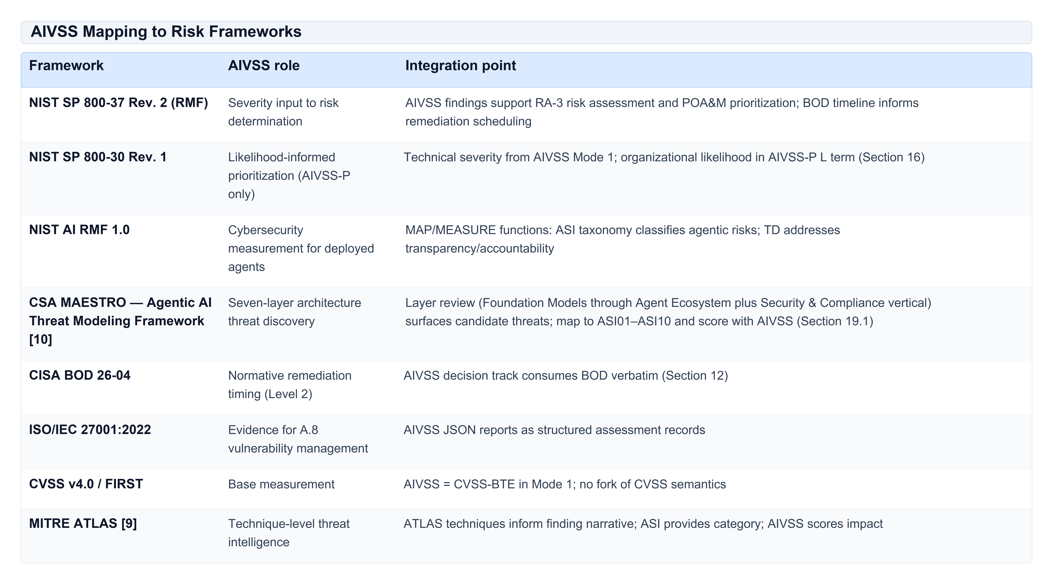
Table 24: AIVSS Mapping to Risk Frameworks

20.2 Federal and regulated environments
For FCEB agencies, BOD 26-04 [3] is the compliance obligation; AIVSS `bod_2604_timeline` MUST be reported unmodified. The `aivss_recommended_timeline` is an organizational overlay only.
For non-federal organizations, BOD 26-04 MAY be adopted as a policy baseline; AIVSS provides a consistent mechanical application of Table 1 plus AI Effect Class escalation.

21 AI Threat Taxonomies and Key References
Practitioners SHOULD cross-reference multiple taxonomies. AIVSS 1.0 uses OWASP ASI01–ASI10 for classification and retains Agent Untraceability as TD (Section 5.6).
Table 25 surveys external threat taxonomies and standards — OWASP ASI, MITRE ATLAS, MAESTRO, KEV, EPSS, NIST, and BOD 26-04 — and how each relates to AIVSS classification, scoring, or timelines.
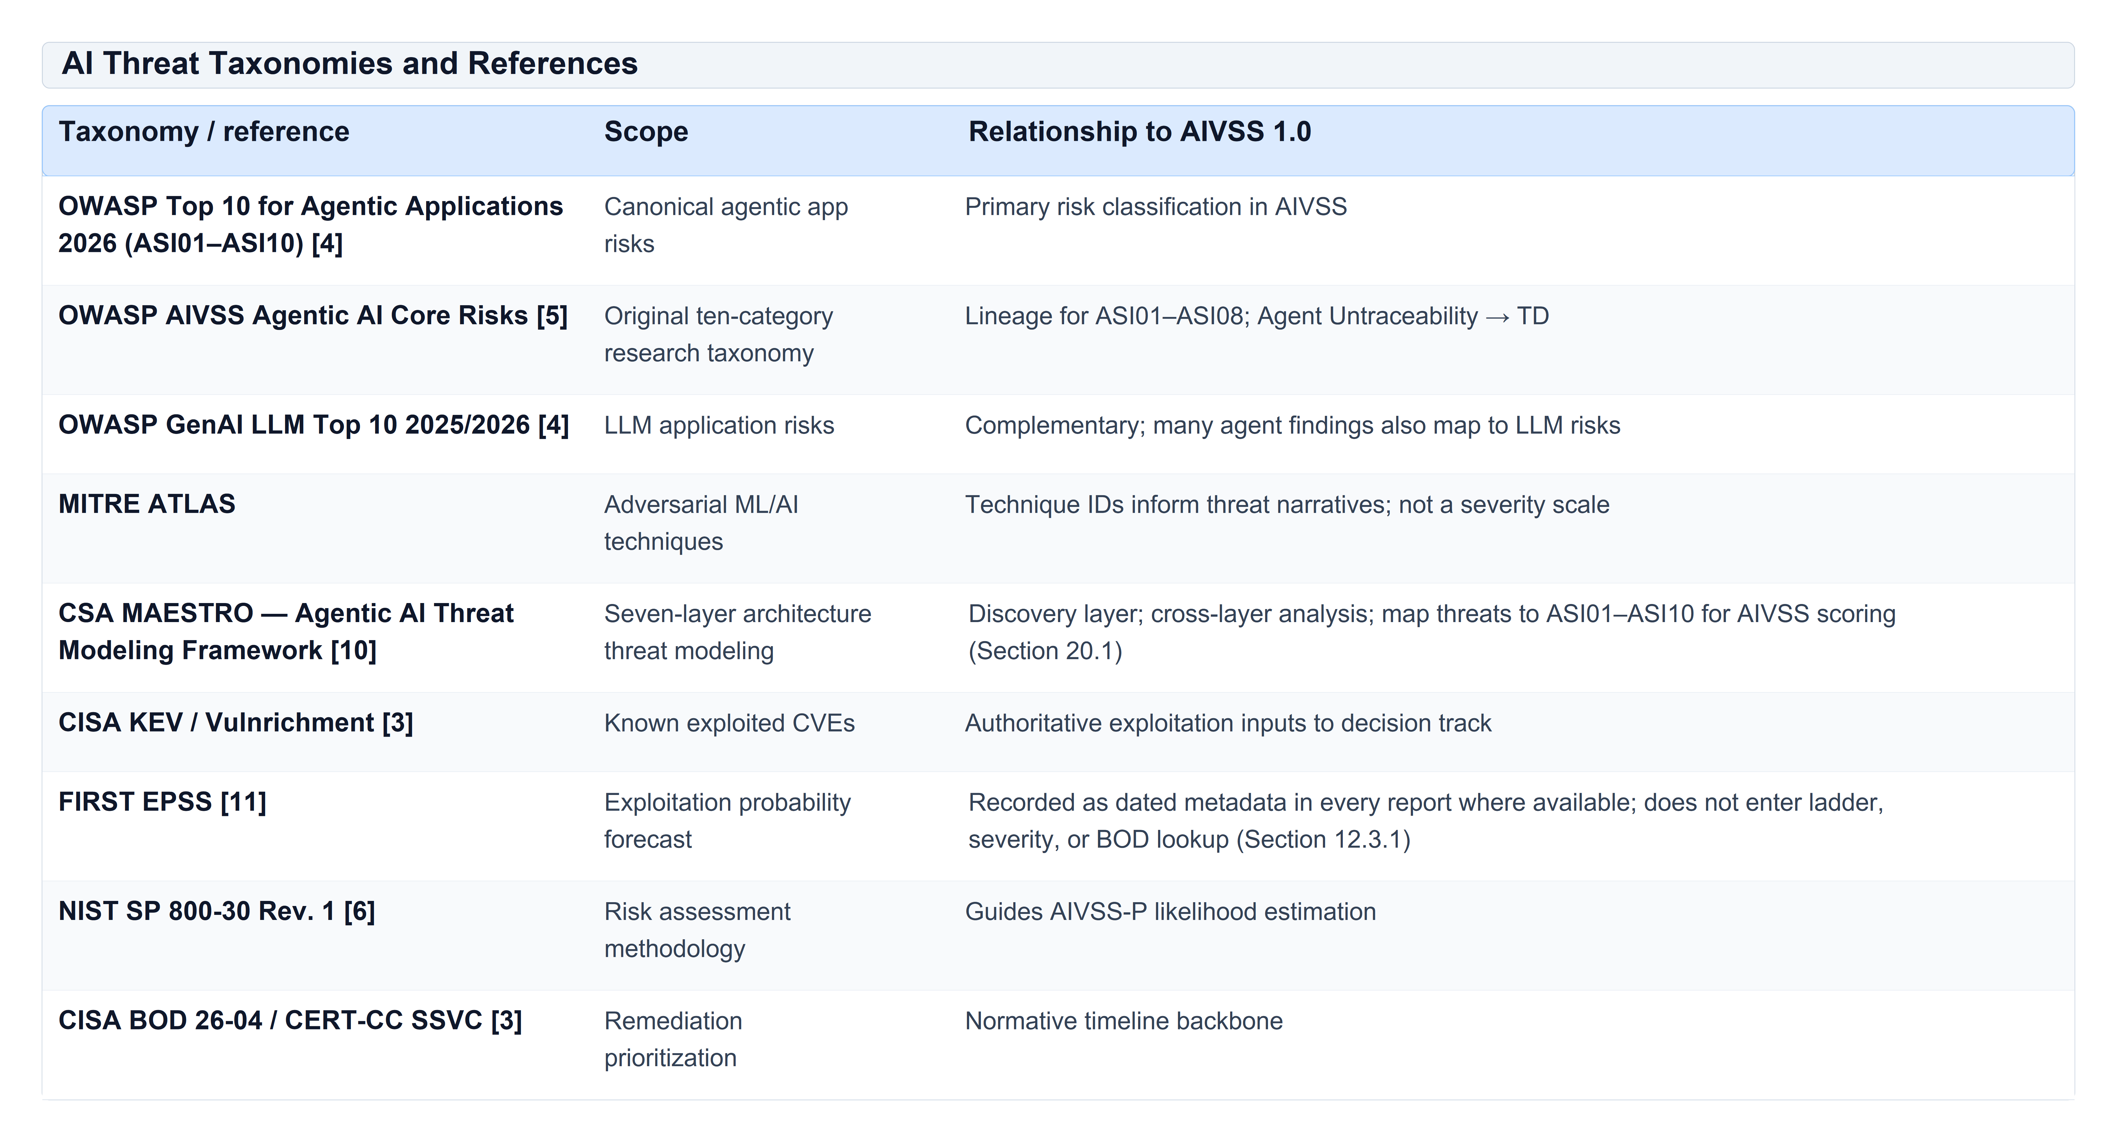
Table 25: AI Threat Taxonomies and References
Crosswalk discipline. One finding → one primary ASI category → one AIVSS vector. Secondary taxonomy mappings (ATLAS, MAESTRO layer, LLM Top 10) belong in finding metadata, not in the score formula.

22 Continuous Improvement
AIVSS 1.0 is a living specification. Continuous improvement activities include:
1. Corpus growth — Collect de-identified assessment JSON reports; publish score distributions (Section 17 commitment).
2. Inter-rater reliability — Periodic studies across LC, CP, AP, SR, TD with Krippendorff's α; revise rubrics where agreement is low.
3. Calculator conformance — Run `aivss-calc verify` and `pytest` on every release; zero tolerance on test-vector drift.
4. Taxonomy alignment — Track OWASP GenAI Security Project updates to ASI01–ASI10; AIVSS adopts taxonomy changes through semver, not silent edits.
5. Mode 2 calibration — Replace strawman MacroVector promotion (Section 13.2) with expert-ranked lookup when available.
6. Community feedback — Issues and PRs against `tools/aivss-calc` and schema files; minimum 12-month deprecation notice for normative changes (Section 17).
Organizations SHOULD recalibrate AIVSS-P band cut-points (Section 16) against their own finding corpus annually.

23 Disclaimer
This document and the reference calculator (`tools/aivss-calc`) are provided as-is for community use under open-source licenses. They do not constitute legal, regulatory, or professional security advice.
1. No endorsement. AIVSS is not endorsed by, affiliated with, or approved by OWASP, FIRST, CISA, NIST, MITRE, or any government agency.
2. No warranty. No guarantee is made that AIVSS scores predict exploitation, breach likelihood, or business impact.
3. Assessor responsibility. Final severity and remediation decisions remain the responsibility of the assessing organization and qualified security professionals.
4. Federal compliance. Only CISA BOD 26-04 itself — not AIVSS overlays — creates FCEB compliance obligations.
5. Mode 2 provisional. AIVSS-BTEA (Mode 2) is experimental and MUST NOT be used in contracts, SLAs, or regulatory filings without explicit expert calibration.
6. AIVSS-P internal use. Organizational priority scores MUST NOT be published externally or compared across organizations.

24 Acknowledgements
AIVSS 1.0 builds on open-source security research and standards community work:
- OWASP AIVSS Project team — original Agentic AI Core Risks taxonomy, including Agent Untraceability; project leadership and community surveys.
- OWASP GenAI Security Project — Top 10 for Agentic Applications 2026 (ASI01–ASI10) and cross-industry peer review.
- Jeff Williams — Appendix E architectural guidance (CVSS-compatible scoring, Option 3).
- FIRST / CVSS SIG — CVSS v4.0 specification and `cvss_lookup.js` reference implementation.
- CISA and CERT/CC — BOD 26-04, KEV catalog, and Vulnrichment program.
- NIST — SP 800-30 risk assessment guidance referenced by AIVSS-P.
- MITRE — ATLAS adversarial AI knowledge base, referenced in implementation guidance.
- MAESTRO framework contributors — seven-layer agentic threat modeling complementary to AIVSS scoring.
- Reference implementation contributors — `tools/aivss-calc` maintainers, test authors, and working-group reviewers.

Appendix A — AIVSS-Agentic Report JSON Schema
Normative machine-readable schema: `schemas/aivss-report-v1.0.json` (accepts `aivss_version` `1.0`; `0.9` retained for backward compatibility in `schemas/aivss-report-v0.9.json`).

A.1 Top-level report structure
Table 26 lists report JSON fields by conformance level — Level 1 core fields plus optional Level 2 `decision` and Level 3 `priority` blocks — with types and semantics.
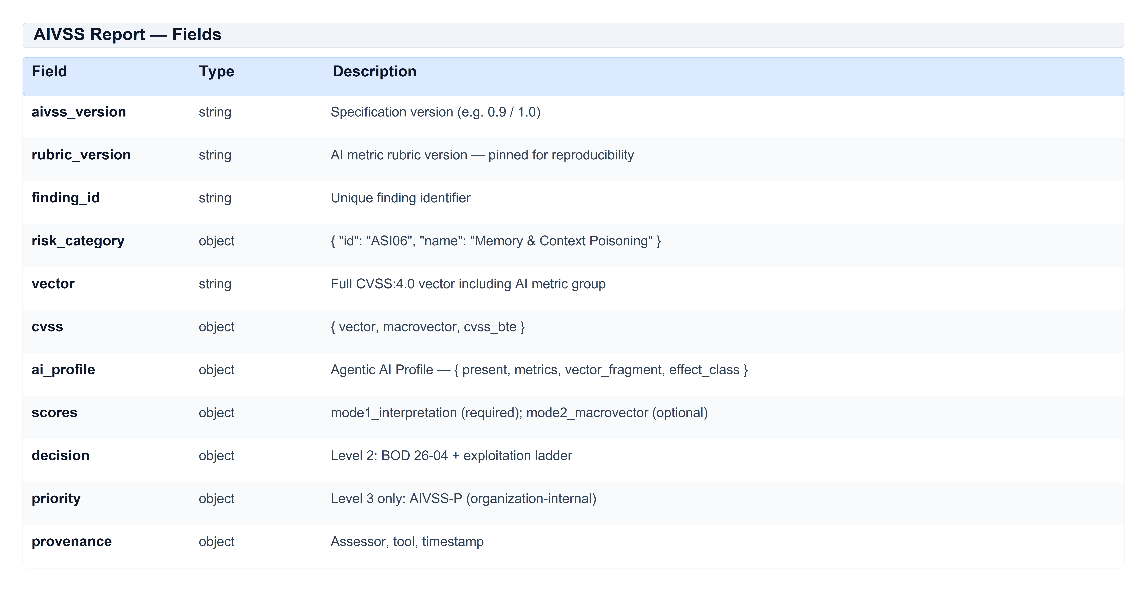
Table 26: AIVSS Report — Fields

A.2 Example report (excerpt)
[ JSON SCHEMA / PAYLOAD ]
{
"finding_id": "AIVSS-ASI06-001",
"risk_category": { "id": "ASI06", "name": "Memory & Context Poisoning" },
"vector": "CVSS:4.0/.../LC:D/CP:C/AP:L/SR:R/TD:H",
"scores": { "mode1_interpretation": { "aivss": 7.8, "status": "normative" } },
"ai_profile": { "effect_class": "A2", "metrics": { "TD": "H (High deficit)" } },
"decision": { "bod_2604_timeline": "3D", "aivss_recommended_timeline": "3D" }
}

Produce full reports with: `aivss-calc assess examples/asi06-example.json`
Validate structure against `schemas/aivss-report-v1.0.json`.

Appendix D — Contributor Survey Findings and Relative Risk Ranking

D.1 Survey context
The following ranking reflects a contributor survey conducted by the AIVSS working group (sample size and instrument documented internally; formal publication planned under Section 17). It informed taxonomy emphasis in version 1.0 and is not an input to any score formula.
During development of the OWASP AIVSS Agentic AI Core Risks taxonomy [5], project contributors and practitioners ranked agentic security concerns by relative operational impact — likelihood of occurrence in deployed agents combined with severity of consequence if exploited. The survey informed the original ten-category taxonomy and later crosswalk to OWASP ASI01–ASI10 [4].
Methodology (summary). Contributors ranked risk themes on a 1–10 impact scale and indicated prevalence in production agent deployments. Results were aggregated by median rank. This appendix preserves the relative ordering that shaped AIVSS research; it is informative, not a scoring input.

D.2 Relative risk ranking — original AIVSS core risks
Table 27 ranks the original ten AIVSS Agentic AI Core Risks by median contributor impact score and shows how each was adopted into OWASP ASI or retained as the TD metric in version 1.0.
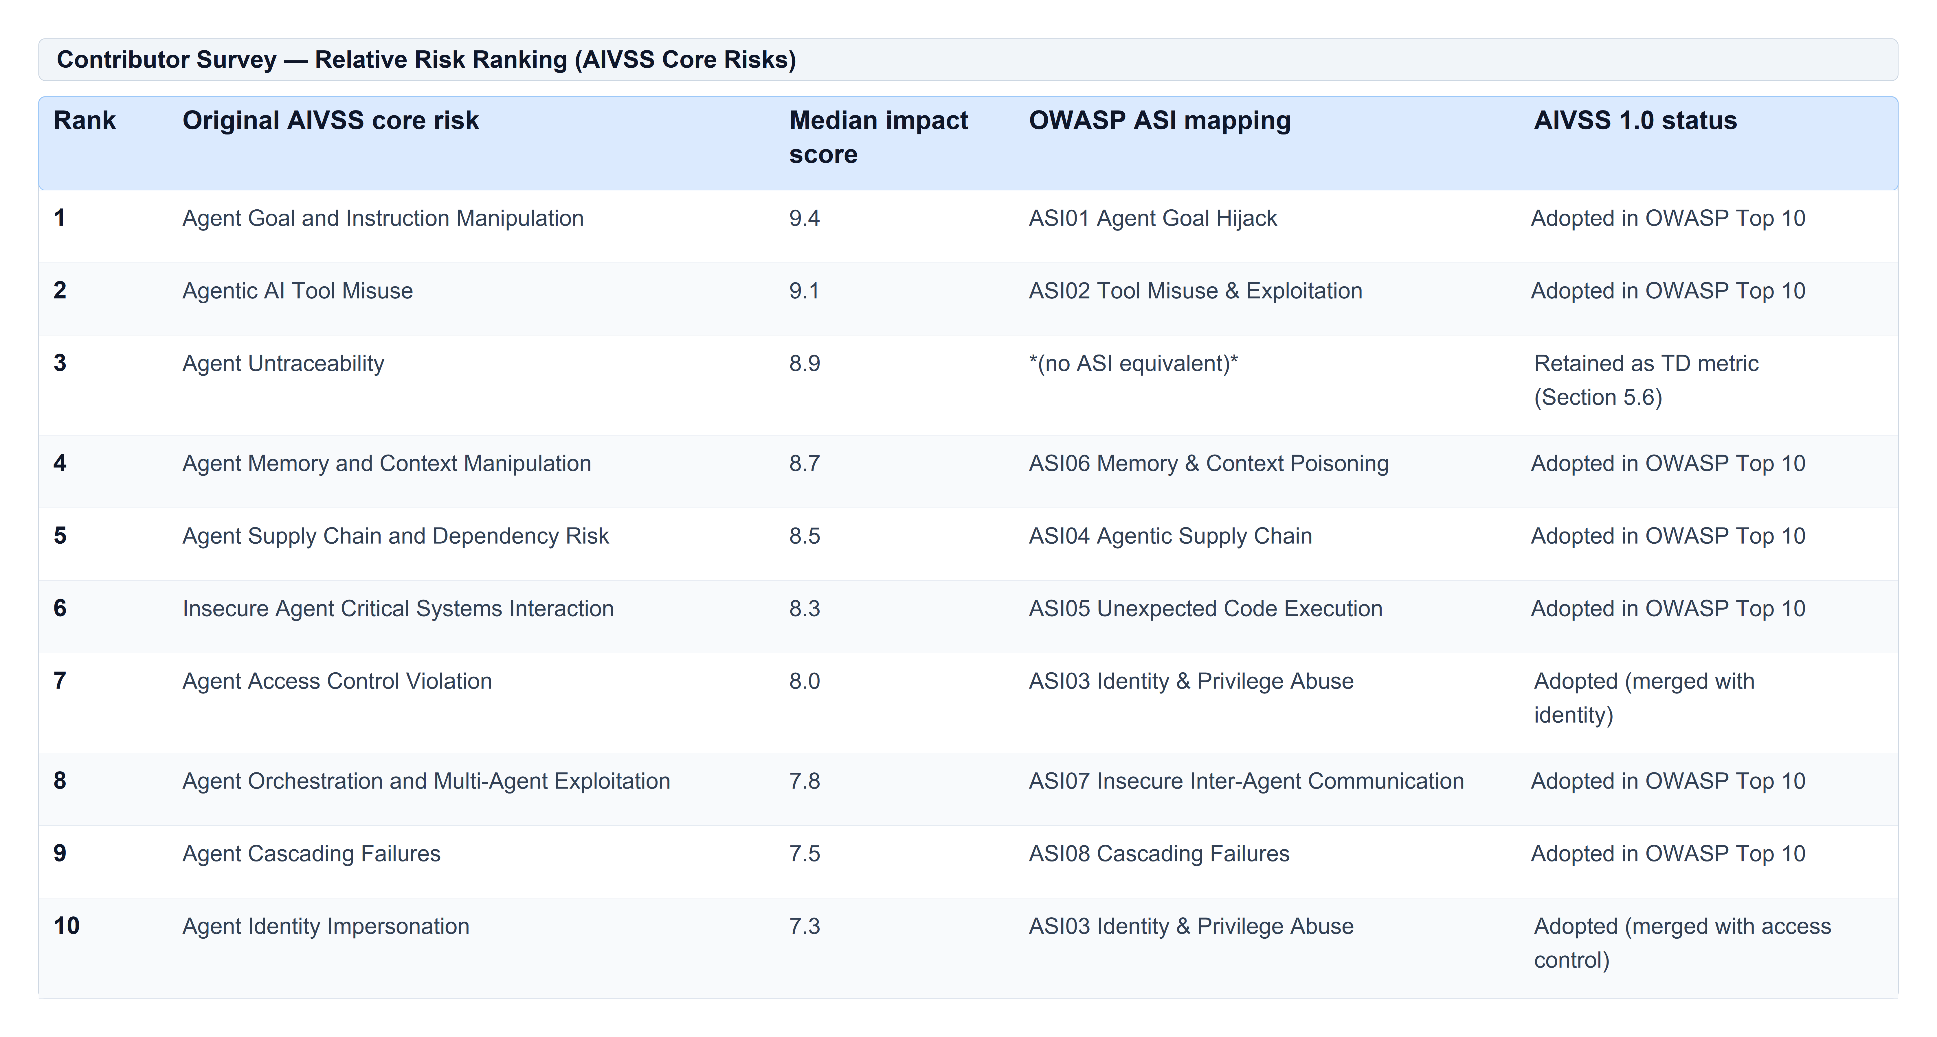
Table 27: Contributor Survey — Relative Risk Ranking (AIVSS Core Risks)

D.3 Key findings
1. Goal hijack and tool misuse ranked highest — consistent with OWASP placing ASI01 and ASI02 at the top of the Agentic Top 10 [4].
2. Agent Untraceability ranked third — contributors rated opaque agent behaviour as nearly as consequential as direct exploitation, because it prevents scoping, attribution, and safe rollback. This validated retaining it in AIVSS 1.0 as mandatory TD assessment even without an OWASP ASI category.
3. Eight of ten original themes map directly to OWASP ASI categories; OWASP later added ASI09 (Human–Agent Trust Exploitation) and ASI10 (Rogue Agents) as separate Top 10 categories.
4. Identity and access control were distinct in the survey but merged in OWASP ASI03 — assessors SHOULD document both impersonation and privilege-abuse angles in finding narratives.

D.4 Use in AIVSS 1.0
Survey rankings do not enter any score formula. They explain why the taxonomy emphasizes certain risks and why Agent Untraceability remains a first-class AIVSS concern via TD. Practitioners MAY use the ranking to prioritize threat-modeling depth (e.g., always deep-dive ASI01, ASI02, and TD logging architecture).

References
1. FIRST. CVSS v4.0 Specification Document, Section 8.2 MacroVectors. https://www.first.org/cvss/v4.0/specification-document
2. FIRST. CVSS v4.0 FAQ (scope of CVSS measurement). https://www.first.org/cvss/v4-0-faq
3. CISA. BOD 26-04: Prioritizing Security Updates Based on Risk, June 10, 2026. CERT/CC SSVC model `cisa:BOD2604:1.0.0`.
4. OWASP GenAI Security Project. Top 10 for Agentic Applications 2026 (ASI01–ASI10), December 9, 2025. https://genai.owasp.org/
5. OWASP AIVSS Project. Agentic AI Core Risks taxonomy (research lineage for ASI01–ASI08). https://owasp.org/www-project-aivss/
6. NIST SP 800-30 Rev. 1. Guide for Conducting Risk Assessments.
7. FIRST. `cvss_lookup.js`, CVSS v4.0 calculator reference implementation (BSD-2-Clause).
8. AIVSS v1.00.8 draft, Appendix E — AIVSS v2 Proposal: CVSS-Compatible AI Scoring (Jeff Williams).
9. MITRE. ATLAS — Adversarial Threat Landscape for AI Systems. https://atlas.mitre.org/
10. Cloud Security Alliance. MAESTRO — Agentic AI Threat Modeling Framework. https://cloudsecurityalliance.org/
11. FIRST. Exploit Prediction Scoring System (EPSS). https://www.first.org/epss/

