CircuitFit Founder Review - Meeting Minutes
Synthetic evidence fixture. This file intentionally contains a mixture of confirmed decisions, open questions and one conflicting request.
Meeting date: 5 June 2026
Attendees: Product, Engineering, Design, Marketing, Security

Decisions
- Keep the beta browser-based and mobile-friendly.
- Use local browser storage for saved workouts during the MVP.
- Use deterministic workout templates before adding AI-generated plans.
- Do not require login for the MVP.

Open Questions
- Should export/import of local workout history be added before beta?
- Should the beta deck show a non-functional leaderboard concept?
- Which accessibility checks are required before the pilot?

Action Register
ID | Action | Owner | Status
ACT-001 | Confirm browser-local persistence | Engineering | Confirmed
ACT-002 | Assess export/import option | Product | Open
ACT-003 | Clarify whether leaderboard is concept-only | Marketing | Open
ACT-004 | Review accessibility checklist | Design | Open

Whiteboard Photograph
The photograph below captures a rough workflow and a late-stage marketing question.
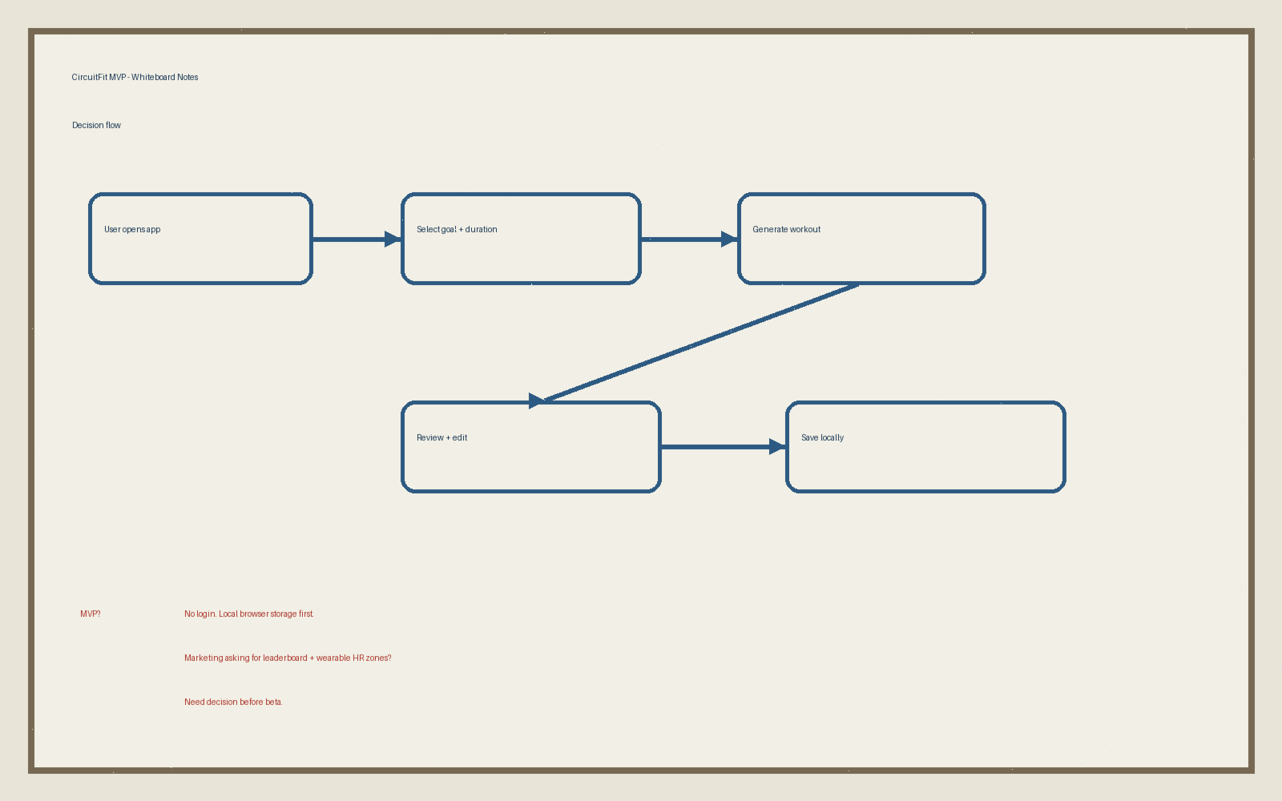
Source note: whiteboard image captured after the meeting. Treat handwritten requests as unverified until approved.

