Kean Gabriel E. Salvahan
BSCS - 3B

Task 1:

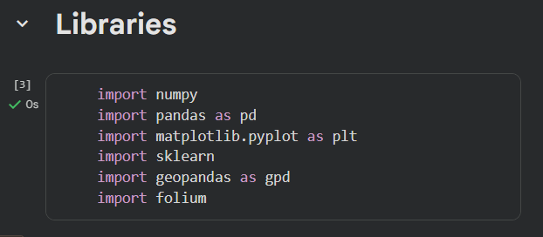

Task 2:

Guide Questions:
1. How many columns does the dataset contain?

Answer: The dataset contains 169 columns.

2. What type of geometries are included?

Answer: There are two types of geometries, Multipolygon and polygon.

3. What does the geometry column represent?

Answer: I represent the geographical shape of each country or administrative unit.

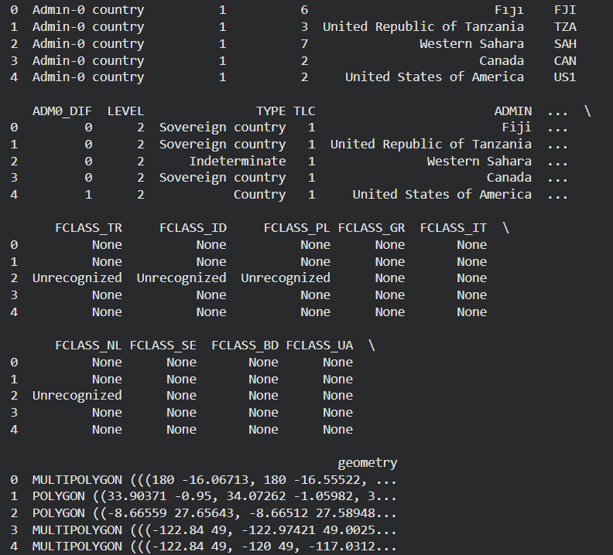

Task 3:

1. What does EPSG:4326 represent?

Answer: ESPG:4326 is an identifier for the World Geodetic System 1984 (WGS84) coordinate system which defines locations using latitude and longitude in decimal degrees based on a, elipsoidal model of the earth.

2. Why is CRS important in spatial analysis?

Answer: Coordinate Reference System is important in spatial analysis for accurately locating, aligning and measuring geospatial data.

Task 4:

1. Why can’t we compute area accurately using ESPG:4326?

Answer: We cannot compute accurate physical areas using EPSG:4326 because it is not a map projection; it is a geographic coordinate system designed to locate points on a 3D sphere (ellipsoid), not measure 2D space.

2. What unit ESPG:3857 based on?

Answer:ESPG:3857 is based on the metre as its unit of measurement.

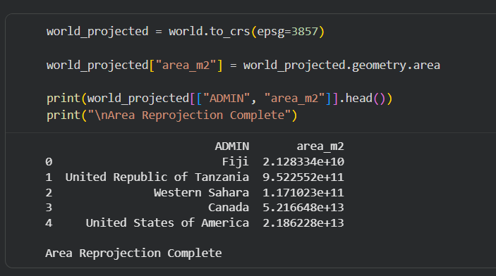

Task 5:

1. What is a centroid?

Answer: In data analysis and machine learning, a centroid is the central point or the arithmetic mean position of all the data points within a specific group (or cluster). If we plot our data on a graph, you can think of the centroid as the physical "center of mass" for that particular grouping of points.

2. How can centroid coordinates be used in clustering?

Answer: Centroid coordinates serve as the "representative" prototypes for a cluster. In clustering algorithms (like K-Means)

3. Why do we extract X and Y separately?

Answer: We extract X and Y (and any other dimensional features) separately because spatial and geometric calculations require independent processing of each axis.

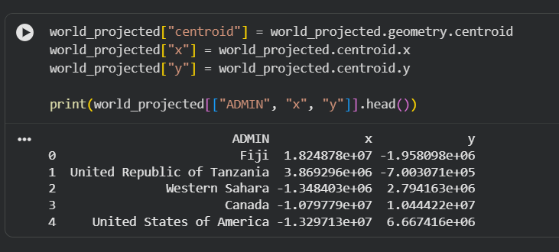

Top 10 Largest Countries

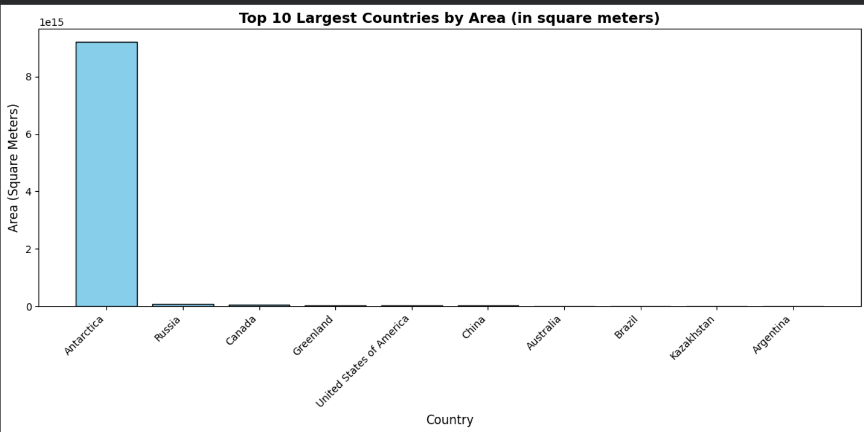

Short Reflection:

The main challenge was the Coordinate Reference Systems (CRS). Initially, it wasn't completely intuitive why calculating the area using the default EPSG:4326 CRS wouldn't yield accurate results. Additionally, getting used to the GeoPandas syntax, specifically reprojecting the data into a metric system (EPSG:3857) and extracting the individual X and Y coordinates from the centroid geometries , required some troubleshooting and careful attention to detail.
I learned that spatial data is much more than just drawing a map; it involves managing complex geometric shapes like polygons and multipolygons. Most importantly, I learned that accurate spatial analysis entirely depends on using the correct CRS. To perform accurate real-world calculations, like finding a country's area in square meters, the data must be converted to a metric-based CRS like EPSG:3857. I also learned what a centroid is and how extracting its coordinates can be useful for advanced analysis like clustering

