|  |  |
| --- | --- |
| **Project: New Haven Urgent Care Team#4** | |
|  | **Test Date: 2019-12-12** |
| **Test Case ID#: 12** | **Name(s) of Tester(s): Guipeng Xie** |
| **Test Description (What are you testing? – you must be specific):**  **I am inserting the data into INITIAL_ASSESSMENT table, then query by sql commands.** |  |
|  |  |

**NOTE: The following information must be provided to be given credit for any test.**

**Test Data (Provide the file name of the script used to insert data, provide a screen capture to reflect data, or provide script here):**

INSERT INTO PATIENT VALUES(001, 'XIE', 'T', 'GUIPENG', '2508 DELAWARE',null, null, 'alkfjaklfj', '1998-07-23', 20);

INSERT INTO PATIENT VALUES(002, 'Fary', 'k', 'Berd', '1141 DELAWARE',null, null, 'ueuiqiuer', '1998-09-23', 21);

INSERT INTO PATIENT VALUES(003, 'CHARLIE', NULL, 'XIE', '4545 SE ST',null, null, 'Headache', '1998-05-06', 25);

INSERT INTO PATIENT VALUES(004, 'Gary', NULL, 'zz', '4545 SE ST','apt3', null, 'PTSD', '1990-08-16', 56);

INSERT INTO PATIENT VALUES(005, 'XI', NULL, 'hee', '46234 SE ST','apt34', '4434', 'STD', '1979-09-28', 65);

INSERT INTO DEPARTMENT VALUES ( 001, 'A0');

INSERT INTO DEPARTMENT VALUES ( 002, 'B0');

INSERT INTO DEPARTMENT VALUES ( 003, 'C0');

INSERT INTO DEPARTMENT VALUES ( 004, 'D0');

INSERT INTO DEPARTMENT VALUES ( 005, 'E0');

insert into INTAKE_DEPARTMENT values (001, 'A0');

INSERT INTO INTAKE_DEPARTMENT VALUES (002, 'B0');

INSERT INTO INTAKE_DEPARTMENT VALUES (003, 'C0');

INSERT INTO INTAKE_DEPARTMENT VALUES (004, 'D0');

INSERT INTO INTAKE_DEPARTMENT VALUES (005, 'E0');

INSERT INTO EMPLOYEE VALUES (001, 'CHARLIE', 'k', 'XIE', 100, 001);

INSERT INTO EMPLOYEE VALUES (002, 'SUNY', 'v', 'jary', 101, 001);

INSERT INTO EMPLOYEE VALUES (003, 'jian', 'r', 'chun', 102, 002);

INSERT INTO EMPLOYEE VALUES (004, 'liang', 'c', 'Moon', 103, 002);

INSERT INTO EMPLOYEE VALUES (005, 'he', 'z', 'xi', 104, 003);

INSERT INTO ASSESSMENT_NURSE (EID, Fname, MINIT, Lname, SSN) select EID, Fname, MINT, Lname, SSN FROM EMPLOYEE;

INSERT INTO SERVICE_PROVIDER (EID, Fname, MINIT, Lname, SSN) SELECT EID, Fname, MINT, Lname, SSN FROM EMPLOYEE;

INSERT INTO VISIT VALUES(001, 119.01, '2019-07-03', 001, 002, 001, 11.11, 'ye', 'were');

INSERT INTO VISIT VALUES(002, 119.01, '2019-09-03', 001, 003, 002, 11.11, 'ye', 'were');

INSERT INTO DIAGNOSIS VALUES('STD', 'Yun', '2019-04-23', '2019-05-21', 100);

INSERT INTO DIAGNOSIS VALUES('PTSD', 'Yun', '2019-06-24', '2019-07-21', 100);

INSERT INTO DIAGNOSIS VALUES('YECF', 'TTT', '2019-06-24', '2019-07-21', 101);

INSERT INTO INITIAL_ASSESSMENT values ('a001', 1, 1);

INSERT INTO INITIAL_ASSESSMENT values ('b002', 2, 2);

**SQL Query(s) used for testing:**

SELECT A.*

FROM ASSESSMENT_NURSE AS A

where A.EID in

(select B.NurseID FROM INITIAL_ASSESSMENT AS B );

The result:

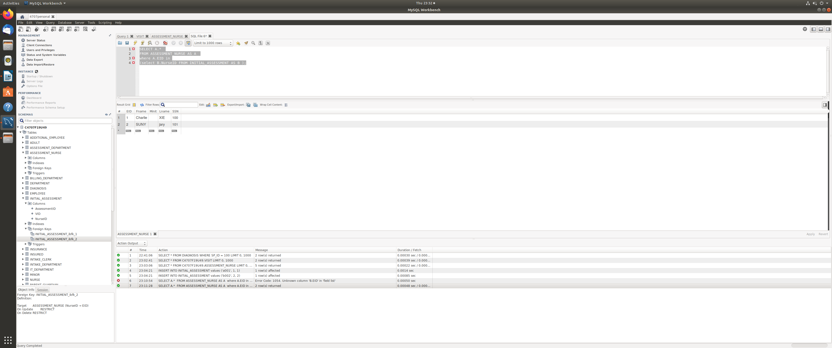Yes, initial assessments have the nurse’s information associated with it. We also can retrieve the nurses information.