|  |  |
| --- | --- |
| **Project: New Haven Urgent Care Team# 4** | |
|  | **Test Date: 2019-12-12** |
| **Test Case ID#: 16** | **Name(s) of Tester(s): Xi He** |
| **Test Description (What are you testing? – you must be specific):**  Are all employees classified as either salaried or hourly? |  |
|  |  |

**NOTE: The following information must be provided to be given credit for any test.**

**Test Data (Provide the file name of the script used to insert data, provide a screen capture to reflect data, or provide script here):**

INSERT INTO DEPARTMENT

VALUES (1, 'INTAKE_DEPARTMENT');

INSERT INTO INTAKE_DEPARTMENT

VALUES(1, 'INTAKE_DEPARTMENT');

INSERT INTO EMPLOYEE

VALUES (1, 'Mary', 'A', 'Green', 123, 1);

INSERT INTO NURSE

VALUES (1, 'Mary', 'A', 'Green', 123);

INSERT INTO ASSESSMENT_NURSE

VALUES (1, 'Mary', 'A', 'Green', 123);

**SQL Query(s) used for testing:**

SELECT *

FROM ASSESSMENT_NURSE;

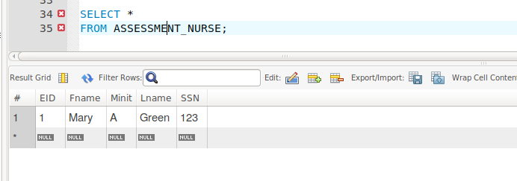

This requirement is not satisfied because there is no indication showing whether an assessment is salaried or hourly. The same situation for other kinds of employees exists. This is caused by the flaw of our design.