|  |  |
| --- | --- |
| **Project: New Haven Urgent Care Team# 4** | |
|  | **Test Date: 2019-12-12** |
| **Test Case ID#: 17** | **Name(s) of Tester(s): Xi He** |
| **Test Description (What are you testing? – you must be specific):**  Can doctors request more than one test/procudure per visit? |  |
|  |  |

**NOTE: The following information must be provided to be given credit for any test.**

**Test Data (Provide the file name of the script used to insert data, provide a screen capture to reflect data, or provide script here):**

INSERT INTO DEPARTMENT

VALUES (1, 'INTAKE_DEPARTMENT');

INSERT INTO INTAKE_DEPARTMENT

VALUES(1, 'INTAKE_DEPARTMENT');

INSERT INTO EMPLOYEE

VALUES (1, 'Mary', 'A', 'Green', 123, 1);

INSERT INTO NURSE

VALUES (1, 'Mary', 'A', 'Green', 123);

INSERT INTO ASSESSMENT_NURSE

VALUES (1, 'Mary', 'A', 'Green', 123);

INSERT INTO PATIENT

VALUES (1, 'Stanley', 'B', 'Shepherd', '123', NULL, NULL, '456', '1996-06-11', 23);

INSERT INTO VISIT

VALUES (1, 100, '2019-12-12', 1, 1, 1, 200, '123', '456');

INSERT INTO EMPLOYEE

VALUES (2, 'Carl', 'C', 'Smith', 999, 1);

INSERT SERVICE_PROVIDER

VALUES (2, 'Carl', 'C', 'Smith', 999);

**SQL Query(s) used for testing:**

INSERT TREATMENT

VALUES (1, 'b', 100, 'yes', 2, 999);

INSERT TREATMENT

VALUES (2, 'c', 200, 'yes', 2, 999);

SELECT *

FROM TREATMENT;

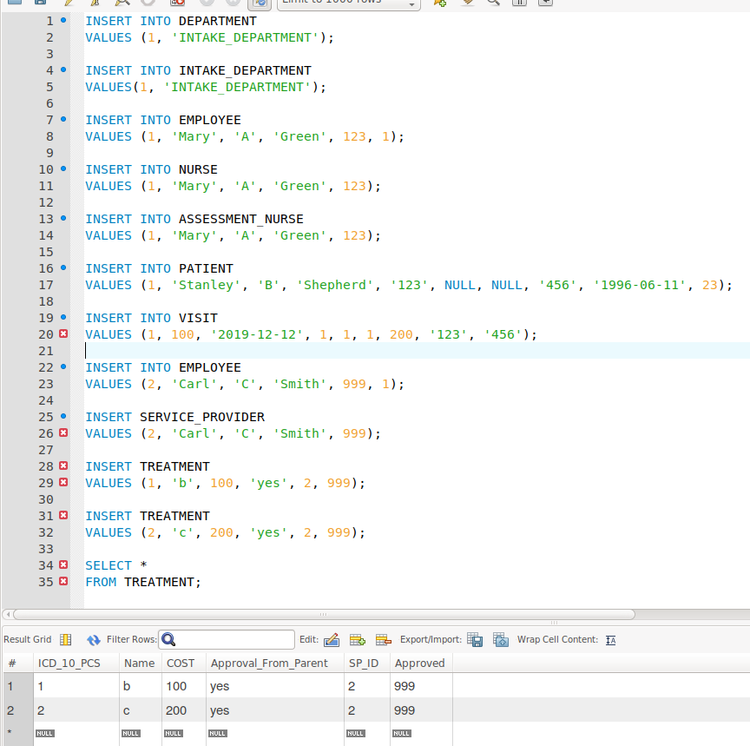

As the result above shows, a service provider can have two treatments. Therefore, this requirement is satisfied.