|  |  |
| --- | --- |
| **Project: New Haven Urgent Care Team# 4** | |
|  | **Test Date: 2019-12-12** |
| **Test Case ID#: 4** | **Name(s) of Tester(s): Xi He** |
| **Test Description (What are you testing? – you must be specific):**  Does your design capture the system’s need to store old insurance information along with current insurance information? A clerk should be able to determine what dates the old insurance was  active and what is currently active. |  |
|  |  |

**NOTE: The following information must be provided to be given credit for any test.**

**Test Data (Provide the file name of the script used to insert data, provide a screen capture to reflect data, or provide script here):**

INSERT INTO PATIENT

VALUES (1, ‘ Stanley’, NULL, ‘Shepherd’, ‘123’, NULL, NULL, ‘456’, ‘1996-06-11’, 23);

INSERT INTO INSURED

VALUES(1, ‘ Stanley’, NULL, ‘Shepherd’, ‘123’, NULL, NULL, ‘456’, ‘1996-06-11’, 23, 100);

INSERT INTO INSURANCE

VALUES(1, 1, ‘2016-01-02’, 1);

INSERT INTO INSURANCE

VALUES(2, 1, ‘2020-01-02’, 1);

**SQL Query(s) used for testing:**

SELECT * FROM INSURANCE;

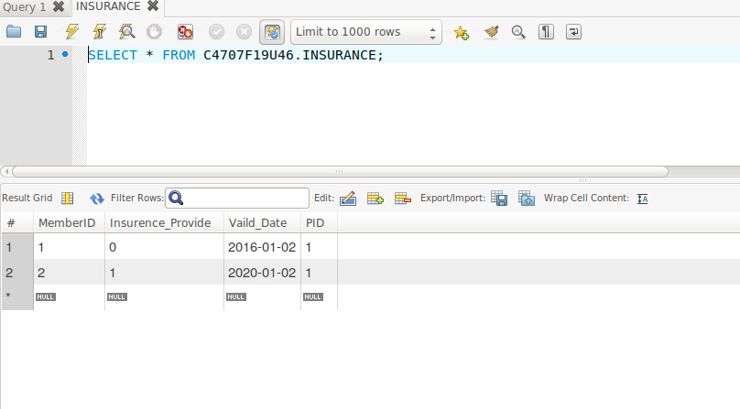

This requirement is satisfied. Old insurance and new insurance can exist at the same time, and they are associated to the same PID. An Clerk is able to find which one is activate now based on their valid dates.