|  |  |
| --- | --- |
| **Project: New Haven Urgent Care Team#** | |
|  | **Test Date: 2019/12/12** |
| **Test Case ID#: 1** | **Name(s) of Tester(s): JunRen Huang** |
| **Test Description (What are you testing? – you must be specific): I test if all patients under the age of 18 must have a parent or guardian in the system.** |  |
|  |  |

**NOTE: The following information must be provided to be given credit for any test.**

**Test Data (Provide the file name of the script used to insert data, provide a screen capture to reflect data, or provide script here):**

**Insert into PARENT_GUARDIAN**

values (1, 'Ken', 'K', 'JIAN', 'Minnesota', null,null);

insert into PATIENT

values (001,'wang','k', 'xi',null,null,null,'xxxx','1001-01-01', 19);

insert into PATIENT

values (002,'wan','k', 'xian',null,null,null,'xxx','1001-02-02', 10);

insert into PATIENT

values (003,'wa','k', 'xiang',null,null,null,'xxxx','1001-02-02', 100);

insert into RELATE

values (1,2);

insert into MINOR

values (002,'wan','k', 'xian',null,null,null,'xxx','1001-02-02', 10);

insert into MINOR

values (003,'wa','k', 'xiang',null,null,null,'xxxx','1001-02-02', 100);

**SQL Query(s) used for testing:**

SELECT *

FROM MINOR

WHERE PID = 2;

The result are following

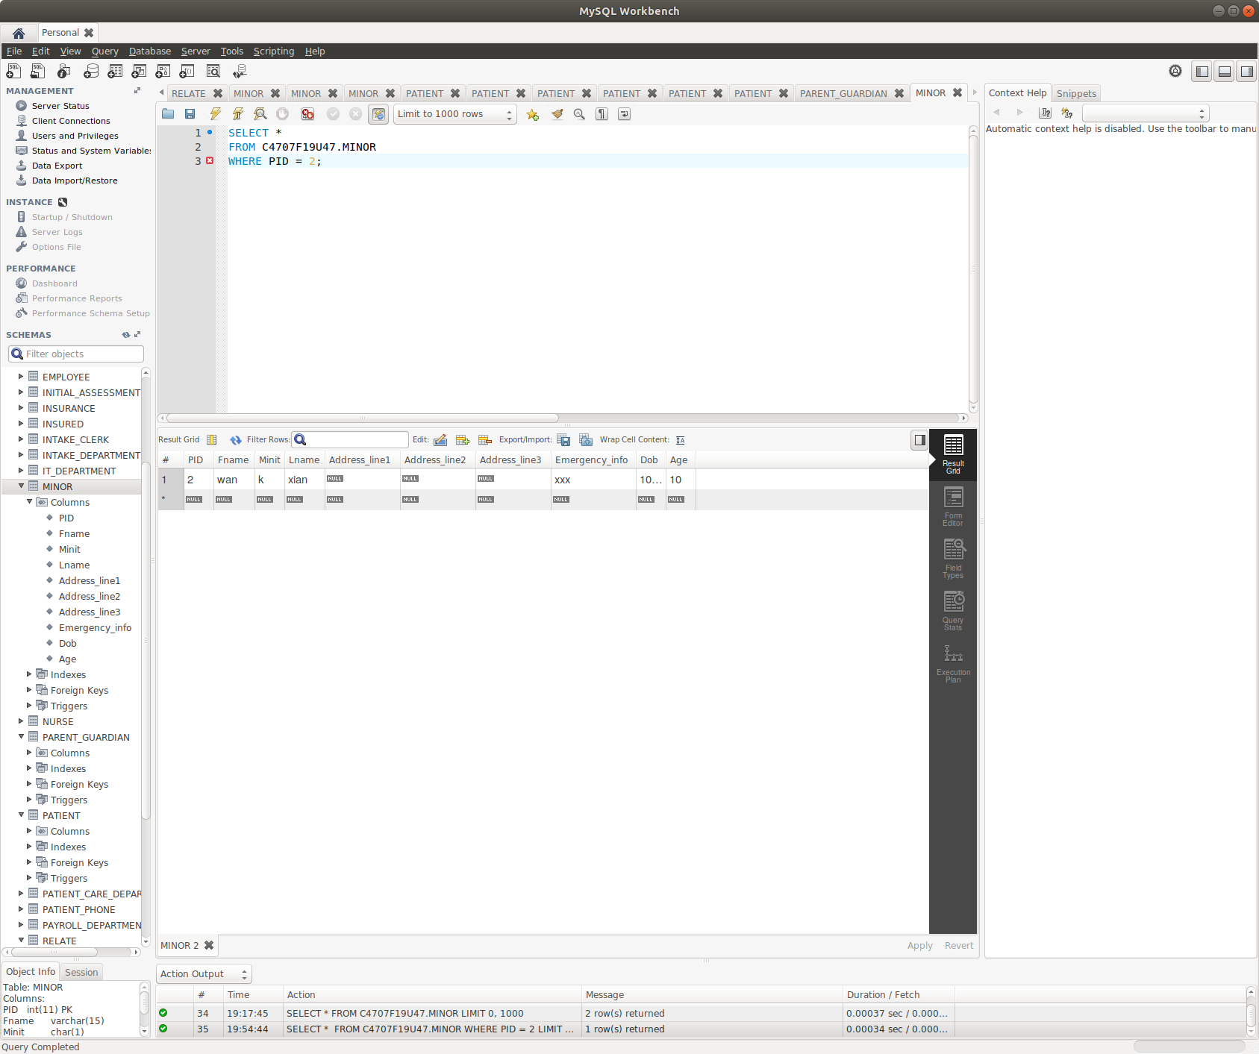

Explain and Discussion

Our design didn’t capture the requirement that all patients under the age of 18 must have a parent or guardian in the system.  As long as we insert the patient to the PATIENT, we can insert the patient to the MINOR. For example, we have a patient named “Wang”, we can insert it to Minor as long as “Wang” exists in PATIENT, but “Wang” doesn’t have parent/guardian information. Although “Wang” is a patient under the age of 18, it doesn’t have parent/guardian in the system. This is our design mistake, and the reason for this is because our MINOR does not have any direct relation to the PARENT_GUARDIAN.