|  |  |
| --- | --- |
| **Project: New Haven Urgent Care Team#** | |
|  | **Test Date: 2019-12-12** |
| **Test Case ID#: 10** | **Name(s) of Tester(s): JunRen Huang** |
| **Test Description (What are you testing? – you must be specific):**  This test is to test does the system document what intake clerk collected the insurance information and the copay. |  |
|  |  |

**NOTE: The following information must be provided to be given credit for any test.**

**Test Data (Provide the file name of the script used to insert data, provide a screen capture to reflect data, or provide script here):**

insert into PATIENT

values (001,'wang','k', 'xi',null,null,null,'xxxx','1001-01-01', 19);

insert into PATIENT

values (002,'wan','k', 'xian',null,null,null,'xxx','1001-02-02', 10);

insert into PATIENT

values (003,'wa','k', 'xiang',null,null,null,'xxxx','1001-02-02', 100);

insert into INSURED

values (001,'wang','k', 'xi','XXXXX',null,null,'xxxx','1001-01-01', 19, 10.1);

insert into INSURED

values (002,'wan','k', 'xian','XXXXXX',null,null,'xxx','1001-02-02', 10, 12.2);

insert into INSURANCE

values (001, 12, '2009-12-12', 001);

insert into INSURANCE

values (002, 13, '2009-12-12', 002);

**SQL Query(s) used for testing:**

SELECT *

from INSURANCE;

SELECT *

from INSURED;

The result are following

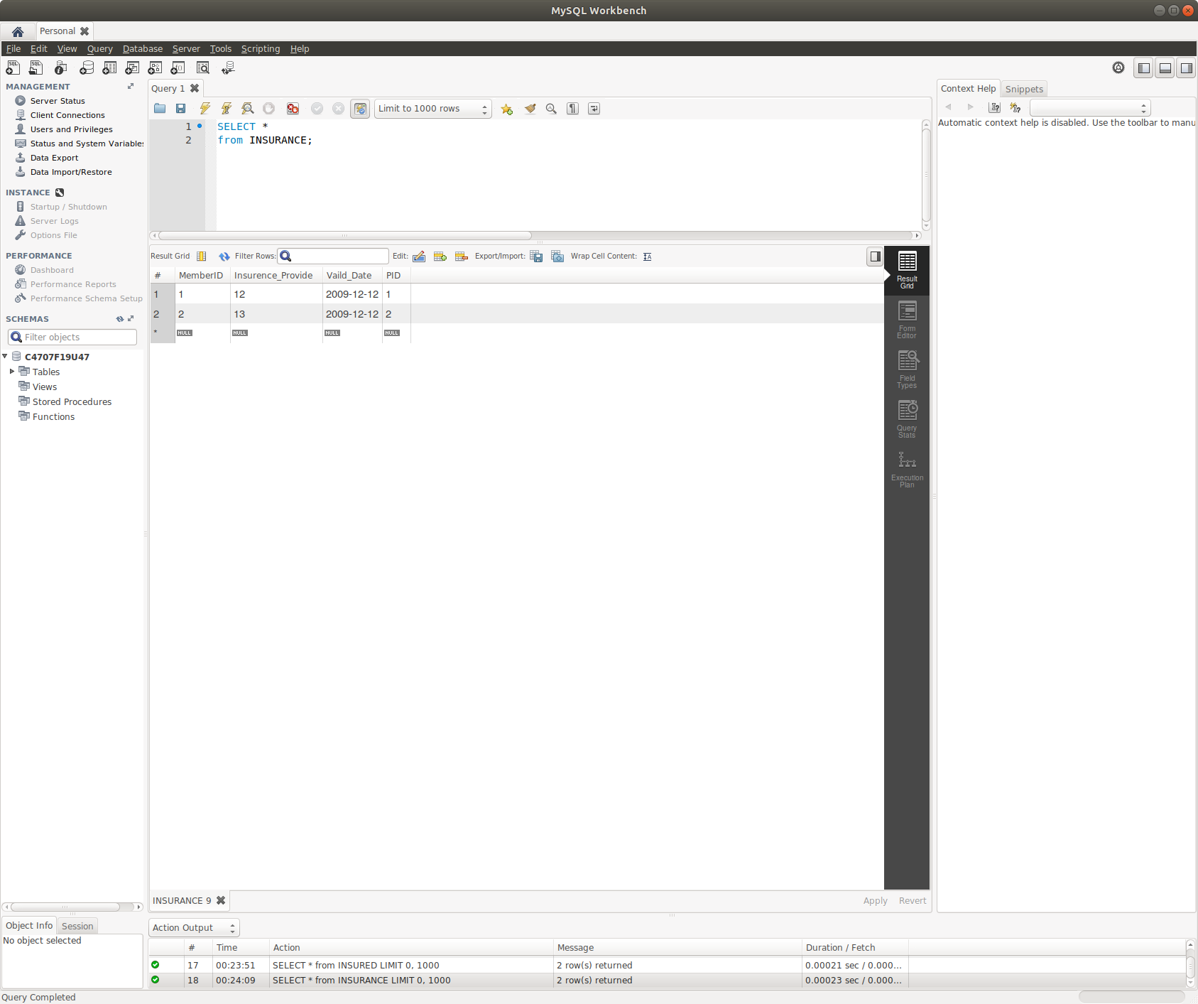

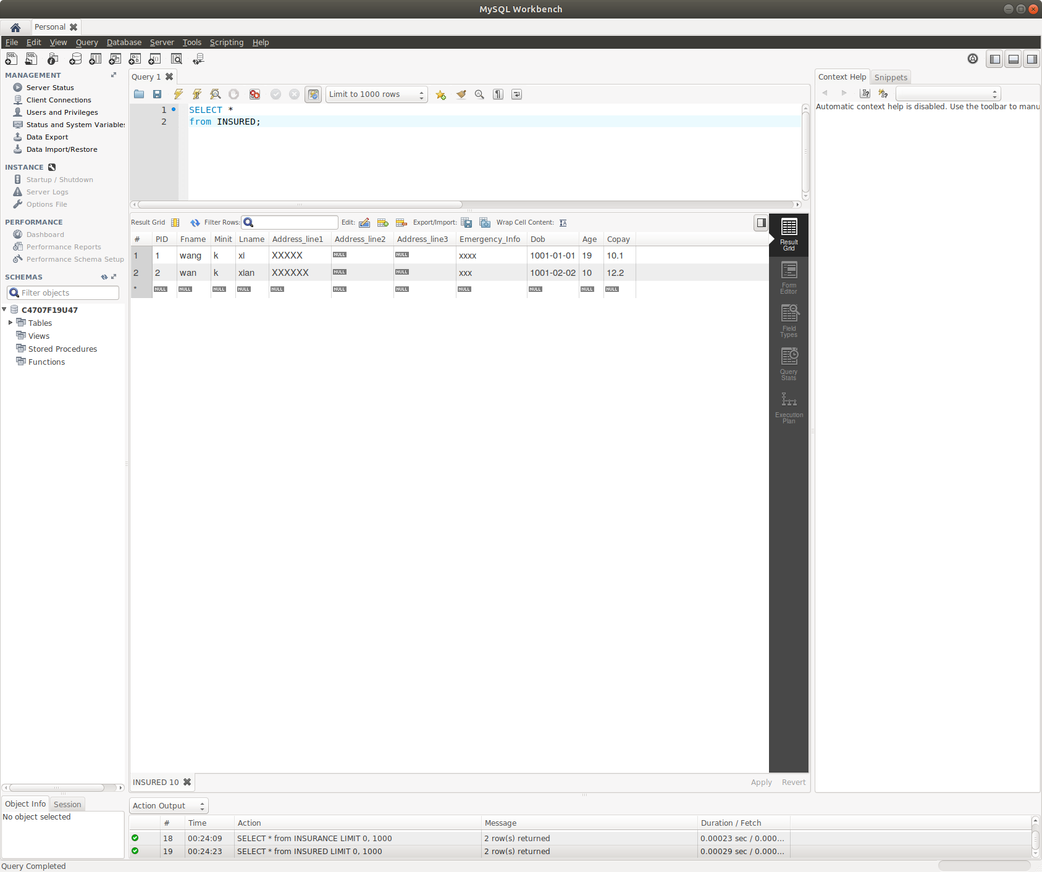

Explain and Discussion

We does not achieve the requirement that system document what intake clerk collected the insurance information and the copay. This our design mistake. We does not have a relation that relate the INTAKE_CLERK with INSURANCE OR INSURED. In order to achieve this requirement we should have a relation that allow intake clerk to access the insurance and copay information, and we have this relation in our prior design but it be removed in our later design.