|  |  |
| --- | --- |
| **Project: New Haven Urgent Care Team#4** | |
|  | **Test Date: 12-12-2019** |
| **Test Case ID#: 11** | **Name(s) of Tester(s):**  **Jian Wang** |
| **Test Description (What are you testing? – you must be specific):**  Does the system allow the patient to visit the urgent care more than one time |  |
|  |  |

**NOTE: The following information must be provided to be given credit for any test.**

**Test Data (Provide the file name of the script used to insert data, provide a screen capture to reflect data, or provide script here):**

insert into NURSE

values ('121', 'Charle', 'C', 'Andrew', '12345678');

insert into ASSESSMENT_DEPARTMENT

values ('121', 'Charle', 'C', 'Andrew', '12345678');

insert into ASSESSMENT_NURSE

values ('121', 'Charle', 'C', 'Andrew', '12345678');

insert into VISIT

values ('112', '400', '2019-12-11', '1','121', '121','400','13546556', 'form1');

insert into VISIT

values ('113', '400', '2019-12-11', '1','121', '121','400','13546556', 'form1');

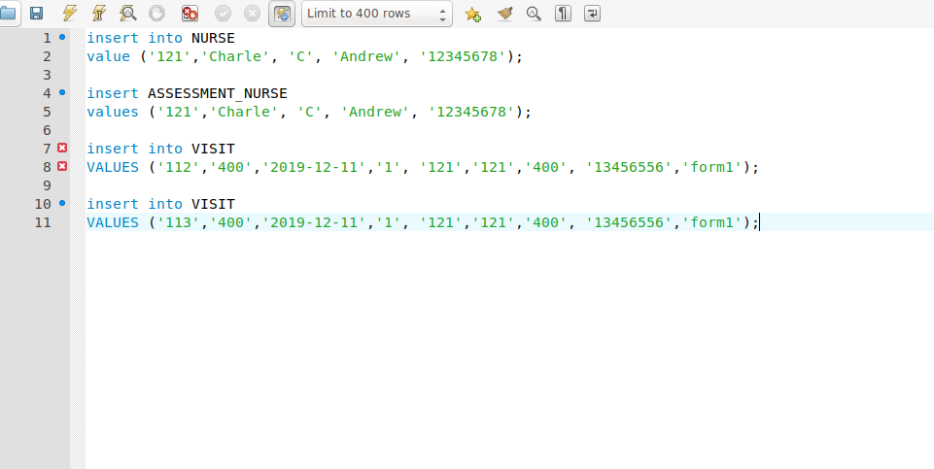

**SQL Query(s) used for testing:**

This case, I have insert VISIT with different visit ID and one same patient ID. And with the foreign key information from Table NURESE and Table ASSESSMENT_NURSE.

SELECT *

FROM VISIT;

