|  |  |
| --- | --- |
| **Project: New Haven Urgent Care Team# 4** | |
|  | **Test Date: 12-12-2019** |
| **Test Case ID#: 13** | **Name(s) of Tester(s): Jian Wang** |
| **Test Description (What are you testing? – you must be specific):** Can a nurse do assessments for multiple patients? |  |
|  |  |

**NOTE: The following information must be provided to be given credit for any test.**

**Test Data (Provide the file name of the script used to insert data, provide a screen capture to reflect data, or provide script here):**

insert into NURSE

values ('121', 'Charle', 'C', 'Andrew', '12345678');

insert into ASSESSMENT_DEPARTMENT

values ('121', 'Charle', 'C', 'Andrew', '12345678');

insert into ASSESSMENT_NURSE

values ('121', 'Charle', 'C', 'Andrew', '12345678');

insert into VISIT

values ('113', '400', '2019-12-11', '1','121', '121','400','13546556', 'form1');

insert into VISIT

values ('120', '400', '2019-12-11', '1','1', '121','400','13546556', 'form1');

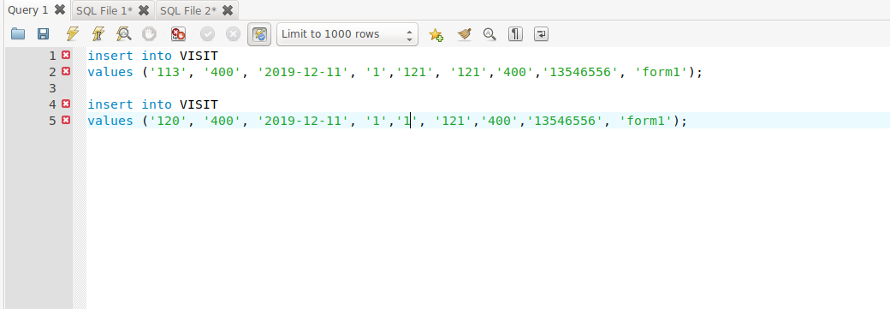

**SQL Query(s) used for testing:**

In this case, I insert two VISIT data with one same nurse id and two different patient id. And the result shows that it is works when there are multiple PID refer to one common assessment nurse id.

Select *

from VISIT;

