|  |  |
| --- | --- |
| **Project: New Haven Urgent Care Team# 4** | |
|  | **Test Date: 12-12-2019** |
| **Test Case ID#: 19** | **Name(s) of Tester(s): Jian Wang** |
| **Test Description (What are you testing? – you must be specific):**  Test at least two FKs for the cardinality numbers that are on the design document (your choice of Fks) – do we capture the max numbers for the relations? |  |
|  |  |

**NOTE: The following information must be provided to be given credit for any test.**

**Test Data (Provide the file name of the script used to insert data, provide a screen capture to reflect data, or provide script here):**

INSERT INTO INITIAL_ASSESSMENT

VALUES ('78','113', '121');

INSERT INTO INITIAL_ASSESSMENT

VALUES ('77','113', '121');

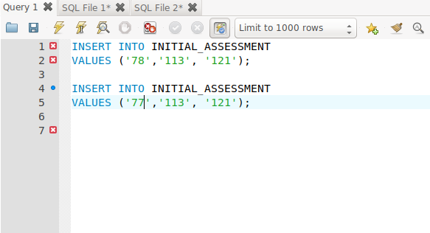

insert into EMPLOYEE

values ('133','XI', 'C', 'HE', '123456789', '1');

insert into SERVICE_PROVIDER

values ('133','XI', 'C', 'HE', '123456789');

insert into TREATMENT

values ('123145466', 'pargment', '100', 'approved', '133', '123456789');

insert into TREATMENT

values ('123145467', 'x ray', '100', 'approved', '133', '123456789');

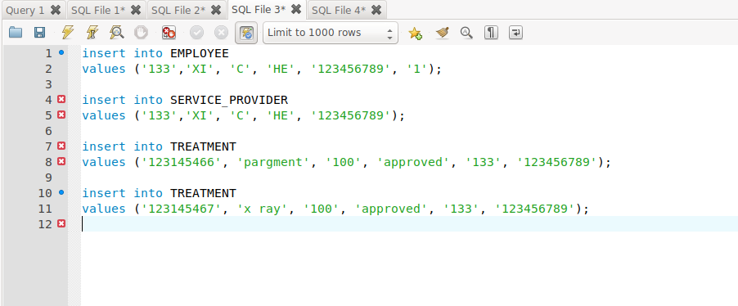

**SQL Query(s) used for testing:**

select *

from INITIAL_ASSESSMENT;

this graph shows that we are failed to build relation which is 1 to 1. One nurse id refer to 2 assessment id.

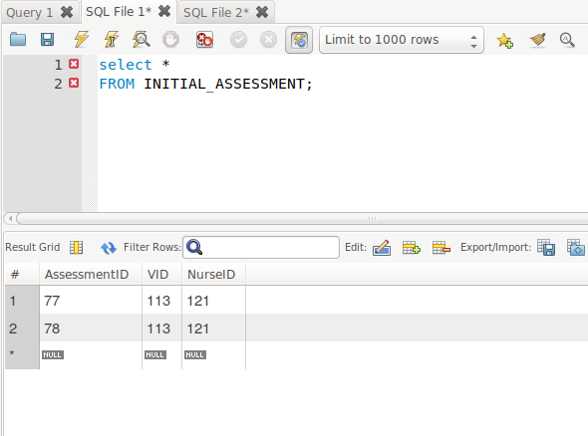

select *

FROM TREATMENT;

this graph shows that we are successfully build a n to 1 connection. One Approved refer to two ICD_10_PCS.

