|  |  |
| --- | --- |
| **Project: New Haven Urgent Care Team#** | |
|  | **Test Date: 2019-12-12** |
| **Test Case ID#: 18** | **Name(s) of Tester(s): JunRen Huang** |
| **Test Description (What are you testing? – you must be specific):**  **This test is to test can there be no tests/procedures for a patient for a given visit.** |  |
|  |  |

**NOTE: The following information must be provided to be given credit for any test.**

**Test Data (Provide the file name of the script used to insert data, provide a screen capture to reflect data, or provide script here):**

insert into PATIENT

values (001,'wang','k', 'xi',null,null,null,'xxxx','1001-01-01', 19);

insert into PATIENT

values (002,'wan','k', 'xian',null,null,null,'xxx','1001-02-02', 10);

insert into PATIENT

values (003,'wa','k', 'xiang',null,null,null,'xxxx','1001-02-02', 100);

insert into DEPARTMENT

values (1, 'First department');

insert into INTAKE_DEPARTMENT

values (1, 'Intake department1');

insert into EMPLOYEE

values (1, 'Ken', 'A','Jian',123456789, 1);

insert into EMPLOYEE

values (2, 'Wang', 'A','Jian',123456781, 1);

insert into NURSE

values (1, 'Ken', 'A','Jian',123456789);

insert into ASSESSMENT_NURSE

values (1, 'Ken', 'A','Jian',123456789);

insert into VISIT

values (1, 123.2, "1010-03-04", 1, 1, 1, 12, "xxxx", "yyyy");

**SQL Query(s) used for testing:**

select *

from TREATMENT;

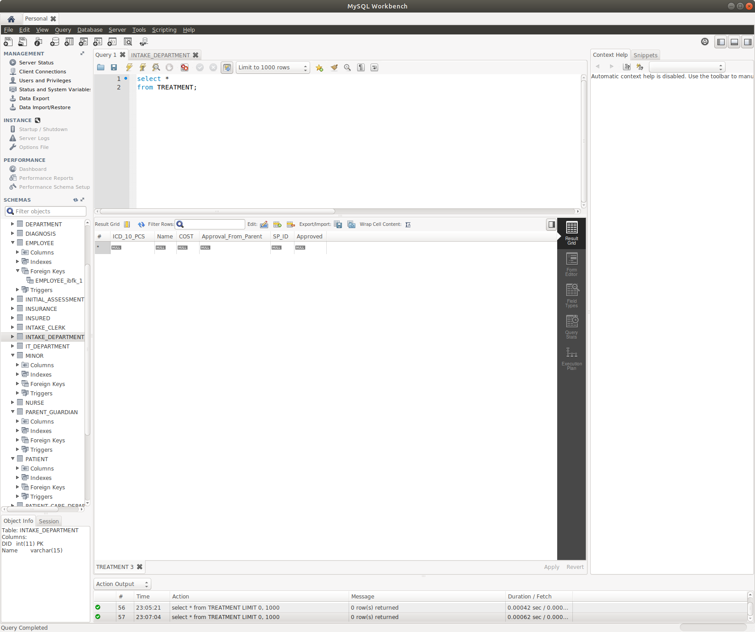The result are following

Explain and Discussion

Our design did meet the requirement that there can be no tests/procedures for a patient for a given visit. As you can see, there are patients and visit exists in the system but no treatment exist, so I think we achieve this requirement. Although our design achieve this design, but our design is actual wrong. Our VISIT have no direct or indirect relation with TREATMENT OR SERVICE_PROVIDER, so there always no tests/procedures for a patient for a given visit.