|  |  |
| --- | --- |
| **Project: New Haven Urgent Care Team#4** | |
|  | **Test Date: 2019-12-12** |
| **Test Case ID#: 12** | **Name(s) of Tester(s): Guipeng Xie** |
| **Test Description (What are you testing? – you must be specific):**  **I am inserting the data into INITIAL_ASSESSMENT table, then query by sql commands.** |  |
|  |  |

**NOTE: The following information must be provided to be given credit for any test.**

**Test Data (Provide the file name of the script used to insert data, provide a screen capture to reflect data, or provide script here):**

INSERT INTO PATIENT VALUES(001, 'XIE', 'T', 'GUIPENG', '2508 DELAWARE',null, null, 'alkfjaklfj', '1998-07-23', 20);

INSERT INTO PATIENT VALUES(002, 'Fary', 'k', 'Berd', '1141 DELAWARE',null, null, 'ueuiqiuer', '1998-09-23', 21);

INSERT INTO PATIENT VALUES(003, 'CHARLIE', NULL, 'XIE', '4545 SE ST',null, null, 'Headache', '1998-05-06', 25);

INSERT INTO PATIENT VALUES(004, 'Gary', NULL, 'zz', '4545 SE ST','apt3', null, 'PTSD', '1990-08-16', 56);

INSERT INTO PATIENT VALUES(005, 'XI', NULL, 'hee', '46234 SE ST','apt34', '4434', 'STD', '1979-09-28', 65);

INSERT INTO DEPARTMENT VALUES ( 001, 'A0');

INSERT INTO DEPARTMENT VALUES ( 002, 'B0');

INSERT INTO DEPARTMENT VALUES ( 003, 'C0');

INSERT INTO DEPARTMENT VALUES ( 004, 'D0');

INSERT INTO DEPARTMENT VALUES ( 005, 'E0');

insert into INTAKE_DEPARTMENT values (001, 'A0');

INSERT INTO INTAKE_DEPARTMENT VALUES (002, 'B0');

INSERT INTO INTAKE_DEPARTMENT VALUES (003, 'C0');

INSERT INTO INTAKE_DEPARTMENT VALUES (004, 'D0');

INSERT INTO INTAKE_DEPARTMENT VALUES (005, 'E0');

INSERT INTO EMPLOYEE VALUES (001, 'CHARLIE', 'k', 'XIE', 100, 001);

INSERT INTO EMPLOYEE VALUES (002, 'SUNY', 'v', 'jary', 101, 001);

INSERT INTO EMPLOYEE VALUES (003, 'jian', 'r', 'chun', 102, 002);

INSERT INTO EMPLOYEE VALUES (004, 'liang', 'c', 'Moon', 103, 002);

INSERT INTO EMPLOYEE VALUES (005, 'he', 'z', 'xi', 104, 003);

INSERT INTO ASSESSMENT_NURSE (EID, Fname, MINIT, Lname, SSN) select EID, Fname, MINT, Lname, SSN FROM EMPLOYEE;

INSERT INTO SERVICE_PROVIDER (EID, Fname, MINIT, Lname, SSN) SELECT EID, Fname, MINT, Lname, SSN FROM EMPLOYEE;

INSERT INTO VISIT VALUES(001, 119.01, '2019-07-03', 001, 002, 001, 11.11, 'ye', 'were');

INSERT INTO VISIT VALUES(002, 119.01, '2019-09-03', 001, 003, 002, 11.11, 'ye', 'were');

INSERT INTO DIAGNOSIS VALUES('STD', 'Yun', '2019-04-23', '2019-05-21', 100);

INSERT INTO DIAGNOSIS VALUES('PTSD', 'Yun', '2019-06-24', '2019-07-21', 100);

INSERT INTO DIAGNOSIS VALUES('YECF', 'TTT', '2019-06-24', '2019-07-21', 101);

INSERT INTO INITIAL_ASSESSMENT values ('a001', 1, 1);

INSERT INTO INITIAL_ASSESSMENT values ('b002', 2, 2);

**SQL Query(s) used for testing:**

SELECT A.*

FROM ASSESSMENT_NURSE AS A

where A.EID in

(select B.NurseID FROM INITIAL_ASSESSMENT AS B );

The result:

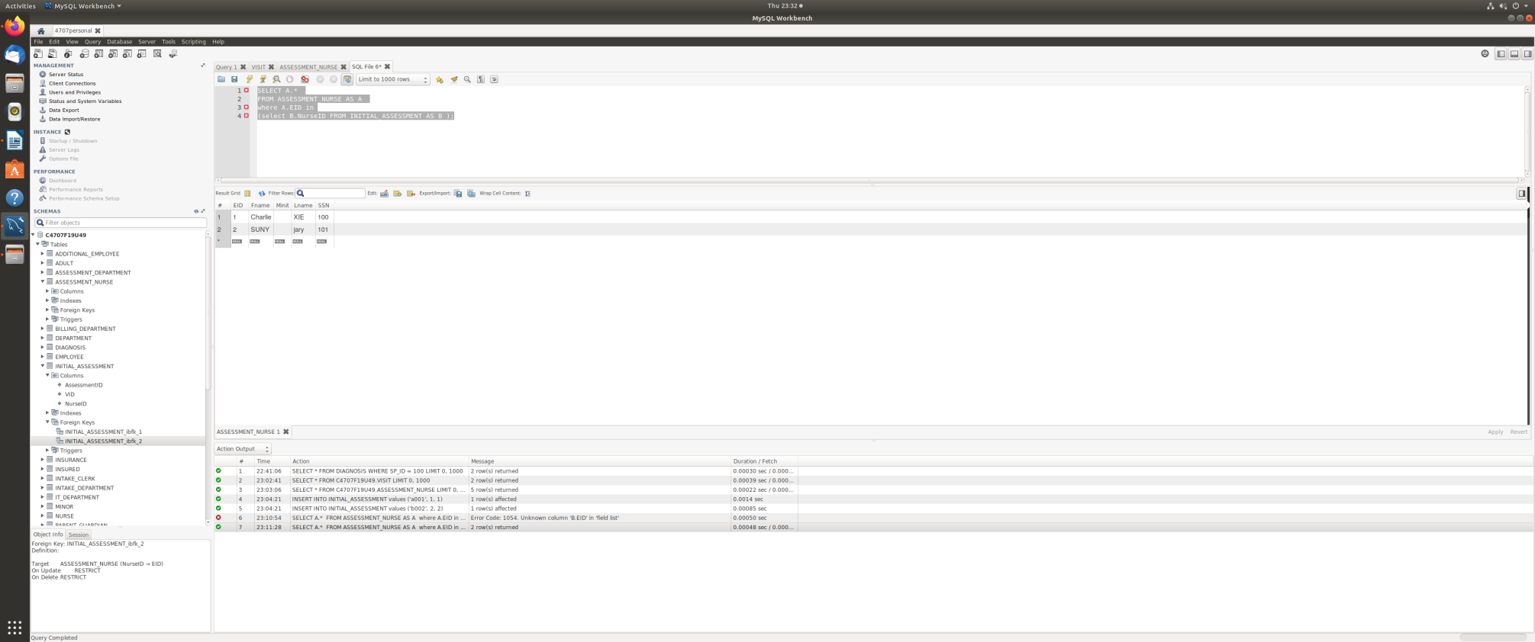

Yes.Following the SQL query command, we can retrieve the nurse’s information  from the initial assessments. Because the table of initial assessments involve the nurse’s EID. We query the nurse’s information by querying the nurse’s EID.