|  |  |
| --- | --- |
| **Project: New Haven Urgent Care Team#4** | |
|  | **Test Date: 2019-12-12** |
| **Test Case ID#: 2** | **Name(s) of Tester(s): Guipeng Xie** |
| **Test Description (What are you testing? – you must be specific):**  Testing the requirement that a patient over the age of 18 does not have a patient or guardian. |  |
|  |  |

**NOTE: The following information must be provided to be given credit for any test.**

**Test Data (Provide the file name of the script used to insert data, provide a screen capture to reflect data, or provide script here):**

INSERT INTO PATIENT VALUES(001, 'XIE', 'T', 'GUIPENG', '2508 DELAWARE',null, null, 'alkfjaklfj', '1998-07-23', 20);

INSERT INTO PATIENT VALUES(002, 'Fary', 'k', 'Berd', '1141 DELAWARE',null, null, 'ueuiqiuer', '1998-09-23', 21);

INSERT INTO PATIENT VALUES(003, 'CHARLIE', NULL, 'XIE', '4545 SE ST',null, null, 'Headache', '1998-05-06', 25);

INSERT INTO PATIENT VALUES(004, 'Gary', NULL, 'zz', '4545 SE ST','apt3', null, 'PTSD', '1990-08-16', 56);

INSERT INTO PATIENT VALUES(005, 'XI', NULL, 'hee', '46234 SE ST','apt34', '4434', 'STD', '1979-09-28', 65);

**SQL Query(s) used for testing:**

SELECT * FROM C4707F19U49.PATIENT;

The result:

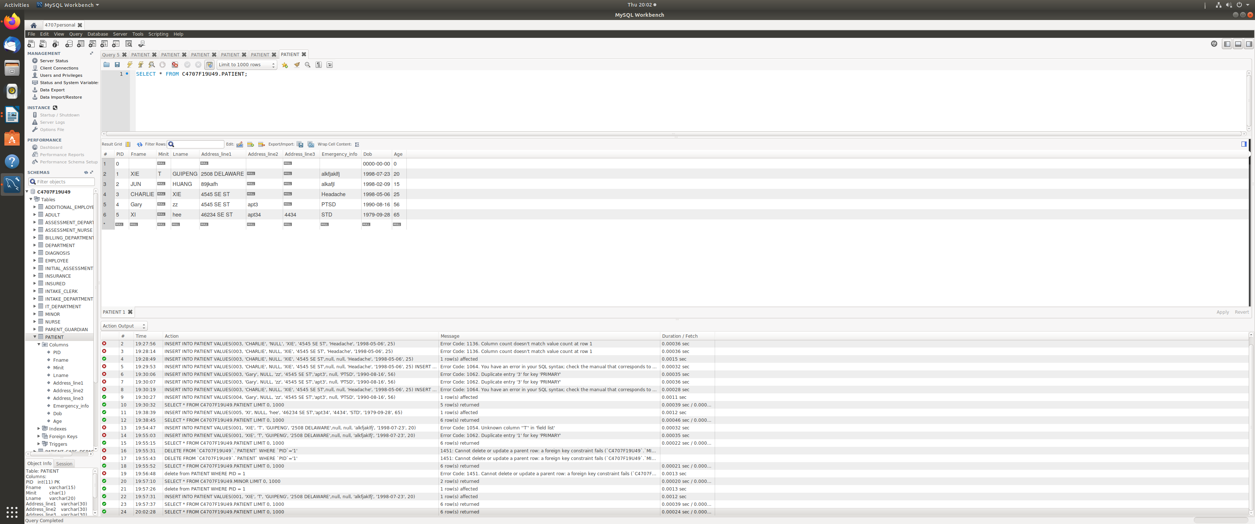

Explain and discussion:

Yes, our query’s result is showed that the patient who age over 18 do not have a patient or guardian. Because, there is not any directly relation between patient and parent_guardian. The only relation between patient and parent_guardian is RELATE table. When select patients’ information, the query will not show any information about parent/guardian.